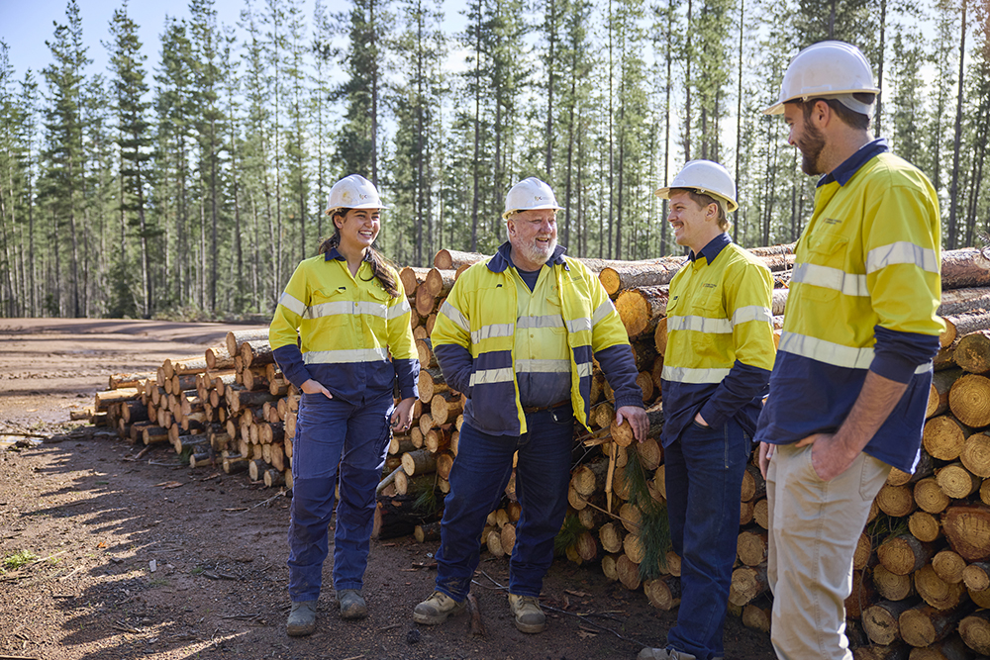




DRAFT
Forest Products Commission
Disability Access and Inclusion Plan 2026-2030







DRAFT
Message from the CEO
and the Workforce Diversification and Inclusion Strategy for WA Public Sector Employment 2020-2025.
In 2024, we launched our Multicultural Plan 2024-2027 and the EEO Management Plan 2024-2026, which outlines our commitment to fostering inclusive and equitable workplaces, ensuring that current and future employees have equal access to employment opportunities.
Since the previous DAIP implementation, we’ve strengthened our policies, improved accessibility, embedded inclusive recruitment practices, and expanded training and awareness to promote equality and respect across our organisation.
The DAIP 2026-2030 builds on these achievements and sets out our next steps to remove barriers and promote participation in all aspects of our work. Together, we will continue to cultivate a culture where every individual feels valued, included and empowered to succeed.
I am proud to present FPC’s second DAIP for January 2026 to December 2030.
At FPC, we are committed to fostering a workplace and community that is inclusive, accessible, and respectful of all individuals. We take the opportunity to reflect on the progress we have made and reaffirm our dedication to continuous improvement.
FPC has enhanced access and inclusion since the inception of our inaugural Disability Access and Inclusion Plan 2020-2025, complemented by initiatives under our People Plan 2024-2026
Stuart West
Chief Executive Officer
We acknowledge the Aboriginal peoples of Western Australia as the traditional custodians of this land and we pay our respects to their Elders, past and present.
/fpcwa

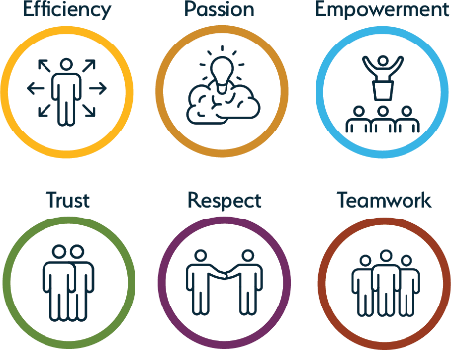
DRAFT
Our agency
Our values
Each of us being our best and treating each other well. This is what we strive for at FPC.
Our vision
To build and maintain a sustainable and commercially viable forest products industry that provides economic and social benefits to the people of Western Australia.
Our mission
To contribute to Western Australia’s economic and regional development.
2
FOREST PRODUCTS COMMISSION DISABILITY ACCESS AND INCLUSION PLAN 2026-2030
Our values are: Efficiency, Passion, Empowerment, Trust, Respect and Teamwork.
At FPC, our values are the foundation of the culture we are building together. We are committed to creating an environment where every individual feels respected, empowered and accountable.
We believe that how we work is just as important as what we achieve, whether in the field, in the office, or engaging with our partners and communities.
Our values shape how we collaborate, how we lead and how we continue to grow a safe, inclusive and high-performing organisation. They guide our behaviours, help build trust and enable us to meet the challenges of a changing forestry sector with confidence and integrity.
Together, we strive for a culture where everyone can be their best and where we treat each other well, always.
FPC works in plantation and native forestry in Western Australia. Our team is committed to positive engagement with communities, industry and government to support a vibrant and sustainable forestry sector.
The Commission delivers timber products and services across three business segments - plantations, native forest and sandalwood - in line with our key priorities of timber production, forest health and adapting to the challenges of climate change.
Our objective is to supply essential timber products for the housing and construction industry in Western Australia as well as for furniture, artisans, firewood and other uses.
We focus on care, innovation and industry support to ensure our forests remain a strategic and sustainable resource for the future.
FPC work is carried out in ten work areas - Albany, Bunbury, Collie, Esperance, Harvey, Kalgoorlie, Manjimup, Nannup, Perth and West Manjimup.






DRAFT
Our commitment to disability access and inclusion
The legislation
It is a legal requirement for public authorities to develop and implement a DAIP as set out in the:
FPC is committed to:
•
ensuring that people with disability and their families can access FPC services and facilities
•
•
Disability Services Act 1993 (Part 5).
Disability Services Regulations 2004 (Schedule 1 – 3).
•
engaging with people with disability, their families where required, disability organisations to ensure that barriers to access and inclusions are appropriately addressed
ensuring FPC staff and contractors are aware of the DAIP and understand their responsibilities in supporting its implementation
•
•
working towards the achievement of the seven desired outcomes outlined in the FPC DAIP
developing and maintain recruitment practices that are inclusive, equitable, and free of bias.
•
As at 30 June 2025, FPC employed 153 people across our work sites with our people primarily based in regional WA. This includes permanent full time and permanent part time employees, fixed term contract staff and casual employees. At FPC, 2.7% of our workforce have reported living with disability, highlighting the importance
of accessibility and inclusion.
3
FOREST PRODUCTS COMMISSION DISABILITY ACCESS AND INCLUSION PLAN 2026-2030
Fast facts
21.4% of Australians or 5.5 million people reported living with disability. In Western Australia, approximately 515,600 have disability.
1 in 5 Western Australians are living with disability

1 in 10 aged 0-64 years have disability

1 in 10 with disability reported a schooling or employment restriction

1 in 9 Western with disability experienced discrimination in the past 12 months

Sources:
Australian Bureau of Statistics 2022 Survey of Disability, Ageing and Carers Developing a Disability Access and Inclusion Plan
Australian Network on Disability 2020

DRAFT
Our progress
Development and implementation of the DAIP 2026-2030
The People and Culture team is responsible for overseeing the development, review, and implementation of the DAIP. FPC continues to
make meaningful progress in enhancing access and inclusion for its staff and contractors through continuous improvement, regular reviews and alignment with complementing strategic plans including our People Plan 2024-2026 and other diversity and inclusion strategies such as the Workforce Diversification and Inclusion Strategy for WA Public Sector Employment 2020-2025.
FPC is committed to continuously seeking input from a broad range of stakeholders - including the Executive, the Strategic Occupational Safety and Health Committee, managers, staff, and
contractors - on matters related to accessibility and inclusion. This includes engaging with people with disability to ensure their voices are heard and that participation is accessible and meaningful.
Review
The DAIP is reviewed every five years to ensure any access and inclusion issues that may arise are addressed.
Consultation
Feedback on the draft DAIP was sought to help shape the Plan. Opportunities to provide feedback were promoted in several ways including:
•
review of the previous DAIP and related reports to reflect on achievements and opportunities for improvement
consultation with relevant stakeholders investigation of contemporary trends and good practice in access and inclusion
notice of the draft DAIP will be published here: FPC: Disability Access and Inclusion Plan notice of the draft DAIP published in the (Southwest Newspaper)
advice and consultation with the Department of Communities.
•
•
•
•
•
4
FOREST PRODUCTS COMMISSION DISABILITY ACCESS AND INCLUSION PLAN 2026-2030
Contact process
The final version of the DAIP will be reviewed and Alternative formats, including hard copy in large endorsed by the Executive Team, then submitted to print, electronic format, audio format and email, can Department of Communities. The Plan will be made be obtained by contacting info@fpc.wa.gov.au. available through FPC external website and the Alternative contact can be made:
intranet. Phone: +61 8 9363 4600
Staff will be informed of the location of the DAIP Postal address: Forest Products Commission,
and reminded to attend various online EEO Locked Bag 888, Perth Business Centre, WA 6849. and diversity training through the Learning and Website: www.fpc.wa.gov.au.
Development Portal (Knowledge Tree).

During the implementation of our DAIP 2020-2025, FPC undertook a range of initiatives:
- Under the People Plan 2024-2026, diversity and inclusion remain a key focus. The newly developed Equal Employment Opportunity, Bullying and Harassment Policy also reinforces our commitment to fairness and equality for all.
- Regular review of our recruitment processes ensure they are inclusive, equitable, and free from bias. All job advertisements feature a clear equity and diversity statement, and panel members and managers receive training to ensure candidates with disability are provided equal opportunities.
- FPC also promotes awareness and engagement by recognising events such as the International Day of People with Disability, encouraging staff participation in activities that foster understanding and inclusion.
- Our Perth office relocation was planned with accessibility in mind - situated near public transport and compliant with the Building Code of Australia (AS1428) standards.
- We introduced a suite of online EEO and diversity training via our Learning and Development Portal, Knowledge Tree, and continue to deliver values-driven workshops that support the development of inclusive workplace culture.





DRAFT
The seven outcomes
FPC aims to achieve the outcomes outlined in the Disability Services Act 1993 (WA) by advancing access and inclusion through the implementation of the following strategies:
5
FOREST PRODUCTS COMMISSION DISABILITY ACCESS AND INCLUSION PLAN 2026-2030

Outcome 2: Buildings and facilities

People with disability have the same opportunities as other people to access the buildings and other facilities of FPC.
Strategy
- FPC buildings and facilities are physically accessible for people with disability.
- Ensure FPC offices and building signage meets the needs of people with disability.
- Ensure, where possible, there is adequate parking and access to meet the needs of people with disability.
- Ensure any feedback regarding access to FPC buildings and facilities from staff or visitors with disability is reviewed and considered in a timely and appropriate manner.

Outcome 4: Service quality

People with disability receive the same level and quality of service from the staff of FPC as other people receive.
Strategy
- Improve staff awareness of disability access issues and requirements.
- Promote policies, code of conduct and strategies that prohibit discrimination, harassment and victimisation of staff with a disability.
- Significant access and inclusion calendar events are recognised and celebrated.

Outcome 3: Information
People with disability receive information from FPC in a format that enables them to access the information as readily as other people.
Strategy
- Ensure FPC website and publications meet accessibility standards and available in alternative formats suitable for people with disability.
- Ensure there is access to translating and interpreting services for people with disability.

Outcome 1: Events and services
People with disability have the same opportunities as other people to access the services of, and events organised by, FPC.
Strategy
- Ensure events and activities organised by FPC are accessible to people of disability.
- Improve awareness of staff and contractors of their obligations and responsibilities under the DAIP.
- Opportunities are provided for people with disability to comment on access to events, services and advice provided by FPC.




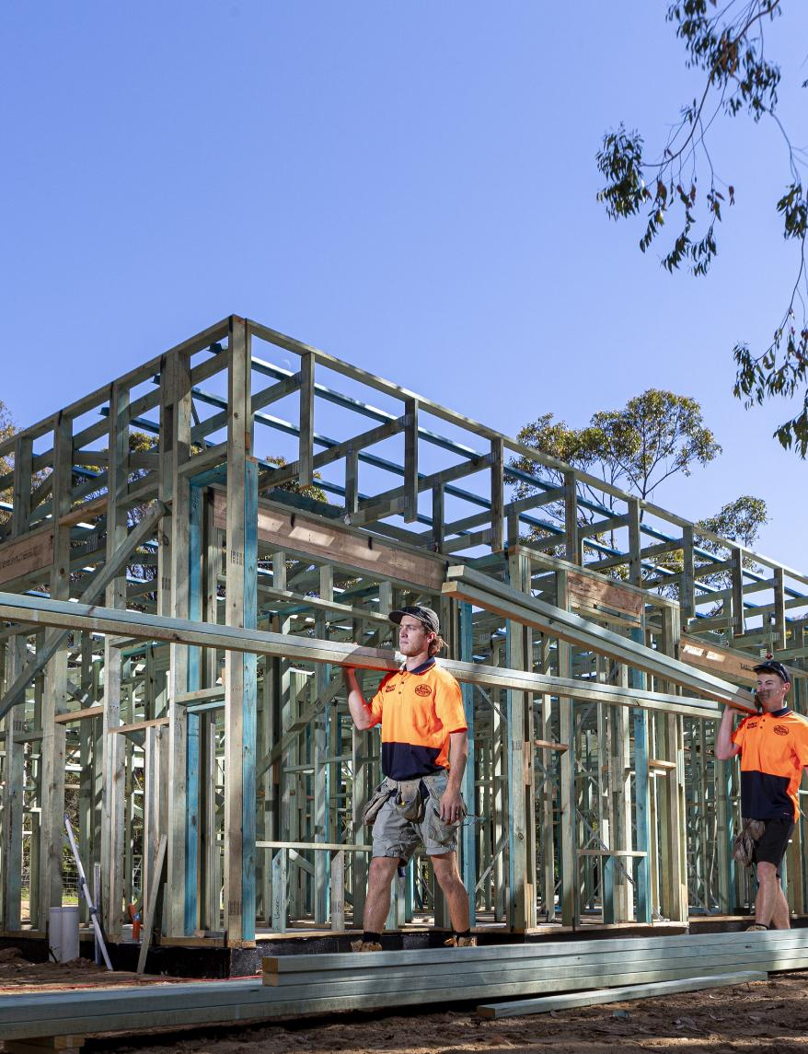
DRAFT
6
FOREST PRODUCTS COMMISSION DISABILITY ACCESS AND INCLUSION PLAN 2026-2030
Outcome 7: Employment
People with disability have the same opportunities as other people to obtain and maintain employment with FPC.
Strategy
1. Ensure recruitment processes are inclusive and support people with disability to apply for roles with FPC.

Outcome 6: Consultation
People with disability have the same opportunities as other people to participate in any public consultation undertaken by FPC.
Strategy
1. Promote protocols that support participation by people with disability in community consultations.

Outcome 5: Complaints
People with disability have the same opportunities as other people to make complaints to FPC.
Strategy
1. Ensure complaints and feedback processes are accessible and supportive for people with disability.


DRAFT
Document version: January 2026

