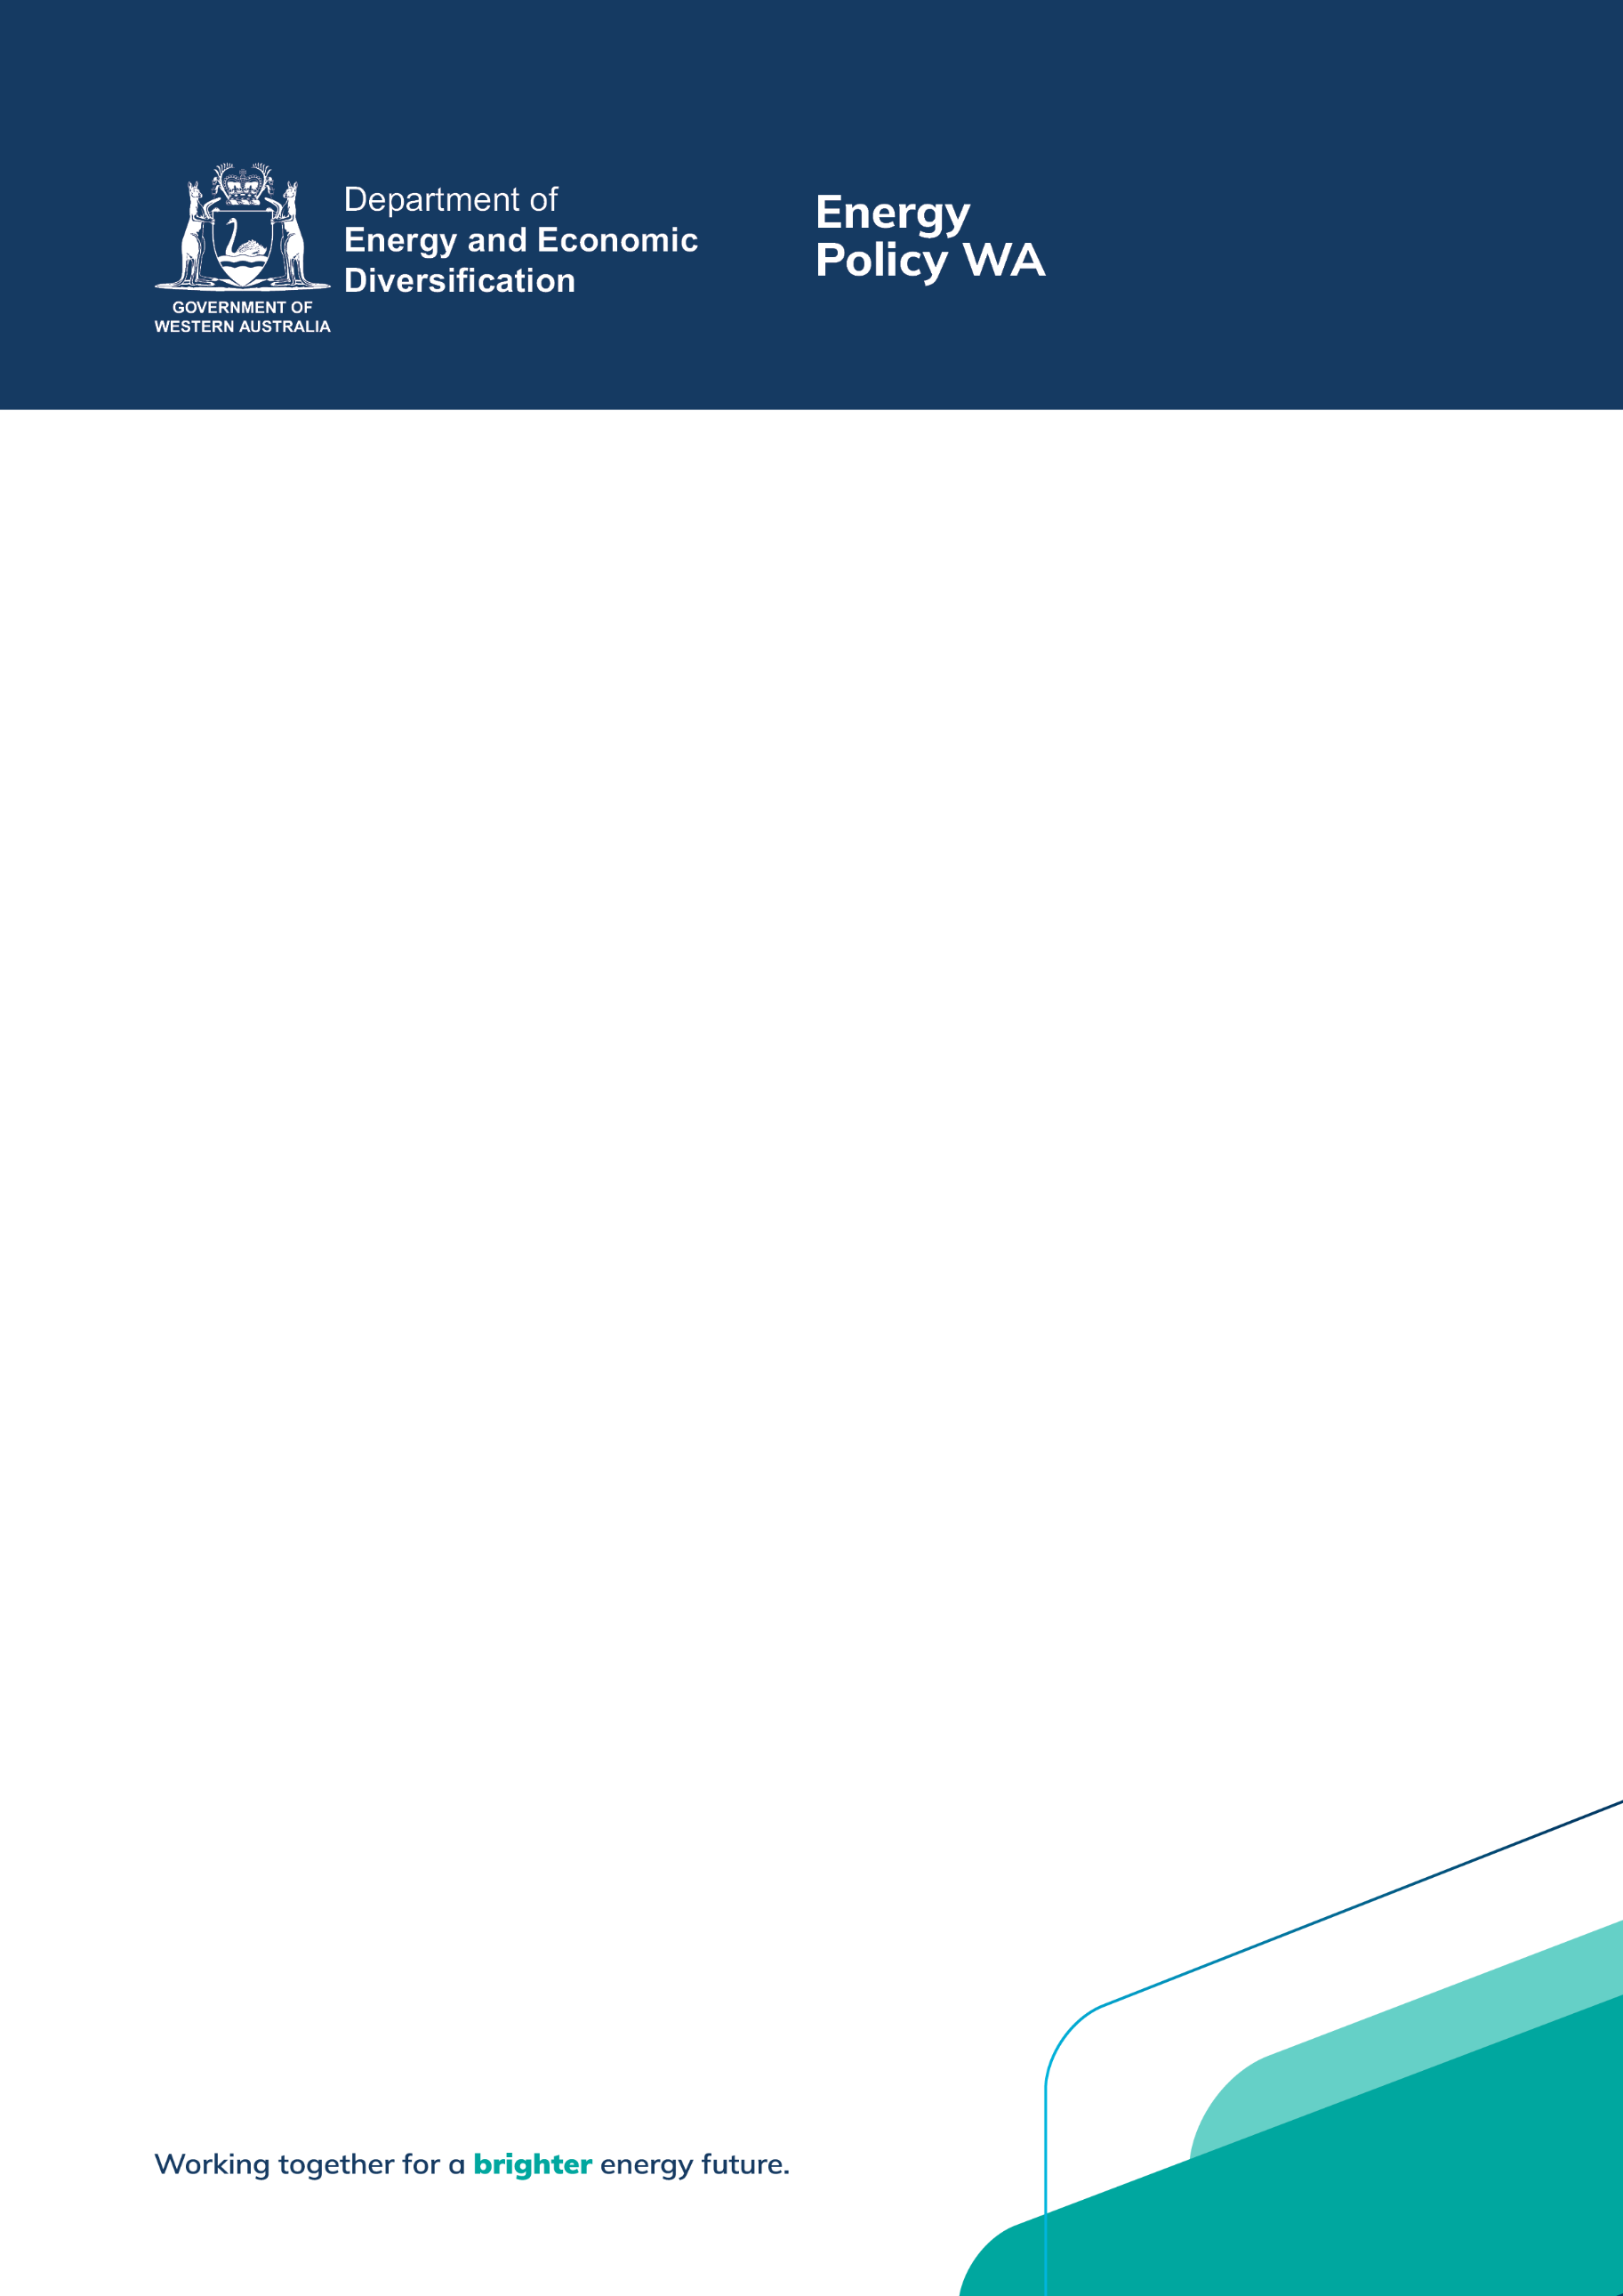



Western Australian Advocacy for Consumers of Energy Grants Program
  - Project Grants – Project Plan Template
April 2026

Western Australian Advocacy for Consumers of Energy Project Grant - Project Plan

Project Plan template overview
Developing a comprehensive project plan is a critical component for the successful execution of any project. It serves as a structured roadmap for implementing and overseeing all project phases, ensuring clear definition of objectives, tasks, and responsibilities.
For the Western Australian Advocacy for Consumers of Energy Project Grant, applicants are required to complete and electronically upload a project plan as part of their grant application. While the provided Project Plan template has been designed to assist applicants in outlining key tasks, milestones, and a sound project budget, its use is not mandatory. Applications utilising alternative templates will still be assessed.
Should you have any questions regarding the completion of this form, please contact the Senior Advisor Consumer Policy and Advocacy at Energy Policy WA via email at epwa-grants@deed.wa.gov.au.
Please complete all sections of this form.

Project outline
Project details
Lead Applicant | Name the lead applicant, or lead Organisation.
Project Title | List the name of the project.
Detailed Project Description
Provide a description of the proposed project. Describe the facts of the project (what, where and how). You could describe how innovative your project is or describe any other unique aspects of the project.

Aims of the project
Briefly outline what the project seeks to achieve. This may be dot points if preferred.
The project aims to:
- XX
- XX

Key project personnel and partner organisations
External partners/stakeholders and key personnel
List partnering organisations and their contributions if relevant.
If there are key project personnel already within these organisations, then please also include them in the table below.
Please add more rows if required.
Project partner / Key project personnel. | Project role/contribution and any specific key skillsets to be contributed.

Milestone payments
It is expected that there will be up to three milestones linked to grant payments for projects with duration of 12 months or under. Projects that extend over a longer period than this could include additional milestones.
Grant agreement execution usually forms the first project milestone, with the final milestone being associated with acquittal of the project. Please add/remove lines as required.
Proposed milestone payments
Milestone | Evidence/Indicator | Payment Value
Briefly list your proposed milestones where payments will be made. | Briefly outline evidence to be provided to demonstrate that the milestone has been reached. Examples provided below. Please edit as required. | Outline expected payment attached to each milestone to nearest whole dollar (GST exclusive)
Grant agreement executed (XX%) | Both parties signing the grant agreement. | $XX
XX% completed | Report outlining XX provided to DEMIRS. | $XX
Acquittal of the project | Final XX and project output provided to DEMIRS, along with financial statements*. | $XX
Important information: Where the Grant amount is valued at under $50,000, financial statements are to be certified by the Chairman, CEO or equivalent of the Organisation. Where the Grant amount is valued at $50,000 or more, financial statements are to be certified by the Chairman, CEO of the Organisation (or equivalent) AND certified by a professional auditor who is:
- not an officer or employee of the Organisation; and
- registered as a company auditor or equivalent under a law in force in Western Australia; or
- a member or fellow of the Institute of Chartered Accountants, Australian Society of Certified Practising Accountants or National Institute of Accountants.
Note: the cost associated with engaging a professional auditor can be categorised as an expense in the Statement of Income and Expenditure.

Budget
Provide a detailed project budget. Please note that a lack of suitable and relevant project information here may adversely affect the grant assessment as to capacity to plan for and manage your project budget. Items that are not costed as part of the project budget in your application may not be funded.
Administration costs should not include expenses for ongoing costs of your organisation, such as office reception expenses and utilities (water, gas, electricity), or the costs of developing this application. However, they can include various administrative costs to manage the project. For example, project management, audit costs, stakeholder engagement, etc. Project administration expenses cannot comprise more than 10 per cent of the total project budget.
Note: There is no requirement for, nor is it expected that, applicants provide in-kind or financial co-contributions to a grant funding application. However, if other sources of funding/in-kind contributions are to be provided, then this should be listed in the budget.

Project Budget
Expense | Amount ($) | Comments / Funding source
List your expenses below.  To assist in demonstrating that the costs are sound please include a short explanation on how the figure was determined. For example, Staff expense (5 hours of project management, 25 hours of research and report by XXXX at $XX = $XX), or Travel costs could be: Two trips from Perth to XXX as part of workshop. XX /Km return at $0 / Km (the ATO rate), plus overnight hotel at XX for room = $XX travel costs, etc. You may wish to include supporting quotes for unusual expenses with the application.  Add/remove line items as required to support your application. | The cost of each budget item must be provided exclusive of GST, rounded to nearest dollar. | List if the expense will be covered by the WA ACE Grant, or otherwise describe the funding source (e.g. in-kind or other funding provider).
 | $
 | $
 | $
 | $
 | $
 | $
Total expenses (GST exclusive) | $
Grant Funding Amount Requested (GST exclusive) | Should equal total expenses, less funding from other sources ($)

Other matters
This section is optional. Each project is unique, and therefore a project plan template cannot capture all the documentation that should be considered by an applicant before submitting or undertaking a project.
Please include information on any other additional matters that may be relevant to the grant assessment process, such as work that is outside the scope of the project, risks and strategies to address those risks, or any other information that is not already provided elsewhere in the application.


Department of Energy and Economic Diversification
Energy Policy WA
Level 1, 66 St Georges Terrace, Perth WA 6000
PO Box Z5044, St Georges Tce, Perth WA 6831

Telephone: (08) 6551 4600
www.energy.wa.gov.au

