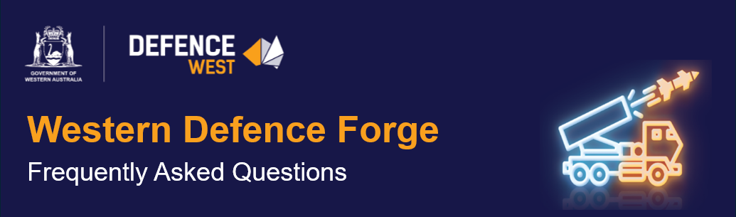

Q. What level of detail is expected in submissions?
Submissions should be clear, concise, and structured. We are seeking sufficient detail to understand capability, role in the supply chain, and key requirements. Supporting material can be included where helpful but should be targeted and relevant.

Q. Is this EME capability mapping or a full application process?
The EME is a market-sounding process designed to understand industry capability and requirements. It is not a formal procurement or final application process. Insights gathered will inform subsequent assessment and potential further engagement.

Q. Are single organisation’s or supply chain clusters preferred?
Submissions are open to both individual organisation’s and connected supply chain or cluster proposals. Integrated approaches demonstrating end-to-end capability are encouraged where relevant.

Q. What happens after the Early Market Engagement (EME) closes?
Submissions will undergo analysis and shortlisting, followed by assessment by a cross-government panel. Further engagement may occur with selected proponents as part of the process.

Q. Is this a procurement or tender process?
No. The EME is a market-sounding process designed to understand industry capability and requirements. It is not a procurement or tender process, and no commitments to contracts have been made.

Q. What types of organisation’s are encouraged to submit?
Submissions are encouraged from organisation’s across the supply chain, including primes, SMEs, service providers, and enabling industries.

Q. Will all submissions progress to the next stage?
Submissions will be assessed through a structured process. Further engagement may occur with shortlisted proponents only.

Q. What evidence of supplier readiness is useful?
Useful information includes ability to scale, workforce capability, supply chain integration, delivery track record, and key dependencies. Submissions should demonstrate capacity for sustainable delivery over time.

Q. Who is responsible for awareness and implementation?
Defence West is coordinating the EME process, working across Government and industry to build awareness and engagement.

Q. Will ownership structures (local vs offshore) affect assessment?
Ownership and control structures may be considered as part of broader assessment of sovereign capability, supply chain integrity, and strategic alignment.

Q. Are there preferred countries for OEMs?
Submissions should reflect alignment with Australia’s defence and regulatory environment. Any constraints will be guided by Commonwealth Defence Industry related policy settings and standards.

Q. What support is available for DISP accreditation?
Organisations are responsible for pursuing DISP accreditation. Defence West can support awareness and connection to relevant information and pathways.

Q. Can international organisation’s participate?
Yes. Submissions are open to international organisations, noting alignment with Australia’s regulatory and Defence Industry policy settings will be considered.

Q. What aligns most with ADF requirements?
Capabilities aligned to defence manufacturing, sustainment and supply chains, particularly those supporting sovereign capability outcomes, are of interest. Detailed alignment will be assessed through the evaluation process.

Q. What capabilities are WA most interested in attracting?
The EME is seeking a broad range of defence-related manufacturing, supply chain and enabling capabilities. Priority will be informed by alignment to defence requirements, sovereign capability objectives, and market viability.

Q. Will Government connect industry to testing/certification partners?
The Early Market Engagement will help identify opportunities for collaboration and connection within the innovation and research ecosystem, including testing and certification pathways.

Q. How will enabling materials be supported?
Submissions identifying enabling technologies and materials will inform understanding of capability gaps and opportunities within the broader ecosystem.

Q. How does the Forge fit within the broader WA innovation ecosystem?
The Western Defence Forge is intended to complement existing Western Australian Government and DSTG innovation and research initiatives, with opportunities for collaboration and integration to be informed through the EME process.

Q. What role exists for ESG / energy reduction technologies?
Innovative technologies, including ESG-aligned solutions, are encouraged where they support defence capability or industrial performance.

Q. What funding or incentive models will be available?
No funding or incentive programs are being committed at this stage. The EME will inform potential future support mechanisms, which would be subject to separate Government consideration.

Q. Will financial guarantees be supported?
Government is not currently considering financial guarantees for contracts. This process is focused on capability and feasibility; any future support mechanisms will be considered separately.

Q. Are there funding programs available now?
Current relevant funding rounds are closed. Any future support mechanisms are subject to Government consideration.

Q. What workforce support exists?
Workforce requirements identified through the EME will inform planning across training, skills development and workforce attraction initiatives in collaboration with Government agencies.

Q. Can workforce be outside WA?
Submissions can outline workforce models, including interstate or international components. However, development of local workforce capability is a key consideration.

Q. Is location predetermined (e.g. Collie)?
No specific location has been predetermined. Locations, including regional options such as Collie, will be informed by industry requirements identified through the EME.

Q. Is explosive ordnance storage in scope?
Specific capabilities, including storage and maintenance, are being explored through the EME. Feasibility will depend on regulatory, infrastructure, and operational considerations.

