Western Australia Economic Structure and Industries
This document provides information on Western Australia’s economic structure, taking a longer-term look as to how the State’s economic structure has evolved over the past 30 years. This includes longer-term tracking of measures on gender, outcomes for Aboriginal people, energy and the environment. The document also provides information on Western Australia’s main industries, as well as emerging industries that have been identified as priorities for growth to support the State’s economic diversification.
A large share of the information in this document is drawn from the Australian Bureau of Statistics’ publication ‘Australian National Accounts: State Accounts’. This is an annual publication that provides detailed information on Western Australia’s economy, as well as the economies of other Australian states and territories. The next release, which will include information for the 2025-26 financial year, will be in November 2026. This document will be updated following that release.

Contents
Gross state product
Per capita incomes
International trade (annual)
Productivity
Industry gross value added
Industry investment
Industry employment
Gender indicators
Aboriginal indicators
Energy
Environment
Mining and energy industries
Primary industries, manufacturing and defence
Tourism, international education and cultural industries
Regions

Gross state product
Back to contents

Gross state product by broad component
Note – Current prices. Original series. (a) Household and general government final consumption expenditure, and gross fixed capital formation. (b) Exports less imports of goods and services. Changes in state final demand can be exaggerated by large swings in business investment without adjusting for the associated changes in imports.
Source: Based on ABS data.
- The nominal value of Western Australia’s gross state product (GSP) in 2024-25 was $458.8 billion. This value comprises:
- state final demand, which measures total consumption and investment, of $328.1 billion, 72% of GSP expenditure
- net (international) exports of goods and services of $170.5 billion, 37% of GSP expenditure.
- net interstate trade and other items, which detracted $39.8 billion (9%) from GSP.
- Mining industry cycles have had a significant effect on the balance of state final demand and net exports in Western Australia’s GSP.
- Investments in mining projects led to a large increase in state final demand from the early 2000s to the mid-2010s.
- The newly installed capacity from this investment then contributed to high growth in net exports from the mid-2010s, but as projects were completed and the pipeline of new projects became smaller, the value of state final demand contracted.
- State final demand has recovered in recent years, while a moderation in commodity prices has led to a fall in net exports.

Gross state product by component (share)
Note – Current prices. Original series. (a) Private gross fixed capital formation. (b) General government final consumption expenditure and public gross fixed capital formation. (c) Exports less imports of goods and services.
Source: Based on ABS data.
- The share of net exports of goods and services in Western Australia’s GSP increased from 22% in 1994-95 to a peak of 52% in 2020-21 during the COVID-19 pandemic when goods exports remained strong while services imports fell. The recovery in services imports and a moderation in commodity prices led to the share falling to 37% in 2024-25.
- The share of private investment in Western Australia’s GSP has been influenced by cycles of mining investment. The share peaked at 36% in 2012-13 when construction activity on multiple iron ore and liquefied natural gas projects was at its height but fell to under 20% as the mining expansion moved from its construction to the operation phase and output from these projects contributed to net exports.
- While household consumption in Western Australia has grown over time, its share of the economy has fallen as net exports have grown at a faster rate. The share of household consumption in Western Australia’s GSP fell from 52% in 1994-95 to 35% in 2024-25.
- The share of public final demand in Western Australia’s GSP has been relatively stable; it was 20% in 1994-95 and 19% in 2024-25.

Comparison of gross state and domestic product of component (share): 2024-25
Note – Current prices. Original series. (a) Private gross fixed capital formation. (b) General government final consumption expenditure and public gross fixed capital formation. (c) Exports less imports of goods and services.
Source: Based on ABS data.
- The changes in Western Australia’s economy over the past 30 years means it now has an economic structure that is quite different to the rest of Australia.
- Household consumption accounted for 52% of Australia’s gross domestic product (GDP) in 2024-25, much higher than its share of Western Australia’s GSP in 2024-25 (but the same as the share of Western Australia’s GSP in 1994-95).
- As Western Australia accounts for a high share of Australia’s exports, the GDP share of net exports for Australia (1% in 2024-25), is much lower compared to its share of Western Australia’s GSP.
- The GDP share of public final demand (29% in 2024-25) is higher compared to its share of Western Australia’s GSP, although this is partly explained by the high share of net exports in Western Australia’s GSP.

Per capita incomes
Back to contents

Gross state and domestic product per capita
Note – Current prices. Original series.
Source: Based on ABS data.
- Western Australia’s nominal GSP has grown at a faster rate than Australia’s nominal GSP over the past 20 years. This has resulted in a large gap between Western Australia’s GSP per capita and Australia’s GDP per capita, although the gap has narrowed somewhat since 2022-23.
- In 2004-05, Western Australia’s GSP was $105.9 billion, which was 11.4 % of Australia’s GDP. In 2024-25, Western Australia’s GSP was $458.8 billion, and its share of Australia’s GDP was 16.5%.
- In 2004-05, Western Australia’s GSP per capita was $53,113, which was 15% higher than Australia’s GDP per capita of $46,246. In 2024-25, Western Australia’s GSP per capita was $152,502, 50% higher Australia’s GDP per capita of $101,438.

Gross state product by factor income
Note – Current prices. Original series. (a) Compensation of employees. (b) Gross operating surplus and gross mixed income. (c) Ownership of dwellings; taxes less subsidies on production and imports; and statistical discrepancy.
Source: Based on ABS data.
- The growth of the mining industry in Western Australia has had a significant effect on the distribution of GSP across factor incomes (the returns to labour and capital).
- Higher commodity prices in the mid-2000s led to profits assuming a greater share of Western Australia’s GSP.
- The high labour demand from the construction of multiple major projects in the early to mid-2010s contributed to the share of wages and salaries in Western Australia’s GSP increasing back to 46% in 2015-16.
- The combination of these projects moving into a far less labour-intensive operational phase and high commodity prices led to profits again assuming a greater share of Western Australia’s GSP.
- In 2024-25:
- Wages and salaries were $174.1 billion (38% of GSP)
- Profits were $258.0 billion (56% of GSP)
- The ‘Other’ category (ownership of dwellings; taxes less subsidies on production and imports; and statistical discrepancy) was $26.7 billion (6% of GSP).

Gross household disposable income per capita
Note – Current prices. Original series.
Source: Based on ABS data.
- A high share of the capital that has generated large profits in recent years in Western Australia is owned outside the State. This means that a significant portion of the additional income from Western Australia’s recent GSP growth has flowed outside the State. As such, the difference in gross household disposable income per capita between Western Australia and Australia is a lot smaller than it is for gross state/domestic product per capita.
- Western Australia’s gross household disposable income per capita tracked largely in line with the national average from 1993-94 to 2001-02 but has been higher than the national average since 2002-03.
- The gap was highest in 2013-14, during the construction phase of the mining expansion, when Western Australia’s gross household disposable income per capita was $55,271, 23% higher than the national figure of $44,914. The gap closed in the transition to the operational phase but has widened slightly in recent years.
- In 2024-25, Western Australia’s gross household disposable income per capita was $69,515, 11% higher than the national figure of $62,628.

International trade (annual)
Back to contents

Exports and imports of goods
Note – Current prices. Original series. Imports of goods are displayed as negative values given they detract from gross state product.
Source: Based on ABS data.
- Western Australia has a very large surplus in goods trade. High-volume production of minerals, energy and agricultural commodities generates significant revenue and the small domestic market for these commodities means nearly all that revenue is derived through exports.
- Between 1994-95 and 2024-25, the value of Western Australia’s goods exports increased at an average annual rate of 9%, driven by significant growth of mineral and petroleum exports.
- The value of Western Australia’s goods exports was $234.4 billion in 2024-25.
- Between 1994-95 and 2024-25 the value of Western Australia’s goods imports increased at an average annual rate of 8%.
- The value of Western Australia’s goods imports was $55.2 billion in 2024-25.

Exports and imports of services
Note – Current prices. Original series. Imports of services are displayed as negative values given they detract from gross state product.
Source: Based on ABS data.
- In contrast to its goods trade surplus, Western Australia usually has a deficit in its trade in services. The deficit emerged in the mid-2000s when growth in incomes and an appreciation in the exchange rate led more Western Australians to travel overseas (an import of services).
- The restrictions on travel and trade associated with the COVID-19 pandemic led to a sharp fall in the value of both imported and exported services. This briefly returned the balance of services trade to close to parity in 2020-21, however the re-opening of borders has led to higher growth in services imports compared to services exports.
- In 2024-25, the value of Western Australia’s services exports was $9.5 billion, while the value of Western Australia’s services imports was $18.3 billion.

Exports of goods by market
Note – Current prices. Original series. Free on board.
Source: Based on ABS data.
- The growth in Western Australia’s goods exports over the past 30 years has been largely due to higher demand from China, in particular for iron ore.
- In 1994-95, China accounted for 6% of Western Australia’s goods exports. In that year, Japan was the State’s largest export market, accounting for 30% of Western Australia’s goods exports, with South Korea accounting for 10%.
- China became Western Australia’s largest market for goods exports in 2006-07, overtaking Japan which had been the largest market since 1962-63.
- In 2024-25, Western Australia’s largest market for goods exports was China ($116.8 billion or 50%), followed by Japan ($24.9 billion or 11%) and South Korea ($15.7 billion or 7%). All other countries accounted for $74.5 billion or 32% of total merchandise exports.
- In 2024-25, Western Australia’s largest market for goods imports was China ($11.2 billion or 21%), followed by the United States ($7.2 billion or 14%) and Malaysia ($4.0 billion or 8%).

Productivity
Back to contents

Contribution to change in real gross state product from the three Ps
Note – Chain volume measures. Original series. Compound annual average change. pp = percentage points.
Source: Based on ABS data.
- The 3Ps framework provides an indication of the contribution to economic growth from changes in population, participation (hours worked per person) and productivity (GSP per hour worked).
- The 3Ps can work with or against each other. For example, economic growth can occur from investment which increases GSP per hour worked, creating higher wages which entice more people into the workforce and higher population growth through migration. In contrast, high population growth without investment growth can depress productivity through a lower capital-to-labour ratio.
- Growth in Western Australia’s gross state product over the past three decades was highest when the contribution of productivity was high. Productivity growth has slowed in Western Australia over the past decade, which has contributed to much lower GSP growth compared to the previous two decades.
- In the period 2015-16 to 2024-25, average annual GSP growth was 1.7 per cent, of which population contributed 1.9 percentage points, participation contributed 0.1 percentage points, and productivity detracted 0.3 percentage points.

Multifactor productivity
Note – Chain volume measures. Original series. Gross value added based multifactor productivity indexes. Market sector industries only. Index 2023-24 = 100.0.
Source: Based on ABS data.
- Productivity can be considered in relation to different inputs.
- Labour productivity is the ratio of output to labour input, that is, the amount of output produced for an hour of work.
- Capital productivity is the ratio of output to capital input, that is, output per unit of capital.
- Multifactor productivity (MFP) is the ratio of a measure of output to a combined input of labour and capital.
- Analysing the contribution of labour and capital to productivity can be complex as:
- Changes in labour productivity can also reflect changes in capital, and changes in capital productivity in labour.
- There can be a lag between a discrete capital investment taking place and that capital starting to contribute to output. For example, many resource projects in Western Australia involve large capital investment which takes place over a few years before producing output over multiple decades.
- Western Australia’s multifactor productivity fell 2.3% in 2024-25, after falling 0.8% in 2023-24.

Net capital stock per capita (change)
Note – Chain volume measures. Original series. Annual change.
Source: Based on ABS data.
- The net capital stock is a measure of wealth representing the net present value of an economy’s assets. The net capital stock is the value of an economy's gross capital stock accounting for depreciation.
- Productivity growth has generally been higher in Western Australia and Australia when there has been a sustained increase in the net capital stock per capita as each worker on average has access to more productive capital.
- As mining activity expanded in 2000s, Western Australia’s net capital stock per capita increased rapidly relative to the national figures. Between 2004-05 and 2014-15, when private investment and capital deepening was at its peak, Western Australia’s net capital stock per capita grew at an annual average of 4.6%, compared to 2.0% for Australia over the same period.
- Net capital stock per capita has declined in Western Australia each year since 2017-18. The move to the operational phase of the mining expansion, the depreciation of existing capital and higher levels of net overseas migration post-pandemic have contributed to this capital shallowing.

Industry gross value added
Back to contents

Contribution to change in real gross state product by industry
Note – Chain volume measures. Original series. Compound annual average change. pp = percentage points. (a) Ownership of dwellings, balancing item, statistical discrepancy and differences between the sum of component chain volume measures and the total chain volume measure for gross state product.
Source: Based on ABS data.
- The mining industry has made a large contribution to Western Australia’s GSP growth over the past 30 years, but the different phases of the mining industry’s expansion has affected the contribution to growth from other industries.
- GSP growth was relatively well-balanced in Western Australia until the mid-2010s, with mining industry output increasing together with output from other industries. Investment in new projects led to growth in the construction industry, and the labour-intensive nature of this phase of the mining industry’s expansion had spillover effects into other industries.
- The end of construction on many major projects led to further increases in mining output as projects became operational. However, it also meant the construction industry was a drag on GSP growth from 2014-15 to 2019-20. The less labour-intensive nature of the operational phase also had implications for economic activity in other industries.
- While Western Australia’s GSP growth has been lower in recent years, it has also become more balanced, as increases in mining output have become more modest and the economic recovery from the COVID-19 pandemic has benefited a range of industries.

Industry gross value added
Note – Current prices. Original series.
Source: Based on ABS data.
- Industry gross value added (GVA) is a measure of the additional value created by an industry in the production of goods and services. The nominal value of GVA is influenced by both the volume of production from an industry and the prices at which it sells goods and services.
- Over the past 30 years, both the volume of the mining industry’s production and the average prices it has received for that production have increased. Western Australia’s mining industry GVA increased from $8.7 billion in 1994-95 to $177.8 billion in 2024-25 and the mining industry’s share of GSP grew from 17% in 1994-95 to 39% in 2024-25.
- The GVA of all Western Australia’s services industries increased from $23.5 billion in 1994-95 to $169.3 billion in 2024-25.
- The GVA of Western Australia’s construction industry has been heavily influenced by cycles of resource construction. The GVA of Western Australia’s agriculture, forestry and fishing, and manufacturing industries has increased over time, but the share of GSP of these industries has fallen as the GVA of mining and services industries has grown at a higher rate.

Industry gross value added: 2024-25
Note – Current prices. Original series. The sum of the gross value added of all industries displayed in this chart is less than gross state product which includes the value of dwelling ownership, taxes less subsidies and a statistical discrepancy.
Source: Based on ABS data.
- Goods-producing industries accounted for 53.0% ($243.2 billion) of Western Australia’s GSP in 2024-25, including:
- mining (38.8% or $177.8 billion)
- construction (6.2% or $28.5 billion)
- manufacturing (4.9% or $22.5 billion)
- agriculture, forestry and fishing (1.7% or $8.0 billion).
- Services industries accounted for 36.9% ($169.3 billion) of Western Australia’s GSP in 2024-25, including:
- healthcare and social assistance (5.4% or $24.9 billion)
- professional, scientific and technical services (4.9% or $22.5 billion)
- finance and insurance services (3.4% or $15.5 billion)
- transport, postal and warehousing (3.2% or $14.8 billion).
- Dwelling ownership and other items accounted for the remaining 10.1% of Western Australia’s GSP in 2024-25.

Industry investment
Back to contents

Contribution to change in gross fixed capital formation by industry
Note – Chain volume measures. Original series. Compound annual average change. pp = percentage points. (a) Dwellings, ownership transfer costs and differences between the sum of component chain volume measures and the total chain volume measure for gross fixed capital formation.
Source: Based on ABS data.
- The capital-intensive nature of the mining industry means that cycles of mining investment have had a significant impact on changes in gross fixed capital formation (investment) in Western Australia.
- In the decade to 2004-05, investment was distributed relatively evenly across Western Australian industries, with non-mining industries making a larger contribution to investment growth than mining industries. The contribution of other investment, in the form of dwellings and other ownership transfer costs, to total investment growth was also larger at this time.
- Over the decade to 2014-15, mining investment in Western Australia grew rapidly. There was also an increase in investment in non-mining industries during this period, some of which was complementary to mining industry investment. However, the particularly high rate of growth in mining investment likely crowded out some investment in non-mining industries.
- In the decade to 2024-25, the volume of mining investment in Western Australia fell. This was only partly offset by an increase in the volume of non-mining investment.

Gross fixed capital formation by industry
Note – Current prices. Original series.
Source: Based on ABS data.
- Prior to the large expansion in the mining industry in the mid-2000s, investment was more evenly distributed across industries in Western Australia. In 1999-00, the mining industry accounted for 20% of total investment in Western Australia.
- The value of mining investment overtook the value of non-mining investment in 2006-07. Mining investment in Western Australia peaked at $62 billion (64% of total investment) in 2012-13 before falling significantly over the following six years. By 2018-19, mining investment had returned to parity with non-mining investment.
- From 2018-19, there has been steady growth in the value of investment in both mining and non-mining industries in Western Australia, providing a more balanced platform for economic growth.

Industry gross fixed capital formation: 2024-25
Note – Current prices. Original series. The sum of the gross fixed capital formation of all industries displayed in this chart is less than total gross fixed capital formation which includes investment not allocated to any individual industry.
Source: Based on ABS data.
- The mining industry accounted for 41.4% ($41.0 billion) of Western Australia’s investment in 2024-25, followed by:
- transport, postal and warehousing (9.5% or $9.4 billion)
- electricity, gas, water and waste services (5.0% or $5.0 billion)
- public administration and safety (3.4% or $3.3 billion).
- The largest increase in Western Australia’s investment in 2024-25 was in rental, hiring and real estate services (up $1.3 billion), followed by electricity, gas, water and waste services (up $1.2 billion) and mining (up $1 billion).
- The largest decrease in Western Australia’s investment in 2024-25 was in agriculture, forestry and fishing (down $620 million), followed by construction (down $499 million) and wholesale trade (down $273 million).

Industry employment
Back to contents

Contribution to change in employment by industry
Note – Original series. Pp = percentage points. Compound annual average change.
Source: Based on ABS data.
- While the Western Australian economy went through a period during which growth in investment and economic output was dominated by the mining industry, as a less labour-intensive industry, mining has not made as large a direct contribution to employment growth in Western Australia. However, changes in employment in the mining and construction industries tend to have flow-on effects to employment in other industries in Western Australia.
- The contribution of the mining and construction industries to employment growth was most pronounced in the decade to 2014-15 during the height of the mining expansion. In this period, total employment in Western Australia grew at an average annual rate of 2.8% with the mining and construction industries combining to contribute 0.8 percentage points of this increase.

Industry employment
Note – Original series. Annual average employed persons. (a) Agriculture, forestry and fishing; manufacturing; construction; and electricity, gas, water and waste services.
Source: Based on ABS data.
- Over the past 30 years, the main changes in the composition of Western Australia’s employment have been the growth in employment in mining, construction and services industries and the declining share of employment in manufacturing and agriculture.
- Between 1994-95 and 2024-25, mining’s share of total employment in Western Australia rose from 3.7% to 9.8%, while the shares for construction and services industries grew marginally.
- Manufacturing was overtaken in its contribution to total employment by construction in 2005-06, and mining in 2010-11. The manufacturing industry’s share of total employment in Western Australia in 2024-25 (5.0%) was just over half of its share in 1994-95 (9.9%).
- The agricultural industry in Western Australia has become more capital intensive and more productive, so despite increases in output, it has required fewer workers. The agriculture, forestry and fishing industry’s share of total employment in Western Australia fell from 5.5% in 1994-95 to 2.2% in 2024-25.

Industry employment: 2024-25
Note – Original series. Annual average employed persons.
Source: Based on ABS data.
- Services industries accounted for 72% of Western Australia’s employment in 2024-25, including:
- healthcare and social assistance (14.3%)
- retail trade (8.8%)
- education and training (8.2%).
- Goods-producing industries accounted for 28% of Western Australia’s employment in 2024-25, including:
- mining (9.8%)
- construction (9.3%)
- manufacturing (5.0%).

Gender indicators
Back to contents

Average weekly hours worked per person (15 years and over)
Note: Original series. Annual averages. The average is calculated as the total number of hours worked divided by the civilian population for males and females, not the number of employed males and females.
Source: Based on ABS data.
- Average hours worked by males in Western Australia is higher than it is for females, but the gap has narrowed over the past 30 years owing to an increase in the labour force participation rate for females and a decline in average hours worked by males.
- In 1994-95, the average weekly hours worked for each male in Western Australia was 29.2, compared to 14.6 for each female.
- In 2024-25, the average weekly hours worked for each male in Western Australia was 27.2, compared to 18.1 for each female.
  - The ratio of average hours worked for each female to average hours worked for each male increased from 0.50 in 1994-95 to 0.67 in 2024-25.

Share of industry employment by gender: 2024-25
Note – Original series. Annual average employed persons.
Source: Based on ABS data.
- In 2024-25, males accounted for 53% of average employment in Western Australia, while females accounted for 47%. However, there are significant differences in the male and female share of employment across individual industries.
- The industries with the highest share of males in employment in Western Australia in 2024-25 were construction (84%), transport, postal and warehousing (79%) and manufacturing (78%).
- The industries with the highest shares of females in employment in Western Australia in 2024-25 were health care and social assistance (78%), education and training (73%) and finance and insurance services (61%).

Average earnings and the gender pay gap
Note: Original series. Data is collected for the middle month of the June and December quarters (May and November). Average weekly ordinary time earnings of full-time adult employees. The gender pay gap for a given point in time is calculated as the difference in the earnings of males and females, divided by male earnings.
Source: Based on ABS data.
- The gender pay gap can be expressed as the difference between the earnings of males and females as a proportion of male earnings.
- In the December quarter 2025:
- the average of weekly ordinary time earnings for full-time adult males in Western Australia, was $2,360, while for females it was $1,905, resulting in a gender pay gap of 19.3%.
- In Australia, the average of weekly ordinary time earnings for full-time adult males was $2,148, while for females it was $1,901, resulting in a gender pay gap of 11.5%.
- Although average earnings for females in Western Australia are on a par with Australia as a whole, the gender pay gap in Western Australia is much higher than the national average. The mining industry’s relatively high share of Western Australia’s total employment, the high share of males in mining industry employment, and the relatively high earnings for mining industry employees are contributing factors to Western Australia’s higher gender pay gap.
- The gender pay gap in Western Australia has trended down since reaching a peak of 28.2% in the June quarter 2011, while the gender pay gap in Australia has trended down since reaching a peak of 18.6% in the December quarter 2014.

Aboriginal indicators
Back to contents

Educational attainment and employment
(a) Share of people aged 20-24 who had completed year 12 or equivalent or a non-school qualification at Certificate III or above. (b) Share of people aged 25-64 years who are employed.
Source: Based on ABS Census data.
- Between 2001 and 2021, the percentage of people aged 20-24 years in Western Australia who had completed Year 12 or equivalent or a non-school qualification at Certificate III or above who identified as:
  - Aboriginal or Torres Strait Islander almost doubled, increasing from 32.2% in 2001 to 61.1% in 2021.
  - Non-indigenous increased from 75.5% to 90.4%.
- The share of people aged 25–64 years in Western Australia who identified as Aboriginal or Torres Strait Islander and were employed increased from 36.8% in 1991 to 49.8% in 2021. However, this was lower than the peak for this figure of 50.4% recorded in 2006.
- Over the same period, the percentage of people aged 25-64 in Western Australia who identified as non-indigenous and were employed increased from 68.0% to 80.4%.

Industry share of total employment: 2021 Census
Note: Calculation of shares excludes categories 'inadequately described', 'not stated' and 'not applicable'.
Source: Based on ABS Census data.
- In 2021, the mining industry accounted for 16.7% of employment of people in Western Australia who identified as Aboriginal or Torres Strait Islander, followed by health care and social assistance (13.3%) and education and training (10.6%).
- Industries in which the share of employment for people who identified as Aboriginal and Torres Strait Islander were larger than the share of employment for non-indigenous people in Western Australia included:
  - mining (16.7% compared to 7.7%)
  - public administration and safety (9.4% compared to 6.2%)
  - education and training (10.6% compared to 9.2%).
- Industries in which the share of employment for people who identified as Aboriginal or Torres Strait Islander were smaller than the share of employment for non-indigenous people in Western Australia included:
  - professional, scientific and technical services (3.5% compared to 7.3%)
  - manufacturing (3.4% compared to 5.6%)
  - financial and insurance services (0.8% compared to 2.3%).

Distribution of total personal income (weekly): 2021 Census
Note: Calculation of shares excludes categories 'not stated', 'not applicable', ‘negative income’ and ‘nil income’.
Source: Based on ABS Census data.
- In 2021, people identifying as Aboriginal and Torres Strait Islander in Western Australia were significantly over-represented in lower income brackets and under-represented in higher income brackets relative to non-indigenous Western Australians.
- Among Western Australians identifying as Aboriginal or Torres Strait Islander:
  - 67.0% had total personal income of less than $1,000 per week, compared with 50.8% of non-indigenous Western Australians.
  - 10.9% had total personal income of $2,000 or more per week, compared to 17.9% of non-indigenous Western Australians.

Energy
Back to contents

Net energy consumption by industry
Note – PJ = petajoules. Total net energy consumption is equal to the consumption of all fuels minus the production of derived fuels.
Source: Department of Climate Change, Energy, the Environment and Water.
- Western Australia’s net energy consumption increased from 554 petajoules (PJ) in 1993-94 to 1,296 PJ in 2023-24.
- The growth of the mining industry has been a significant factor in the increase in Western Australia’s energy consumption over the past 30 years. Net energy consumption in the mining industry increased from 99 PJ in 1993-94 to 419 PJ in 2023-24. This represents 43% of the increase in Western Australia’s total net energy consumption over this period.
- The contribution of the mining industry to the increase in energy consumption has been higher in recent years, accounting for 74% of the increase in Westen Australia’s net energy consumption between 2013-14 and 2023-24.
- Between 1993-94 to 2023-24, net energy consumption in Western Australia’s:
- transport increased from 122 PJ to 269 PJ
- electricity generation increased from 109 PJ to 267 PJ
- manufacturing industry increased from 155 PJ to 216 PJ.

Consumption of selected fuels by industry, 2023-24
Note – PJ = petajoules.
Source: Department of Climate Change, Energy, the Environment and Water.
- Different energy fuels are used in varying quantities across Western Australia’s industries, with individual industries having different levels of reliance on certain fuels.
- Natural gas is the most consumed energy fuel in Western Australia and is used mainly for electricity generation and in the mining and manufacturing industries. The manufacturing industry (which includes minerals processing) relies on natural gas for around 75% of its energy consumption.
- Diesel is used in Western Australia mainly for transport and in the mining industry. The agricultural industry accounted for 6% of Western Australia’s diesel consumption in 2023-24 but has a high reliance on diesel as an energy fuel, with diesel accounting for over 85% of the industry’s fuel consumption.
- Around 75% of coal consumption in Western Australia in 2023-24 was for electricity generation, with the manufacturing industry consuming most of the balance.
- Petrol in Western Australia is used almost exclusively for transport.

Electricity generation by fuel type
Note – (a) Wind, solar, biogas and hydro. (b) Oil and multi-fuel fired power plants (prior to 2013-14).
GWh = Gigawatt hours.
Source: Department of Climate Change, Energy, the Environment and Water.
- The growth in Western Australia’s electricity generation was primarily through natural gas in the 2010s but is now increasingly through renewables.
- Western Australia’s total electricity generation was 45,659 gigawatt hours (GWh) in 2023-24.
- Natural gas contributed 27,448 GWh in 2023-24, and its share of Western Australia’s total electricity generation was 60%, below the peak share of 62% in 2019-20.
- The output of renewables increased around tenfold between 2008-09 and 2023-24. In 2023-24 renewables contributed 8,209 GWh and accounted for 18% of Western Australia’s total electricity generation.
- Among renewables, wind contributed 3,580 GWh, small-scale solar contributed 3,563 GWh and large-scale solar contributed 901 GWh.
- Coal contributed 7,928 GWh in 2023-24. The share of coal in Western Australia’s total electricity generation fell from 34% in 2008-09 to 17% in 2023-24.

Environment
Back to contents

Greenhouse gas emissions by sector
Note – Mt = million tonnes. Carbon dioxide equivalent AR5.
Source: Department of Climate Change, Energy, the Environment and Water.
- Western Australia’s net CO₂ equivalent emissions in 2023-24 were 90.9 million tonnes (Mt), 2.0% higher than 2022-23 and the highest on record.
- Of Western Australia’s emissions in 2023-24:
- energy contributed 81.1 Mt
- agriculture contributed 8.7 Mt
- industry contributed 5.0 Mt
- waste contributed 2.1 Mt
- land use contributed an emissions reduction of 6.0 Mt.
- The emissions of the energy sector increased by 111% between 1993-94 and 2023-24.
- The most dynamic movement has come from the role of land use, which has evolved from contributing 18.4 Mt of emissions in 1993-94 to an emissions reduction of 6.0 Mt in 2023-24.

Per capita greenhouse gas emissions and energy consumption
Note – 1992-93 = 100 for all the time series displayed on the chart.
Source: Department of Climate Change, Energy, the Environment and Water.
- On a per capita basis, Western Australia’s greenhouse gas emissions declined at a similar trajectory to Australia’s until the mid-2010s. From the mid-2010s, per capita greenhouse gas emissions in Australia have continued to trend down while in Western Australia the reduction has been more limited.
- In 2023-24, per capita greenhouse gas emissions in Australia were around 42% lower than in 1993-94 while in Western Australia they were around 27% lower.
- A key reason for this has been divergence in per capita levels of energy consumption in Western Australia compared to Australia as a whole, particularly from the mid-2000s.
- In 2023-24, net energy consumption per capita in Australia was around 6% lower than in 1993-94 while in Western Australia it was around 34% higher.

Interstate comparison of greenhouse gas emissions per dollar of gross state product
Note – Kg = Kilograms of carbon dioxide equivalent per dollar of gross state product (chain volume measures).
Source: Department of Climate Change, Energy, the Environment and Water.
- While total greenhouse gas emissions have increased in Western Australia over the past 30 years, the emissions intensity of economic activity has declined, as it has in other Australian states.
- Using the measure of emissions in kilograms of carbon dioxide equivalent per dollar of real GSP, between 1993-94 and 2023-24:
- Western Australia’s emissions intensity fell from 0.51 to 0.20, a reduction of 61%
- Queensland’s emissions intensity fell from 0.79 to 0.26, a reduction of 66%
- New South Wales emissions intensity fell from 0.36 to 0.13, a reduction of 64%.
- The decline in emissions intensity of Western Australia’s economic activity has stalled, with emissions in kilograms of carbon dioxide equivalent per dollar of real GSP in 2023-24 at the same level as they were in 2013-14. Except for the Northern Territory where there was a rise in the emissions intensity of economic activity (largely due to an increase in LNG production), all other states and territories had lower emissions in kilograms of carbon dioxide equivalent per dollar of real GSP in 2023-24 compared to 2013-14.

Mining and energy industries
Back to contents

Global production share (percentage) and ranking: 2024
Commodity | WA | Rest of Australia | Rest of World | WA’s global ranking
Lithium | 41.6 | 0.4 | 58.0 | 1
Garnet | 37.1 | 0.0 | 62.9 | 1
Iron ore | 35.6 | 0.4 | 64.0 | 1
Rutile | 27.8 | 15.7 | 56.4 | 1
LNG | 11.9 | 8.1 | 80.0 | 3
Alumina | 8.1 | 4.0 | 87.9 | 2
Rare earth oxides | 7.6 | 0.0 | 92.4 | 3
Zircon | 7.5 | 25.9 | 66.6 | 4
Gold | 6.3 | 2.5 | 91.2 | 3
Salt | 3.6 | 0.3 | 96.1 | 6
Nickel | 3.5 | 0.0 | 96.5 | 5
Manganese | 2.9 | 13.7 | 83.4 | 7
Illmenite¹ | 1.7 | 2.7 | 95.5 | 10
Cobalt | 1.6 | 0.0 | 98.4 | 4
Lead | 1.3 | 9.5 | 89.2 | 12
Zinc | 0.4 | 8.7 | 90.8 | >11
Copper | 0.3 | 3.0 | 96.7 | >13
Note – Mt = million tonnes. Kt = thousand tonnes. t = tonnes. Mct = million carats. 1 Excludes ilmenite feedstock for synthetic rutile production. Sum of the shares of WA, Rest of Australia and Rest of World may not add to 100% due to rounding.
Source: WA Department of Mines, Petroleum and Exploration, Resource Data Files.
- Western Australia is the main exporter of minerals and petroleum in Australia and accounts for a significant proportion of the world’s minerals and petroleum production.
- Western Australia had 139 higher-value, export-oriented mining projects in 2024-25, including 65 gold projects, 28 iron ore projects, 12 mineral sands projects and 8 lithium projects.
- In 2024-25, Western Australia’s resources industry also included:
- 11 principal producers of basic raw materials required for the local construction industry.
- 15 major mineral processing operations to transform bauxite into alumina; gold doré into gold bars; nickel concentrate into nickel matte, powder, briquettes, and sulphate; rutile and synthetic rutile into titanium dioxide pigment; zircon into fused zirconia; silica sand into silicon metal; spodumene concentrate into lithium hydroxide; and rare earth concentrate into rare earth carbonate.
- 19 projects that produced LNG, condensate, oil, domestic gas and/or LPG, from 51 fields in onshore and offshore areas of the State.

Sales of mineral and energy commodities
Note – Current prices. Original series. (a) Lithium (spodumene), nickel, cobalt, copper, manganese, rare earths, zircon, zinc, platinum group elements, silica sands, tantalum, tin and chromite. (b) Data for lithium (spodumene), manganese, rare earths and chromite are not available for some years.
Source: WA Department of Mines, Petroleum and Exploration, Resource Data Files.
- Western Australia’s minerals and petroleum sales fell 2.1% to $225.8 billion in 2025. Minerals sales increased 0.5% to $181.7 billion while petroleum sales fell 11.6% to $44.1 billion.
- Iron ore sales were down 7.3% to $126.2 billion in 2025. The sales value was supported by a record sales volume for a calendar year of 889.5 million tonnes, but the average unit sales price was down from A$157 a tonne in 2024 to A$142 a tonne in 2025.
- The value of gold sales increased 53.1% to $36.3 billion in 2025 as the gold price reached record highs amid geopolitical tensions.
- The value of LNG sales fell 10.7% to $31.9 billion in 2025 as sales volumes fell from 48.1 million tonnes in 2024 to 44.3 million tonnes in 2025.
- The value of battery and critical mineral sales fell 24.4% to $8.0 billion in 2025, with a lower sales volume for nickel and a lower average unit sales price for lithium contributing to the fall.

Sales of mineral and energy commodities: 2025

Note – Current prices. Original series. (a) Spodumene. (b) Garnet, illmenite, leucoxene, rutile, zircon and synthetic rutile.
Source: WA Department of Mines, Petroleum and Exploration, Resource Data Files.
- Iron ore accounted for 55.9% of the value of Western Australia’s minerals and petroleum sales in 2025, followed by gold (16.1%) and LNG (14.1%).
- The largest increases in the value of Western Australia’s minerals and petroleum sales in 2025 were in:
- gold (up $12.6 billion or 53.1%)
- alumina (up $0.3 billion or 4.5%)
- mineral sands (up $0.2 billion or 16.4%).
- The largest decreases in the value of Western Australia’s minerals and petroleum sales in 2025 were in:
- iron ore (down $9.9 billion or 7.3%)
- LNG (down $3.8 billion or 10.7%)
- nickel (down $2.0 billion or 61.5%).

Primary industries, manufacturing and defence
Back to contents

Exports of agricultural commodities
Note – Current prices. Original series. Total excludes confidential items. (a) Confidential before April 2018. (b) Includes cereal preparations.
Source: Based on ABS data.
- Agriculture has long been one of Western Australia’s largest export industries. Changes in export values from year to year reflect variability in growing conditions on the output of major component industries such as grain and canola as well as price fluctuations for export commodities.
- In 2025, Western Australia’s top agricultural exports were:
- wheat ($4.6 billion)
- canola seeds ($2.7 billion)
- barley ($2.2 billion).
- meat and livestock ($1.8 billion).
- Export values for some of Western Australia’s agricultural commodities have been higher in recent years as conducive growing conditions and restrictions in supply from other markets led to higher demand for Western Australia’s production. Between 2021 and 2025, Western Australia’s exports of:
- wheat rose 72% to $4.6 billion (33% of agricultural exports in 2025)
- canola seeds rose 56% to $2.7 billion (19% of agricultural exports in 2025).

Manufacturing industry gross value added
Note – Current prices. Original series.
Source: Based on ABS data.
- Western Australia’s manufacturing industry includes minerals processing facilities located throughout the State (such as gold, alumina and lithium refineries), facilities that process agricultural commodities, and advanced manufacturing activities such as shipbuilding.
- The GVA of Western Australia’s manufacturing industry has increased in recent years after a period of around ten years of little change.
- The GVA of Western Australia’s manufacturing industry was $22.5 billion in 2024-25, 58% more than in 2019-20.
- In real terms, Western Australia’s manufacturing GVA rose 15% between 2019-20 and 2024-25.
- Although the share of manufacturing in Western Australia’s and Australia’s economy has declined over the past 30 years, Western Australia’s share of Australia’s manufacturing industry GVA has increased over time.
- Western Australia’s share of Australia’s manufacturing industry GVA increased from 7.8% in 1994-95 to 15.2% in 2024-25.

Defence industry gross value added
Note – Current prices. Original series.
Source: Based on ABS data.
- The defence industry is an emerging part of Western Australia’s economy. GVA from expenditure by the Department of Defence contributed $850 million to the Western Australian economy in 2024-25.
- Between 2016-17 and 2024-25, the defence industry’s contribution to the Western Australian economy more than doubled from $338 million to $850 million and Western Australia’s share of Australia’s total defence GVA increased from 5.5% to 7.1%.
- In 2024-25 the jurisdictions with the largest share of Australia’s total defence GVA were:
- New South Wales ($3.2 billion or 27%)
- Victoria ($2.4 billion or 20%)
- Australian Capital Territory ($2.1 billion or 18%)
- South Australia ($2.0 billion or 17%).
- Employment associated with defence expenditure in Western Australia was estimated to be 4,000 in 2024-25.

Tourism, international education and cultural industries
Back to contents

Visitor expenditure: 2025
Note – Current prices. Original series. (a) The indirect effects measure the effect of tourism demand on businesses that provide goods and services to the tourism industry. These effects are calculated by Tourism Research Australia using input-output analysis methods.
Source: Tourism Research Australia.
- Visitor expenditure in Western Australia was $19.2 billion in 2025. This comprised:
- intrastate overnight visitor spend of $7.9 billion
- intrastate daytrip spend of $4.6 billion
- international visitor spend of $3.4 billion
- interstate visitor spend of $3.3 billion.
- Of the $3.4 billion in international visitor expenditure in Western Australia in 2025, the top markets were:
  - China ($503 million)
  - United Kingdom ($414 million)
  - Singapore ($279 million).
- In 2023-24, the tourism industry made a direct contribution to Western Australia’s GSP of $7.8 billion (5.8% more than 2022-23) and the number of direct tourism-filled jobs in Western Australia was 72,700 (4.1% more than 2022-23).
  - If indirect effects are included^{(a)}, in 2023-24 the contribution to Western Australia’s GSP was $15.9 billion and the number of tourism-filled jobs in Western Australia was 120,100.

Exports of education-related travel services^{(a)}
Note – Current prices. Original series. (a) The value of education-related services exports can include expenditure by international students that is funded from income earned while in Australia.
Source: Based on ABS data.
- The value of education-related travel services exports provides a measure of the economic contribution of the international education sector.
- The value of Western Australia’s education-related travel services exports was $2.2 billion in 2019 but then fell to $1.3 billion in 2021, as new international students were restricted from travelling to the State due to the pandemic.
- The international education sector rebounded following the re-opening of the State’s borders in early 2022. Western Australia’s education-related travel services exports reached $4.3 billion in 2025.
- Western Australia’s share of Australia’s education-related services exports largely tracks its share of international student enrolments, although changes in the composition of types of study and source countries relative to the Australian average can lead to differences in the two shares. In 2025, Western Australia accounted for:
  - 7.8% of Australia’s education-related services exports
  - 8.5% of Australia’s international student enrolments.

Cultural and creative activity value added
Note – Current prices. Original series.
Source: ‘Western Australian Cultural and Creative Activity: Contribution to state product and industry value add’, report by Associate Professor Yogi Vidyattama and Dr Marion McCutcheon, University of Canberra.
- Cultural and creative industries represent a diverse and growing sector of the Western Australian economy, including activities such as advertising and promotion, architecture services, internet publishing and broadcasting, print media and publishing, and visual arts and crafts.
- The value added of cultural and creative activity in Western Australia in 2024 was estimated at $6.1 billion. This was 48% higher than the estimated value added in 2018 ($4.2 billion).
- Western Australia accounted for 9.3% of the value of cultural and creative activity in Australia in 2024, an increase of 0.8 percentage points compared to 2018.
- The value added of computer system design in Western Australia in 2024 was estimated at $4.3 billion. This was 69% higher than the estimated value added in 2018 ($2.5 billion).

Regions
Back to contents

Gross state product, population and minerals and petroleum sales by development commission region
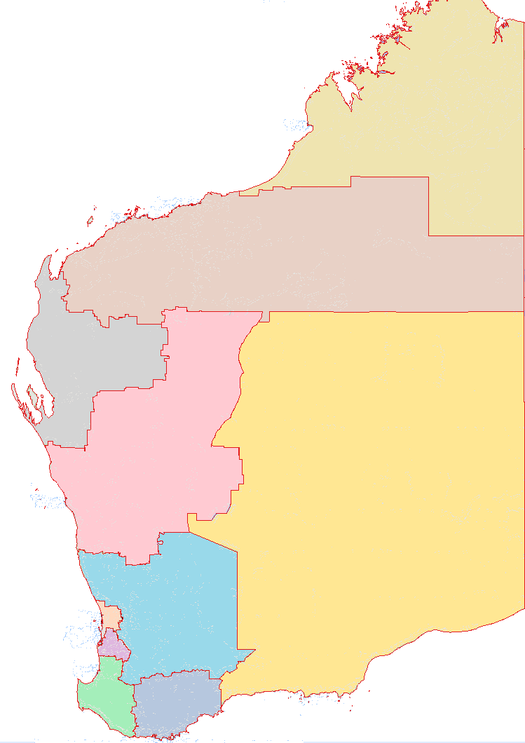
Mid West
Busselton
Albany
Geraldton
Broome
Port Hedland
Kalgoorlie-Boulder
Esperance
Bunbury
Karratha
South West
Great Southern
Peel
Perth
Wheatbelt
Goldfields-Esperance
Gascoyne
Offshore Western Australia
Pilbara
Kimberley

Region | Gross regional product 2024-25 |  | Population 2024-25 |  | Mineral sales 2025
Region | $billion | Share (%) | No. | Share (%) | $billion | Share (%)
Perth | 292.9 | 63.8 | 2,284,706 | 75.0 | 0.1 | 0.0
Pilbara(a) | 90.6 | 19.7 | 62,170 | 2.0 | 128.8 | 70.9
South West | 19.8 | 4.3 | 206,297 | 6.8 | 2.4 | 1.3
Goldfields-Esperance | 14.8 | 3.2 | 58,646 | 1.9 | 29.6 | 16.3
Peel | 10.8 | 2.4 | 175,310 | 5.8 | 11.0 | 6.1
Wheatbelt | 9.2 | 2.0 | 79,885 | 2.6 | 1.6 | 0.9
Mid West | 9.0 | 2.0 | 58,931 | 1.9 | 7.1 | 3.9
Great Southern | 5.8 | 1.3 | 67,150 | 2.2 | 0.0 | 0.0
Kimberley | 4.6 | 1.0 | 40,562 | 1.3 | 0.8 | 0.5
Gascoyne | 1.4 | 0.3 | 10,725 | 0.4 | 0.2 | 0.1
WA total(b) | 458.8 | 100.0 | 3,044,382 | 100.0 | 181.7 | 100.0
Note – Original series. Estimated resident population. (a) Includes Offshore Western Australia for mining sales. (b) Components may not sum to the total because the total includes Migratory - Offshore - Shipping (WA), Christmas Island LGA and Cocos Islands LGA.
Source: WA Department of Primary Industries and Regional Development, Remplan; based on ABS data; and WA Department of Mines, Petroleum and Exploration.

Population growth by broad region and major urban centre: 2004-05 to 2024-25
Original series Estimated resident population. Vertical axis does not start at zero. Source: Based on ABS data

Western Australia’s population is concentrated in the Perth metropolitan area and most of Western Australia’s gross state product is also allocated to Perth. However, most of the State’s exports originate from production in regional areas. While mining production takes place in most regions, the Pilbara is the dominant mining region, particularly for iron ore and liquefied natural gas.
Further economic information and data on Western Australia’s regions can be found at the Regional WA Data Hub. Information on individual regions can be accessed via the links below.
Gascoyne | Kimberley | Pilbara
Goldfields-Esperance | Mid West | South West
Great Southern | Peel | Wheatbelt

Visit Western Australia's economy and international trade (www.wa.gov.au) for more information on Western Australia’s economy, trade relationships and key export industries.
Western Australia Trade Profile  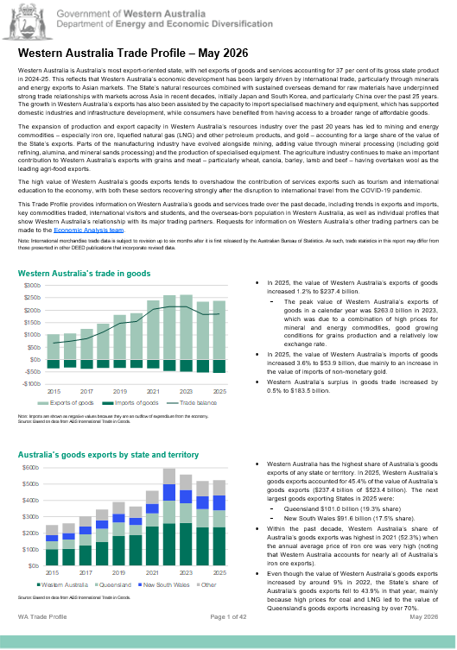 | Western Australia Iron Ore Profile  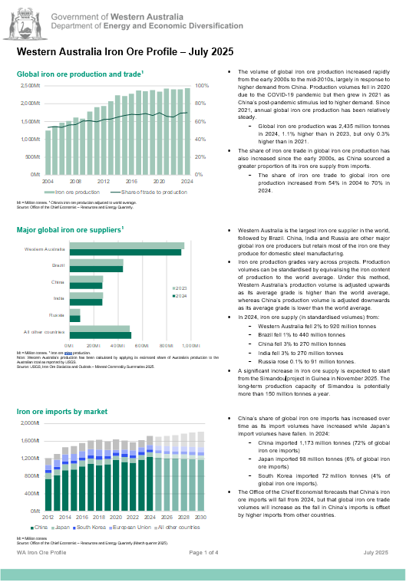
Western Australia LNG Profile  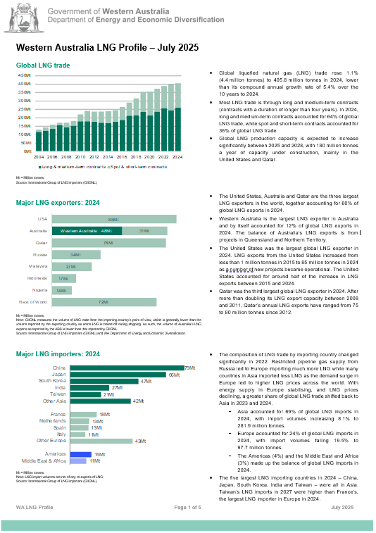 | Western Australia Battery and Critical Minerals Profile  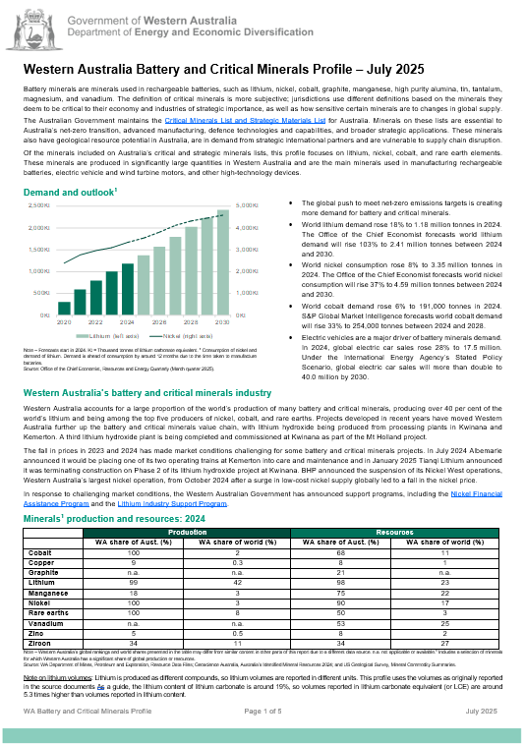
For any queries or feedback on these products, please contact us at economic.analysis@deed.wa.gov.au

