Western Australia Battery and Critical Minerals Profile – September 2026
Battery minerals are minerals used in rechargeable batteries, such as lithium, nickel, cobalt, graphite, manganese, high purity alumina, tin, tantalum, magnesium, and vanadium. The definition of critical minerals is more subjective; jurisdictions use different definitions based on the minerals they deem to be critical to their economy and industries of strategic importance, as well as how sensitive certain minerals are to changes in global supply.
The Australian Government maintains the Critical Minerals List and Strategic Materials List for Australia. Minerals on these lists are essential to Australia’s net-zero transition, advanced manufacturing, defence technologies and capabilities, and broader strategic applications. These minerals also have geological resource potential in Australia, are in demand from strategic international partners – particularly in a global environment with greater focus on energy security – and are vulnerable to supply chain disruption.
Of the minerals included on Australia’s critical and strategic minerals lists, this profile focuses on lithium, nickel, cobalt, and rare earth elements.

Demand and outlook¹
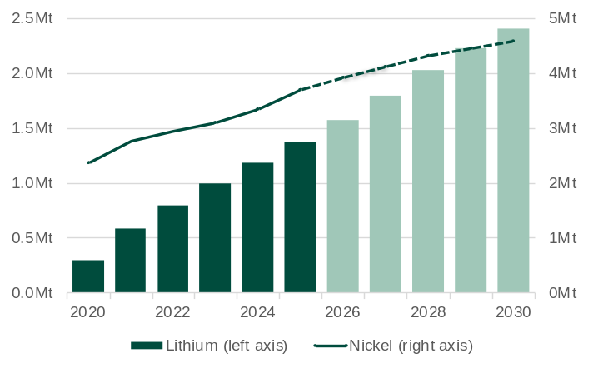
Note – Forecasts start in 2026. Mt = Million tonnes. Lithium measured in lithium carbonate equivalent (LCE). 1. Consumption of nickel and demand of lithium. Demand is ahead of consumption by around 12 months due to the time taken to manufacture batteries.
Source: Office of the Chief Economist, Resources and Energy Quarterly (June quarter 2025).

- The global push to meet net-zero emissions targets is creating more demand for battery and critical minerals, with electric vehicles being a major driver of battery minerals demand. In 2025, global electric car sales increased 24% to 21 million. Under the International Energy Agency’s Stated Policy Scenario, annual global electric car sales are projected to more than double to 55 million by 2035.
- World lithium demand increased 16% in 2025 to 1.38 million tonnes (lithium carbonate equivalent). The Office of the Chief Economist forecasts world lithium demand will increase 75% between 2025 and 2030.
- World nickel consumption increased 11% in 2025 to 3.69 million tonnes. The Office of the Chief Economist forecasts world nickel consumption will increase 24% between 2025 and 2030.
- World cobalt demand increased 10% to 223,000 tonnes in 2025. S&P Global Market Intelligence forecasts world cobalt demand will increase 32% to 295,000 tonnes between 2025 and 2030.

Western Australia’s battery and critical minerals industry
Western Australia accounts for a large proportion of the world’s production of many battery and critical minerals, producing over 40 per cent of the world’s lithium and being among the top five producers of nickel, cobalt, and rare earths in 2024. Western Australia has advanced along the battery and critical minerals value chain in recent years, with lithium hydroxide now produced at processing plants in Kwinana.
Prices for some battery and critical minerals increased significantly in 2021 and 2022, which incentivised an increase in global supply and led to prices falling in 2023 and 2024, returning to around their 2021 levels. The price volatility has been challenging for Western Australian producers and led to BHP suspending its Nickel West operations from October 2024, Tianqi Lithium halting Phase 2 of construction at its Kwinana processing plant in January 2025, and Albemarle placing its lithium hydroxide refinery at Kemerton into care and maintenance in February 2026. The Western Australian Government introduced support measures – including the Lithium Industry Support Program and no-interest loan initiative for the nickel industry – in response to these challenging conditions.
Despite recent challenges, the longer-term prospects for battery and critical minerals are positive. An indication of this was the signing of the Australia-US critical minerals framework in October 2025. This agreement commits at least US$2 billion to fast-track an US$8.5 billion project pipeline supporting defence and advanced technologies. Western Australia is expected to be a major beneficiary of the framework through investments in projects like the Wagerup gallium refinery and Browns Range rare earths operation, with potentially more projects to follow.
Minerals¹ production (2024) and resources (2025)
Mineral | Production |  | Resources
Mineral | WA share of Aust. (%) | WA share of world (%) | WA share of Aust. (%) | WA share of world (%)
Cobalt | 100 | 2 | 69 | 10
Copper | 10 | 0.3 | 10 | 1
Graphite | n.a. | n.a. | 10 | n.a.
Lithium | 99 | 42 | 98 | 22
Manganese | 18 | 3 | 78 | 25
Nickel | 100 | 3 | 90 | 16
Rare earths | 100 | 8 | 55 | 4
Vanadium | n.a. | n.a. | 53 | 25
Zinc | 4 | 0.4 | 8 | 2
Zircon | 22 | 8 | 32 | 25
Note – Western Australia’s global rankings and world shares presented in the table may differ from similar content in other parts of this report due to a different data source. n.a. not applicable or available.
1. Includes a selection of minerals for which Western Australia has a significant share of global production or resources.
Source: WA Department of Mines, Petroleum and Exploration, Resource Data Files; Geoscience Australia, Australia’s Identified Mineral Resources 2025; and US Geological Survey, Mineral Commodity Summaries.

Note on lithium volumes: Lithium is produced as different compounds, so lithium volumes are reported in different units. This profile uses the volumes as originally reported in the source documents. As a guide, the lithium content of lithium carbonate is around 19%, so volumes reported in lithium carbonate equivalent (or LCE) are around 5.3 times higher than volumes reported in lithium content.

Contribution to the Western Australian economy
Sales value
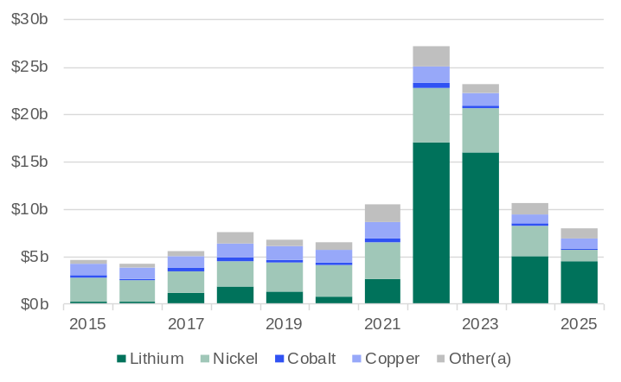
Note – The value of some minerals in the ‘other’ category is not included in the total for some years due to confidentiality restrictions. (a) Includes zircon, zinc, manganese, rare earths, platinum group elements, silica sands, tantalum, tin and chromite.
Source: WA Department of Mines, Petroleum and Exploration, Resource Data Files.

- Lithium (spodumene) accounted for 56% of the value of Western Australia’s battery and critical minerals sales in 2025, with nickel accounting for 16% and copper 13%.
- The value of Western Australia’s battery and critical minerals sales fell 24% to $8.0 billion in 2025. The main driver of the fall was lower volumes of nickel reflecting the suspension of NickelWest operations.
- In 2025, the sales value of:
  - lithium (spodumene) fell 11% to $4.5 billion
  - nickel fell 61% to $1.3 billion
  - copper increased 6% to $1.0 billion
  - cobalt fell 6% to $168 million.

Employment¹
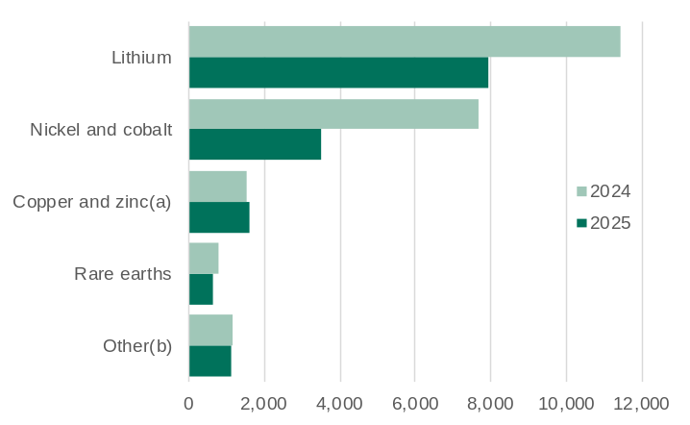
1. Direct full-time equivalent (FTE). Includes operational and construction employment. (a) Includes lead. (b) Includes manganese, silica and silica sand, zircon, phosphate, vanadium, and magnesite.
Source: WA Department of Mines, Petroleum and Exploration, Resource Data Files.

- Direct full-time equivalent (FTE) employment in Western Australia’s battery and critical minerals industry fell 34.1% to 14,877 in 2025, due to large falls in employment in projects producing lithium, and nickel and cobalt.
- In 2025, direct FTE employment in Westen Australia for projects producing:
  - lithium fell 30.4% to 7,954
  - nickel and cobalt fell 54.3% to 3,502
  - copper and zinc increased 5.8% to 1,634
  - rare earths fell 19.3% to 637.

Royalty receipts
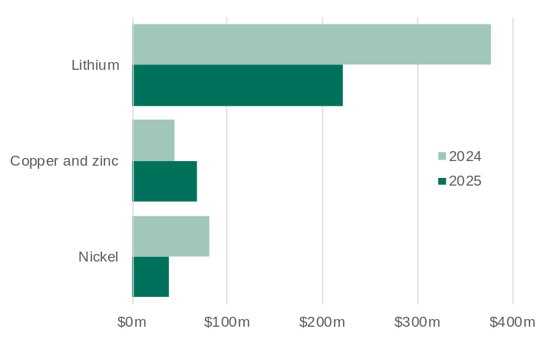
(a) Includes lead.
Source: WA Department of Mines, Petroleum and Exploration, Resource Data Files.

- Western Australia has a 5% royalty rate on the value of lithium concentrate (spodumene) feedstock.
- Lithium royalty receipts fell 41% to $221 million in 2025, accounting for 2.2% of Western Australia’s royalty receipts (excluding North West Shelf grants).
- Western Australia has a 2.5% royalty rate on the value of nickel sold. The WA Government’s Nickel Financial Assistance Program provided a 50% rebate on royalties paid on nickel sales each quarter between March 2024 to June 2025, if the average price of nickel in concentrate was below US$20,000 a tonne for a given quarter.
- Nickel royalty receipts fell 51% to $39 million in 2025, accounting for 0.4% of Western Australia’s royalty receipts (excluding North West Shelf grants).
- Western Australia’s royalty rate for copper and zinc depends on the form in which it is sold: 2.5% for metallic form, 5.0% for concentrate, or 7.5% for crushed or screened material.
- Copper and zinc royalty receipts increased 54% to $68 million in 2025, accounting for 0.7% of Western Australia’s royalty receipts (excluding North West Shelf grants).
Lithium
Lithium supply (share of world) ¹: 2024
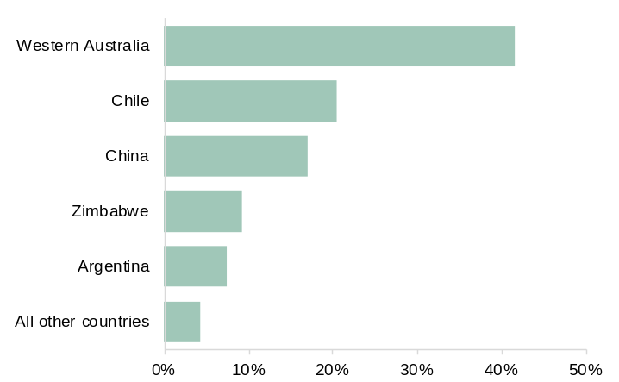
1. Lithium content from mine production.
Source: WA Department of Mines, Petroleum and Exploration, Resource Data Files, and US Geological Survey, Mineral Commodity Summaries.

- Lithium’s main use is in rechargeable batteries (for mobile phones, laptops, digital cameras and electric vehicles), which accounts for 80% of global lithium consumption.
- Western Australia (42%) was the largest lithium supplier in the world in 2024, followed by Chile (20%), China (17%), Zimbabwe (9%) and Argentina (8%).
- The average cost of Western Australia’s lithium supply, which is largely spodumene concentrate, is competitive against other major lithium suppliers.
  - The average total cash cost of Western Australia’s lithium production was US$4,701 a lithium carbonate equivalent (LCE) in 2024. This was 36% below the world average (US$7,293 a LCE), 73% lower than Chile’s average total cash cost (US$17,657 a LCE) and 15% lower than China’s average total cash cost (US$5,552 a LCE).

Western Australia’s lithium¹ sales
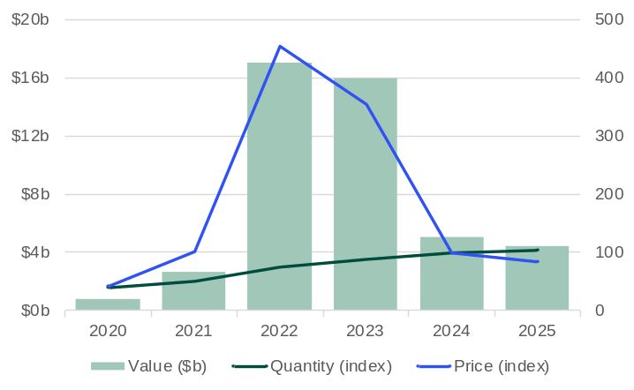
1. Spodumene concentrate. Index 2024 = 100.
Source: WA Department of Mines, Petroleum and Exploration, Resource Data Files.

- While the volume of Western Australia’s lithium sales has increased steadily over the past five years, the value of those sales has changed considerably due to large swings in lithium prices.
- The value of Western Australia’s lithium sales fell 11% to $4.5 billion in 2025, which was the net result from the:
  - average unit price of sales falling 15%
  - quantity of sales increasing 4% to 4.0 million tonnes.
- Greenbushes is Western Australia’s largest lithium mine, accounting for 41% of the State’s spodumene concentrate production (LCE basis) in 2025, followed by Pilgangoora (19%), Mt Marion (13%), Wodgina (12%) and Kathleen Valley (9%).

Lithium prices¹
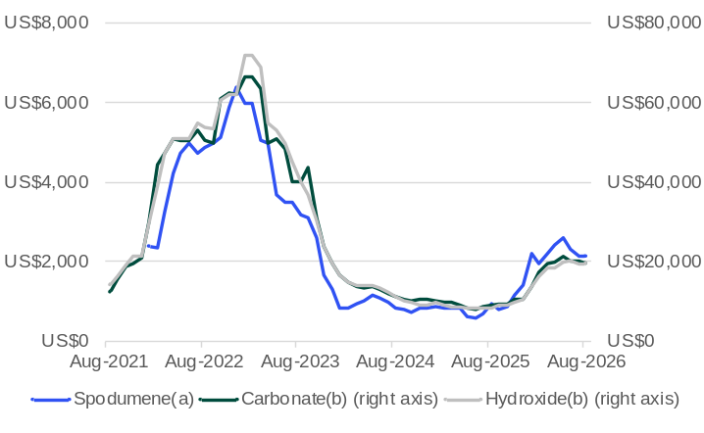
1. Price per tonne. (a) Cost, insurance, and freight Asia. (b) Concentrate free-on-board Australia.
Note – Spodumene concentrate prices are available from January 2022.
Source: S&P Global Market Intelligence.

- Lithium prices fell significantly from their peak in 2023 due to a large rise in global supply and slowing demand from China's electric vehicle sector. Prices were largely stable in 2025 and increased sharply in early 2026, owing to higher demand for energy storage systems, a bringing forward of demand after the announcement of the phase-out of tax rebates for exports of battery products in China, and Zimbabwe introducing limits on lithium concentrate exports.
- In August 2026, the monthly average price for:
  - lithium spodumene fell 0.3% to US$2,133 a tonne but was 127% higher than a year ago
  - lithium hydroxide fell 0.8% to US$19,400 a tonne but was 128% higher than a year ago
  - lithium carbonate fell 4.5% to US$19,525 a tonne but was 113% higher than a year ago.
- The Office of the Chief Economist forecasts the annual average price for:
  - lithium spodumene to be US$2,411 a tonne in 2026 and US$2,336 a tonne in 2027
  - lithium hydroxide to be US$21,087 a tonne in 2026 and US$21,447 a tonne in 2027.

Nickel and cobalt
Nickel and cobalt supply (share of world)¹: 2024
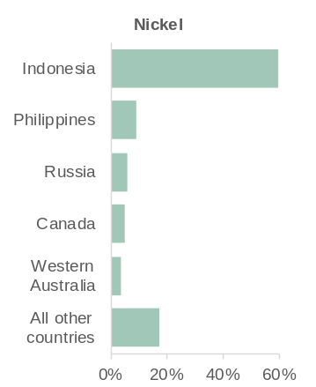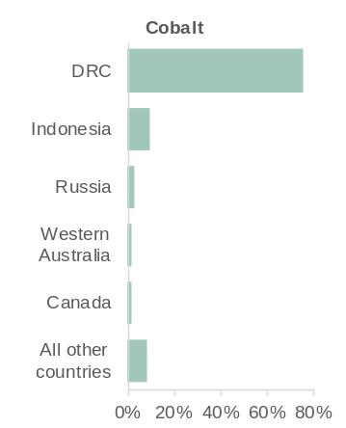
DRC = Democratic Republic of Congo. 1. Nickel and cobalt content from mine production.
Source: WA Department of Mines, Petroleum and Exploration, Resource Data Files, and US Geological Survey, Mineral Commodity Summaries.

- Nickel is mainly used to make stainless steel. Around 15% of the world’s nickel consumption is for batteries.
- Western Australia is the 5th largest nickel supplier in the world, accounting for 3% of global supply in 2024.
- Indonesia is by far the largest nickel supplier in the world, accounting for 59% of global nickel supply in 2024.
- Cobalt is mainly used in rechargeable battery electrodes. Over 80% of the world’s consumption of cobalt is for manufacturing rechargeable batteries.
- Western Australia is the 4th largest cobalt supplier in the world, despite accounting for only 2% of global supply in 2024.
- The DRC is by far the largest cobalt supplier in the world, accounting for 76% of global cobalt supply in 2024.

Western Australia’s nickel and cobalt sales
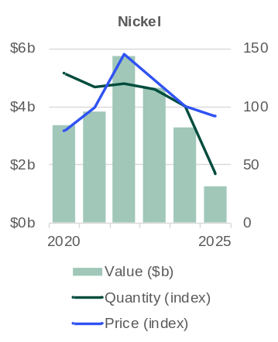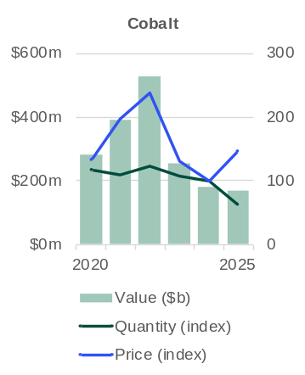
Index 2024 = 100.
Source: WA Department of Mines, Petroleum and Exploration, Resource Data Files.

- The value of Western Australia’s nickel sales fell 61% to $1.3 billion in 2025, which was the net result of the:
  - average unit price of sales falling 8%
  - quantity of sales falling 58% to 53,722 tonnes.
- The value of Western Australia’s cobalt sales fell 6% to $168 million in 2025, which was the net result of the:
  - average unit price of sales increasing 46%
  - quantity of sales falling 36% to 3,050 tonnes.
- Following the suspension of BHP’s Nickel West operations in October 2024, Western Australia’s two largest nickel mines are Murrin Murrin and Nova-Bollinger, which accounted for 63% and 32% of the State’s paid nickel production in 2025.
- The Murrin Murrin (94%) and Nova-Bollinger (6%) mines were also the source of the State’s paid cobalt mine production in 2025.

Nickel and cobalt prices¹
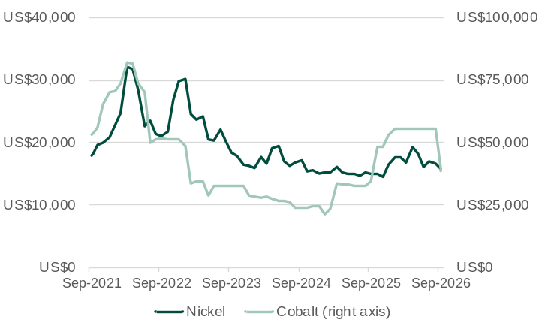
1. Price per tonne. London Metal Exchange (LME) Cash.
Source: S&P Global Market Intelligence.

- The nickel price increased in early 2026 as Indonesia announced mining quotas and the Middle East conflict resulted in price increases for some inputs to production. Prices have fallen back in recent months, in part due to an improved supply outlook from Indonesia and the Philippines.
- The cobalt price increased sharply in 2025 after the DRC announced an export ban in March and then announced in September that the export ban would be replaced with a quota system that will remain in place until at least 2027. The higher price led to greater interest in cobalt-free alternatives, contributing to a sharp drop in price in September 2026.
- In September 2026, the monthly average price for:
  - nickel was US$15,768 a tonne, 5.6% lower than the previous month but 4.8% higher than a year ago
  - cobalt was US$38,699 a tonne, 31% lower than the previous month but 12% higher than a year ago.
- The annual average price for:
  - nickel was US$15,162 a tonne in 2025, with the Office of the Chief Economist forecasting a price of US$17,396 a tonne in 2026 and US$17,457 a tonne in 2027
  - cobalt was US$36,795 a tonne in 2025, with S&P Global Market Intelligence forecasting a price of US$56,857 a tonne in 2026 and US$51,787 a tonne in 2027.

Rare earths
Rare earths supply (share of world)¹: 2024
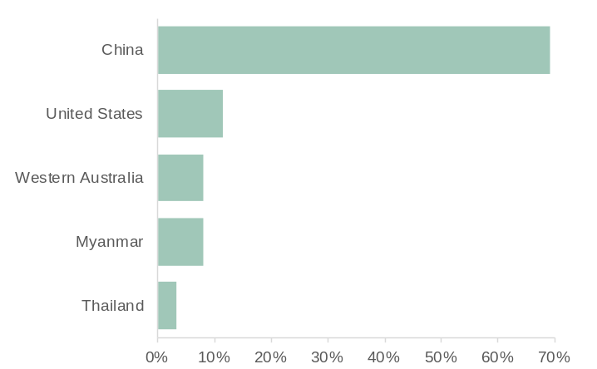
1. Rare earth oxide equivalent content from mine production.
Source: WA Department of Mines, Petroleum and Exploration, Resource Data Files, and US Geological Survey, Mineral Commodity Summaries.

- Rare earths are used in high-tech consumer products and defence applications. For example:
  - neodymium is used in electric vehicle motor magnets and wind turbines
  - praseodymium is used in aircraft engines
  - cerium is used in catalytic converters for cars
  - lanthanum is used in lenses for cameras and telescopes.
- Western Australia is the 3rd largest rare earths supplier in the world, accounting for 8% of global supply in 2024.
- China is by far the largest rare earths supplier in the world, accounting for 69% of global supply in 2024, followed by the United States (12%).

Neodymium prices¹
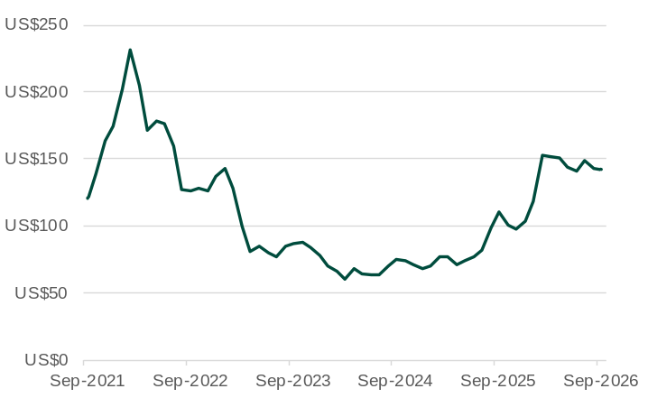
1. Price per kilogram.
Source: WA Department of Energy and Economic Diversification estimates based on information from Trading Economics.

- Prices for rare earths rose sharply in 2020 and 2021 as demand outstripped supply. Demand for rare earths was high due its uses in decarbonisation-based applications. However, with a ramp up of global production of rare earths, especially in China, the price of rare earths fell back to near pre-2020 levels.
- Increased interest in rare earths in 2025 led to a rise in prices, which continued in early 2026, although prices have eased in recent months as more supply has become available, including from Myanmar. The monthly average neodymium price was US$141.8 a kilogram in September 2026.

Western Australia’s rare earths sales
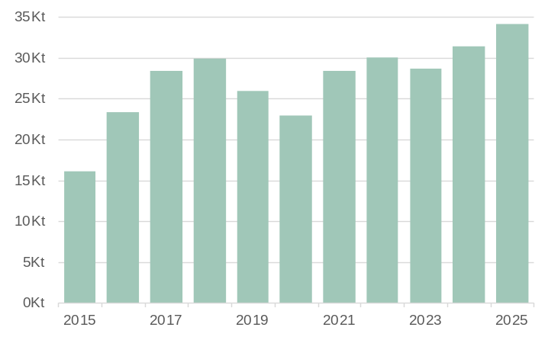
Kt = Thousand tonnes.
Source: WA Department of Mines, Petroleum and Exploration, Resource Data Files.

- The quantity of Western Australia’s rare earths sales increased 8.6% to 34.1 kilo tonnes in 2025.
- Sales values for rare earths are not available for most years due to data confidentiality restrictions.
- Western Australia’s rare earths production mainly comes from the Mt Weld mine. The production capacity of Mt Weld was expanded to supply a rare earths processing plant in Kalgoorlie, which started operating in 2024 and can produce up to 38,000 tonnes of rare earths carbonate a year.
- Other rare earths projects in Western Australia include:
  - The Eneabba rare earths refinery (20,000 tonnes a year starting in 2027)
  - The proposed developments of Browns Range Stage 2 (4,350 tonnes of total rare earths oxides a year), North Stanmore Heavy Rare Earths (throughput of 8 million tonnes of ore a year), and Cummins Range rare earths and phosphate (12,000 tonnes of mixed rare earths concentrate).

