Western Australia Economic Profile – September 2026
The main updates in this month’s Economic Profile relate to commodity prices, consumer prices and monetary policy, and engineering construction activity.
Commodity prices
The ongoing conflict in the Middle East and the damage and disruption to oil production facilities led to another surge in oil prices during September 2026, with price movements continuing to be prone to volatility on a day-to-day basis. This volatility has also been seen in prices for other commodities, including gold, which tends to vary based on its relative attractiveness as a safe haven asset, and is thus influenced by both the level of global economic uncertainty and factors affecting the yield from other safe haven assets (such as interest rates).
The iron ore price has trended down in recent months but has been less volatile than prices for most other commodities over the past two years. As iron ore is by far Western Australia’s largest export commodity, this has provided some stability for the State’s economy. Changes in the prices and volumes of Western Australia’s other exports have largely offset each other, with the annual value of the State’s goods exports being between $235 to 240 billion for each month over the past year. In contrast, the annual value of the State’s goods imports has increased by 40 per cent over the past year to $72 billion, with large increases in the value of imports of petroleum (owing to higher oil prices), machinery and transport equipment (for use in resource projects under construction) and non-monetary gold.
Consumer prices and monetary policy
With the fuel excise returning to its full rate in early August 2026, the price index for automotive fuel in Perth was around 15 per cent higher in August 2026 compared to July 2026. This was a major driver of Perth’s annual rate of inflation increasing from 3.8 per cent in July to 4.3 per cent in August, although housing costs continue to make a sizeable contribution to inflation. Higher fuel prices also drove Australia’s annual inflation rate from 3.5 per cent in July to 4.0 per cent in August, while the trimmed mean annual inflation rate for Australia, which excludes items with higher price volatility, was – for the third consecutive month – 3.6 per cent.
The Reserve Bank of Australia’s Monetary Policy Board decided on 29 September to increase the cash rate by 0.25 basis points to 4.60 per cent, which was the fourth increase in 2026 and brought the cash rate to its highest level since 2011. Higher inflation also led to other central banks increasing rates in September 2026, including in the United States, Japan and the Euro area.
Engineering construction activity
The value of engineering construction activity in the pipeline in Western Australia in the June quarter 2026 was 8.0 per cent higher compared to the June quarter 2025. More notable is how the composition of the pipeline of activity has changed. While heavy industry (mostly resource projects) still accounts for most activity, its share of the total fell from 63 per cent in June 2025 to 50 per cent in June 2026. In contrast, the share of electricity – including generation and transmission infrastructure – increased from 8 per cent in June 2025 to 17 per cent in June 2026, highlighting the additional construction activity occurring as part of the State’s energy transition.
Note: Charts with headings that have been marked with an asterisk have been updated this month.

Contents

State final demand and net exports
State final demand – components
Gross state product
Commodity prices and exchange rates
Consumer prices and interest rates
Labour market – employment
Labour market – vacancies and spare capacity
Labour market – wages
Population
Housing
Construction
Regional labour markets and construction
International trade

State final demand and net exports
Back to contents

State final demand by component (contribution to change)
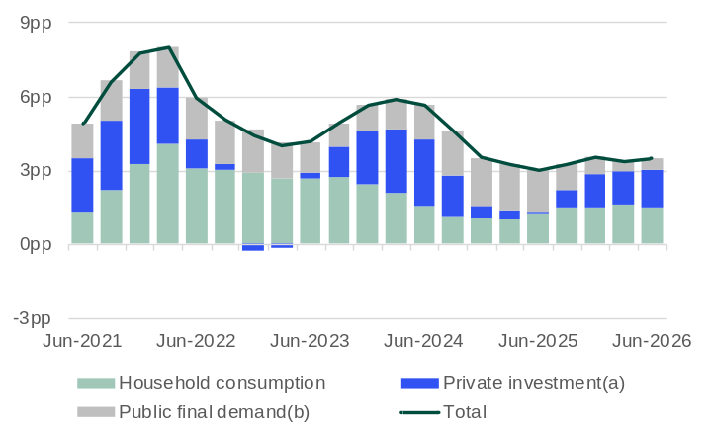 Note – Chain volumes measures. Seasonally adjusted series. Change between the sum of the latest four quarters and the sum of the same quarters of the previous year. pp = percentage points. (a) Private gross fixed capital formation. (b) General government final consumption expenditure and public gross fixed capital formation.
Source: Based on ABS data.
- State final demand (SFD) measures total consumption and investment by the private and public sectors.
- SFD accounts for most of Western Australia’s gross state product (GSP) – 72% ($328.1 billion) in 2024-25 – although this share is low compared to other states and territories due to net exports being particularly high for Western Australia.
- Western Australia’s real SFD increased 3.5% in 2025-26. Contributions to Western Australia’s real SFD growth in the year to the June quarter 2026 were:
- private investment: 1.6 percentage points
- household consumption: 1.5 percentage points
- public final demand: 0.5 percentage points.
- The WA Government Budget 2026-27 forecasts that Western Australia’s real SFD growth will be 2.25% in both 2026-27 and 2027-28, an easing from the current pace of growth.

Interstate comparison of state final demand by component (contribution to change): June quarter 2026
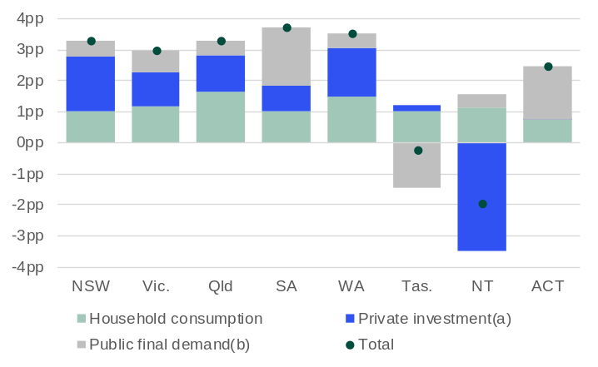
Note – Chain volumes measures. Seasonally adjusted series. Change between the sum of the latest four quarters and the sum of the same quarters of the previous year. pp = percentage points. (a) Private gross fixed capital formation. (b) General government final consumption expenditure and public gross fixed capital formation.
Source: Based on ABS data.
- Western Australia’s SFD growth continues to outpace Australia’s domestic final demand growth. In the June quarter 2026, Western Australia’s SFD was 38% higher than it was in the June quarter 2020, while Australia’s domestic final demand was 31% higher.
- Western Australia’s real SFD growth of 3.5% for 2025-26 was the second highest growth rate of all the states and territories, behind South Australia (3.7%).
- Western Australia’s recent SFD growth has been less reliant on public final demand than most other Australian states and territories. In the year to the June quarter 2026, Western Australia recorded the strongest private-sector contribution to real SFD growth nationally, with household consumption and private investment contributing a combined 3.0 percentage points, compared with 0.5 percentage points from public final demand.

Net exports by component (contribution to change)
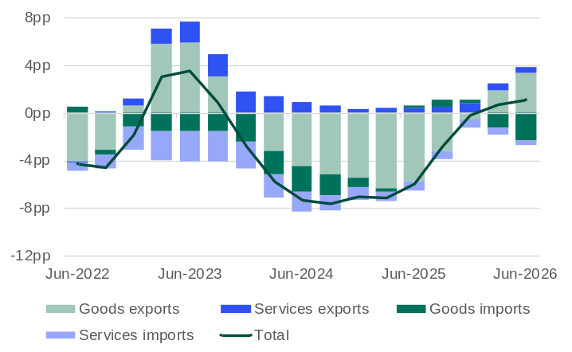
Note – Chain volumes measures. Seasonally adjusted series. Change between the sum of the latest four quarters and the sum of the same quarters of the previous year. pp = percentage points. Exports are spending on goods and services produced in Western Australia but consumed by people from another country and are added to GSP. Imports are spending on goods and services produced in another country but consumed by Western Australians and are subtracted from GSP.
Source: Based on ABS data.
- Net exports are the difference between international exports and imports of both goods and services. As Western Australia exports large volumes of resource commodities, movements in Western Australia’s net exports are heavily influenced by goods exports.
- Western Australia’s real net exports fell across 2024 and 2025 due mainly to lower export volumes from the mining industry. An increase in goods exports has contributed to net exports growing in 2026, although this has been partly offset by higher goods imports.
- Western Australia’s real net exports increased 1.0% in 2025-26 with:
- goods exports contributing 3.3 percentage points
- services exports contributing 0.5 percentage points
- services imports detracting 0.4 percentage points
- goods imports detracting 2.4 percentage points.
- The WA Government Budget 2026-27 forecasts that Western Australia’s net exports of goods and services will grow 2.5% in 2026-27 and 1.25% in 2027-28.

State final demand – components
Back to contents

Household consumption by component (contribution to change): June quarter 2026
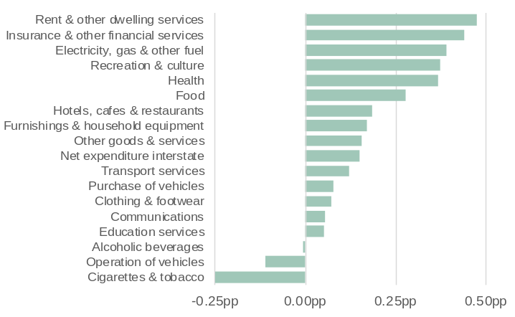
Note – Chain volume measures. Seasonal adjusted series. Change between the sum of the latest four quarters and the sum of the same quarters of the previous year. pp = percentage points.
Source: Based on ABS data.
- Household consumption in Western Australia increased 3.0% in 2025-26.
- Spending on rent and other dwelling services (up 2.2%) contributed the most to growth in Western Australia’s household consumption in 2025-26. Other leading contributors to growth in household consumption over this period were:
- insurance and other financial services (up 5.7%)
- electricity, gas and other fuel (up 25.7%)
- recreation and culture (up 4.1%).
- Spending on cigarettes and tobacco (down 24.0%) detracted the most from Western Australia’s household consumption in 2025-26, followed by operation of vehicles (down 2.0%).
- The WA Government Budget 2026-27 forecasts that Western Australia’s household consumption will grow 2.75% in both 2026-27 and 2027-28.

Private investment by component (contribution to change): June quarter 2026
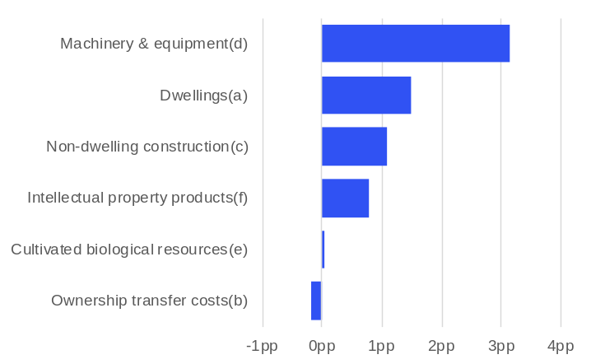
Note –. Chain volumes measures. Seasonally adjusted series. Change between the sum of the latest four quarters and the sum of the same quarters of the previous year. pp = percentage points. (a) Buildings or parts of buildings used as residences. (b) Fees, commissions, stamp duty and other government charges for transferring ownership of dwellings and non-dwelling constructions. (c) Non-residential buildings and other structures. (d) Transport equipment and other machinery and equipment. (f) Computer software, research and development, entertainment, literary or artistic originals, and mineral exploration. (e) Livestock and plantations of trees yielding repeat products (e.g. vineyards and orchards).
Source: Based on ABS data.
- Private investment in Western Australia increased 6.4% in 2025-26.
- Spending on machinery and equipment (up 11.3%) contributed the most to growth in Western Australia’s private investment in 2025-26, followed by dwellings (up 9.2%) and non-dwelling construction (up 2.7%).
- Spending on ownership transfer costs (down 0.2%) detracted from Western Australia’s private investment over 2025-26.
- The WA Government Budget 2026-27 forecasts that Western Australia’s business investment (which excludes dwelling and ownership transfer costs) will grow 1.0% in 2026-27 and 0.75% in 2027-28 and dwelling investment will grow 5.25% in 2026-27 and 3.5% in 2027-28.

Public final demand by component (contribution to change): June quarter 2026
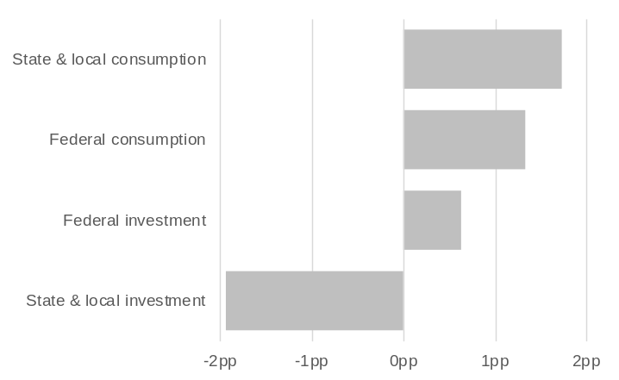
Note – Chain volumes measures. Seasonally adjusted series. Change between the sum of the latest four quarters and the sum of the same quarters of the previous year. pp = percentage points.
Source: Based on ABS data.
- Public final demand in Western Australia, which comprises local, state and federal government consumption and investment, increased 1.7% in 2025-26.
- State and local government consumption (up 3.6%) contributed the most to growth in Western Australia’s public final demand in 2025-26, followed by federal government consumption (up 4.2%) and federal government investment (up 17.6%).
- State and local government investment (down 11.2%) detracted from Western Australia’s public final demand in 2025-26.
- The WA Government Budget 2026-27 forecasts that government consumption in Western Australia will grow 1.0% in 2026-27 and 2.5% in 2027-28 while government investment will grow 2.0% in 2026-27 and grow 1.25% in 2027-28.

Gross state product
Back to contents

Gross state and domestic product (change)
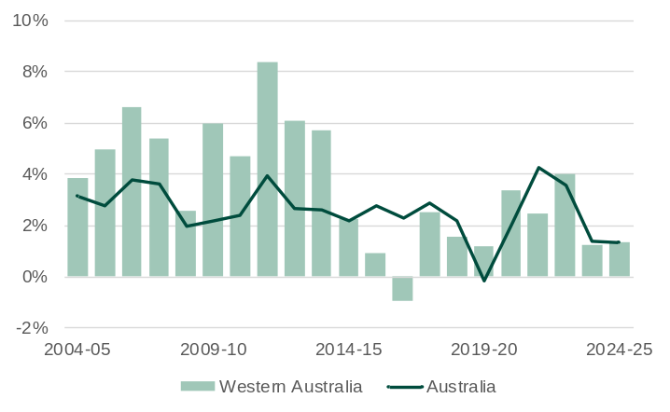
Note – Chain volume measures. Original series. Annual change.
Source: Based on ABS data.
- Gross state product (GSP) is a measure of the total economic production of a state or territory and is the state/territory equivalent of a nation’s gross domestic product (GDP).
- Western Australia’s GSP was less affected by the COVID-19 pandemic in 2019-20 compared to other states and territories and grew at a relatively consistent rate in the next three financial years. Growth was lower at both a state and national level in 2023-24 and 2024-25.
- Western Australia’s real GSP rose 1.2% in 2023-24 and 1.3% in 2024-25, slightly lower than growth in Australia’s real GDP, which was 1.4% in both 2023-24 and 2024-25.
- The WA Government Budget 2026-27 forecasts that Western Australia’s real GSP growth will be 2.25% in 2026-27 and 2.0% in 2027-28.

Gross state product by industry (contribution to change)
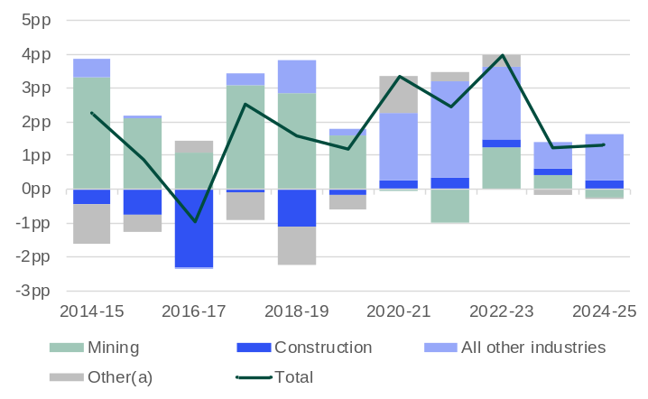
Note –. Chain volumes measures. Original series. Annual change. pp = percentage points. (a) Ownership of dwellings, balancing item, statistical discrepancy and differences between the sum of component chain volume measures and the total chain volume measure for gross state product.
Source: Based on ABS data.
- The mining industry was the main driver of Western Australia’s GSP growth between 2013-14 and 2019-20 as output increased from newly completed projects. The completion of construction on these major mining projects was largely responsible for the construction industry detracting from growth over this period.
- The mining industry has detracted from Western Australia’s growth in three of the past five financial years as output from the State’s iron ore and LNG projects has consolidated after a period of expansion, and weather-related disruptions have contributed to lower output in some years.
- Western Australia has been able to maintain GSP growth since 2020-21 despite the lower contribution to growth from the mining industry as many non-mining industries made a greater contribution to GSP growth compared to the previous five-year period, including:
- professional, scientific and technical services
- construction
- health care and social assistance
- agriculture, forestry and fishing
- transport, postal and warehousing.

Gross state product by industry (contribution to change): 2024-25

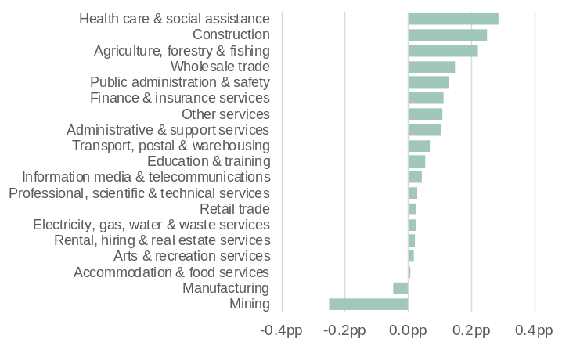
Note – Chain volumes measures. Original series. Annual change. pp = percentage points.
Source: Based on ABS data.
- Health care and social assistance (up 5.8%) made the largest contribution to Western Australia’s real GSP growth in 2024-25, followed by construction (up 4.4%) and agriculture, forestry and fishing (up 14.6%). In 2024-25, Western Australia’s:
- health care and social assistance industry had increased demand for key health programs and services from a growing population
- construction industry benefited from strong dwelling construction activity
- agriculture, forestry and fishing gained from a higher grain harvest.
- Mining (down 0.6%) was the main detractor from Western Australia’s real GSP growth in 2024-25. Weather events and maintenance work caused some disruption to mining production in 2024-25, particularly for oil and gas. Iron ore production volumes were largely unchanged from the previous year, with the impact of disruptions offset by new capacity and improved efficiency.

Commodity prices and exchange rates
Back to contents

Mineral commodity prices (index)*
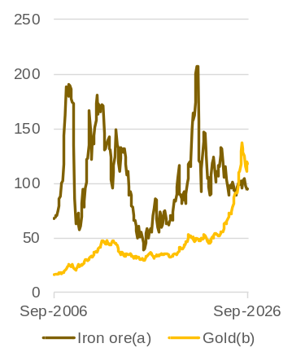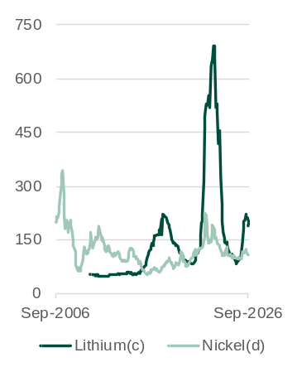
Note – Index based on current prices in US dollars. September 2025 = 100. (a) China spot price per dry tonne of 62% Fe fines on a cost, insurance, and freight basis. (b) London afternoon fixing price per troy ounce of 99.5% fine. (c) Asia lithium carbonate price per tonne on a cost, insurance and freight basis. (d) London Metal Exchange (LME) Cash.
Source: World Bank and S&P Global Market Intelligence.
- There have been varying trends in the prices for Western Australia’s main mineral exports over the past year.
- The iron ore price has been relatively stable, varying around US$100 a tonne since mid-2024. The average monthly iron ore price was US$97.7 a tonne in September 2026.
- The gold price has risen due to geopolitical tensions stimulating safe-haven demand, although has fallen in recent months due to expectations of higher interest rates. The average monthly gold price was US$4,319 a troy ounce in September 2026, still 18% above the price in September 2025.
- Lithium prices increased in the first half of 2026 following the significant falls from 2023 as large additions in global supply were coupled with lower sales growth in electric vehicles. The uptick in 2026 has been driven by demand as well as Zimbabwe’s limit on lithium exports. The estimated average monthly price for lithium carbonate was US$18,050 a tonne in September 2026.
- Nickel prices have followed a similar, albeit less spectacular, trajectory to lithium prices. The average monthly price for nickel was US$16,324 a tonne in August 2026, 8.1% higher than September 2025.

Non-mineral commodity prices (index)*

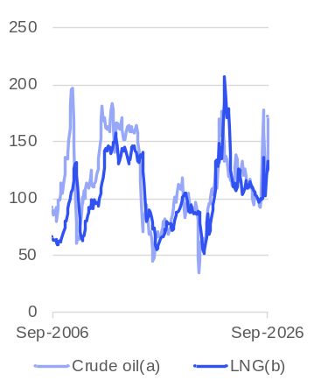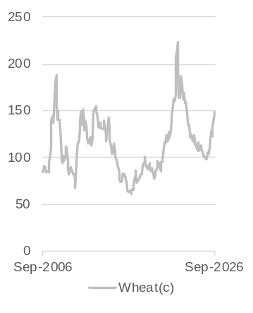
Note – Index based on current prices in US dollars. September 2025 = 100. (a) Crude oil, United Kingdom Brent price per barrel. (b) Japan liquefied natural gas import price per million British thermal units on a cost, insurance, and freight basis. (c) United States hard red winter Gulf export price per tonne.
Source: World Bank.
- Prices for Western Australia’s main energy exports (LNG and other petroleum) increased sharply following the onset of conflict in the Middle East in 2026. Prices fell in June 2026 as prospects for a resolution to the conflict improved but have increased again as the conflict has continued, storage volumes in Europe are at low levels ahead of winter and oil supply infrastructure has been damaged.
- The average monthly Brent crude oil price was US$116.8 a barrel in September 2026, 72% higher than September 2025.
- The Japan average monthly LNG price was US$14.3 per mmBTU in September 2026, 24% higher than September 2025.
- Global wheat prices tend to move with actual and expected growing conditions. Trade policies and changes in input costs (especially for transport) can also affect wheat prices, which partly explains the similar movements between the wheat price and the oil price.
- The average monthly price for wheat was US$347 a tonne in September 2026, 48% higher than September 2025.

Australian dollar exchange rates*

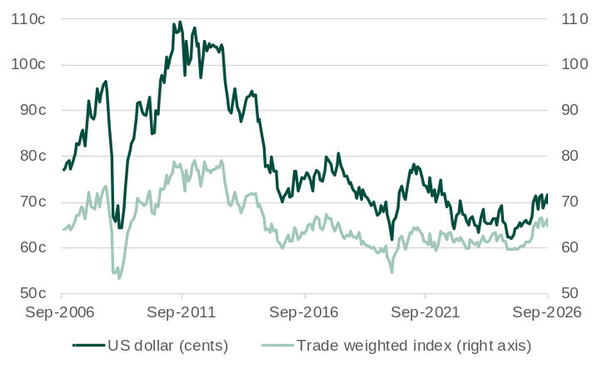
Note – Values are for the last recorded day in each month. Trade weighted index May 1970 = 100.0.
Source: RBA.
- The Australian dollar exchange rate is influenced by many factors, including the price of Australia’s main export commodities, and actual and expected differences in global interest rates.
- The exchange rate is often quoted against the US dollar because it is the most traded global currency. The trade‑weighted index (TWI) provides a broader measure based on 17 major trading‑partner currencies.
- The Australian dollar has appreciated over the past year with increases in interest rates and higher prices for many export commodities, although global economic uncertainty has contributed to volatility in the exchange rate in recent months.
- The Australian dollar was 69.8 US cents at the end of September 2026, 2.6% lower than at the end of August 2026 but 5.7% higher than one year ago.
- Australia’s TWI at the end of September 2026 was 2.3% lower than at the end of August 2026 but 5.5% higher than one year ago.

Consumer prices and interest rates
Back to contents

Consumer price index (change)^{(a)}*
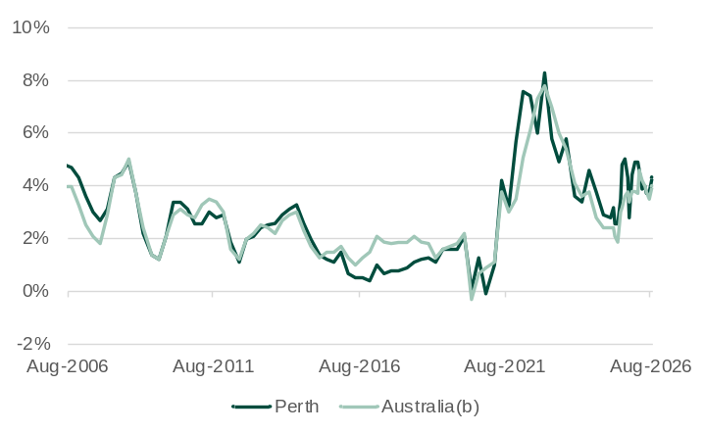
Note – Original series. All groups consumer price index. (a) Annual movements prior to April 2025 are calculated by comparing each quarter to the same quarter in the previous year. From April 2025 these movements are calculated by comparing each month to the same month in the previous year. (b) Weighted average of eight capital cities.
Source: Based on ABS data.
- After falling from a high of 8.3% in the December quarter 2022 to 2.6% in June 2025, consumer price inflation in Perth has trended up over the past year.
- Perth’s annual inflation rate, as measured by year-on-year growth in the consumer price index (CPI), was 4.3% in August 2026, up from 3.8% in July 2026.
- Australia’s annual inflation rate in August 2026 was 4.0%, up from 3.5% in July 2026. The trimmed mean annual inflation rate for Australia, which excludes items with higher price volatility, was 3.6% in August 2026 unchanged from July 2026.
- The measure of Perth’s CPI in the WA Government Budget 2026-27 excludes the electricity sub-index, to smooth the effect of successive household electricity credits. On this basis, the WA Government Budget 2026-27 forecasts Perth’s annual average CPI will increase 3.75% in 2026-27 and 2.75% in 2027-28.

Consumer price index by component (contribution to change): August 2026*
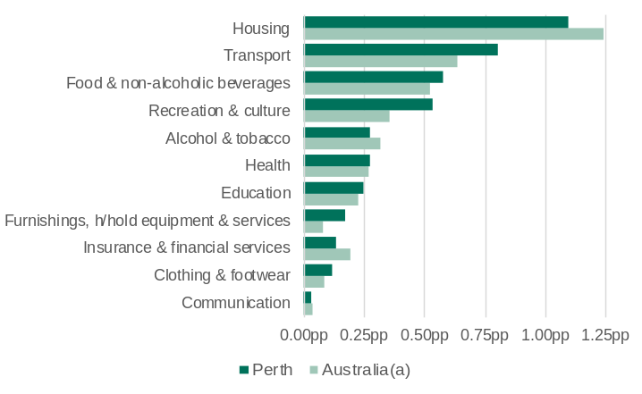
Note – Original series. All groups consumer price index. Year-on-year change in monthly index. pp = percentage points. (a) Weighted average of eight capital cities.
Source: Based on ABS data.
- Housing (up 5.5%), transport (up 6.8%), and food and non-alcoholic beverages (up 3.3%) made the largest contributions to the year-on-year increase in Perth’s CPI in August 2026.
- Housing (up 5.7%), transport (up 5.6%), and food and non-alcoholic beverages (up 3.0%) also made the largest contribution to the year-on-year increase in Australia’s CPI in August 2026.
- New dwelling purchases by owner-occupiers contributed around half of the increase to the housing component in Perth’s CPI in the year to August 2026 (0.55 of 1.10 percentage points), while the largest contributor to the increase in the housing component in Australia’s CPI was utilities (0.44 of 1.24 percentage points).
- The Federal Government’s temporary fuel excise reduction was halved in early July 2026 and then ended in early August 2026. This contributed to the price index for automotive fuel in Perth being 14.8% higher in August 2026 compared to July 2026. Automotive fuel contributed around three quarters of the increase to the transport component in Perth’s CPI in the year to August 2026 (0.59 of 0.80 percentage points).

Monetary policy interest rates*
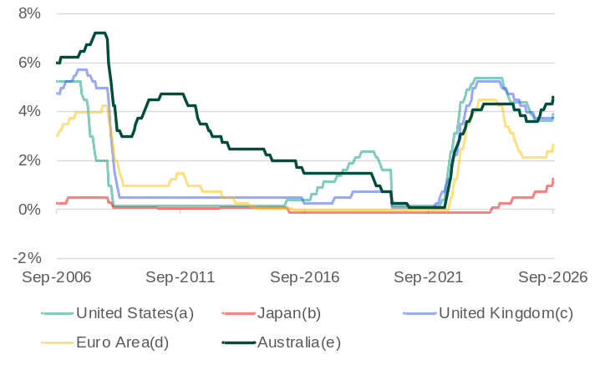
(a) Federal funds maximum target rate until December 2008 and the midpoint of the target range for the federal funds rate from January 2009 onwards. (b) Policy rate. (c) Bank rate. (d) Refinancing rate. (e) Cash rate.
Source: RBA and Central Banks.
- Higher inflation led to a tightening of monetary policy in Australia in 2022 and 2023, with the Reserve Bank of Australia (RBA) increasing Australia’s cash rate from 0.10% to 4.35% between May 2022 and November 2023. Disinflation allowed the RBA to reduce the cash rate by 25 basis points three times in 2025, but with the pick-up in inflation from late 2025, the RBA has increased the cash rate by 25 basis points on four occasions in 2026. The increase in September 2026 took the cash rate to 4.60%, the highest since 2011.
- Monetary policy in the United States, United Kingdom and Euro Area followed a similar trajectory to Australia in 2022 and 2023, but there was some divergence in the easing cycles across these markets. While rates have remained on hold in the United Kingdom since late 2025, the European Central Bank and the US Federal Reserve have responded to recent higher inflation by raising interest rates.
- Japan has had a different monetary policy trajectory as its increase in inflation occurred later. The Bank of Japan increased interest rates for the first time in 17 years in March 2024 with five more rate hikes since taking the policy rate to 1.25% in September 2026, the highest rate since 1995.

Labour market – employment
Back to contents

Employment and total monthly hours worked (change)*
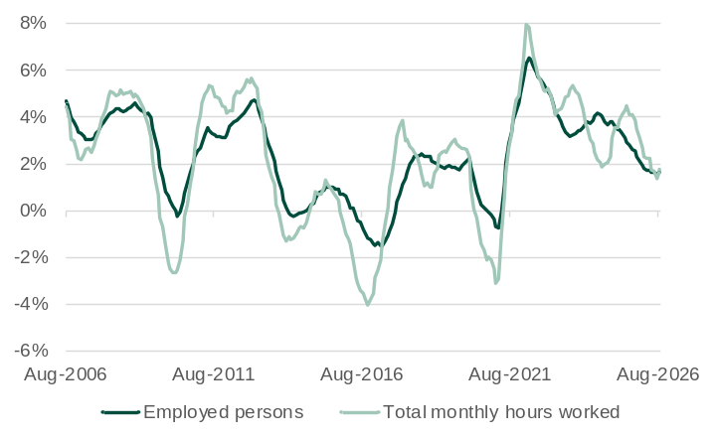
Note – Seasonally adjusted series. 12-month rolling average for employed persons and total monthly hours worked. Year-on-year change in monthly series.
Source: Based on ABS data.
- Employment growth in Western Australia has moderated from the very high rates reached during the economic recovery from the COVID-19 pandemic.
- Western Australia’s annual average employment increased 1.6% to 1.67 million in August 2026.
- The WA Government Budget 2026-27 forecasts Western Australia’s annual average employment will increase by 1.75% in 2026-27 and 1.5% in 2027-28.
- Annual average growth in hours worked increased back above employment growth in August 2026. Western Australia’s annual average monthly hours worked in all jobs increased 1.7% to 237.6 million hours in August 2026.
- A contributing factor to higher growth in hours worked was that annual average growth in August 2026 for full-time employment (2.1%) was higher than overall employment (1.6%).
- With growth in hours worked higher than growth in employment, there was a 0.1% increase in the annual average of hours worked per employed person (per month) in August 2026 to 142.1 hours.

Filled jobs by industry (change): June quarter 2026*
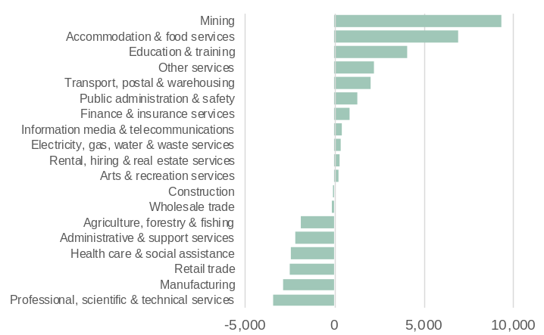
Note – Original series. Change between the sum of the latest four quarters and the sum of the same quarters of the previous year. The source of this data has changed from the Labour Force Survey to the Labour Account.
Source: Based on ABS data.
- The increase in average filled jobs in Western Australia in the year to the June quarter 2026 was led by goods producing industries, which increased by 1.2%.
- The increase in filled jobs in mining (up 9,325) more than offset decreases in manufacturing (down 2,850) and agriculture, forestry and fishing (down 1,850).
- Average filled jobs in Western Australia’s service industries grew by 0.7% in the year to the June quarter 2026, with mixed results across individual industries.
  - The largest increases in filled jobs were in accommodation and
  - food services (up 6,925), education and training (up 4,075), and other services (up 2,175).
  - The largest decreases in filled jobs were in professional, scientific and technical services (down 3,425), retail trade (down 2,500), and health care and social assistance (down 2,450).

Participation rate*
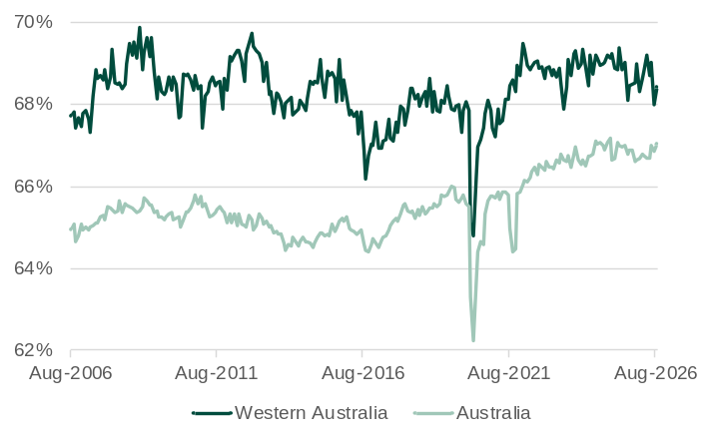
Note – Seasonally adjusted series. Monthly series.
Source: Based on ABS data.
- The labour force participation rate (participation rate) is the share of the civilian population aged 15 and over who are in the labour force. The labour force is the sum of the number of people (in the civilian population aged 15 and over) who are employed or unemployed.
- Western Australia’s participation rate was 68.4% in August 2026, 0.4 percentage points higher than July 2026.
- Australia’s participation rate was 67.1% in August 2026, 0.2 percentage points higher than July 2026.
- Western Australia’s participation rate has consistently been higher than Australia’s participation rate. The largest recorded difference was in October 2012 at 4.5 percentage points.
- The WA Government Budget 2026-27 forecasts Western Australia’s participation rate will average 68.6% in 2026-27 and 68.4% in 2027-28.

Labour market – vacancies and spare capacity
Back to contents

Internet vacancies by occupation group*
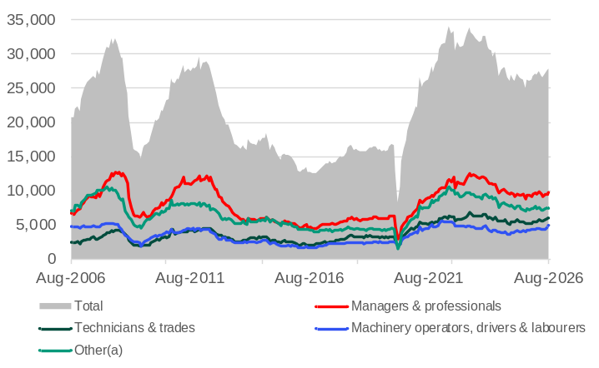
Note – Seasonally adjusted series. Online job advertisements on SEEK, CareerOne and Australian JobSearch. Excludes job advertisements on other online job boards, employer web sites, newspapers, and word of mouth. (a) Community and personal services; clerical and administrative; sales; and other.
Source: Jobs and Skills Australia.
- Western Australia had 27,865 internet vacancies in August 2026, 0.5% more than the previous month and 11.3% more than one year ago.
- Between August 2025 and August 2026, the number of internet vacancies in Western Australia for:
- managers and professionals increased 9.1% to 9,709
- technicians and trades workers increased 13.4% to 5,937
- machinery operators, drivers and labourers increased 24.8% to 4,905
- other occupations (including community and personal services, clerical and administrative and sales workers) increased 5.0% to 7,314.
- In August 2026, the highest number of internet vacancies in Western Australia were for:
- automotive and engineering trades workers (2,346)
- general-inquiry clerks, call centre workers and receptionists (1,669)
- sales assistants and salespersons (1,323)
- drivers and storepersons (1,247).

Underutilisation rate*
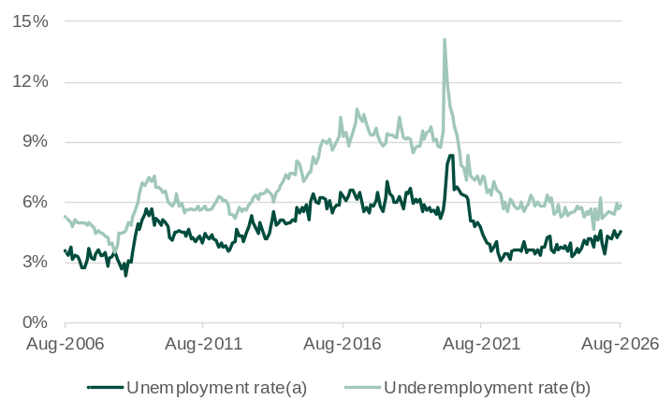
Note – Seasonally adjusted series. Monthly series. Underutilisation rate is the sum of the unemployment and underemployment rates. (a) Proportion of unemployed in the labour force (people without a job who are actively looking for work). (b) Proportion of underemployed in the labour force (workers wanting more hours).
Source: Based on ABS data.
- Western Australia’s underutilisation rate, which is the sum of the unemployment and underemployment rates, was 10.3% in August 2026, up from 10.0% in July 2026, with increases in both the unemployment rate and the underemployment rate.
- The unemployment rate was 4.5% in August 2026, up from 4.4% in July 2026.
- The underemployment rate was 5.8% in August 2026, up from 5.7% in July 2026.
- In August 2026, there were 0.35 internet vacancies for every unemployed person in Western Australia. This ratio has declined from its recent peak of 0.68 in August 2022, although it is above its average over the past ten years of 0.33.

Comparison of unemployment and underemployment rates: Western Australia and Australia*
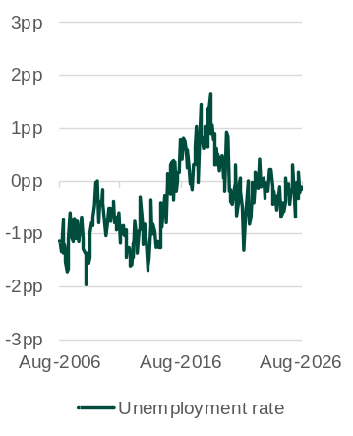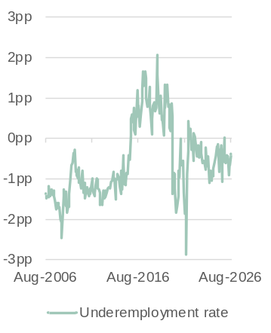
Note – Seasonally adjusted series. Monthly series. The charts show Western Australia’s rate minus Australia’s rate, with the difference expressed in percentage points (pp).
Source: Based on ABS data.
- Western Australia’s unemployment rate has generally been lower than Australia’s unemployment rate over the past 20 years. The main exception was in the mid-to-late 2010s with the transition of the mining expansion from a construction phase to a less labour-intensive operational phase. In the post-pandemic period, the difference in most months has been relatively small.
- The difference between the underemployment rates for Western Australia and Australia has largely mirrored the difference between their unemployment rates but with slightly wider margins at times as changes in the labour market have occurred more through changes in hours worked rather than changes in employment.
- In August 2026, Western Australia’s:
- unemployment rate (4.47%) was 0.2 percentage points below Australia’s unemployment rate (4.65%).
  - underemployment rate (5.8%) was 0.4 percentage points below Australia’s underemployment rate (6.2%).

Labour market – wages
Back to contents

Wage price index (change) and labour utilisation rate
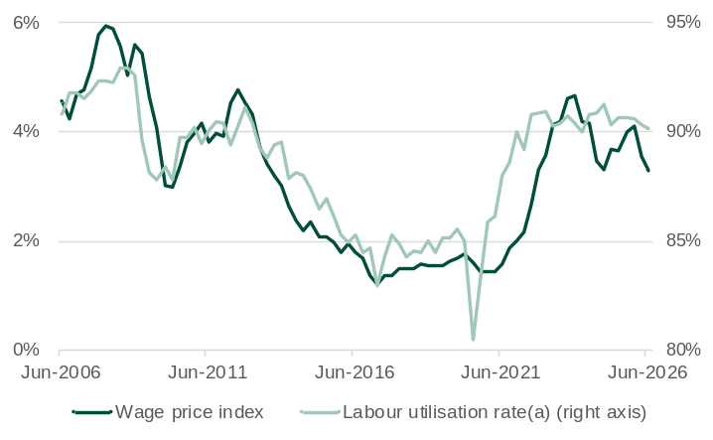
Note – Current prices. Original series. Year-on-year change in quarterly wage price index. 2008-09 = 100.0. Right vertical axis does not start at zero. (a) The labour utilisation rate is the proportion of persons in the labour force not underutilised (that is, neither unemployed nor underemployed).
Source: Based on ABS data.
- Nominal wage growth in Western Australia generally corresponds with the rate of labour utilisation; that is, when the rate of labour utilisation is high and spare capacity is low, employers offer higher wages to attract and retain workers. However, the correlation between labour utilisation and wage growth has not been as strong in recent years, with wage growth taking some time to respond the sharp increase in the labour utilisation rate during the economic recovery from the COVID-19 pandemic.
- Annual wage growth in Western Australia, as measured by the year-on-year change in the wage price index (WPI), was 3.3% in the June quarter 2026, down from 3.6% in the March quarter 2026.
- The WA Government Budget 2026-27 forecasts Western Australia’s annual average wages will increase 3.25% in both 2026-27 and 2027-28.
- Australia’s annual wage growth (in seasonally adjusted terms) was 3.2% in the June quarter 2026, the same as the March quarter 2026.

Wage price index (nominal and real change)
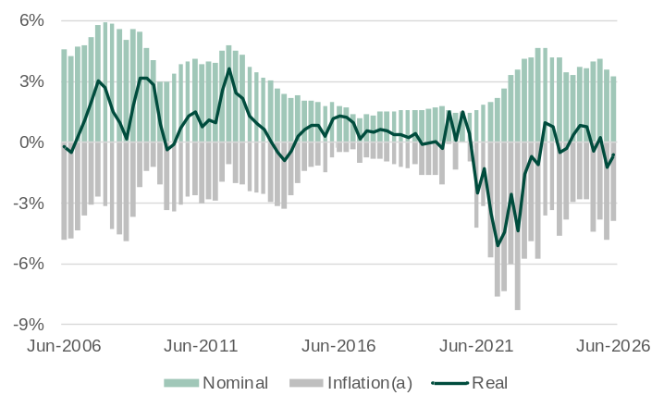
Note – Original series. Nominal = index of current prices. Real = index of current prices deflated by all-groups consumer price index for Perth. Year-on-year change in quarterly indexes. (a) Change in all-groups consumer price index for Perth are multiplied by negative one, given inflation detracts from real wages.
Source: Based on ABS data.
- Western Australia’s real wages – as measured by the difference in the year-on-year change in the wage price index and the year-on-year change in Perth’s consumer price index – fell for 10 consecutive quarters between June 2021 and September 2023 as the annual rate of inflation outpaced the annual rate of nominal wage growth. As inflation returned to around its longer-term average, real wages increased for a time, but the recent increase in inflation has again constrained real wage growth.
- Real wages in Western Australia fell 0.6% in the June quarter 2026, with the increase in Perth’s consumer price index (3.9%) greater than the increase in the wage price index (3.3%).
- The fall in real wages in Australia in the June quarter 2026 was slightly higher (0.7%) compared to Western Australia, with the increase in the national wage price index being slightly lower (3.2%) and the increase in the national consumer price index being slightly higher (4.0%).

Interstate comparison of average weekly earnings^{(a)}: June quarter 2026
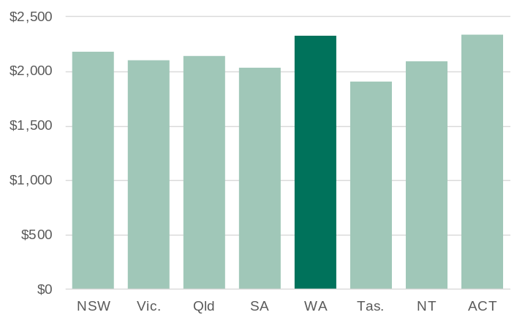
Note – Seasonally adjusted series except for private and public sectors (original series). Data is collected for the middle month of the June and December quarters (May and November). (a) Full-time adult total earnings.
Source: Based on ABS data.
- Western Australia’s average weekly earnings are higher than the national average, due in part to the relatively high share of workers employed in the highly paid mining and mining services industries.
- In the June quarter 2026, average weekly earnings in Western Australia were $2,318, 7.3% higher than the national average of $2,160.
- Average weekly earnings for males in Western Australia were $2,501, 9.4% higher than the national average for males.
- Average weekly earnings for females in Western Australia were $1,977, 0.6% higher than the national average for females.
- In the June quarter 2026, Western Australia’s average weekly earnings in the:
- private sector was $2,325, 10.3% more than the national average
- public sector was $2,286, 2.0% less than the national average.

Population
Back to contents

Estimated resident population (change)*
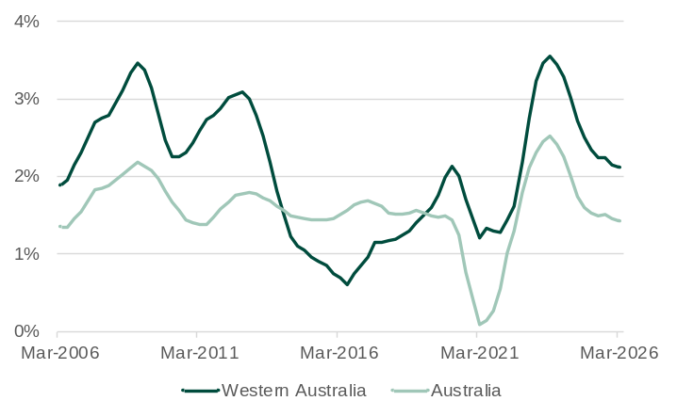
Note – Original series. Year-on-year change in quarterly series.
Source: Based on ABS data.
- Western Australia’s population growth has slowed since mid-2023, but the rate of growth is still high relative to both the years leading to 2020 and to the national growth rate.
- Western Australia’s population growth rate reached a high of 3.6% in the year to the September quarter 2023 but has trended down since to 2.1% in the year to the March quarter 2026.
- Australia’s population growth rate in the year to the March quarter 2026 was 1.4%.
- Western Australia’s estimated residential population was 3.10 million in the March quarter 2026, accounting for 11.1% of Australia’s estimated resident population of 27.92 million.
- In the year to the March quarter 2026, Western Australia’s population grew by 64,198 with the increase comprising:
- net overseas migration of 41,531 (14.2% of the Australian total)
- natural increase of 12,353 (12.3% of the Australian total)
- net interstate migration of 10,314.
- The WA Government Budget 2026-27 forecasts Western Australia’s population will grow by 1.6% in 2026-27 and 1.5% in 2027-28.

Net overseas migration*
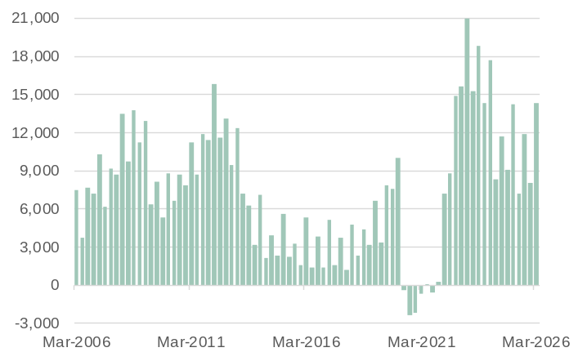
Note – Original series. Quarterly series. Overseas arrivals less departures.
Source: Based on ABS data.
- Western Australia’s net overseas migration was significantly affected by the closing and then re-opening of borders during the COVID-19 pandemic.
- In the year to the March quarter 2026, Western Australia’s net overseas migration was 41,531, 4.3% less than in the year to the March quarter 2025.
- Net overseas migration was 14,376 in the March quarter 2026, down from the record high of 20,995 in the March quarter 2023.
- Western Australia’s share of Australia’s net overseas migration has fluctuated over time based on economic conditions in the State relative to other parts of Australia. In the year to the March quarter 2026, Western Australia’s share of Australia’s net overseas migration was 14.2%, above the long-term average of around 12%.

Net interstate migration*
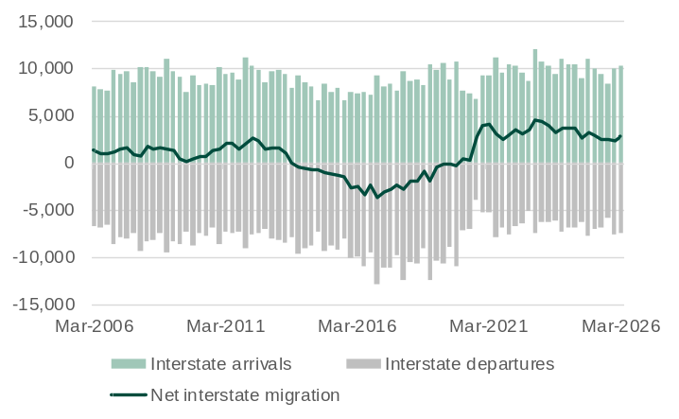
Note – Original series. Quarterly series.
Source: Based on ABS data.
- Western Australia has had 25 consecutive quarters of positive net interstate migration from the March quarter 2020 to the March quarter 2026. This followed 26 quarters of negative net interstate migration from the September quarter 2013 to the December quarter 2019.
- In the year to the March quarter 2026, Western Australia’s net interstate migration was 10,314, with:
- 38,129 interstate arrivals
- 27,815 interstate departures.
- Net interstate migration was 2,875 in the March quarter 2026, higher than the 2,415 in the previous quarter.

Housing
Back to contents

Dwelling building activity*
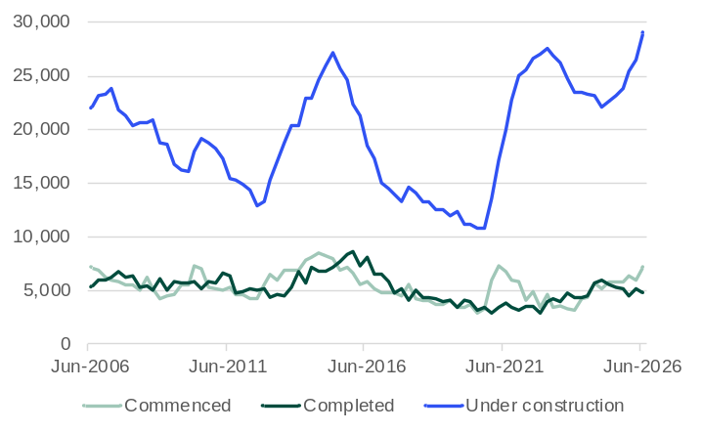
Note – Seasonally adjusted series for dwelling commencements and completions and original series for dwellings under construction. Quarterly series.
Source: Based on ABS data.
- The number of dwellings completed usually tracks the number of dwellings commenced with a lag as dwellings are built. Changes in the average time taken to complete builds will disrupt this relationship, as it has in recent years in Western Australia.
- Stimulus measures introduced by the Australian and Western Australian Government in mid-2020 contributed to a large increase in the number of dwelling units commenced.
- However, longer timeframes for construction meant there was not a corresponding increase in completions. This led to a sharp increase in the number of dwellings under construction.
- The number of dwellings under construction fell in 2023 and 2024 as completions picked up. However, an increase in commencements and a fall in completions has led to another increase in the number of dwellings under construction.
- Between the June quarters of 2025 and 2026, the number of dwelling units in Western Australia that were:
- commenced increased 23.3% to 7,240
- completed fell 8.8% to 4,814
- under construction increased 25.4% to 29,048.

House and rental price indexes (change)*
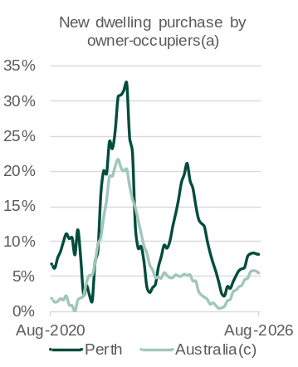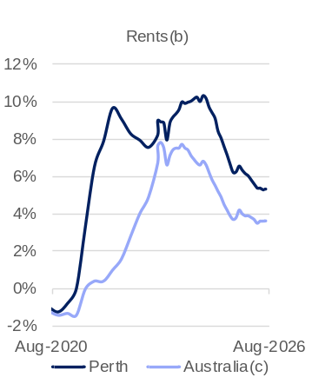
Note – Original series. (a) Percentage change from same month of the previous year. (b) Percentage change from same month of previous years from July 2023. Prior to July 2023 percentage change from same quarter of previous year. (c) Weighted average of eight capital cities.
Source: Based on ABS data.
- Housing costs in Perth had appeared to be moderating after a large upswing driven by population growth and constraints on new supply, but renewed pressure on construction costs have flowed through to prices for new dwellings.
- New dwelling price growth in Perth rose through 2024 to a peak of 21% in July 2024, then slowed to low single‑digit rates. In contrast, national new dwelling prices followed a much smoother path over this period.
- Price growth for new dwellings has trended up in both Perth and nationally since mid-2025. The year-on-year increase in prices for new dwellings purchased by owner-occupiers in Perth was 8.1% in August 2026, above the 5.4% increase nationally.
- Rental price growth in Perth has eased but remains elevated and above the national rate of growth.
- The year-on-year change in Perth’s rents was 5.3% in July 2026, above the 3.6% rise nationally.
- The cumulative change in the price index for Perth’s rents between the end of 2021 and the end of 2025 was 37%, compared to 24% nationally.

Median price of established house transfers (unstratified)(a): June quarter 2026
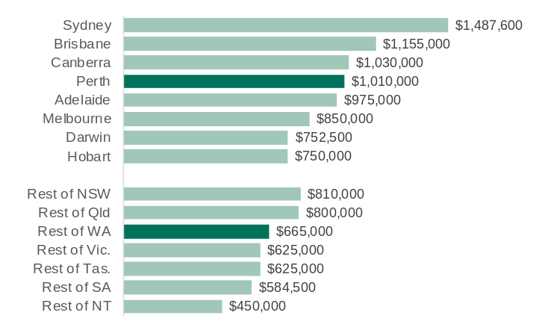
Note – Current prices. Original series. Quarterly series. (a) No grouping (stratifying) or weighting is applied and as such there is no adjustment for changes in the quality of houses transferred in different quarters.
Source: Based on ABS data.
- House prices in Perth and the rest of Western Australia have increased significantly in recent years, as they have in most other parts of Australia. Price growth slowed in the June quarter 2026, but median prices were still significantly higher than one year prior.
- The median price of established house transfers (unstratified)^{(a)} in Perth was $1,010,000 in the June quarter 2026, 18.8% higher than the June quarter 2025.
- The median price of established house transfers (unstratified)^{(a)} in the rest of Western Australia was $665,000 in the June quarter 2026, 20.9% higher than the June quarter 2025.
- The WA Government Budget 2026-27 forecasts Western Australia’s median house price will increase 9.0% in 2026-27 and 4.6% in 2027-28.

Construction
Back to contents

Private new capital expenditure
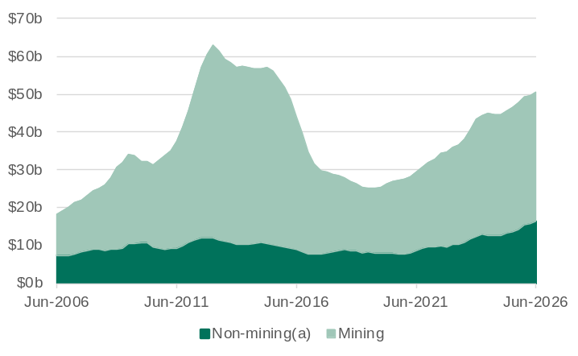
Note – Current prices. Original series. Quarterly series. 4-quarter rolling sum. (a) All industries other than mining; agriculture, forestry and fishing; public administration and safety; and superannuation funds.
Source: Based on ABS data.
- Private new capital expenditure, which comprises expenditure on non-dwelling construction and machinery and equipment, accounted for 89% of business investment in Western Australia in 2024-25. Mining accounts for most of Western Australia’s private new capital expenditure, with the share changing over time with cycles of investment in the mining industry.
- In 2025-26, the value of Western Australia’s new capital expenditure in:
- the mining industry increased 3.6% to $34.2 billion
- non-mining industries increased 20.2% to $16.4 billion.
- Western Australia accounted for 24.1% of the value of Australia’s private new capital expenditure in 2025-26, including 62.3% of Australia’s mining industry new capital expenditure and 10.6% of Australia’s non-mining industries new capital expenditure.
- In real terms, Western Australia’s private new capital expenditure increased 7.1% in 2025-26.

Engineering construction activity in the pipeline*
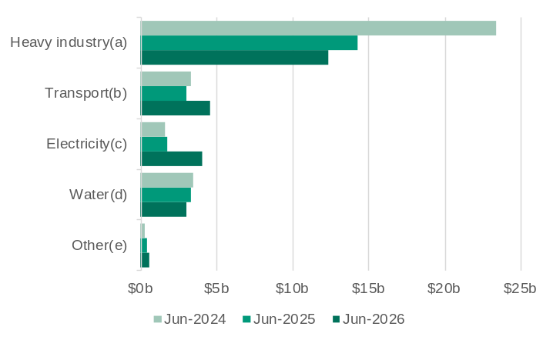
Note – Current prices. Original series. Quarterly series. Work yet to be done. (a) Oil, gas, coal, bauxite, alumina and other mineral production, storage and distribution facilities; refineries; pumping stations; construction of mines; drilling wells; chemical plants; other industrial processing plants; and ovens. (b) Roads, highways and subdivisions; and bridges, railways and harbours. (c) Electricity generation and transmission and pipelines. (d) Water storage and supply, sewage and drainage. (e) Telecommunications; and recreations and other structures. Source: Based on ABS data.
- The value of engineering construction activity in the pipeline in Western Australia has increased over the past year as the value of construction work completed has been more than replaced by committed new activity.
- The value of engineering construction activity in the pipeline in Western Australia in the June quarter 2026 was $24.6 billion, 8.0% more than in the June quarter 2025 (but 24% less than in the June quarter 2024).
- The value of engineering construction activity in the pipeline for heavy industry and water fell over the past year, but this was more than offset by increases for transport and electricity. In the June quarter 2026, the value of engineering construction activity in the pipeline for:
- heavy industry fell 13.4% to $12.4 billion
- transport increased 52% to $4.6 billion
- electricity increased 135% to $4.1 billion
- water fell 9.0% to $3.0 billion.

Building activity in the pipeline*
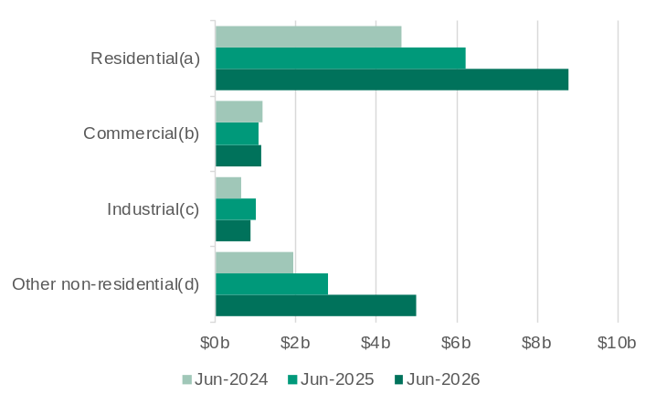
Note – Current prices. Original series. Quarterly series. Work yet to be done. (a) Houses; semi-detached, row or terrace houses, townhouses; and apartments. (b) Retail and wholesale trade buildings; transport buildings; and offices. (c) Factories and other secondary buildings; warehouses; and agricultural and aquacultural buildings. (d) Education buildings; religion buildings; aged care buildings; health buildings; entertainment and recreation buildings; and short-term accommodation buildings. Source: Based on ABS data.
- The value of building activity in the pipeline in Western Australia has risen substantially over the past year as the value of building work completed over the past year has been more than replaced by committed new building activity.
- The value of total building activity in the pipeline in Western Australia in the June quarter 2026 was $15.8 billion, 42% more than in the June quarter 2025.
- The value of residential building activity in the pipeline in Western Australia in the June quarter 2026 was $8.8 billion, 41% more than in the June quarter 2025.
- The value of non-residential building activity in the pipeline in Western Australia in the June quarter 2026 was $7.0 billion, 44% more than in the June quarter 2025, with the increase driven by:
- Health buildings up by $1.4 billion to $2.1 billion, mainly due to the New Women and Babies Hospital in Murdoch
- Short-term accommodation buildings up 81% to $909 million
- Entertainment and recreation buildings up 130% to $488 million.

Regional labour markets and construction
Back to contents

Internet vacancies by region*
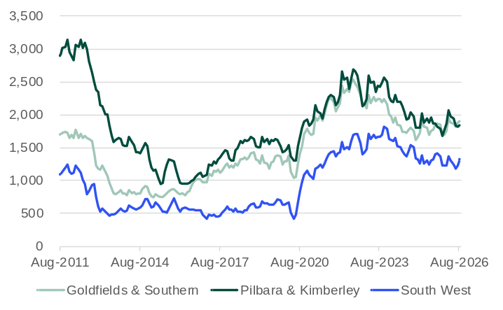
Note – Original series. Monthly series. 3-month moving average. Custom Internet Vacancy Index regions.
Source: Jobs and Skills Australia.
- Internet vacancies have trended down over the past three years across Western Australian regions but remain at high levels. Between August 2025 and August 2026, internet vacancies in the:
  - Goldfields & Southern region increased 7.8% to 1,903
  - Pilbara & Kimberley region fell 1.4% to 1,841
  - South West region increased 0.2% to 1,322.
- In August 2026, the highest numbers of internet vacancies in the:
  - Goldfields & Southern region were for technicians and trade workers (463) and professionals (388)
  - Pilbara & Kimberley region were for technicians and trade workers (519) and professionals (358)
  - South West region were for professionals (305) and technicians and trade workers (259).
- The largest increase in the number of internet vacancies between August 2025 and August 2026 was for mobile plant operators in the Goldfields & Southern region; medical practitioners/nurses in the Pilbara & Kimberley region; and automotive and engineering trades workers in the South West region.

Unemployment rate by region
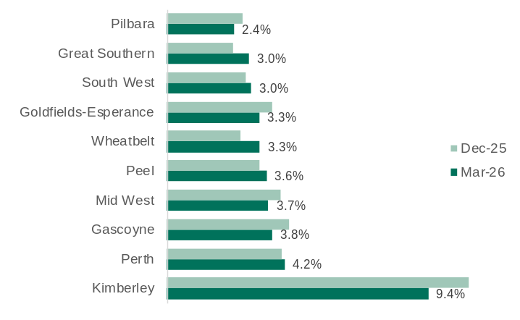
Note – Smoothed seasonally adjusted series. Development commission regions.
Source: Jobs and Skills Australia.
- The unemployment rate remained relatively low across most of Western Australia’s regions in the March quarter 2026.
- There was significant variation in the movement of unemployment rates across Western Australia’s regions between the December quarter 2025 and the March quarter 2026.
  - There were relatively large falls in the unemployment rate in the Kimberley (by 1.4 percentage points), Gascoyne (by 0.6 percentage points), Goldfields-Esperance and Mid-West (both by 0.5 percentage points).
  - In contrast, there were relatively large increases in the unemployment rate in the Wheatbelt (by 0.7 percentage points) and Great Southern (by 0.6 percentage points).
- Although the Kimberley has the highest unemployment rate of Western Australia’s regions, its unemployment rate in the March quarter 2026 (9.4%) was much lower than it was prior to the COVID-19 pandemic (15.1% in the December quarter 2019).

Building approvals per capita by region: 2024-25

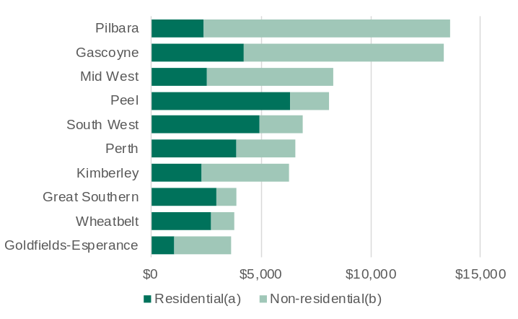
Note – Current prices. Original series. Monthly series. Development commission regions. (a) Residential building approvals for the construction of houses and apartments. (b) Non-residential building approvals for the construction of commercial buildings (retail/wholesale trade, transport, offices), industrial buildings (factories, warehouses, agriculture) and other non-residential buildings (education, religion, health, entertainment/recreation, short-term accommodation).
Source: Based on ABS data.
- The labour-intensive nature of the building industry means large parts of a region’s workforce are active when building activity is high. Building approvals can therefore provide a good indication of broader economic conditions across regional economies.
  - Comparing building approvals on a per capita basis accounts for differences in regional populations and provides an indication of relative demand across regions.
- In 2024-25, the value of residential building approvals per capita was highest in the Peel region ($6,338), followed by the South West ($4,927) and Gascoyne region ($4,216).
- The value of non-residential building approvals per capita was highest in the Pilbara region ($11,206) in 2024-25, reflecting the industrial and commercial buildings needed to support the region’s large mining industry, followed by the Gascoyne region ($9,102).

International trade
Back to contents

Exports of goods*
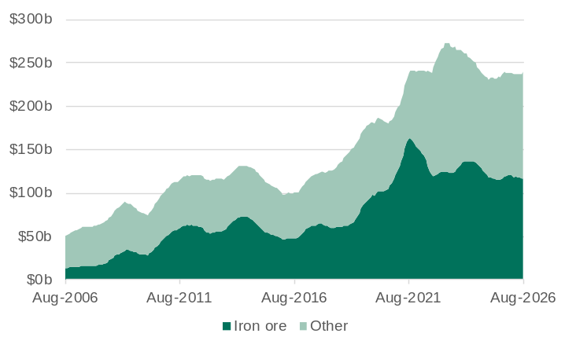
Note – Current prices. Free on board. Original series. 12-month rolling sum.
Source: Based on ABS data.
- The value of Western Australia’s exports increased significantly between 2016 and 2023, driven by high prices for iron ore, liquefied natural gas, battery and critical minerals and grains. With the prices for these commodities returning to longer-term averages, the value of Western Australia’s exports has fallen from its peak.
- Western Australia exported $239.0 billion of goods in the year to August 2026, 2.6% more than in the year to August 2025.
- In the year to August 2026, the value of exports of:
- iron ore was $116.0 billion, 0.9% more than in the year to August 2025
- all other commodities was $123.0 billion, 4.3% more than in the year to August 2025.

Imports of goods*
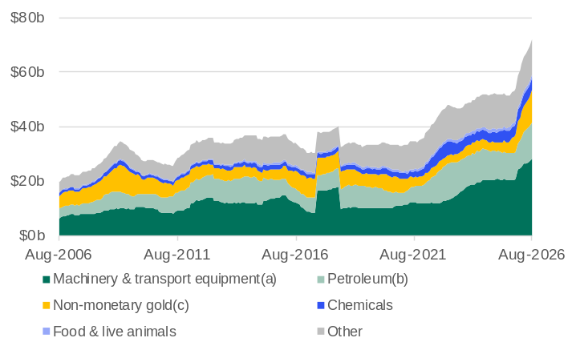
Note – Current prices. Customs value. Original series. 12-month rolling sum. The large increase in the value of imports in 2017 was due largely to the arrival of the Prelude floating LNG plant. (a) Includes road vehicles. (b) Petroleum, petroleum products and other mineral fuels. (c) For further refining at the Perth Mint.
Source: Based on ABS data.
- Higher prices and increased demand for a range of goods have kept the total value of Western Australia’s imports at a high level over the past few years. In 2026, the importation of high-value equipment for the second train of the Pluto LNG project, the higher oil price, and an increase in non-monetary gold imports have all contributed to a significant increase in the value of Western Australia’s imports.
- Western Australia imported $72.2 billion of goods in the year to August 2026, 40.1% more than in the year to August 2025.
- In the year to August 2026, the value of imports of:
- machinery and transport equipment was $28.2 billion, 38.4% more than in the year to August 2025
- petroleum was $13.3 billion, 36.0% more than in the year to August 2025
- non-monetary gold was $12.1 billion, 189% more than in the year to August 2025
- chemicals was $4.5 billion, 9.3% more than in the year to August 2025
- food and live animals was $1.2 billion, 4.2% more than in the year to August 2025.

Shipping freight rates*
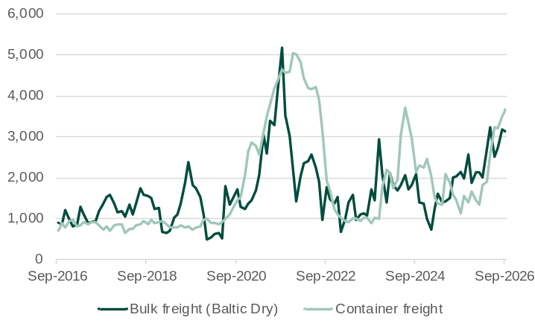
Note – Current prices. Original series. Values are for the last recorded day in each month. The Baltic Dry Index is a composite of three sizes of cargo ships measured by deadweight (DWt) tonnage (or weight of cargo excluding the weight of the ship).
Source: Trading Economics.
- The Baltic Dry Index (BDI) and containerized freight index (CFI) are useful indicators for global trade as 90% of the world’s goods trade occurs via maritime transport.
- The BDI measures the cost of shipping raw materials over 20 sea routes.
- The CFI measures the cost of transporting goods in containers from China’s major ports.
- Both the BDI and CFI increased significantly from mid-2020 to late-2021 as the global economic recovery from the COVID-19 pandemic led to increasing demand for raw materials and goods and disruptions in supply chains led to higher freight rates. Both indices had fallen back to pre-pandemic levels by 2023, but various disruptions and events have caused volatility in both indices.
- The conflict in the Middle East has led to higher fuel prices, limited shipping capacity and longer vessel routes from rerouting, contributing to both the BDI and CFI increasing in 2026. The CFI in particular has increased in recent months and was 175% higher at the end of September 2026 compared to the end of February 2026.

Visit Western Australia's economy and international trade (www.wa.gov.au) for more information on Western Australia’s economy, trade relationships and key export industries.
Western Australia Trade Profile  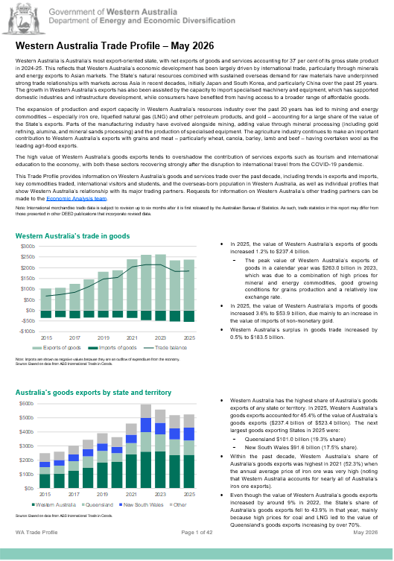 | Western Australia Iron Ore Profile  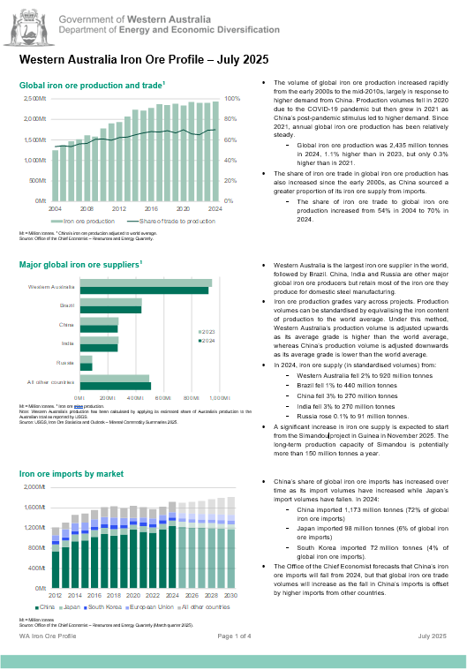
Western Australia LNG Profile  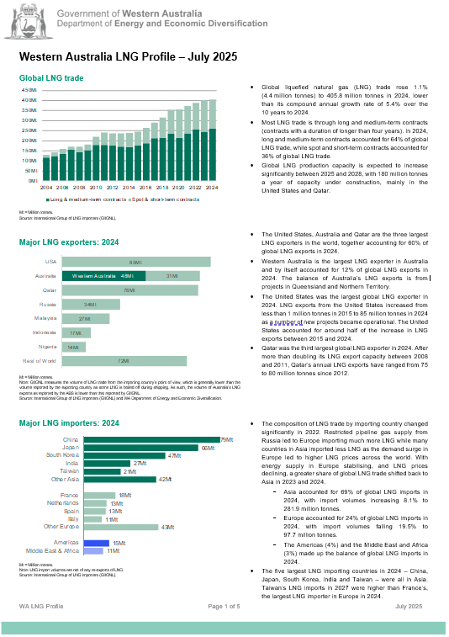 | Western Australia Battery and Critical Minerals Profile  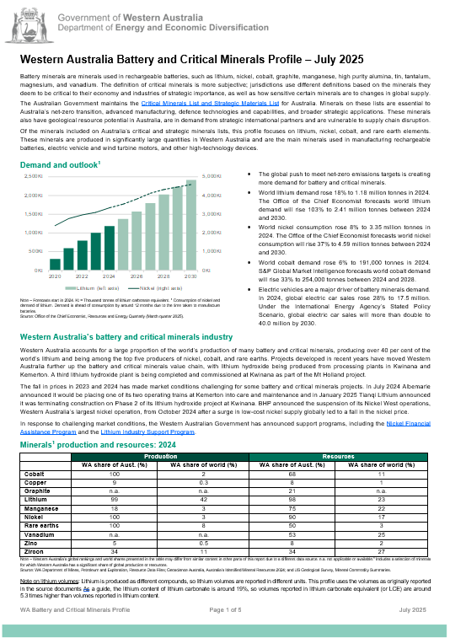
For any queries or feedback on these products, please contact us at economic.analysis@deed.wa.gov.au

