Western Australia Iron Ore Profile – September 2026

Global iron ore production and trade¹
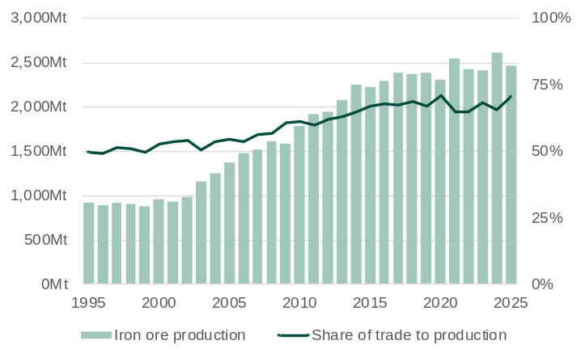
Mt = Million tonnes. 1. China’s iron ore production adjusted to world average.
Source: Office of the Chief Economist – Resources and Energy Quarterly.

- Global iron ore production increased rapidly from the early 2000s to the mid-2010s, largely in response to higher demand from China. Production volumes have continued to trend up over the past ten years, but at a slower rate and with added volatility related to the COVID-19 pandemic and China’s post-pandemic stimulus.
- The share of iron ore trade in global iron ore production has also increased from around 50% in the early 2000s to around 70% in 2025. This has largely been a result of China sourcing a greater proportion of its iron ore from imports to supply the growth in its iron ore demand.
- The volume of global iron ore production fell in 2025 as China and some other countries reduced domestic (non-traded) production. In 2025:
  - Iron ore production fell 5.3% to 2,467 million tonnes.
  - Iron ore trade increased 1.8% to 1,744 million tonnes.

Major global iron ore suppliers¹
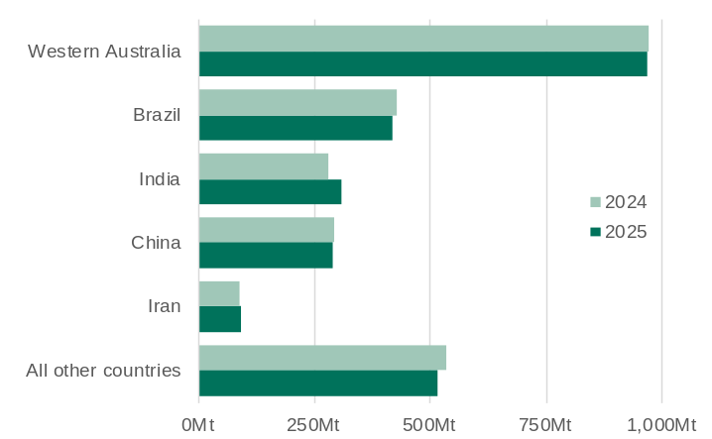
Mt = Million tonnes. 1. Iron ore mine production.
Note: Western Australia’s production has been calculated by applying its estimated share of Australia’s production to the Australian total as reported by USGS.
Source: USGS, Iron Ore Statistics and Outlook – Mineral Commodity Summaries 2026.

- Western Australia is the largest iron ore supplier in the world, followed by Brazil. India, China and Iran are other major global iron ore producers but retain most of the iron ore they produce for domestic steel manufacturing.
- Iron ore production grades vary across projects. Production volumes can be standardised by equivalising the iron content of production. Under this method, Western Australia’s production volume is adjusted upwards to account for its higher-grade hematite ores, whereas China’s production volume is adjusted downwards to account for its lower-grade magnetite ores.
- In 2025, iron ore supply (in standardised volumes) from:
  - Western Australia fell 0.2% to 970 million tonnes
  - Brazil fell 2% to 420 million tonnes
  - India rose 10% to 310 million tonnes
  - China fell 1% to 290 million tonnes
  - Iran rose 3% to 93 million tonnes.
- A significant increase in iron ore supply will come from the Simandou project in Guinea. The project started operations in November 2025 and following ramp up will export up to 120 million tonnes of iron ore a year.

Iron ore imports by market
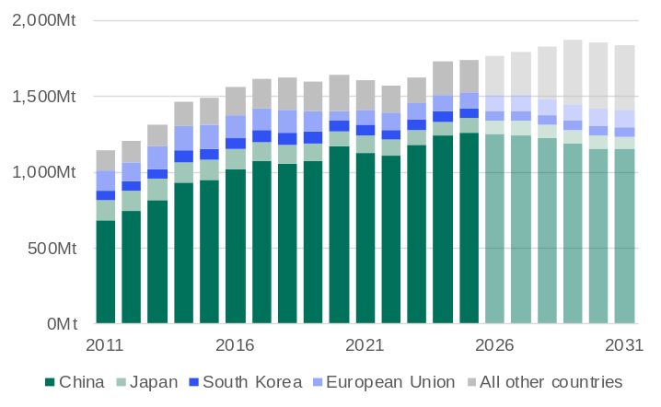
Mt = Million tonnes.
Source: Office of the Chief Economist – Resources and Energy Quarterly (December quarter 2025).

- China’s share of global iron ore imports has increased over time as its import volumes have increased while Japan’s import volumes have fallen. In 2025, iron ore imports for:
  - China were 1,260 million tonnes (72.3% of global total)
  - Japan were 96 million tonnes (5.5% of global total)
  - South Korea were 69 million tonnes (3.9% of global total).
- The Office of the Chief Economist forecasts that iron ore imports for China, Japan and South Korea will all fall from 2025 levels, but that this fall will be offset over the next few years by higher imports from other countries.
  - China’s iron ore imports are forecast to be 8.5% lower in 2031 compared to 2025, with its share of global iron ore imports falling to 62.7%.
  - Global iron ore trade is forecast to increase by 7.3% between 2025 and 2029, before falling from 2030.

Iron ore price¹
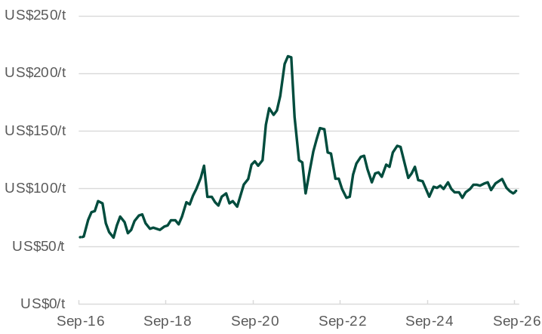
1. The monthly average benchmark (62% iron content) iron ore price delivered to China inclusive of cost and freight.
Source: World Bank, Commodity Markets.

- The iron ore price has been relatively stable over the past two years compared to the larger swings seen in previous years.
- The average monthly iron ore price was US$97.70 a tonne in September 2026, 1.5% higher than the previous month.
  - The iron price increased above US$100 a tonne in early September 2026 due mainly to steel mills in China restocking before a holiday period, with the price falling back below US$100 a tonne later in the month.
- The WA Government Budget 2026-27 forecasts the average iron ore price will be US$85.2 a tonne in 2026-27. Beyond this, the iron ore price is forecast to average US$72.0 a tonne each year between 2027-28 and 2029-30. This reflects a forecasting approach of the iron ore price returning to its long-term average.

Western Australia’s iron ore exports¹
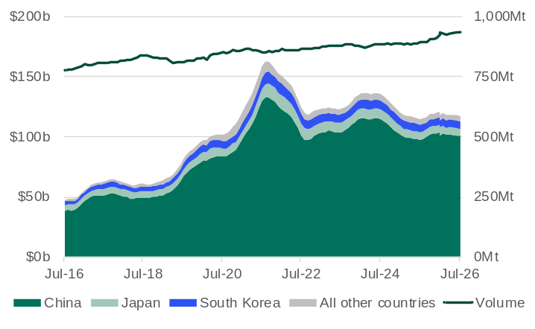
Mt = Million tonnes. 1. 12-month rolling total for both value and volume.
Source: Based on data from ABS International Trade in Goods and Services, Australia.

- The volume of Western Australia’s iron ore exports in the year to July 2026 was 935 million tonnes, 4.5% more than in the year to July 2025.
- The value of Western Australia’s iron ore exports in the year to July 2026 was $117.0 billion, 2.0% more than the year to July 2025.
- In the year to July 2026, the value of Western Australia’s iron ore exports to:
  - China was $100.4 billion (85.8% of the total)
  - Japan was $6.3 billion (5.3% of the total)
  - South Korea was $6.2 billion (5.3% of the total)
  - All other countries was $4.1 billion (3.5% of the total).

Iron ore exploration expenditure¹
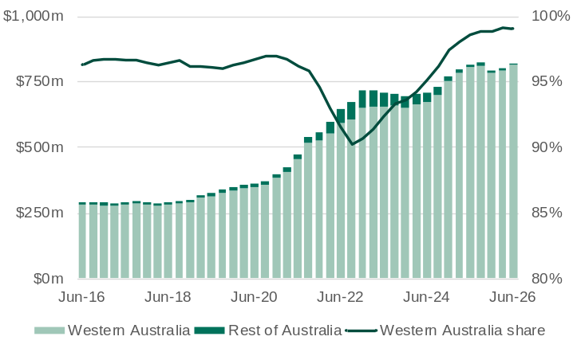
1. Four-quarter rolling total. Right axis does not start at zero.
Source: Based on data from ABS Mineral and Petroleum Exploration, Australia.

- Higher iron ore prices in recent years and a need to replenish iron ore reserves have led to greater expenditure on iron ore exploration in Western Australia.
- In 2025-26, expenditure on iron ore exploration in Western Australia was $812 million, 1.1% more than in 2024-25.
- Western Australia accounts for nearly all of Australia’s iron ore production and iron ore reserves, and therefore nearly all iron ore exploration expenditure in Australia.
  - Over 2025-26, Western Australia accounted for 99% of total iron ore exploration expenditure in Australia.
Western Australia’s iron ore sales by major producer¹
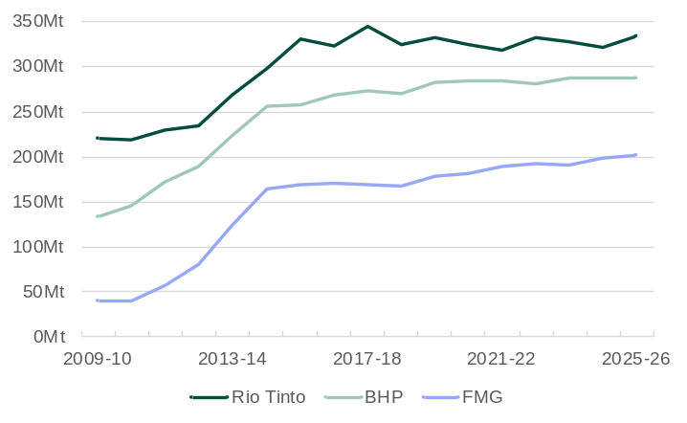
Mt = Million tonnes. 1. Western Australian operation only. Inclusive of third-party tonnes. Wet tonnes.
Source: Rio Tinto, BHP and Fortescue Metals Group Investor Information, Operations reports.

- Rio Tinto, BHP and FMG are the largest global iron ore producers behind Vale from Brazil.
- Rio Tinto’s iron ore shipments from Western Australia increased 3.9% to 333 million tonnes in 2025-26. Guidance for shipments in 2026 is 323 to 338 million tonnes. Rio Tinto’s rail and port capacity is 360 million tonnes a year and it is developing new mines to enable its production to meet this capacity.
- BHP’s iron ore sales volumes from Western Australia increased 0.2% to 288 million tonnes in 2025-26. Production guidance for 2025-26 is 286 to 298 million tonnes. BHP is expanding its port capacity to 330 million tonnes a year.
- FMG’s iron ore shipments from Western Australia increased 1.5% to 201 million tonnes in 2025-26. Guidance for shipments in 2026-27 is 197 to 207 million tonnes. FMG’s port capacity is around 210 million tonnes a year.

Major iron ore projects in Western Australia¹
Operator | Mine/deposit | Capex  ($m) | Capacity (Mtpa) | Fe  content² | Start of operations
Recently completed
BHP | South Flank | 4,700 | 80 | 62 | 2021
Rio Tinto | West Angelas C+D | 735 | 35 | 62 | 2021
Mt Gibson | Shine | 20 | 1.5 | 59 | 2021
Rio Tinto | Western Turner Syncline 2 | 1,000 | 30 | 62 | 2021
Rio Tinto | Gudai-Darri | 4,300 | 43 | 59 | 2022
Rio Tinto | Robe Valley | 1,200 | 30 | 62 | 2022
FMG | Iron Bridge 2 | 5,600 | 22 | 67 | 2023
MRL | Onslow Iron | 2,500 | 30 | 58 | 2024
Rio Tinto | Western Range | 3,000 | 25 | 62 | 2025
Hancock | McPhee Creek | 840 | 10 | 56 | 2026
Under construction or committed
BHP | Western Ridge Crusher | 1,500 | 25 | n.a | 2026
Rio Tinto and Hancock | Hope Downs 2 | 2,200 | 31 | 62 | 2027
Rio Tinto | Brockman Syncline 1 | 2,700 | 34 | 62 | 2027
Rio Tinto | West Angelas A-West | 1,000 | 35 | 62 | 2027
Mtpa = million tonnes per annum. n.a. – not available or not applicable. 1. Includes mines and rail and port infrastructure. 2. Product grade if available, otherwise reserve grade for direct shipping ores.
Source: Company investor information (announcements, reports and presentations).

- Rio Tinto is developing several replacement projects (Western Range, Brockman Syncline 1, Hope Downs 2, West Angelas and Greater Nammuldi) to increase the capacity of its Pilbara iron ore operations to 345 to 360 million tonnes a year. The combined annual capacity of these replacement projects is about 130 million tonnes.
- The Rhodes Ridge Joint Venture approved a $294 million feasibility study for phase one of the Rhodes Ridge iron ore project, targeting 40-50 million tonnes a year of initial production, with first ore expected around 2030.
- Rio Tinto and BHP are exploring collaboration at the neighbouring Yandicoogina and Yandi operations, including development of Rio Tinto’s Wunbye deposit and processing BHP’s Yandi Lower Channel Deposit ore through Rio Tinto’s existing wet plants, to unlock up to 200 million tonnes of Pilbara iron ore, with first ore potentially early next decade.

Western Australia’s iron ore exports by port
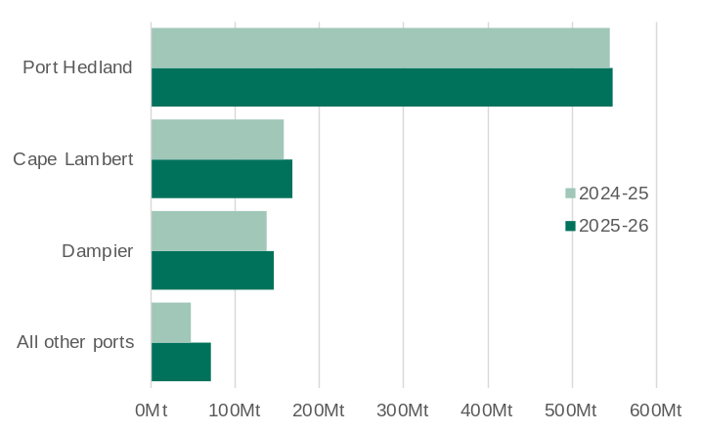
Mt = Million tonnes.
Source: Based on data from ABS International Trade in Goods and Services, Australia.

- Port Hedland accounted for 59% of Western Australia’s iron ore export volumes in 2025-26. The next largest ports in Western Australia for iron ore export volumes in 2025-26 were Cape Lambert (18%) and Dampier (16%).
- In 2025-26, the volume of iron ore exports from:
  - Port Hedland increased 0.8% to 550 million tonnes
  - Cape Lambert increased 6.1% to 168 million tonnes
  - Dampier increased 6.5% to 147 million tonnes
  - All other ports increased 46% to 71 million tonnes.
- The large increase in exports from all other ports in 2025-26 was due to the ramp up of production from the Onslow Iron project. Iron ore exports from the port of Onslow increased from 13.1 million tonnes in 2024-25 to 30.8 million tonnes in 2025-26.

Western Australia’s iron ore sales volume
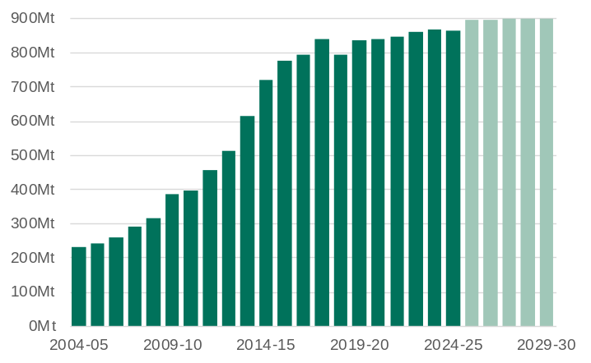
Mt = Million tonnes.
Source: WA Department of Mines, Petroleum and Exploration, Resource Data Files; and WA Government Mid-year Financial Projections Statement 2025-26 (December 2025).
1. S&P Global Market Intelligence.

- The volume of Western Australia’s iron ore sales increased rapidly from the early 2000s and has settled at a high level.
- Western Australia’s iron ore sales fell 0.2% to 864 million tonnes in 2024-25. The WA Government Budget 2026-27 forecasts that iron ore sales will increase to 895 million tonnes in 2025-26 and will settle at around 900 million tonnes for each year between 2026-27 and 2029-30.
- In 2025, Western Australia’s iron ore production was mainly iron ore fines (69.5%), followed by lump (25.8%) and concentrate (4.7%).¹
- Production of iron ore products varied across Western Australia’s major producers in 2025 as follows:
  - Rio Tinto: 66% fines and 34% lump
  - BHP: 69% fines and 31% lump
  - FMG: 88% fines and 12% concentrate
  - Hancock Prospecting: 58% fines and 42% lump
  - Mineral Resources: 100% fines
  - CITIC Pacific and Karara Mining: 100% concentrate.

Western Australia’s iron ore sales and royalty receipts¹
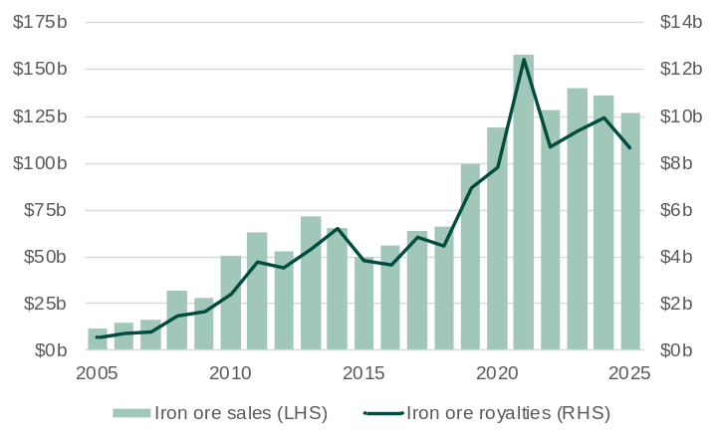
1. Regulation 86A of the Mining Regulations 1981 requires that royalties be paid within 30 days following the end of a quarter. As a result, cash receipts are necessarily offset by one quarter. The value of royalty receipts is different to the value of royalty income published in State Budget papers, which is accounted for in the year the royalty liability is accrued, rather than paid.
Source: WA Department of Mines, Petroleum and Exploration, Resource Data Files.

- The value of Western Australia’s iron ore sales fell 7.3% to $126.2 billion in 2025.
- The Western Australian Government’s iron ore royalty receipts fell 12.9% to $8.7 billion in 2025.
- Both iron ore sales and royalty receipts were down from their 2021 peaks (of $157.8 billion and $12.4 billion respectively) when the average iron ore price was particularly high in Australian dollar terms.
- In 2025, iron ore accounted for 86% of Western Australia’s total royalty receipts (excluding North West Shelf grants).
- The WA State Budget 2026-27 forecasts iron ore royalty income will fall from $8.8 billion in 2025-26 to $5.6 billion in 2029-30, based on the assumption that the iron ore price will fall and then settle at its long-term average over the period.

Western Australia’s iron ore industry employment¹
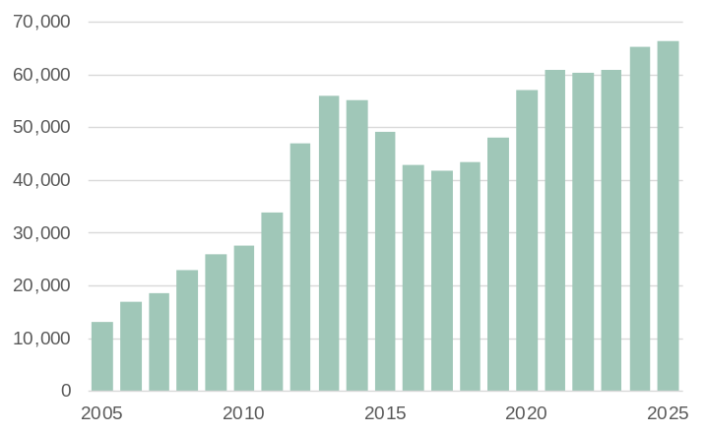
1. Direct employment. Full-time equivalent (average on site).
Source: WA Department of Mines, Petroleum and Exploration, Resource Data Files.

- Direct full-time equivalent (FTE) employment in Western Australia’s iron ore industry increased 1.5% to a record high of 66,367 in 2025.
- Iron ore accounted for 49% of direct FTE employment in Western Australia’s minerals mining industry in 2025 (excluding exploration).
- Western Australia’s largest employing iron ore mine sites in 2025 were:
  - FMG’s East Pilbara Iron Ore (6,816 FTE) and Greater Solomon (4,207 FTE)
  - BHP’s Mining Area C (4,781 FTE) and Newman (4,003 FTE)
  - Roy Hill Iron Ore (3,799 FTE)
  - CITIC Pacific’s Sino-Cape Preston Iron (3,084 FTE)
  - Rio Tinto’s Robe River-Deepdale (2,737 FTE) and Hope Downs (2,689 FTE).

