Western Australia LNG Profile – September 2026

Global LNG trade
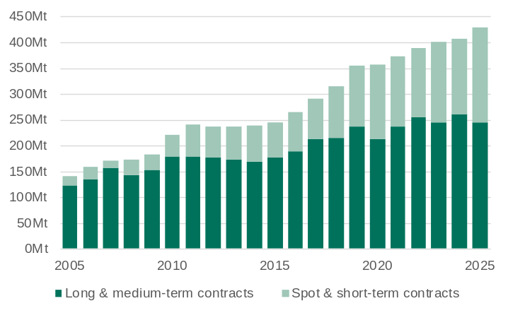
Mt = Million tonnes.
Note: Long and medium-term contracts are contracts with a duration of four or more years.
Source: International Group of LNG importers (GIIGNL).

- Global LNG trade continued to grow in 2025, increasing 5.4% (22.1 million tonnes) to 427.9 million tonnes in 2025.
- The volume of global LNG trade more than tripled over the 20 years to 2025 with large increase in production capacity in Qatar, the United States and Australia meeting growing demand in Asia and Europe.
- As LNG production capacity takes years to develop and LNG projects generally produce close to nameplate capacity, increases in global LNG trade generally correspond with increases in global production capacity. There were large increases in global production capacity in the late-2010s, but net increases have been lower in recent years.
- LNG trade has occurred mostly through long and medium-term contracts, but the share of spot and short-term contracts has increased, particularly through higher export volumes from the United States to Europe. In 2025, long and medium-term contracts accounted for 57% of global LNG trade (64% in 2024), while spot and short-term contracts accounted for 43% of global LNG trade (36% in 2024).

Major LNG exporters: 2025
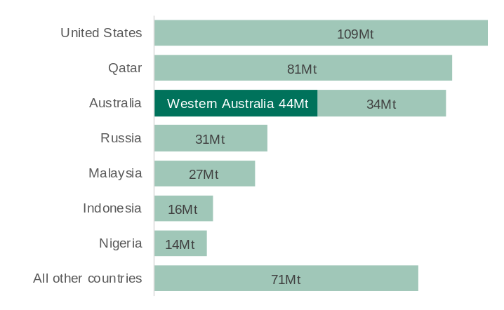
Mt = Million tonnes.
Note: GIIGNL measures the volume of LNG trade from the importing country’s point of view, which is generally lower than the volume reported by the exporting country as some LNG is boiled off during shipping. As such, the volume of Australia’s LNG exports as reported by the ABS tends to be lower than that reported by GIIGNL.
Source: International Group of LNG importers (GIIGNL) and WA Department of Energy and Economic Diversification.

- The United States, Australia and Qatar together accounted for 63% of global LNG exports in 2025.
- Western Australia is the largest LNG exporter in Australia and by itself accounted for 10% of global LNG exports in 2025. The balance of Australia’s LNG exports is from projects in Queensland and Northern Territory.
- The United States was the largest LNG exporter in 2025. LNG exports from the United States increased from less than 1 million tonnes in 2015 to 109 million tonnes in 2025, accounting for around 60% the increase in global LNG exports between 2015 and 2025.
- Qatar was the second largest global LNG exporter in 2025. After more than doubling its LNG export capacity between 2008 and 2011, Qatar’s annual LNG exports have ranged from 75 to 81 million tonnes since 2012.
- There is currently around 200 million tonnes a year of LNG production capacity under construction, mainly in the United States and Qatar. However, the onset of conflict in the Middle East in 2026 has made the timing for the expansion of Qatar’s production capacity uncertain.

Major LNG importers: 2025
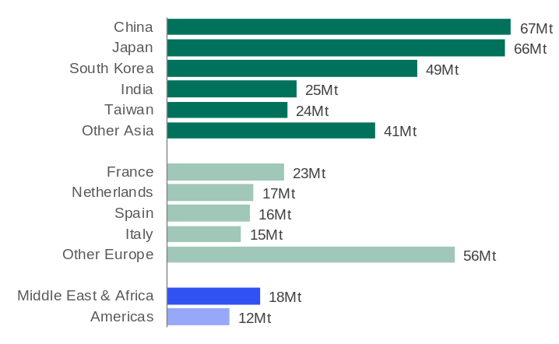
Mt = Million tonnes
Note: LNG import volumes are net of any re exports of LNG.
Source: International Group of LNG importers (GIIGNL).

- The five largest LNG importing countries – China, Japan, South Korea, India and Taiwan – are all in Asia.
- In 2025:
  - Asia accounted for 63% of global LNG imports, with import volumes falling 4% to 271.0 million tonnes.
  - Europe accounted for 30% of global LNG imports, with import volumes increasing 29% to 126.3 million tonnes.
  - The Middle East and Africa (4%) and the Americas (3%) made up the balance of global LNG imports.
- Global LNG trade changed significantly in 2022 as lower pipeline gas supply from Russia led to Europe importing more LNG. The demand surge in Europe led to higher LNG prices, and many Asian countries imported less LNG. As energy supply in Europe and LNG prices stabilised, a greater share of global LNG trade shifted back to Asia in 2024.The availability of supply from new projects in the United States contributed to the increase in Europe’s LNG imports in 2025.

Major LNG importers in Asia¹
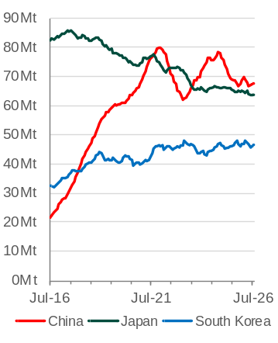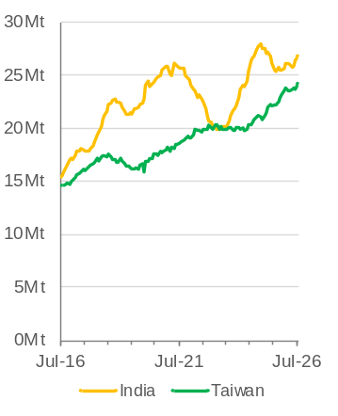
Mt = Million tonnes. 1. 12-month rolling total.
Source: WA Department of Energy and Economic Diversification estimates based on data from CEIC China Premium Database; Japanese Ministry of Finance; Korean Customs Service; Indian Ministry of Commerce and Industry; and EnergyQuest, Australian LNG Monthly Report.

- China overtook Japan as the world’s largest LNG importer in 2021 after a large increase in its LNG imports from the mid-2010s and a longer-term decline in Japan’s LNG imports over the same period. The volume of China’s LNG imports has been volatile over the past five years, varying with overall gas demand and the availability of pipeline gas.
- LNG import volumes for South Korea, India and Taiwan have all trended up over the past ten years. The volume of India’s LNG imports has been more volatile as Indian consumers tend to be more sensitive to changes in prices.
- LNG import volumes for major Asian buyers have largely been maintained over the past year despite lower supply from Middle East exporters. In the 12 months to July 2026, LNG imports for:
  - China were 67.4 million tonnes, 1.9% less than the previous 12 months
  - Japan were 63.5 million tonnes, 2.8% less than the previous 12 months
  - South Korea were 46.3 million tonnes, 0.5% less than the previous 12 months
  - India were 26.7 million tonnes, 4.8% more than the previous 12 months
  - Taiwan were 24.2 million tonnes, 8.6% more than the previous 12 months.

Asia LNG prices (per mmBTU)
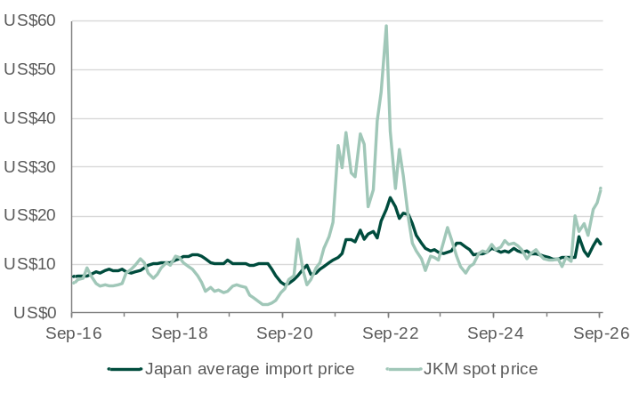
mmBTU = Million British thermal units.
Note: The JKM LNG spot price is the front month price at the end of the reference month.
Source: World Bank, Commodity Markets; EnergyQuest, LNG Report.

- Average LNG prices in Asia generally move with the oil price (with a lag of three to four months) as the bulk of Asian LNG trade is through contracts that link LNG prices to the oil price.
- LNG spot prices are subject to more volatility as LNG spot trade is used to balance short-term deviations from expected demand and supply. The spot price was particularly volatile between 2021 and 2023 as restricted natural gas supply in Europe led to higher demand for LNG, which flowed through to higher Asian LNG spot prices.
- LNG prices increased sharply with the onset of the Middle East conflict as the oil price increased and LNG supply from Qatar and other countries through the Strait of Hormuz was restricted. The spot price has surged higher in recent months as buyers have sought to secure additional supply to meet additional demand for cooling during summer.
  - The average LNG import price to Japan was US$14.25 per mmBTU in September 2026.
  - The JKM front month price was US$25.74 per mmBTU at the end of September 2026.

Australia’s LNG exports¹
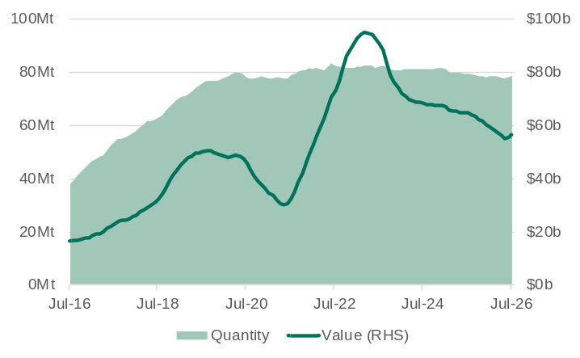
Mt = Million tonnes. 1. 12-month rolling total.
Source: Based on data from ABS International Trade in Goods and Services, Australia.

- The volume of Australia’s LNG exports has been quite stable over the past five years, following a ramp up of production from multiple projects that began production from the mid-2010s. The end of production from one of the trains at the North West Shelf production in 2025 has led to a small fall in Australia’s LNG export volumes.
- The volume of Australia’s LNG exports was 78.4 million tonnes in the 12 months to July 2026, 1.3% less than in the 12 months to July 2025.
- With export volumes stable, changes in the value of Australia’s LNG exports over the past few years have occurred mostly through changes in LNG prices.
- The value of Australia’s LNG exports was $56.3 billion in 12 months to July 2026, 12.9% less than in the 12 months to July 2025.
Western Australia’s LNG export capacity
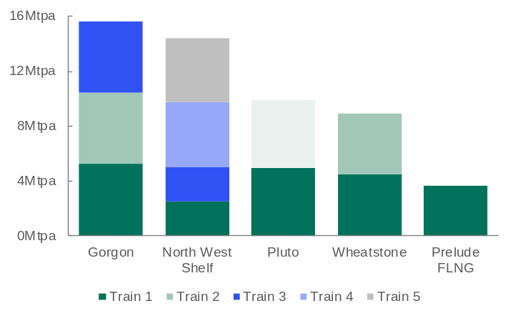
Note: North West Shelf’s Train 2 was physically and electrically isolated from the rest of the Karratha Gas Plant from January 2025. Pluto Train 2 is expected to be operational in 2026.
Source: WA Department of Energy and Economic Diversification based on published information.

- Western Australia has an established and reliable LNG export industry. The State’s first LNG project, the North West Shelf, marked 35 years of LNG exports in 2024.
- Western Australia currently has five operating LNG export projects. The North West Shelf, Pluto, Gorgon and Wheatstone projects all source gas from the Carnarvon Basin and have onshore LNG trains in Western Australia’s Pilbara region. The Prelude project is a floating LNG vessel located in the Browse Basin offshore Western Australia.
- Western Australia’s current total LNG export capacity is around 47 million tonnes a year.
- In November 2021, a final investment decision was made for a second LNG train for the Pluto project with a capacity of 5 million tonnes a year. LNG exports from Pluto Train 2 are expected to begin in 2026.
Western Australia’s natural gas reserves and resources as at June 2026
Basin | Reserves (PJ) | Contingent resources (PJ)
Carnarvon | 52,778 | 10,843
Browse | 15,099 | 17,379
Bonaparte | 4,094 | 6,287
Perth | 1,222 | 901
Canning | - | 493

Note: PJ = petajoules. Reserves and resources are categorised by probability or likelihood of recovery. Reserves refer to 2P reserves that are proved (90%) and probable (50%). Contingent resources refer to 2C resources (best estimate of contingent resources). Bonaparte Basin figures refer to Australia’s share of reserves and resources.
Source: EnergyQuest, Energy Quarterly (March 2026).

- Western Australia’s LNG projects are underpinned by large, conventional gas reserves in the Carnarvon and Browse Basins, which provide LNG buyers with security of supply.
- Western Australia also has onshore shale and tight gas resources in the Canning, Carnarvon and Perth basins.
- In 2025-26, petroleum exploration expenditure in Western Australia was $405 million. This was 21% of total petroleum exploration expenditure in Australia in this period.

LNG shipping duration: days
Exporter | Western Australia | Queensland | Qatar | United States
Importer
Japan (Tokyo) | 8 | 8 | 14 | 20
China (Shanghai) | 7 | 9 | 12 | 22
Korea (Incheon) | 8 | 9 | 13 | 22
India (Kochi) | 7 | 11 | 4 | 21
Taiwan (Yun-An) | 6 | 8 | 11 | 22

Note: Shipping distances calculated from the ports of Dampier (Western Australia), Gladstone (Queensland), Ras Laffan (Qatar), and Corpus Christi (United States). Shipping duration calculated assuming a speed of 19.5 knots and rounded to the nearest whole day.
Source: WA Department of Energy and Economic Diversification based on information from Sea-Distances.org.

- Western Australia’s LNG projects are located relatively close to Asia, comparing favourably (with the exception of India) to the shipping distances from Qatar.
- The shipping distance from Western Australia’s projects to Japan is around 3,600 nautical miles or about 8 days travel, with similar shipping duration to other major Asian importers.
- The expansion of the Panama Canal in 2016 shortened the trade route for LNG exports from the US to Asia. However, shipping to Asia from the US Gulf Coast still takes more than twice the time of shipping from Western Australia.
Domestic gas price index by market (% change)¹
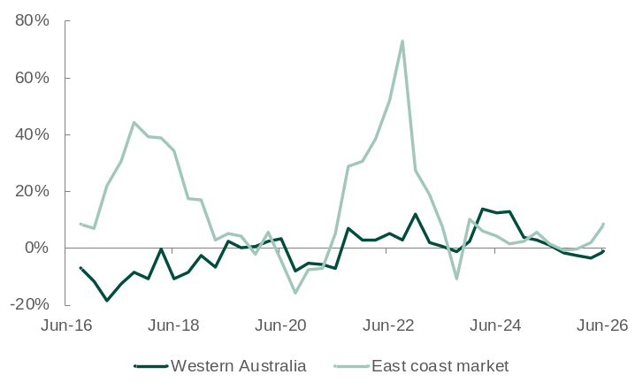
Note: Output prices of the domestic gas extraction industry. Original series. 1. Change from same quarter of previous year.
Source: Based on data from ABS Producer Price Indexes, Australia.

- The WA Domestic Gas Policy requires LNG exporters to make gas available to Western Australian consumers, equivalent to 15% of their LNG exports. This policy has helped stabilise domestic gas prices in Western Australia relative to Australia’s East coast market in recent years.
- The price of domestic gas extraction in Western Australia fell 1.3% between the June quarters of 2025 and 2026. Over the same period, the price of domestic gas extraction in the East coast market increased 8.4%.
- The relative price stability in Western Australia over the past ten years indicates that Western Australia’s domestic gas market has been less exposed to changes in local LNG production and global LNG prices. In contrast, both the ramp up of LNG production from new projects in Queensland in the mid-to-late 2010s and higher global LNG prices in the period 2021 to 2023 fed through to higher domestic gas prices in the East coast market.
Western Australia’s LNG sales
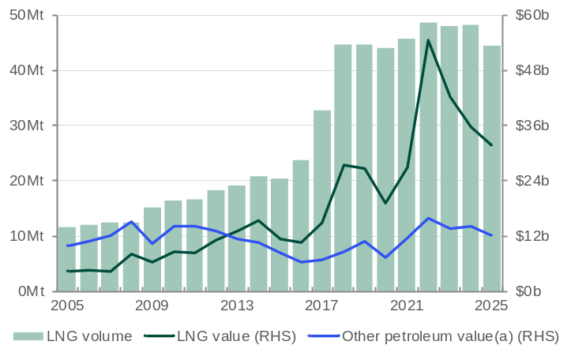
Mt = Million tonnes. (a) Includes condensate, crude oil, LPG and domestic gas.
Source: WA Department of Mines, Petroleum and Exploration, Resource Data Files.

- The volume of Western Australia’s LNG sales in 2025 was 44.3 million tonnes, 7.8% lower than 2024.
- The value of Western Australia’s LNG sales fell 10.7% to $31.9 billion in 2025.
- In 2025, LNG accounted for 14.1% of the value of Western Australia’s total minerals and petroleum sales ($225.8 billion), compared to 15.5% in 2024.
- Western Australia’s LNG projects also produce condensate and liquefied petroleum gas (LPG), mostly for export markets, and supply the majority of Western Australia’s domestic gas.

Western Australia’s LNG deliveries by destination country
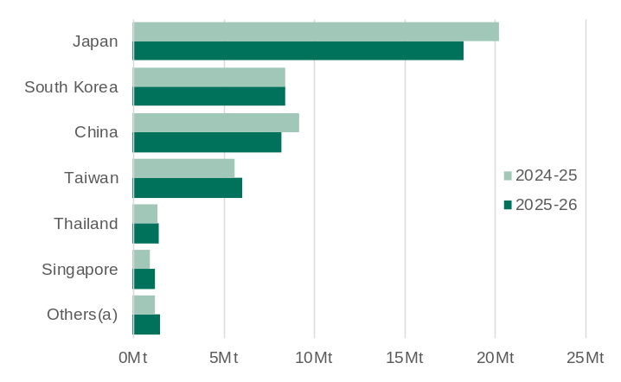
Mt = Million tonnes. (a) 2024-25 includes India, Indonesia, Malaysia and the Philippines; 2025-26 includes Bangladesh, India, Indonesia, Malaysia, the Philippines, Türkiye and Vietnam.
Source: EnergyQuest, Australian LNG Monthly Report.

- Japan was Western Australia’s first LNG customer in 1989 and remains the state’s largest customer. Western Australia accounted for around 29% of Japan’s LNG imports in 2025.
- South Korea was the second largest market for Western Australia’s LNG in 2025. Western Australia accounted for around 20% of South Korea’s LNG imports in 2025.
- Western Australia was the first jurisdiction to export LNG to China in 2006 via the North West Shelf’s contract with Guangdong Dapeng LNG. Western Australia accounted for around 12% of China’s LNG imports in 2025.
- Of Western Australia’s total LNG exports in 2025-26:
  - Japan accounted for 40%
  - South Korea accounted for 19%
  - China accounted for 18%
  - Taiwan accounted for 13%
  - Thailand and Singapore each accounted for 3%.

Western Australia’s LNG production by company: 2025-26
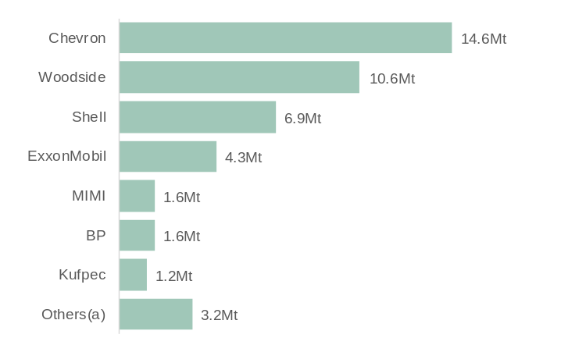
Mt = Million tonnes. (a) PE Wheatstone, Beach, Tokyo Gas, Inpex, Kansai Electric, Osaka Gas, CNOOC, Mitsui, Kogas, Kyushu Electric, CPC, and Jera.
Source: EnergyQuest, Energy Quarterly (September 2026).

- In 2025-26, Chevron (33%), Woodside (24%) and Shell (16%) accounted for the largest shares of Western Australia’s LNG production.
- Chevron has a 1/6th share of the North West Shelf project and is the operator and largest stakeholder in the Gorgon and Wheatstone projects.
- Woodside is the operator of the North West Shelf project. Woodside’s share of the North West Shelf project increased from 1/6 to 1/3 following its merger with BHP’s oil and gas portfolio in 2022. Woodside also has a 90% share and is the operator of the Pluto project and a 13% share of the Wheatstone project.
- In December 2024, Woodside and Chevron announced an agreement for an asset swap, which includes Woodside acquiring Chevron’s interest in the North West Shelf project and Chevron acquiring Woodside’s interest in the Wheatstone project. The transaction is expected to be finalised in 2026.
- Shell has a 1/6th share of the North West Shelf project, a 25% share of the Gorgon project and is the operator and largest stakeholder of the Prelude floating LNG project.

Western Australia’s LNG projects and associated developments¹ (as of 30 September 2026)
Project | Stakeholders | Capex  ($b) | Capacity (Mtpa) | Start of  operations | Details
North West Shelf  Trains 1-5 | Woodside (33.33%)²  BP (16.67%)  Chevron (16.67%)²  MIMI (16.67%)  Shell (16.67%) | 34.0 | 14.4 | September 1989 | The North West Shelf LNG project is located within the Burrup Strategic Industrial Area in Western Australia’s Pilbara region.  Trains 1 and 2 began in 1989, Train 3 in 1992, Train 4 in 2004 and Train 5 in 2008. Train 2 has now been taken offline.  In September 2025, the Australian Government gave final approval for the North West Shelf Extension to 2070, following approval by the Western Australian Government in December 2024.
Pluto  Train 1 | Woodside (90%)  MidOcean Energy (5%)  Kansai Electric (5%) | 15.0 | 4.9 | April  2012 | Pluto is currently a single train LNG project located within the Burrup Strategic Industrial Area in Western Australia’s Pilbara region.  In November 2021, a final investment decision was made to backfill and expand the Pluto LNG project with gas from the Scarborough fields (see Scarborough and Pluto Train 2 below).
Gorgon  Trains 1-3 | Chevron (47.3%)  ExxonMobil (25%)  Shell (25%)  Osaka Gas (1.25%)  MidOcean Energy (1%)  JERA (0.417%)³ | 55.0 | 15.6 | March 2016 | Gorgon is a three-train LNG project located on Barrow Island in Western Australia’s Pilbara region. Gorgon exported its first LNG cargo in March 2016. Trains 2 and 3 began production in October 2016 and March 2017 respectively.  In June 2023, Chevron announced first production from Gorgon Stage 2, which will help maintain gas supply to the Gorgon project through eleven additional wells in the Gorgon and Jansz-lo fields.
Wheatstone  Trains 1-2 | Chevron (64.14%)²  KUFPEC (13.4%)  Woodside (13%)²  PE Wheatstone (8%)  Kyushu Electric (1.46%) | 40.0 | 8.9 | October 2017 | Wheatstone is a two-train LNG project located within the Ashburton North Strategic Industrial Area in Western Australia’s Pilbara region. Train 1 began production in October 2017 and Train 2 began production in June 2018.
Prelude  Floating LNG vessel | Shell (67.5%)  Inpex (17.5%)  KOGAS (10%)  OPIC (5%) | 19.6 | 3.6 | June  2019 | Prelude is a floating LNG project located in the Browse Basin. Prelude also produces up to 1.3 million tonnes of condensate a year and 0.4 million tonnes of LPG a year. The vessel is expected to operate at the Prelude gas field for 25 years and will also source gas from other fields (see Crux below).
Waitsia Stage 2  Development | Mitsui E&P (50%)  Beach Energy (50%) | 1.3 | n.a. | December 2025 | Waitsia Stage 2 involves further development of the Waitsia gas field, including a production facility capable of producing 250 terajoules of gas a day. The Waitsia Joint Venture has an agreement to enable Waistia gas to be tolled and processed through the North West Shelf facilities to produce up to 7 million tonnes of LNG.
Scarborough and Pluto Train 2 | Scarborough Gas Fields  Woodside (74.9%)  JERA (15.1%)  LNG Japan (10%) | 18.8 | 5.0 | 2026 | Scarborough involves an offshore floating production unit capable of providing feed gas to produce 8 million tonnes a year of LNG plus domestic gas. The onshore development involves a new LNG train, modifications to Pluto Train 1 to allow it to process up to 3 million tonnes a year of LNG from Scarborough gas and a new domestic gas plant capable of producing 225 terajoules of gas a day.  In July 2024, Woodside announced project costs had increased by 4% to US$12.5 billion (estimated to be A$18.8 billion).
Scarborough and Pluto Train 2 | Pluto Train 2  Woodside (51%)  Global Infrastructure Partners (49%)
Jansz-lo Compression  Geryon and Eurytion gas fields | See Gorgon | 6.0  3.0 | n.a | 2027  2028 | Chevron announced in July 2021 it would build and install a 27,000-tonne floating field-control station, a 6,500-tonne subsea compression infrastructure and a 135-kilometre submarine power cable from the Jansz-lo gas field to the Gorgon project’s three LNG trains and gas plant on Barrow Island.  Chevron announced FID in December 2025 for Gorgon Stage 3, which will connect the offshore Geryon and Eurytion gas fields to existing infrastructure and processing facilities on Barrow Island.
Crux | Shell (82%)  SGH Energy (15%)  Osaka Gas (3%) | 3.5 | n.a. | 2027 | Shell announced in May 2022 it would proceed with the development of the Crux gas field in the Browse Basin, which will be connected to the Prelude floating LNG vessel via a 160 kilometre pipeline.

Mtpa = million tonnes per annum. Capex = Capita expenditure. n.a. – not applicable.
1. Major projects under construction or committed only. 2. In December 2024, Woodside and Chevron announced an agreement for an asset swap, which includes Woodside acquiring Chevron’s interest in the North West Shelf project and Chevron acquiring Woodside’s interest in the Wheatstone project. The transaction is expected to be finalised in 2026. 3. In March 2026, JERA announced it would sell its share of the project to MidOcean Energy. The transaction is subject to regulatory and partner approvals.
Source: EnergyQuest, Energy Quarterly; WA Department of Energy and Economic Diversification; and company investor information (announcements, reports and presentations).

