Western Australia Trade Profile – May 2026
Western Australia is Australia’s most export-oriented state, with net exports of goods and services accounting for 37 per cent of its gross state product in 2024-25. This reflects that Western Australia’s economic development has been largely driven by international trade, particularly through minerals and energy exports to Asian markets. The State’s natural resources combined with sustained overseas demand for raw materials have underpinned strong trade relationships with markets across Asia in recent decades, initially Japan and South Korea, and particularly China over the past 25 years. The growth in Western Australia’s exports has also been assisted by the capacity to import specialised machinery and equipment, which has supported domestic industries and infrastructure development, while consumers have benefited from having access to a broader range of affordable goods.
The expansion of production and export capacity in Western Australia’s resources industry over the past 20 years has led to mining and energy commodities – especially iron ore, liquefied natural gas (LNG) and other petroleum products, and gold – accounting for a large share of the value of the State’s exports. Parts of the manufacturing industry have evolved alongside mining, adding value through mineral processing (including gold refining, alumina, and mineral sands processing) and the production of specialised equipment. The agriculture industry continues to make an important contribution to Western Australia’s exports with grains and meat – particularly wheat, canola, barley, lamb and beef – having overtaken wool as the leading agri-food exports.
The high value of Western Australia’s goods exports tends to overshadow the contribution of services exports such as tourism and international education to the economy, with both these sectors recovering strongly after the disruption to international travel from the COVID-19 pandemic.
This Trade Profile provides information on Western Australia’s goods and services trade over the past decade, including trends in exports and imports, key commodities traded, international visitors and students, and the overseas-born population in Western Australia, as well as individual profiles that show Western Australia’s relationship with its major trading partners. Requests for information on Western Australia’s other trading partners can be made to the Economic Analysis team.
Note: International merchandise trade data is subject to revision up to six months after it is first released by the Australian Bureau of Statistics. As such, trade statistics in this report may differ from those presented in other DEED publications that incorporate revised data.

Western Australia’s trade in goods
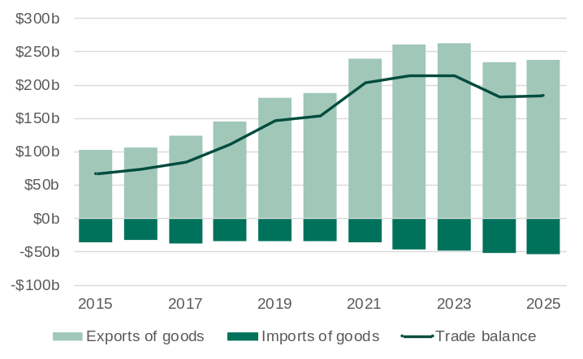
Note: Imports are shown as negative values because they are an outflow of expenditure from the economy.
Source: Based on data from ABS International Trade in Goods.

- In 2025, the value of Western Australia’s exports of goods increased 1.2% to $237.4 billion.
  - The peak value of Western Australia’s exports of goods in a calendar year was $263.0 billion in 2023, which was due to a combination of high prices for mineral and energy commodities, good growing conditions for grains production and a relatively low exchange rate.
- In 2025, the value of Western Australia’s imports of goods increased 3.6% to $53.9 billion, due mainly to an increase in the value of imports of non-monetary gold.
- Western Australia’s surplus in goods trade increased by 0.5% to $183.5 billion.

Australia’s goods exports by state and territory
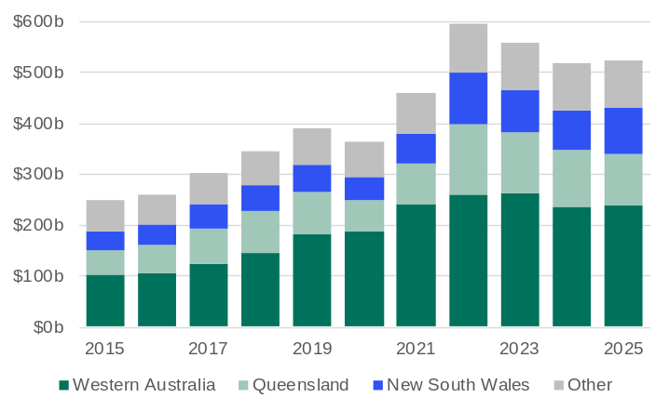
Source: Based on data from ABS International Trade in Goods.

- Western Australia has the highest share of Australia’s goods exports of any state or territory. In 2025, Western Australia’s goods exports accounted for 45.4% of the value of Australia’s goods exports ($237.4 billion of $523.4 billion). The next largest goods exporting States in 2025 were:
  - Queensland $101.0 billion (19.3% share)
  - New South Wales $91.6 billion (17.5% share).
- Within the past decade, Western Australia’s share of Australia’s goods exports was highest in 2021 (52.3%) when the annual average price of iron ore was very high (noting that Western Australia accounts for nearly all of Australia’s iron ore exports).
- Even though the value of Western Australia’s goods exports increased by around 9% in 2022, the State’s share of Australia’s goods exports fell to 43.9% in that year, mainly because high prices for coal and LNG led to the value of Queensland’s goods exports increasing by over 70%.

Western Australia’s major goods exports by market: 2025
The tables below show the markets for Western Australia’s main goods exports for 2025. China is Western Australia’s largest export market for iron ore, lithium concentrate, and agri-food. China accounts for very large shares of Western Australia’s exports of iron ore and lithium concentrate, with iron ore crucial to China’s steel production and infrastructure development, and lithium vital to China’s electric vehicle and battery manufacturing.
Western Australia’s other major export commodities are less concentrated on a single market. Gold is exported from Western Australia in three forms: non-monetary gold for safe-haven investment, jewellery and industry; gold ore for overseas refining; and collectible gold coins; and is exported to nations with advanced financial systems, active gold trading hubs and strong demand for gold from investors, jewellers and industry. The main component of the State’s petroleum exports is LNG, which is shipped to Asian countries that have limited domestic energy production.
Western Australia's cereals exports are highly sought after in Asia due to their high quality, genetically unmodified status and reliable supply. Countries like China use barley for malting and brewing, Japan and South Korea use wheat for premium udon and ramen noodles, Indonesia for flour milling and the Philippines for both food processing and animal feed. Western Australia’s canola is highly sought after in Europe primarily because European markets demand high-quality, non-genetically modified canola for biodiesel production under strict sustainability standards.
Western Australia’s alumina exports mainly go to countries in the Middle East and Africa as feedstock for the aluminium refining and smelting operations.
Iron ore | Value ($m) | Share (%) | Gold¹ | Value ($m) | Share (%) | Petroleum² | Value ($m) | Share (%)
China⁵ | 102,693 | 85.8 | United States | 13,632 | 33.9 | Japan | 14,347 | 35.9
Japan | 6,486 | 5.4 | Hong Kong⁶ | 7,977 | 19.9 | Singapore | 6,755 | 16.9
South Korea | 6,149 | 5.1 | China⁵ | 4,579 | 11.4 | South Korea | 6,506 | 16.3
Taiwan | 1,672 | 1.4 | India | 3,499 | 8.7 | China⁵ | 4,784 | 12.0
Vietnam | 1,404 | 1.2 | South Korea | 3,416 | 8.5 | Taiwan | 3,457 | 8.7
All other markets | 1,256 | 1.0 | All other markets | 7,072 | 17.6 | All other markets | 4,111 | 10.3
Total | 119,659 | 100.0 | Total | 40,175 | 100.0 | Total | 39,959 | 100.0
Share of  WA total exports | 50.4% |  | Share of  WA total exports | 16.9% |  | Share of  WA total exports | 16.8%

Agri-food³ | Value ($m) | Share (%) | Alumina | Value ($m) | Share (%) | Lithium concentrate⁴ | Value ($m) | Share (%)
China⁵ | 3,776 | 26.7 | Bahrain | 1,638 | 23.1 | China⁵ | 4,436 | 94.7
Indonesia | 1,328 | 9.4 | United Arab Emirates | 1,443 | 20.4 | Indonesia | 121 | 2.6
Philippines | 1,217 | 8.6 | South Africa | 914 | 12.9 | South Korea | 100 | 2.1
Japan | 1,083 | 7.7 | Mozambique | 726 | 10.2 | Belgium | 24 | 0.5
South Korea | 811 | 5.7 | Oman | 475 | 6.7 | United States | 3 | 0.1
All other markets | 5,914 | 41.9 | All other markets | 1,893 | 26.7 | All other markets | 1 | 0.0
Total | 14,130 | 100.0 | Total | 7,088 | 100.0 | Total | 4,687 | 100.0
Share of  WA total exports | 6.0% |  | Share of  WA total exports | 3.0% |  | Share of  WA total exports | 2.0%

1. Non-monetary gold, gold ore and gold coin. 2. Liquefied natural gas, condensate, crude oil and liquefied petroleum gas. 3. Mainly wheat, canola seeds, barley, meat, wool, animal feed, rock lobster and live cattle and sheep. ⁴ 4. Does not include lithium hydroxide. 5. Mainland. 6. Special Administrative Region of China.
Source: Based on data from ABS International Trade in Goods; and Department of Home Affairs, Integrated Cargo System data.

Western Australia’s iron ore exports by market
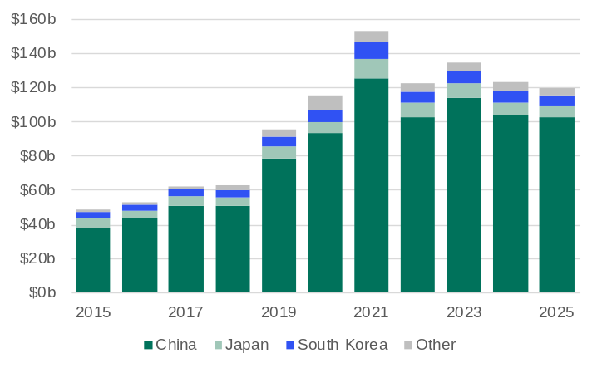
Source: Based on data from ABS, International Trade in Goods.

- Western Australia’s exports of iron ore are heavily concentrated to markets in Northeast Asia, particularly China.
- The market distribution of Western Australia’s iron ore exports has been relatively stable over the past decade, reflecting the nature of steel production in these countries over this period and that Western Australia has become the largest supplier of iron ore to the region.
  - China’s share increased from 79% in 2015 to 86% in 2025
  - Japan’s share fell from 11% in 2015 to 5% in 2025
  - South Korea’s share fell from 7% in 2015 to 5% in 2025.

Western Australia’s non-monetary gold exports by market
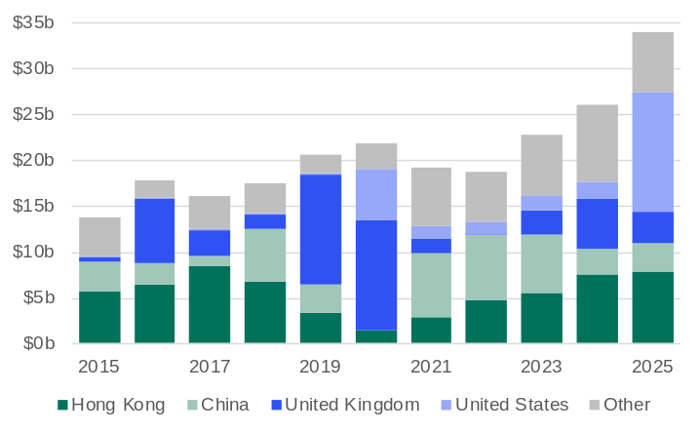
Source: Based on data from ABS, International Trade in Goods.

- Western Australia’s exports of non-monetary gold tend to be concentrated in a small number of markets, but the market distribution of exports can vary significantly from year to year based on demand from individual countries and the availability of supply from other exporters.
- The United Kingdom accounted for 39% of Western Australia’s non-monetary gold exports in 2016, 58% in 2019 and 55% in 2020. This was related to higher demand for gold in the United Kingdom from the higher levels of economic uncertainty at the time of the vote to leave the European Union in 2016 and the eventual withdrawal in early 2020.
- The United States accounted for 7% of Western Australia’s non-monetary gold exports in 2024 but 39% in 2025. The increase was related to higher demand for gold in the United States from uncertainty on trade policy.

Western Australia’s agri-food exports by market
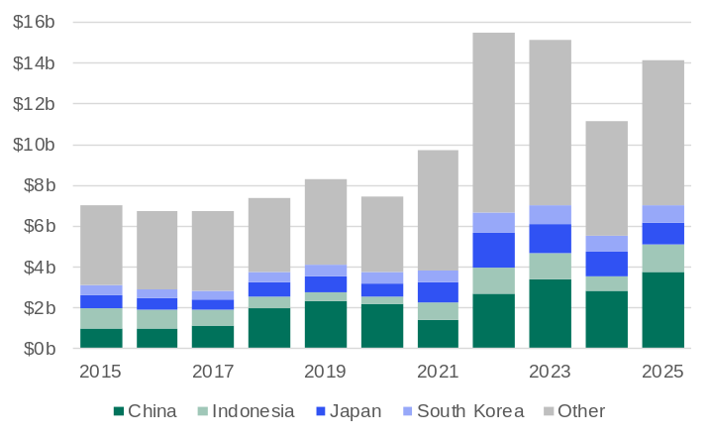
Source: Based on data from ABS, International Trade in Goods.

- Western Australia’s exports of agri-food are more dispersed across markets compared to its exports of minerals and energy commodities.
- China’s share of Western Australia’s agri-food exports increased from 14% in 2015 to 27% in 2025, although was lower in 2021 and 2022 after the Chinese Government imposed restrictions on Australian exports of certain goods, including barley, beef and lobster.
- While the top five markets for Western Australia’s agri-food exports in 2025 were all in Asia, exports of some agri-food exports extend to a diverse range of markets. For example, the largest markets for Western Australia’s canola seeds exports in 2025 were the United Arab Emirates (23%), Belgium (21%) and the Netherlands (12%).

Western Australia’s petroleum imports by product
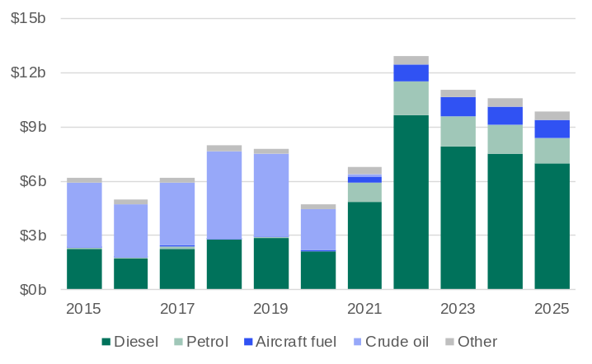
Source: Based on data from ABS, International Trade in Goods.

- Western Australia’s industries consume large volumes of petroleum and with domestic oil production declining, petroleum is one of the State’s highest value import items.
- The closure of the Kwinana refinery in 2021 led to a significant change in the composition of Western Australia’s petroleum imports. Prior to 2021, crude oil accounted for around 60% of the value of Western Australia’s petroleum imports, but with no domestic refining capacity, Western Australia no longer imports crude oil, with all petroleum imports being refined products.
- The increase in the oil price in 2022 from the onset of the conflict between Russia and Ukraine led to a large increase in the value of Western Australia’s petroleum imports, with the fall in the oil price leading to lower import values in subsequent years.
- The value of Western Australia’s petroleum imports in 2025 was $9.8 billion, which included $7.0 billion in diesel, $1.4 billion in petrol, and $1.0 billion in aircraft fuel.

Western Australia’s petroleum imports by market
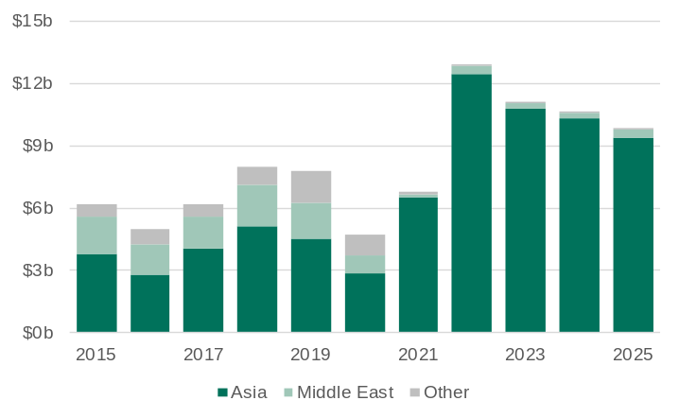
Source: Based on data from ABS, International Trade in Goods.

- The shift in the composition of Western Australia’s petroleum imports also led to a change in the markets that Western Australia sourced its petroleum imports.
- Western Australia’s largest source market for crude oil imports was the United Arab Emirates. However, with Western Australia no longer importing crude oil, nearly all the State’s petroleum imports are sourced from Asian markets that have large refining capacity.
- Western Australia’s largest source markets for petroleum imports in 2025 were:
  - Singapore ($3.1 billion)
  - Malaysia ($2.1 billion)
  - Brunei Darussalam ($1.7 billion).
- The share of Western Australia’s petroleum imports from the Middle East fell from 30% in 2015 to 4% in 2025.

Western Australia’s machinery and transport equipment imports by market
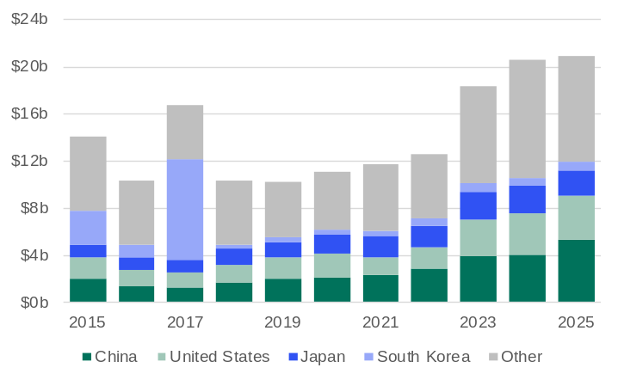
Source: Based on data from ABS, International Trade in Goods.

- The capital-intensive nature of Western Australia’s economy means that machinery and transport equipment (which includes machinery for use by industry, civil engineering equipment, and transport vehicles) is generally the State’s highest value category of imports.
- Western Australia imports machinery and transport equipment from a wide range of markets, reflecting that some machinery and equipment can be very specialised and/or needed at a specific time.
- Western Australia’s largest source markets for machinery and transport equipment imports in 2025 were:
  - China ($5.3 billion)
  - United States ($3.7 billion)
  - Japan ($2.2 billion).
- In 2017, Western Australia’s imports of machinery and transport equipment from South Korea were $8.4 billion, most of which was the importation of the Prelude floating LNG vessel, which was built in South Korea and now operates off the coast of Western Australia.

Western Australia’s trade in services
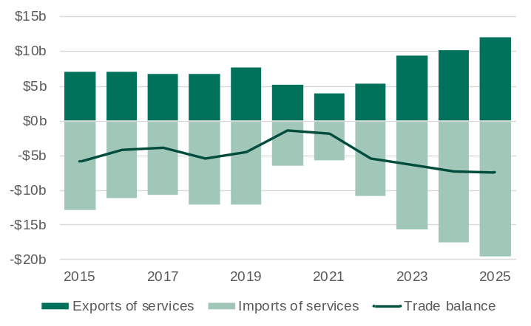
Note: Imports are shown as negative values because they are an outflow of expenditure from the economy.
Source: Based on data from ABS, International Trade: Supplementary Information.

- Western Australia’s services trade has increased at a high rate after the disruption from international travel restrictions that were imposed during the COVID-19 pandemic.
- The value of Western Australia’s services exports increased 18.4% to $12.1 billion in 2025. Western Australia accounted for 8.5% of Australia’s services exports in 2025.
- The value of Western Australia’s services imports increased 11.9% to $19.6 billion in 2025. Western Australia accounted for 10.9% of Australia’s services imports in 2025.
- Western Australia had a services trade deficit of $7.5 billion in 2025.

Western Australia’s services exports by sector
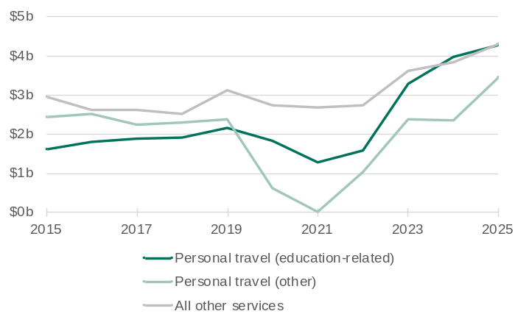
Note: The value of education related services exports can include expenditure by international students that is funded from income earned while in Australia.
Source: Based on data from ABS, International Trade: Supplementary Information.

- Western Australia’s services exports are mainly the spending by international students and visitors in the State.
- The value of Western Australia’s international education and tourism exports both reached a record high in 2025.
  - Western Australia’s education-related personal travel services exports increased 7.7% to $4.3 billion in 2025.
  - Western Australia’s other personal travel services exports increased 47% to $3.5 billion in 2025.
- In 2025, Western Australia accounted for:
  - 7.8% of Australia’s education-related personal travel services exports
  - 13.5% of Australia’s other personal travel services exports.

Western Australia’s services imports by sector
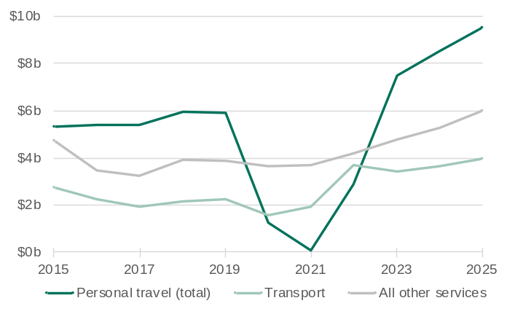
Source: Based on data from ABS, International Trade: Supplementary Information.

- Western Australia’s services imports are mainly the spending by Western Australians while travelling overseas, and international transport services provided to Western Australian passengers and traders of goods (freight).
- The value of Western Australia’s international tourism and transport services imports both reached a record high in 2025.
  - Western Australia’s total personal travel services imports increased 11.8% to $9.5 billion in 2025
  - Western Australia’s transport services imports increased 9.1% to $4.0 billion in 2025.
- In 2025, Western Australia accounted for:
  - 13.9% of Australia’s total personal travel services imports
  - 13.7% of Australia’s transport services imports.

Western Australia’s trade with its main export markets and selected regions
The table of contents below provides links to trade profiles for Western Australia’s largest trading partners and selected regions in 2025. Each trade profile provides an overview of Western Australia’s trade with that market and the goods and services that are prominent in the trade relationship.
The categorisation of goods in the trade profiles is based on the Standard International Trade Classification (SITC). The SITC is a numerical system developed by the United Nations to categorise traded goods based on their production materials, processing stages, and market uses, and is the primary classification used for Australia's international merchandise trade statistics, produced by the Australian Bureau of Statistics (ABS). As the ABS applies confidentiality restrictions to some trade data (for reasons including to prevent the release of data that may enable the identification of information that is commercially sensitive), the trade profiles combine some commodities into broader categories using information from data sources other than the ABS.
There are also links to tables showing a market breakdown of the value of Western Australia’s exports, imports and total trade from 2015 to 2025, the number of international visitors to Western Australia from 2015 to 2025, the number of international student enrolments in Western Australia from 2015 to 2025, and overseas-born residents in Western Australia from 2001 to 2021 (in 5-year increments, as per the census). These tables show the top 20 markets as they are for the latest year, noting that some of the markets that are in the top 20 for the latest year of data have not always been in the top 20.
Table of contents
China 7
Japan 9
United States 11
South Korea 13
Singapore 15
Hong Kong (SAR of China) 17
Taiwan 19
India 21
United Kingdom 23
Malaysia 25
Indonesia 27
Association of Southeast Asian Nations (ASEAN) 29
European Union (EU) 32
Gulf Cooperation Council (GCC) 35
Western Australia’s exports of goods by market ($billion) 38
Western Australia’s imports of goods by market ($billion) 39
Western Australia’s total trade in goods by market ($billion) 40
Western Australia’s international student enrolments by market 41
Western Australia’s overseas born population (as of 30 June) 42

China-Western Australia trade relationship | Back to contents
Western Australia’s trade relationship with China expanded rapidly from the early 2000s, driven by China’s industrialisation and growing demand for raw materials as well as its accession to the World Trade Organisation in 2001. By 2006, China had become Western Australia’s largest trading partner. Iron ore has provided the foundation for this relationship. Western Australia’s vast iron ore reserves supply China’s steel industry, which underpins its construction, infrastructure and manufacturing sectors. LNG is another key export, with shipments beginning in 2006 via the North West Shelf’s contract with Guangdong Dapeng LNG, helping meet China’s residential and industrial energy needs. Western Australia’s other major exports to China include gold, lithium – critical for batteries in electronics and electric vehicles – and agri-food products such as barley and wool. These commodities are essential to China’s technological development, food security and energy transition.
Imports from China to Western Australia have evolved from basic consumer goods to a wide range of manufactured and industrial products. By the 2000s, China had become a major supplier of machinery, equipment, electronics, motor vehicles and consumer goods to Western Australia. China is now Western Australia’s largest source of imports, providing affordable goods for households and equipment for businesses. Chinese imports also support Western Australia’s energy transition, supplying solar panels, batteries, inverters and electric vehicles used in mining operations and renewable energy systems.
While the trade relationship has diversified to include education, tourism and technology, commodities remain central. The strength of the trade relationship reflects economic interdependence and mutual benefit.

Western Australia’s trade in goods with China
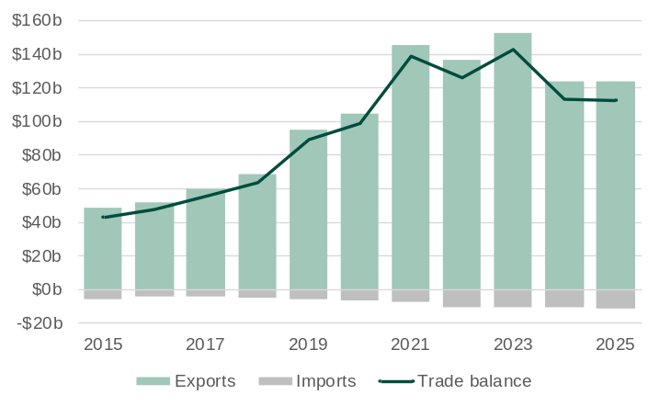
Note: Imports are shown as negative values because they are an outflow of expenditure from the economy.
Source: Based on data from ABS International Trade in Goods.

- Western Australia’s large trade surplus with China is primarily due to the value of iron ore exports far exceeding the value of its imports of manufactured goods like machinery, electronics and consumer products.
- The value of Western Australia’s goods exports to China was $124.1 billion in 2025, 0.3% higher than in 2024.
  - The value of Western Australia’s exports to China increased significantly between 2015 and 2023 due to rising demand and prices for iron ore, lithium and LNG, driven by China's industrial recovery and clean energy transition. The value of exports has since declined as commodity prices fell amid weaker Chinese economic growth, reduced steel production and stabilising global energy markets.
- The value of Western Australia’s goods imports from China was $11.2 billion in 2025, 5.3% higher than in 2024.

Western Australia-China main commodities traded: 2025
The table below shows the values for the main commodities traded between Western Australia and China in 2025.
Exports | Value ($m) | Share (%) | Imports⁴ | Value ($m) | Share (%)
Iron ore | 102,693 | 82.8 | Motor cars | 783 | 7.0
Petroleum¹ | 4,784 | 3.9 | Refined petroleum oils | 459 | 4.1
Lithium concentrate | 4,436 | 3.6 | Electrical machinery and apparatus | 420 | 3.7
Non-monetary gold | 3,162 | 2.5 | Furniture | 402 | 3.6
Barley | 1,667 | 1.3 | Civil engineering plant and equipment | 385 | 3.4
Gold ore² | 1,401 | 1.1 | Inorganic chemicals⁵ | 343 | 3.1
Mineral sands³ | 1,351 | 1.1 | Industrial machinery and equipment | 340 | 3.0
Wool | 554 | 0.4 | Mechanical handling equipment | 274 | 2.4
Nickel ore, concentrate and matte | 411 | 0.3 | Ships, boats and floating structures | 263 | 2.3
Rock lobster | 357 | 0.3 | Railway vehicles | 252 | 2.2
All other exports | 3,269 | 2.6 | All other imports | 7,296 | 65.0
Total exports | 124,085 | 100.0 | Total imports | 11,217 | 100.0
Share of Western Australia’s exports | 52.3% |  | Share of Western Australia’s imports | 20.8%
Ranking as an export market | 1 |  | Ranking as an import market | 1
1. Liquefied natural gas, condensate, crude oil and liquefied petroleum gas. 2. May include other precious metal ore. 3. Titanium and zirconium ores. 4. Excludes confidential import items of mainly electrical machinery and equipment, articles of iron and steel, iron and steel, and machinery and mechanical parts, although the value of these items is included in the total. 5. Mainly sodium hydroxide (soda lye or liquid soda and caustic soda) used in mostly alumina and gold refining and titanium dioxide pigment production.
Source: Based on. data from ABS International Trade in Goods and Services, Australia; and Department of Home Affairs, Integrated Cargo System data.

Visits from China to Western Australia
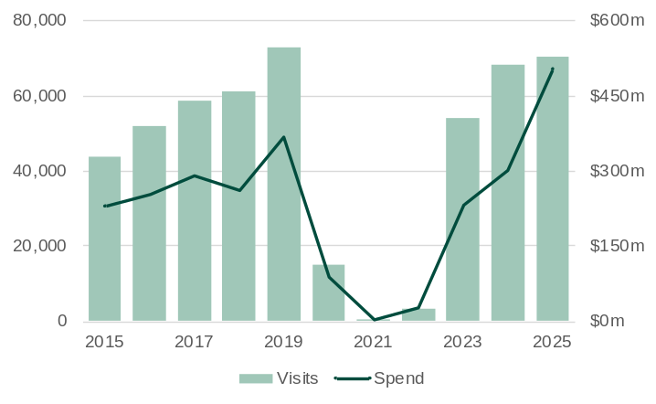
Source: Tourism Research Australia, International Visitor Survey.

- International visitors to Western Australia declined sharply from early 2020 due to COVID-19 travel restrictions, with the recovery beginning in 2022 at varying rates across markets.
  - In 2025, visitor numbers from China to Western Australia were 3.6% below pre-pandemic levels in 2019.
- China was Western Australia’s 4th largest market for international visitors in 2025, with 70,340 visits (6.6% of the State’s total international visits).
  - Visitor numbers from China to Western Australia increased 2.9% in 2025.
- Visitors from China spent a total of $503 million in Western Australia in 2025, 66% more than in 2024.
- On average, visitors from China spent $7,153 per visit in Western Australia in 2025, well above the average of $3,188 per visit from all markets.

Student enrolments from China in Western Australia
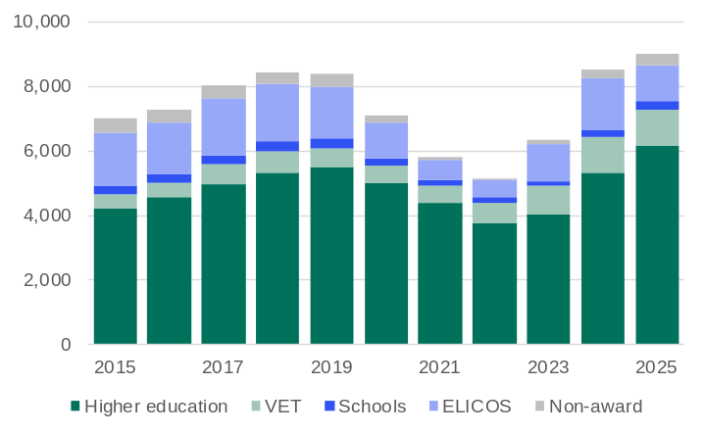
Note: Year to date in December. VET = Vocational education and training. ELICOS = English language intensive courses for overseas students. Non-award = Foundation courses or study abroad and exchange programs.
Source: Australian Department of Education and Training, International Education Data and Research.

- International student enrolments in Western Australia dropped sharply in 2020 and 2021 due to COVID-19 travel restrictions but began recovering in 2022 and climbed to record highs in 2024 and 2025, with growth varying across markets.
  - In 2025, student enrolments from China in Western Australia were 7.6% above pre-pandemic levels in 2019.
- China was Western Australia’s 3rd largest market for international students in 2025, with 9,015 enrolments (10.1% of the State’s total international student enrolments).
  - Student enrolments from China in Western Australia increased 5.6% in 2025.
- Most students from China in Western Australia in 2025 were enrolled in higher education (68%), followed by intensive English language courses (12%) and vocational education and training (12%).

Western Australian residents born in China
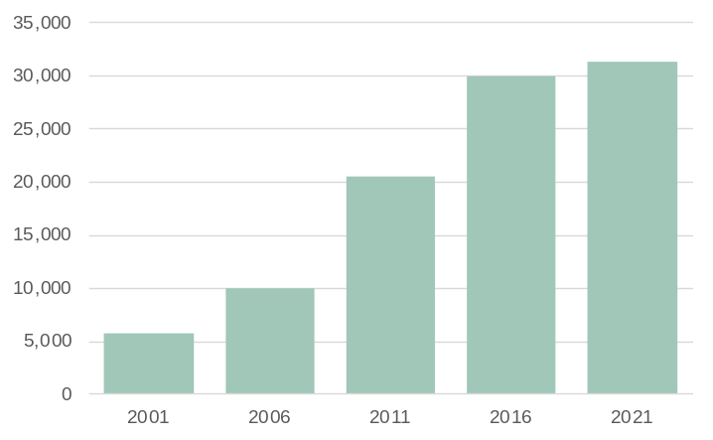
Note: Population counts as of June.
Source: Based on data from ABS Australia’s Population by Country of Birth.

- Western Australia had 31,220 residents in 2021 who were born in China, 4.2% more than in 2016.
- People born in China accounted for 3.3% of Western Australia’s overseas-born resident population in 2021, in line with the 3.3% share in 2016.
- People born in China were the 7th largest overseas-born resident population in Western Australia in 2021.

Japan-Western Australia trade relationship | Back to contents
Western Australia’s trade relationship with Japan grew significantly during the 1960s, driven by Japan’s rapid industrialisation and need for raw materials. Japan became a key partner in developing Western Australia’s resource sector, particularly through long-term supply contracts and direct investment in major projects. Iron ore was the initial cornerstone of the trade relationship, with Western Australia supplying Japan’s steel industry, which was vital for its post-war reconstruction and economic growth. From the 1980s, LNG from the North West Shelf and later other Western Australian LNG projects became equally significant, supporting Japan’s energy needs, especially after the Fukushima disaster in 2011 led to Japan requiring increased volumes of natural gas to replace nuclear power. Western Australia’s other major exports to Japan include nickel, which feeds Japan’s manufacturing sectors, including electronics and automotive production, and wheat, which supports its food supply.
On the import side, Japan is a major supplier of motor vehicles, medical equipment, machinery and industrial components. Japanese imports support Western Australia’s mining operations, healthcare sector and infrastructure development. The automotive sector is particularly significant, with Japan being the largest exporter of road vehicles to Western Australia. Imports from Japan also contribute to Western Australia’s energy transition, with Japanese firms investing in renewable technologies and electric vehicles.
Japan was Western Australia’s largest trading partner from the early 1970s until being overtaken by China in 2006. Japan remains Western Australia’s second-largest trading partner and a stable and strategic partner for Western Australia, with deep-seated ties in trade and investment.

Western Australia’s trade in goods with Japan
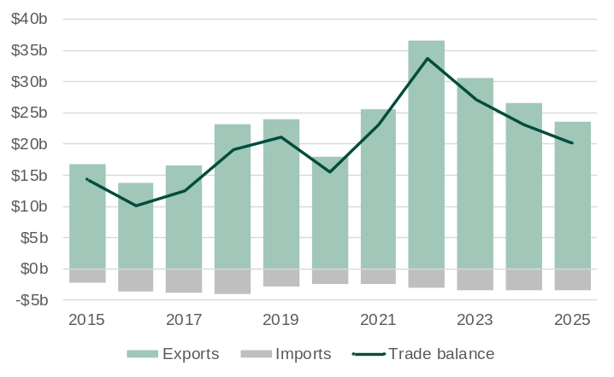
Note: Imports are shown as negative values because they are an outflow of expenditure from the economy.
Source: Based on data from ABS International Trade in Goods.

- Western Australia's large trade surplus with Japan is driven by the high value of its exports of petroleum, iron ore and other resources, which are greater than the value of imports, mainly vehicles and machinery.
- The value of Western Australia’s goods exports to Japan was $23.6 billion in 2025, 10.8% lower than in 2024.
  - The sharp rise in the value of Western Australia’s exports to Japan in 2022 was due to high global prices for LNG and iron ore. The decline in export values over the past three years was driven mainly by falling prices for iron ore and LNG.
- The value of Western Australia’s goods imports from Japan was $3.5 billion in 2025, 3.9% higher than in 2024.

Western Australia-Japan main commodities traded: 2025
The tables below show the values for the main commodities traded between Western Australia and Japan in 2025.
Exports | Value ($m) | Share (%) | Imports⁴ | Value ($m) | Share (%)
Petroleum¹ | 14,347 | 60.8 | Motor cars | 1,227 | 35.1
Iron ore | 6,486 | 27.5 | Non-monetary gold⁵ | 486 | 13.9
Gold ore² | 572 | 2.4 | Tyres and parts | 432 | 12.4
Wheat | 451 | 1.9 | Motor vehicles for transporting goods | 373 | 10.7
Nickel | 349 | 1.5 | Civil engineering plant and equipment | 202 | 5.8
Canola seeds | 225 | 1.0 | Inorganic chemicals⁶ | 128 | 3.7
Barley | 155 | 0.7 | Rails or railway track | 59 | 1.7
Animal feed³ | 138 | 0.6 | Tubes and pipes | 58 | 1.7
Gold coin | 33 | 0.1 | Motor vehicle parts | 46 | 1.3
Meat (beef) | 25 | 0.1 | Refined petroleum oils | 45 | 1.3
All other exports | 805 | 3.4 | All other imports | 438 | 12.5
Total exports | 23,586 | 100.0 | Total imports | 3,494 | 100.0
Share of Western Australia’s exports | 9.9% |  | Share of Western Australia’s imports | 6.5%
Ranking as an export market | 2 |  | Ranking as an import market | 4
1. Liquefied natural gas, condensate, crude oil and liquefied petroleum gas. 2. May include other precious metal ore. 3. Mainly hay and lupins. 4. Excludes confidential import items of mainly electrical machinery and equipment, articles of iron and steel, iron and steel, and machinery and mechanical parts, although the value of these items is included in the total. 5. Western Australia imports non-monetary gold from other countries primarily for refining into high-purity products such as gold bars and coins at the Perth Mint, which are then re-exported globally. 6. Mainly sodium hydroxide (soda lye or liquid soda and caustic soda) used in mostly alumina and gold refining and titanium dioxide pigment production.
Source: Based on. data from ABS International Trade in Goods and Services, Australia; and Department of Home Affairs, Integrated Cargo System data.

Visits from Japan to Western Australia
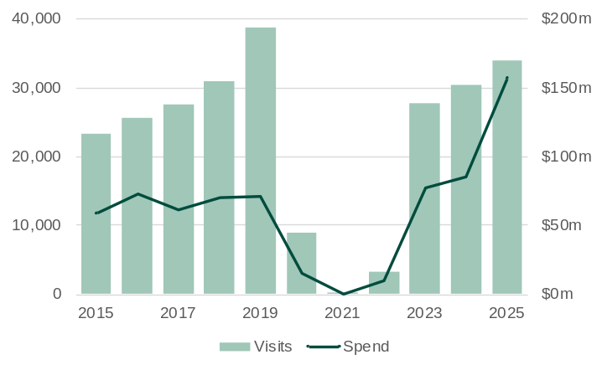
Source: Tourism Research Australia, International Visitor Survey.

- International visitors to Western Australia declined sharply from early 2020 due to COVID-19 travel restrictions, with the recovery beginning in 2022 at varying rates across markets.
  - In 2025, visitor numbers from Japan to Western Australia were 12.3% below pre-pandemic levels in 2019.
- Japan was Western Australia’s 10th largest market for international visitors in 2025, with 33,981 visits (3.2% of the State’s total international visits).
  - Visitor numbers from Japan to Western Australia increased 11.9% in 2025.
- Visitors from Japan spent a total of $158 million in Western Australia in 2025, 85% more than in 2024.
- On average, visitors from Japan spent $4,638 per visit in Western Australia in 2025, above the average of $3,188 per visit from all markets.

Student enrolments from Japan in Western Australia
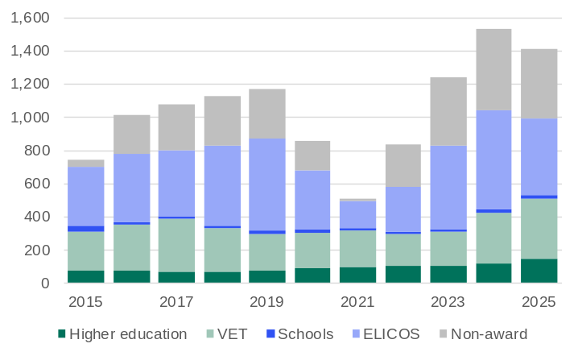
Note: Year to date in December. VET = Vocational education and training. ELICOS = English language intensive courses for overseas students. Non-award = Foundation courses or study abroad and exchange programs.
Source: Australian Department of Education and Training, International Education Data and Research.

- International student enrolments in Western Australia dropped sharply in 2020 and 2021 due to COVID-19 travel restrictions but began recovering in 2022 and climbed to record highs in 2024 and 2025, with growth varying across markets.
  - In 2025, student enrolments from Japan in Western Australia were 20% above pre-pandemic levels in 2019.
- Japan was Western Australia’s 15th largest market for international students in 2025, with 1,409 enrolments (1.6% of the State’s total international student enrolments).
  - Student enrolments from Japan in Western Australia fell 7.9% in 2025.
- Most students from Japan in Western Australia in 2025 were enrolled in either intensive English language courses (33%) or non-award courses such as foundation courses or study abroad and student exchange programs (30%).

Western Australian residents born in Japan
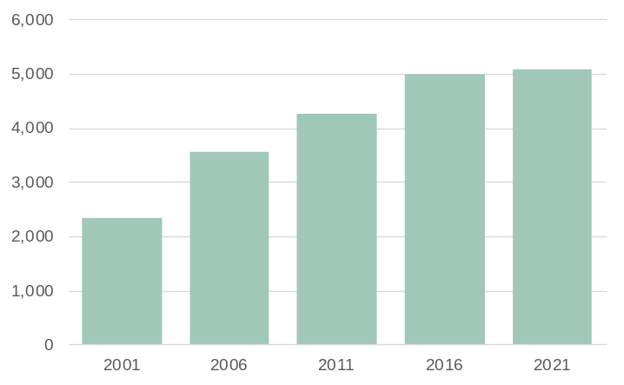
Note: Population counts as of June.
Source: Based on data from ABS Australia’s Population by Country of Birth.

- Western Australia had 5,090 residents in 2021 who were born in Japan, 1.8% more than in 2016.
- People born in Japan accounted for 0.5% of Western Australia’s overseas-born resident population in 2021, below the 0.6% share in 2016.
- People born in Japan were the 31st largest overseas-born resident population in Western Australia in 2021.

United States-Western Australia trade relationship | Back to contents
Western Australia’s trade relationship with the United States was initially centred on agricultural exports such as wool and wheat. Over time, the relationship diversified and deepened, especially after the Australia-United States Free Trade Agreement came into effect in 2005. Western Australia has seen steady growth in trade with the United States, particularly in high-value sectors. The United States is now one of Western Australia’s largest trading partners, with major exports including gold, critical minerals and agri-food products. Gold is especially important, with the United States being Western Australia’s largest export market for non-monetary gold and second largest export market for gold coins, which are used in US investment and manufacturing sectors. Mineral sands and nickel are vital for US electronics, aerospace and battery manufacturing.
The United States is also a major foreign investor in Western Australia’s export industries, with Chevron’s Gorgon and Wheatstone LNG projects representing some of the largest US investments in Australia. Alcoa operates bauxite mines and alumina refineries in Western Australia, producing a significant share of the State’s alumina exports, while US investment in lithium is led by Albemarle’s stake in Greenbushes, complemented by Liontown’s offtake agreements with Tesla and Ford to supply lithium from its Kathleen Valley project.
On the import side, Western Australia sources high-value manufactured goods from the United States, including machinery, motor vehicles, aircraft, pharmaceuticals and advanced technology. These imports are crucial for Western Australia’s mining, agriculture, health and transport sectors, supporting productivity and innovation. Western Australia also imports gold from the United States for refining at the Perth Mint. Overall, the trade relationship has evolved from basic commodities to a sophisticated exchange of resources, technology and services, reflecting the complementary strengths of both economies and underpinning broader strategic ties.

Western Australia’s trade in goods with the United States
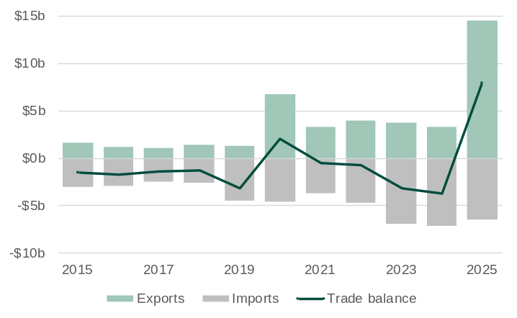
Note: Imports are shown as negative values because they are an outflow of expenditure from the economy.
Source: Based on data from ABS International Trade in Goods.

- Western Australia generally has a trade deficit with the United States due to the value of its imports of machinery, pharmaceuticals and motor vehicles exceeding the value of its exports of mainly gold and battery and critical minerals. Western Australia’s exports of non-monetary gold to the United States were particularly high in 2020 and 2025, leading to Western Australia having a trade surplus with the United States in those years.
- The value of Western Australia’s goods exports to the United States was $14.5 billion in 2025, more than four times the value in 2024.
  - Western Australia’s exports of non-monetary gold to the United States increased from $1.8 billion in 2024 to $13.1 billion in 2025. The United States imported large quantities of gold primarily as a safe-haven investment amid growing economic uncertainty.
- The value of Western Australia’s goods imports from the United States was $6.5 billion in 2025, 8.6% lower than in 2024.

Western Australia-United States main commodities traded: 2025
The tables below show the values for the main commodities traded between Western Australia and the United States in 2025.
Exports | Value ($m) | Share (%) | Imports³ | Value ($m) | Share (%)
Non-monetary gold | 13,138 | 90.7 | Non-monetary gold⁴ | 1,387 | 21.4
Gold coin | 495 | 3.4 | Motor vehicles for transporting goods | 804 | 12.4
Mineral sands¹ | 173 | 1.2 | Civil engineering plant and equipment | 508 | 7.8
Nickel | 112 | 0.8 | Motor vehicle parts | 370 | 5.7
Meat (lamb) | 107 | 0.7 | Engines and motors (non-electric) | 278 | 4.3
Meat (beef) | 75 | 0.5 | Tyres and parts | 271 | 4.2
Silver and platinum | 42 | 0.3 | Fertilisers | 205 | 3.2
Inorganic chemicals² | 38 | 0.3 | Electrical machinery and apparatus | 187 | 2.9
Pigments, paints and varnishes | 31 | 0.2 | Measuring and checking instruments | 162 | 2.5
Measuring and checking instruments | 18 | 0.1 | Telecommunications equipment | 130 | 2.0
All other exports | 319 | 2.2 | All other imports | 2,166 | 33.5
Total exports | 14,486 | 100.0 | Total imports | 6,469 | 100.0
Share of Western Australia’s exports | 6.1% |  | Share of Western Australia’s imports | 12.0%
Ranking as an export market | 4 |  | Ranking as an import market | 2
1. Titanium and zirconium ores. 2. Mainly silicon 3. Excludes confidential import items of mainly iron and steel, although the value of these items is included in the total. 4. Western Australia imports non-monetary gold from other countries primarily for refining into high-purity products such as gold bars and coins at the Perth Mint, which are then re-exported globally.
Source: Based on. data from ABS International Trade in Goods and Services, Australia; and Department of Home Affairs, Integrated Cargo System data.

Visits from the United States to Western Australia
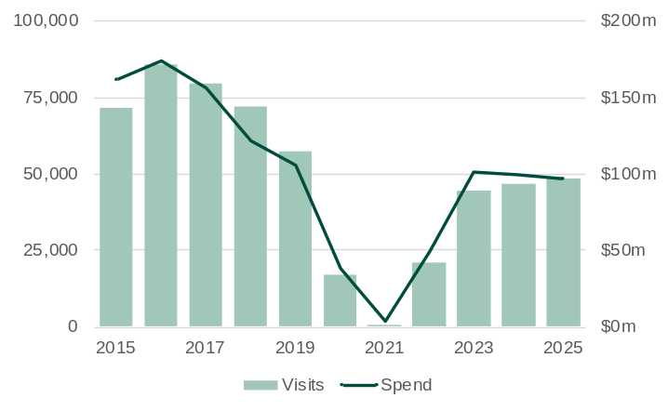
Source: Tourism Research Australia, International Visitor Survey.

- International visitors to Western Australia declined sharply from early 2020 due to COVID-19 travel restrictions, with the recovery beginning in 2022 at varying rates across markets.
  - In 2025, visitor numbers from the United States to Western Australia were 15.2% below pre-pandemic levels in 2019.
- The United States was Western Australia’s 7th largest market for international visitors in 2025, with 48,405 visits (4.5% of the State’s total international visits).
  - Visitor numbers from the United States to Western Australia increased 4.5% in 2025.
- Visitors from the United States spent a total of $97 million in Western Australia in 2025, 2.7% less than in 2024.
- On average, visitors from the United States spent $2,004 per visit in Western Australia in 2025, below the average of $3,188 per visit from all markets.

Student enrolments from the United States in Western Australia
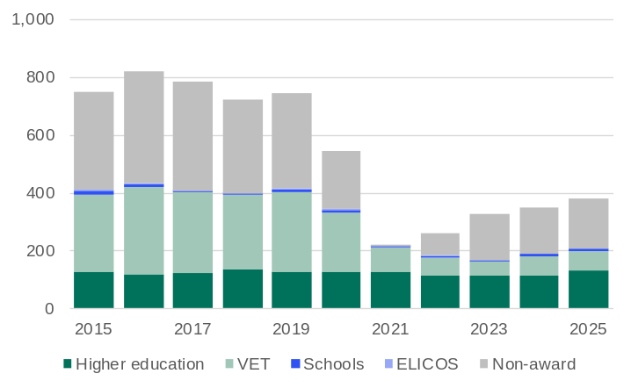
Note: Year to date in December. VET = Vocational education and training. ELICOS = English language intensive courses for overseas students. Non-award = Foundation courses or study abroad and exchange programs.
Source: Australian Department of Education and Training, International Education Data and Research.

- International student enrolments in Western Australia dropped sharply in 2020 and 2021 due to COVID-19 travel restrictions but began recovering in 2022 and climbed to record highs in 2024 and 2025, with growth varying across markets.
  - In 2025, student enrolments from the United States in Western Australia were 49% below pre-pandemic levels in 2019.
- The United States was Western Australia’s 30th largest market for international students in 2025, with 382 enrolments (0.4% of the State’s total international student enrolments).
  - Student enrolments from the United States in Westen Australia increased 8.8% in 2025.
- Most students from the United States in Western Australia in 2025 were enrolled in either non-award courses such as foundation courses or study abroad and student exchange programs (46%) or higher education (35%).

Western Australian residents born in the United States
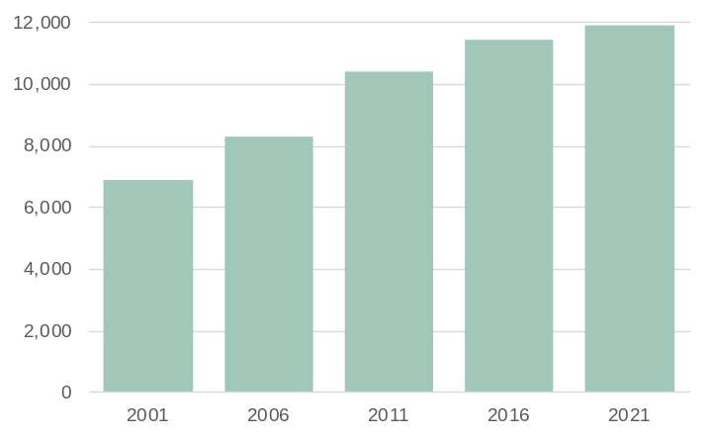
Note: Population counts as of June.
Source: Based on data from ABS Australia’s Population by Country of Birth.

- Western Australia had 11,890 residents in 2021 who were born in the United States, 3.8% more than in 2016.
- People born in the United States accounted for 1.3% of Western Australia’s overseas-born resident population in 2021, in line with the 1.3% share in 2016.
- People born in the United States were the 15th largest overseas-born resident population in Western Australia in 2021.

South Korea-Western Australia trade relationship | Back to contents
Western Australia’s trade relationship with South Korea developed from the 1970s, when South Korea’s rapid industrialisation created a strong demand for minerals and energy. Western Australia quickly became a major supplier, especially of iron ore, which was vital for Korean steelmakers like POSCO, supporting South Korea’s globally competitive shipbuilding, automotive and construction industries. LNG exports from Western Australia to South Korea grew from the 1990s, as South Korea expanded its energy infrastructure and demand for cleaner fuels increased. Over time, Western Australia’s exports to South Korea expanded to include gold, copper, wheat and other agri-food products, which helped meet food demand in a densely populated country with limited arable land.
On the import side, South Korea supplies Western Australia with refined petroleum products and advanced manufactured goods, including electronics, motor vehicles and battery technologies. These imports support Western Australia’s mining operations, energy transition and infrastructure development. Overall, the trade partnership has evolved from a focus on raw materials to a broader, mutually beneficial relationship that supports economic growth, industrial development and the energy transition in both Western Australia and South Korea.

Western Australia’s trade in goods with South Korea
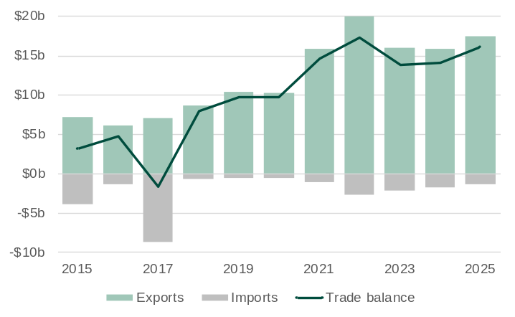
Note: Imports are shown as negative values because they are an outflow of expenditure from the economy. Western Australia’s imports from South Korea were very high in 2017-18 due to the arrival of the Prelude floating LNG plant, which was constructed in South Korea and transported to Western Australia.
Source: Based on data from ABS International Trade in Goods.

- Western Australia’s large trade surplus with South Korea is driven by the high value of its exports of iron ore and petroleum, which are greater than the value of imports, mainly motor cars and refined petroleum products.
- The value of Western Australia’s goods exports to South Korea was $17.4 billion in 2025, 10.1% lower than in 2024.
  - The value of Western Australia’s exports to South Korea rose steadily from the mid-2010s due to strong demand and higher prices for iron ore, LNG and gold. The value of exports fell after 2022 due mainly to falling global prices for iron ore and LNG.
- The value of Western Australia’s goods imports from South Korea was $1.3 billion in 2025, 22% lower than in 2024.

Western Australia-South Korea main commodities traded: 2025
The tables below show the values for the main commodities traded between Western Australia and South Korea in 2025.
Exports | Value ($m) | Share (%) | Imports⁴ | Value ($m) | Share (%)
Petroleum¹ | 6,506 | 37.4 | Motor cars | 498 | 37.2
Iron ore | 6,149 | 35.3 | Inorganic chemicals⁵ | 101 | 7.6
Non-monetary gold | 1,920 | 11.0 | Silver and platinum | 100 | 7.4
Gold ore² | 1,491 | 8.6 | Refined petroleum oils | 60 | 4.5
Wheat | 561 | 3.2 | Motor vehicles for transporting goods | 50 | 3.7
Nickel | 340 | 2.0 | Fertilisers | 47 | 3.5
Animal feed³ | 170 | 1.0 | Civil engineering plant and equipment | 43 | 3.2
Lithium concentrate | 100 | 0.6 | Electrical machinery | 39 | 2.9
Base metals | 62 | 0.4 | Telecommunications equipment | 29 | 2.2
Pigments and paints | 56 | 0.3 | Aluminium | 27 | 2.0
All other exports | 53 | 0.3 | All other imports | 345 | 25.8
Total exports | 17,408 | 100.0 | Total imports | 1,339 | 100.0
Share of Western Australia’s exports | 7.3% |  | Share of Western Australia’s imports | 2.5%
Ranking as an export market | 3 |  | Ranking as an import market | 12
1. Liquefied natural gas, condensate, crude oil and liquefied petroleum gas. 2. May include other precious metal ore. 3. Mainly hay and lupins. 4. Excludes confidential import items of mainly iron and steel, although the value of these items is included in the total. 5. Mainly sodium hydroxide (soda lye or liquid soda and caustic soda) used in mostly alumina and gold refining and titanium dioxide pigment production.
Source: Based on. data from ABS International Trade in Goods and Services, Australia; and Department of Home Affairs, Integrated Cargo System data.

Visits from South Korea to Western Australia
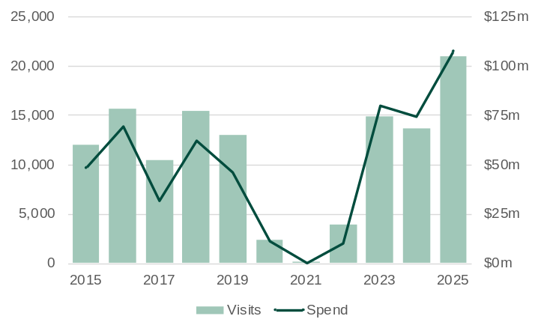
Source: Tourism Research Australia, International Visitor Survey.

- International visitors to Western Australia declined sharply from early 2020 due to COVID-19 travel restrictions, with the recovery beginning in 2022 at varying rates across markets.
  - In 2025, visitor numbers from South Korea to Western Australia were 61% above pre-pandemic levels in 2019.
- South Korea was Western Australia’s 14th largest market for international visitors in 2025, with 20,964 visits (2.0% of the State’s total international visits).
  - Visitor numbers from South Korea to Westen Australia increased 54% in 2025.
- Visitors from South Korea spent a total of $108 million in Western Australia in 2025, 44% more than in 2024.
- On average, visitors from South Korea spent $5,136 per visit in Western Australia in 2025, above the average of $3,188 per visit from all markets.

Student enrolments from South Korea in Western Australia
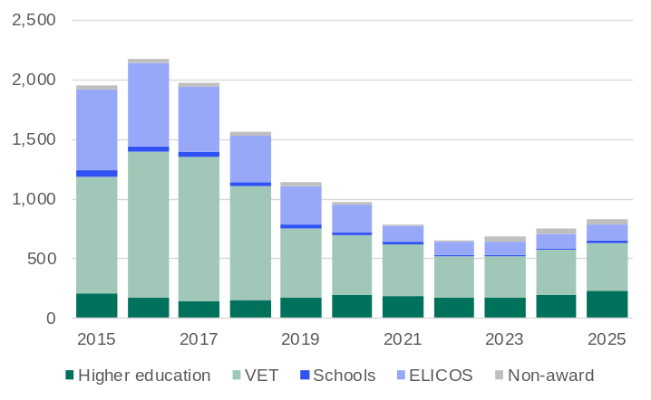
Note: Year to date in December. VET = Vocational education and training. ELICOS = English language intensive courses for overseas students. Non-award = Foundation courses or study abroad and exchange programs.
Source: Australian Department of Education and Training, International Education Data and Research.

- International student enrolments in Western Australia dropped sharply in 2020 and 2021 due to COVID-19 travel restrictions but began recovering in 2022 and climbed to record highs in 2024 and 2025, with growth varying across markets.
  - In 2025, student enrolments from South Korea in Western Australia were 27% below pre-pandemic levels in 2019.
- South Korea was Western Australia’s 20th largest market for international students in 2025, with 833 enrolments (0.9% of the State’s total international student enrolments).
  - Student enrolments from South Korea in Western Australia increased 11.1% in 2025.
- Most students from South Korea in Western Australia in 2025 were enrolled in vocational education and training (48%) or higher education (28%).

Western Australian residents born in South Korea
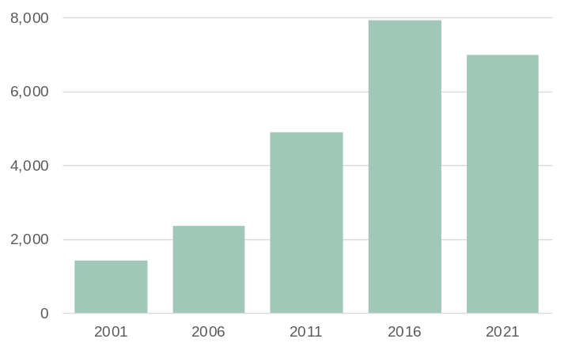
Note: Population counts as of June.
Source: Based on data from ABS Australia’s Population by Country of Birth.

- Western Australia had 6,990 residents in 2021 who were born in South Korea, 11.7% less than in 2016.
- People born in South Korea accounted for 0.7% of Western Australia’s overseas-born resident population in 2021, below the 0.9% share in 2016.
- People born in South Korea were the 25th largest overseas-born resident population in Western Australia in 2021.

Singapore-Western Australia trade relationship | Back to contents
Western Australia’s trade relationship with Singapore began in the post-independence era of the 1960s, as Singapore rapidly developed into a major regional trading and refining hub. Singapore is a major gateway for Western Australian exports into Southeast Asia and is a strategic partner in trade, investment and innovation. The trade relationship between Singapore and Western Australia initially focused on agricultural products and basic minerals, but as Singapore’s economy industrialised and its port became one of the world’s largest, the relationship shifted towards energy and high-value commodities.
Singapore imports LNG, crude oil, gold, iron ore and agri-food products from Western Australia that support its energy security, industrial needs and food supply. Western Australia’s LNG fuels Singapore’s electricity generation and is also re-exported, including as a marine fuel to vessels through its growing bunkering hub. Crude oil from Western Australia is refined at facilities like Pulau Bukom and Jurong Island into petrol, diesel and petrochemicals for regional and global export, giving Western Australia access to high-value petroleum refining and distribution networks. Gold is traded and stored in Singapore’s world-class vaulting facilities, making it a major global bullion hub, while iron ore is re-exported or used in steel-related manufacturing and trading activities (despite Singapore’s limited domestic steel production). Western Australia’s agri-food exports – including meat, dairy, wheat, vegetables and fruit – are consumed locally or processed and re-exported, supported by Singapore’s advanced logistics and initiatives like the Australia-Singapore Food Pact.
In return, Singapore supplies Western Australia with refined petroleum products, electronics and high-value manufactured goods, and invests in Western Australia’s infrastructure, agribusiness and technology. Overall, the trade partnership has evolved from basic goods to a sophisticated, mutually beneficial exchange that supports economic growth, energy security and regional integration for both Western Australia and Singapore.

Western Australia’s trade in goods with Singapore
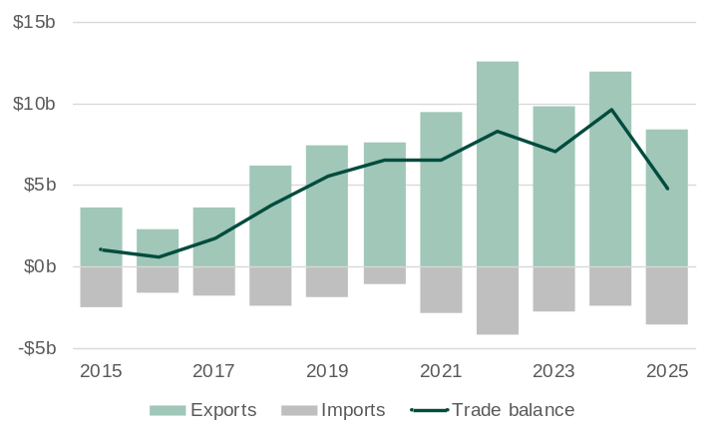
Note: Imports are shown as negative values because they are an outflow of expenditure from the economy.
Source: Based on data from ABS International Trade in Goods.

- Western Australia has a trade surplus with Singapore, driven by the high value of its exports of petroleum, relative to the value of its imports of mainly refined petroleum products.
- The value of Western Australia’s goods exports to Singapore was $8.4 billion in 2025, 30% lower than in 2024.
  - The increase in the value of Western Australia’s exports to Singapore from the mid-2010s was largely driven by LNG and crude oil exports, reflecting Singapore’s growing role as an energy refiner and trading hub. The fall in value in 2025 was in part due to lower exports of non-monetary gold.
- The value of Western Australia’s goods imports from Singapore was $3.6 billion in 2025, 49% higher than in 2024.

Western Australia-Singapore main commodities traded: 2025
The tables below show the values for the main commodities traded between Western Australia and Singapore in 2025.
Exports | Value ($m) | Share (%) | Imports³ | Value ($m) | Share (%)
Petroleum¹ | 6,755 | 80.7 | Refined petroleum oils | 3,022 | 84.9
Non-monetary gold | 1,034 | 12.4 | Edible products and preparations | 146 | 4.1
Mineral sands² | 120 | 1.4 | Residual petroleum products | 73 | 2.1
Meat (pork and lamb) | 93 | 1.1 | Prepared additives for mineral oils | 22 | 0.6
Animal oils and fats | 23 | 0.3 | Automatic data processing machines | 22 | 0.6
Silver and platinum | 23 | 0.3 | Industrial machinery and equipment | 17 | 0.5
Gold coin | 22 | 0.3 | Measuring and checking instruments | 16 | 0.4
Rock lobster | 20 | 0.2 | Taps, cocks and valves | 15 | 0.4
Milk and dairy products | 18 | 0.2 | Ships, boats and floating structures | 12 | 0.3
Wheat | 16 | 0.2 | Civil engineering plant and equipment | 10 | 0.3
All other exports | 246 | 2.9 | All other imports | 202 | 5.7
Total exports | 8,371 | 100.0 | Total imports | 3,558 | 100.0
Share of Western Australia’s exports | 3.5% |  | Share of Western Australia’s imports | 6.6%
Ranking as an export market | 5 |  | Ranking as an import market | 3
1. Liquefied natural gas, condensate, crude oil and liquefied petroleum gas. 2. Titanium and zirconium ores and pigments and preparations based on titanium dioxide. 3. Excludes confidential import items of mainly articles of iron and steel, machinery and mechanical parts, and electrical machinery and equipment, although the value of these items is included in the total.
Source: Based on. data from ABS International Trade in Goods and Services, Australia; and Department of Home Affairs, Integrated Cargo System data.

Visits from Singapore to Western Australia
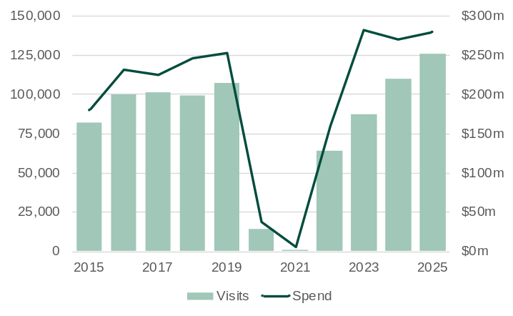
Source: Tourism Research Australia, International Visitor Survey.

- International visitors to Western Australia declined sharply from early 2020 due to COVID-19 travel restrictions, with the recovery beginning in 2022 at varying rates across markets.
  - In 2025, visitor numbers from Singapore to Western Australia were 17.6% above pre-pandemic levels in 2019.
- Singapore was Western Australia’s 2nd largest market for international visitors in 2025, with 125,938 visits (11.8% of the State’s total international visits).
  - Visitor numbers from Singapore to Western Australia increased 14.9% in 2025.
- Visitors from Singapore spent a total of $279 million in Western Australia in 2025, 3.1% more than in 2024.
- On average, visitors from Singapore spent $2,218 per visit in Western Australia in 2025, below the average of $3,188 per visit from all markets.

Student enrolments from Singapore in Western Australia
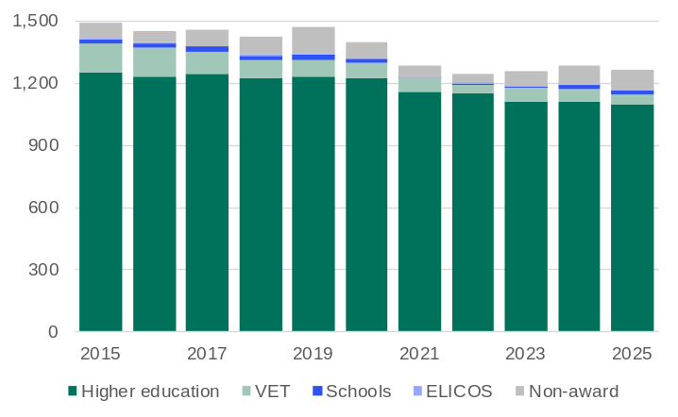
Note: Year to date in December. VET = Vocational education and training. ELICOS = English language intensive courses for overseas students. Non-award = Foundation courses or study abroad and exchange programs.
Source: Australian Department of Education and Training, International Education Data and Research.

- International student enrolments in Western Australia dropped sharply in 2020 and 2021 due to COVID-19 travel restrictions but began recovering in 2022 and climbed to record highs in 2024 and 2025, with growth varying across markets.
  - In 2025, student enrolments from Singapore in Western Australia were 14.0% below pre-pandemic levels in 2019.
- Singapore was Western Australia’s 16th largest market for international students in 2025, with 1,264 enrolments (1.4% of the State’s total international student enrolments).
  - Student enrolments from Singapore in Western Australia fell 1.6% in 2025.
- Most students from Singapore in Western Australia in 2025 were enrolled in higher education (87%), followed by non-award courses such as foundation courses or study abroad and student exchange programs (8%).

Western Australian residents born in Singapore
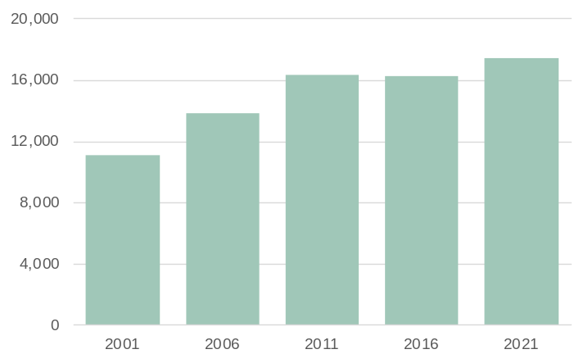
Note: Population counts as of June.
Source: Based on data from ABS Australia’s Population by Country of Birth.

- Western Australia had 17,420 residents in 2021 who were born in Singapore, 7.1% more than in 2016.
- People born in Singapore accounted for 1.9% of Western Australia’s overseas-born resident population in 2021, above the 1.8% share in 2016.
- People born in Singapore were the 11th largest overseas-born resident population in Western Australia in 2021.

Hong Kong (SAR of China)-Western Australia trade relationship | Back to contents
Western Australia's trade relationship with Hong Kong has evolved over time from colonial-era commercial ties into a modern, diversified economic partnership. Historically, both Western Australia and Hong Kong were part of the British Empire, which laid the foundation for early trade and cultural exchanges. However, the relationship gained significant momentum in the early 2000s, with the rise of Hong Kong as a global financial and logistics hub to support China’s industrialisation and Western Australia’s emergence as a major exporter of minerals and energy.
Western Australia exports a range of high-value commodities to Hong Kong. Gold is the most significant export, including both non-monetary gold and gold coin. Rock lobster is another major export, with Hong Kong being Western Australia’s second-largest market for this commodity. On the import side, Western Australia receives a variety of goods from Hong Kong, including precious metals, jewellery, and telecommunications and electronic equipment. Many of these imports are high value, finished goods that support the State’s retail and consumer markets. Additionally, gold imported from Hong Kong is refined in Western Australia and re-exported, highlighting the integrated nature of the trade relationship.
Hong Kong also plays a strategic role as trading hub, facilitating trade between Western Australia and mainland China. Overall, the trade relationship between Western Australia and Hong Kong is marked by mutual benefit, with Western Australia supplying high-quality raw and semi-processed materials, while Hong Kong provides additional access to mainland China and other markets across Asia and high-end consumer goods.

Western Australia’s trade in goods with Hong Kong
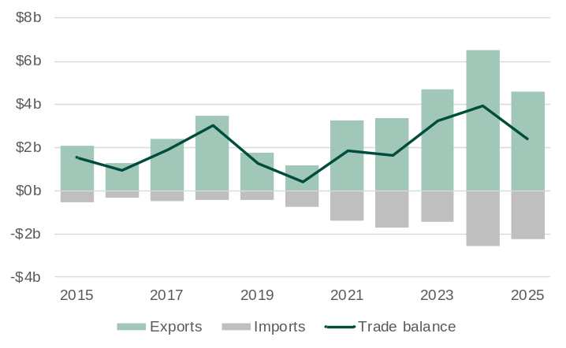
Note: Imports are shown as negative values because they are an outflow of expenditure from the economy.
Source: Based on data from ABS International Trade in Goods.

- Western Australia has a trade surplus with Hong Kong primarily because the value of its exports like gold and rock lobster outweighs the value of its imports from Hong Kong.
- The value of Western Australia’s goods exports to Hong Kong was $8.2 billion in 2025, 4.7% higher than in 2024.
  - Non-monetary gold generally accounts for over 90% of the value of Western Australia’s exports to Hong Kong.
- The value of Western Australia’s goods imports from Hong Kong was $360 million in 2025, more than seven times higher than in 2024.

Western Australia-Hong Kong main commodities traded: 2025
The tables below show the values for the main commodities traded between Western Australia and Hong Kong in 2025.
Exports | Value ($m) | Share (%) | Imports² | Value ($m) | Share (%)
Non-monetary gold | 7,779 | 95.0 | Non-monetary gold³ | 159 | 44.5
Gold coin | 198 | 2.4 | Silver and platinum | 127 | 35.5
Rock lobster | 72 | 0.9 | Refined petroleum oils | 41 | 11.6
Iron ore | 49 | 0.6 | Jewellery | 3 | 0.7
Base metal waste and scrap | 27 | 0.3 | Motor cars | 2 | 0.6
Petroleum¹ | 12 | 0.1 | Glassware | 2 | 0.6
Fruit and nuts | 8 | 0.1 | Edible products and preparations | 2 | 0.5
Silver and platinum | 6 | 0.1 | Pearls and precious stones | 1 | 0.4
Meat (lamb and poultry) | 4 | 0.1 | Monitors and projectors | 1 | 0.3
Coins (other than gold) | 4 | 0.1 | Motor vehicle parts and accessories | 1 | 0.3
All other exports | 31 | 0.4 | All other imports | 18 | 5.1
Total exports | 8,189 | 100.0 | Total imports | 358 | 100.0
Share of Western Australia’s exports | 3.4% |  | Share of Western Australia’s imports | 0.7%
Ranking as an export market | 6 |  | Ranking as an import market | 26
1. Liquefied natural gas, condensate, crude oil and liquefied petroleum gas. 2. Excludes confidential import items of mainly articles of iron and steel, and electrical machinery and equipment, although the value of these items is included in the total. 3. Western Australia imports non-monetary gold from other countries primarily for refining into high-purity products such as gold bars and coins at the Perth Mint, which are then re-exported globally.
Source: Based on. data from ABS International Trade in Goods and Services, Australia; and Department of Home Affairs, Integrated Cargo System data.

Visits from Hong Kong to Western Australia
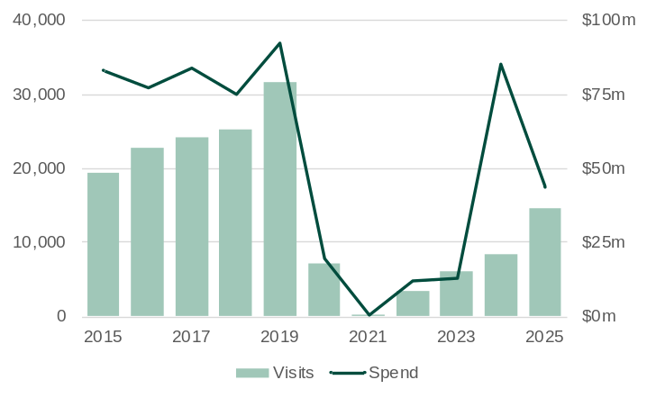
Source: Tourism Research Australia, International Visitor Survey.

- International visitors to Western Australia declined sharply from early 2020 due to COVID-19 travel restrictions, with the recovery beginning in 2022 at varying rates across markets.
  - In 2025, visitor numbers from Hong Kong to Western Australia were 54% below pre-pandemic levels in 2019.
- Hong Kong was Western Australia’s 19th largest market for international visitors in 2025, with 14,556 visits (1.3% of the State’s total international visits).
  - Visitor numbers from Hong Kong to Western Australia increased 75% in 2025.
- Visitors from Hong Kong spent a total of $43 million in Western Australia in 2025, 49% less than in 2024.
- On average, visitors from Hong Kong spent $2,982 per visit in Western Australia in 2025, above the average of $3,188 per visit from all markets.

Student enrolments from Hong Kong in Western Australia
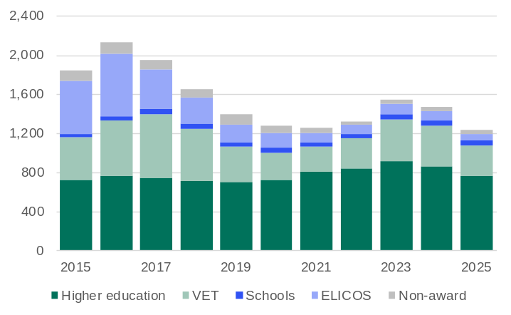
Note: Year to date in December. VET = Vocational education and training. ELICOS = English language intensive courses for overseas students. Non-award = Foundation courses or study abroad and exchange programs.
Source: Australian Department of Education and Training, International Education Data and Research.

- International student enrolments in Western Australia dropped sharply in 2020 and 2021 due to COVID-19 travel restrictions but began recovering in 2022 and climbed to record highs in 2024 and 2025, with growth varying across markets.
  - In 2025, student enrolments from Hong Kong in Western Australia were 10.9% below pre-pandemic levels in 2019.
- Hong Kong was Western Australia’s 17th largest market for international students in 2025, with 1,239 enrolments (1.4% of the State’s total international student enrolments).
  - Student enrolments from Hong Kong in Western Australia fell 15.3% in 2025.
- Most Hong Kong students in Western Australia in 2025 were enrolled in higher education (62%), followed by vocational education and training (24%).

Western Australian residents born in Hong Kong
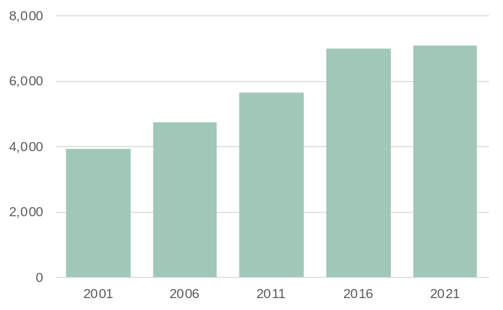
Note: Population counts as of June.
Source: Based on data from ABS Australia’s Population by Country of Birth.

- Western Australia had 7,080 residents in 2021 who were born in Hong Kong, 1.4% more than in 2016.
- People born in Hong Kong accounted for 0.8% of Western Australia’s overseas-born resident population in 2021, in line with the 0.8% share in 2016.
- People born in Hong Kong were the 24th largest overseas-born resident population in Western Australia in 2021.

Taiwan-Western Australia trade relationship | Back to contents
Western Australia's trade relationship with Taiwan has evolved since the mid-20th century, beginning with modest exchanges of agri-food and mineral products and growing into a robust economic partnership. Despite the absence of formal diplomatic ties with Australia, Taiwan has become a key trading partner for Western Australia, driven by complementary economic strengths and sustained by strong commercial and cultural links.
Western Australia exports mainly LNG and iron ore to Taiwan, supporting Taiwan’s manufacturing base and energy security. Western Australia’s iron ore is vital for Taiwan’s steel production, while LNG powers its electricity generation and heavy industries. On the import side, Taiwan supplies Western Australia with refined petroleum oils, chemicals, telecommunications equipment and computers. These goods are important for Western Australia’s domestic consumption and industrial operations, with refined petroleum oils crucial for transport and mining and telecommunications and IT equipment supporting the State’s growing technology and services sectors.
The trade relationship allows Tawian secure and reliable access to raw materials needed for its export-driven economy, while Western Australia gains access to advanced manufactured goods and technology. The trade relationship exemplifies how strategic economic partnerships can thrive by mutual benefit and shared regional interests.

Western Australia’s trade in goods with Taiwan
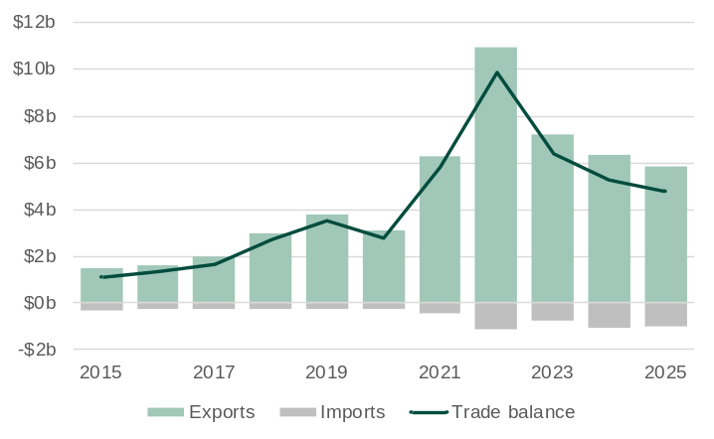
Note: Imports are shown as negative values because they are an outflow of expenditure from the economy.
Source: Based on data from ABS International Trade in Goods.

- Western Australia has a trade surplus with Taiwan, with the high value of its exports of iron ore and petroleum greater than the value of its imports of mainly refined petroleum products and chemicals.
- The value of Western Australia’s goods exports to Taiwan was $5.8 billion in 2025, 7.8% lower than in 2024.
  - The rise and fall in the value of Western Australia’s exports to Taiwan over the past five years largely reflects changes in the price for Western Australia’s two main export commodities to Taiwan: LNG and iron ore.
- The value of Western Australia’s goods imports from Taiwan was $1.0 billion in 2025, 2.1% lower than in 2024.

Western Australia-Taiwan main commodities traded: 2025
The tables below show the values for the main commodities traded between Western Australia and Taiwan in 2025.
Exports | Value ($m) | Share (%) | Imports⁴ | Value ($m) | Share (%)
Petroleum¹ | 3,457 | 59.4 | Refined petroleum oils | 612 | 59.3
Iron ore | 1,672 | 28.7 | Inorganic chemicals⁵ | 127 | 12.3
Miscellaneous base metals | 37 | 0.6 | Automatic data processing machines | 19 | 1.8
Rock lobster | 30 | 0.5 | Telecommunication equipment | 15 | 1.5
Animal feed² | 25 | 0.4 | Tyres and parts | 15 | 1.4
Cereal preparations | 24 | 0.4 | Optical goods | 11 | 1.1
Non-monetary gold | 23 | 0.4 | Motorcycles | 10 | 1.0
Inorganic chemicals³ | 20 | 0.3 | Tubes and pipes | 10 | 1.0
Nickel | 10 | 0.2 | Flat-rolled products of alloy steel | 10 | 0.9
Pigments and paints | 9 | 0.2 | Pumps for air or gas | 10 | 0.9
All other exports | 513 | 8.8 | All other imports | 195 | 18.9
Total exports | 5,819 | 100.0 | Total imports | 1,033 | 100.0
Share of Western Australia’s exports | 2.5% |  | Share of Western Australia’s imports | 1.9%
Ranking as an export market | 7 |  | Ranking as an import market | 15
1. Liquefied natural gas, condensate, crude oil and liquefied petroleum gas. 2. Mainly hay and lupins. 3. Mainly ammonia. 4. Excludes confidential import items of mainly electrical machinery and equipment, although the value of these items is included in the total. 5. Mainly sodium hydroxide (soda lye or liquid soda and caustic soda) used in mostly alumina and gold refining and titanium dioxide pigment production.
Source: Based on. data from ABS International Trade in Goods and Services, Australia; and Department of Home Affairs, Integrated Cargo System data.

Visits from Taiwan to Western Australia
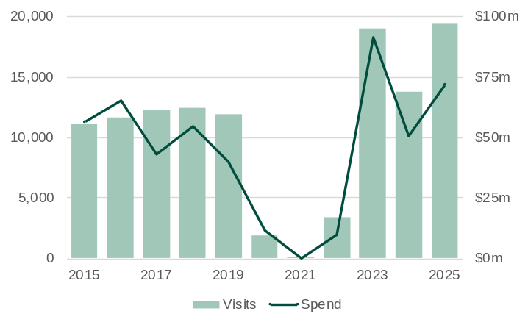
Source: Tourism Research Australia, International Visitor Survey.

- International visitors to Western Australia declined sharply from early 2020 due to COVID-19 travel restrictions, with the recovery beginning in 2022 at varying rates across markets.
  - In 2025, visitor numbers from Taiwan to Western Australia were 63% above pre-pandemic levels in 2019.
- Taiwan was Western Australia’s 15th largest market for international visitors in 2025, with 19,472 visits (2.1% of the State’s total international visits).
  - Visitor numbers from Taiwan to Western Australia increased 41% in 2025.
- Visitors from Taiwan spent a total of $72 million in Western Australia in 2025, 42% more than in 2025.
- On average, visitors from Taiwan spent $3,696 per visit in Western Australia in 2025, above the average of $3,188 per visit from all markets.

Student enrolments from Taiwan in Western Australia
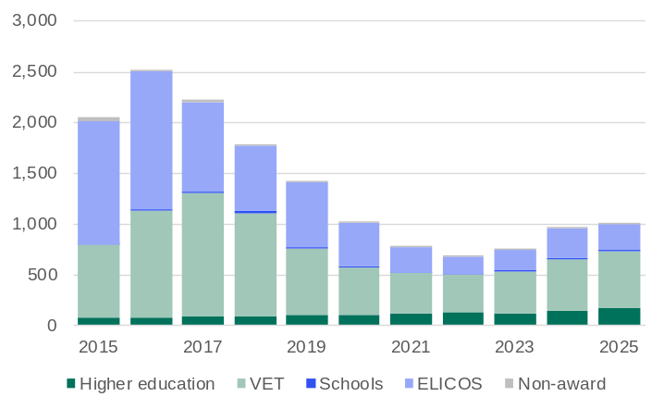
Note: Year to date in December. VET = Vocational education and training. ELICOS = English language intensive courses for overseas students. Non-award = Foundation courses or study abroad and exchange programs.
Source: Australian Department of Education and Training, International Education Data and Research.

- International student enrolments in Western Australia dropped sharply in 2020 and 2021 due to COVID-19 travel restrictions but began recovering in 2022 and climbed to record highs in 2024 and 2025, with growth varying across markets.
  - In 2025, student enrolments from Taiwan in Western Australia were 29% below pre-pandemic levels in 2019.
- Taiwan was Western Australia’s 19th largest market for international students in 2025, with 1,009 enrolments (1.1% of the State’s total international student enrolments).
  - Student enrolments from Taiwan in Western Australia increased 4.0% in 2025.
- Most students from Taiwan in Western Australia in 2025 were enrolled in vocational education and training (55%), followed by intensive English language courses (25%).

Western Australian residents born in Taiwan
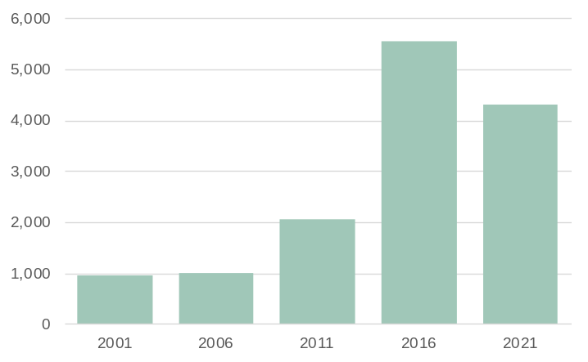
Note: Population counts as of June.
Source: Based on data from ABS Australia’s Population by Country of Birth.

- Western Australia had 4,320 residents in 2021 who were born in Taiwan, 22% less than in 2016.
- People born in Taiwan accounted for 0.5% of Western Australia’s overseas-born resident population in 2021, below the 0.6% share in 2016.
- People born in Taiwan were the 36th largest overseas-born resident population in Western Australia in 2021.

India-Western Australia trade relationship | Back to contents
Western Australia’s trade relationship with India began to expand in the 1990s, as India began to reform its economy and achieve higher rates of growth. India is becoming an increasingly important export market for Western Australia, helping the State to diversify its markets beyond its largest trade partners in Northeast Asia.
India is now a major destination for Western Australia’s minerals exports, with non-monetary gold accounting for the largest share of merchandise trade. Other key exports include iron ore, silver, alumina, mineral sands, and gold ore. India’s strong demand for gold – driven by its cultural traditions, jewellery manufacturing and household investment – makes it one of the world’s largest gold consumers. Western Australia is well positioned to benefit from India’s tightening of gold import regulations and the centralisation of imports through the India International Bullion Exchange, which favours reputable, large-scale exporters.
As India accelerates its clean energy transition, demand for Western Australia’s battery minerals is rising, creating new opportunities for offtake agreements and joint ventures in downstream processing and manufacturing. India is also Western Australia’s largest source of international students, reflecting strong people-to-people ties and growing collaboration in education.
On the import side, India supplies Western Australia with refined petroleum products, high-value manufactured goods, and textiles. The sharp rise in refined petroleum imports over the past decade is largely due to Western Australia’s reduced domestic refining capacity, India’s expanding export-oriented refining sector, and the need for competitively priced, diversified fuel sources amid global supply shifts. Indian machinery supports Western Australia’s industrial sectors through the supply of cost-effective equipment, including industrial machinery, electrical components, automotive parts, agricultural equipment and textile machinery, while textiles and motor vehicles are important for local consumers and businesses.

Western Australia’s trade in goods with India
Note: Imports are shown as negative values because they are an outflow of expenditure from the economy.
Source: Based on data from ABS International Trade in Goods.

- Western Australia generally has a trade surplus with India, with the value of its exports of gold, iron ore and chemicals greater than the value of its imports of mainly refined petroleum products and motor vehicles.
- The value of Western Australia’s goods exports to India was $4.6 billion in 2025, 29% lower than in 2024.
  - The decline in the value of Western Australia’s exports to India in 2025 was mostly due to lower exports of non-monetary gold, reflecting a slowdown in demand in India for gold jewellery and investments amid much higher gold prices.
- The value of Western Australia’s goods imports from India was $2.2 billion in 2025, 14% lower than in 2024.

Western Australia-India main commodities traded: 2025
The tables below show the values for the main commodities traded between Western Australia and India in 2025.
Exports | Value ($m) | Share (%) | Imports³ | Value ($m) | Share (%)
Non-monetary gold | 3,173 | 69.1 | Refined petroleum oils | 1,250 | 56.2
Gold ore¹ | 326 | 7.1 | Tubes and pipes | 140 | 6.3
Pigments and paints | 233 | 5.1 | Heating and cooling equipment | 59 | 2.7
Inorganic chemicals² | 176 | 3.8 | Electricity distribution equipment | 56 | 2.5
Iron ore | 167 | 3.6 | Industrial machinery and equipment | 48 | 2.1
Silver and platinum | 77 | 1.7 | Motor vehicles for transporting goods | 36 | 1.6
Base metals | 73 | 1.6 | Taps, cocks and valves | 30 | 1.3
Base metal waste and scrap | 60 | 1.3 | Civil engineering plant and equipment | 30 | 1.3
Alumina | 51 | 1.1 | Tyres and parts | 27 | 1.2
Ferrous waste and scrap | 51 | 1.1 | Textiles | 25 | 1.1
All other exports | 209 | 4.5 | All other imports | 523 | 23.5
Total exports | 4,595 | 100.0 | Total imports | 2,223 | 100.0
Share of Western Australia’s exports | 1.9% |  | Share of Western Australia’s imports | 4.1%
Ranking as an export market | 8 |  | Ranking as an import market | 7
1. May include other precious metal ore. 2. Mainly colloidal precious metals (nanoparticles of gold, silver, platinum and palladium). 3. Excludes confidential import items of mainly articles of iron and steel, although the value of these items is included in the total.
Source: Based on. data from ABS International Trade in Goods and Services, Australia; and Department of Home Affairs, Integrated Cargo System data.

Visits from India to Western Australia
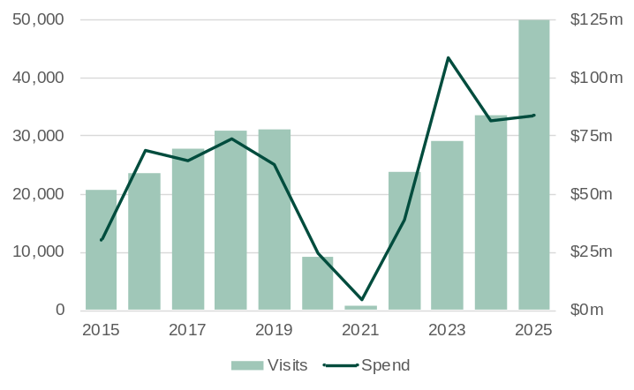
Source: Tourism Research Australia, International Visitor Survey.

- International visitors to Western Australia declined sharply from early 2020 due to COVID-19 travel restrictions, with the recovery beginning in 2022 at varying rates across markets.
  - In 2025, visitor numbers from India to Western Australia were 61% above pre-pandemic levels in 2019.
- India was Western Australia’s 6th largest market for international visitors in 2025, with 49,963 visits (4.7% of the State’s total international visits).
  - Visitor numbers from India to Western Australia increased 49% in 2025.
- Visitors from India spent a total of $84 million in Western Australia in 2025, 2.4% more than in 2024.
- On average, visitors from India spent $1,674 per visit in Western Australia in 2025, below the average of $3,188 per visit from all markets.

Student enrolments from India in Western Australia
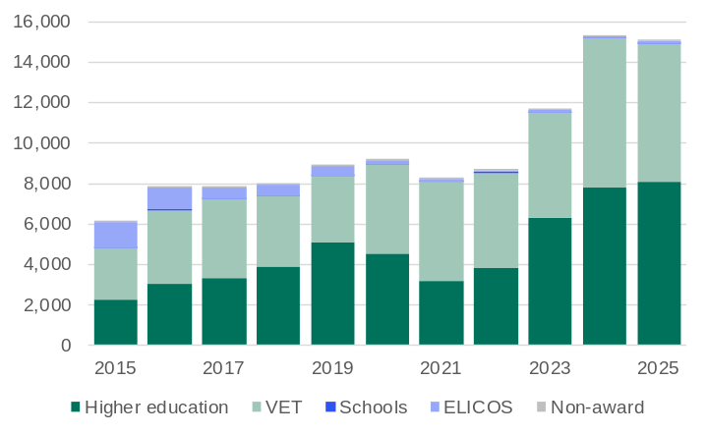
Note: Year to date in December. VET = Vocational education and training. ELICOS = English language intensive courses for overseas students. Non-award = Foundation courses or study abroad and exchange programs.
Source: Australian Department of Education and Training, International Education Data and Research.

- International student enrolments in Western Australia dropped sharply in 2020 and 2021 due to COVID-19 travel restrictions but began recovering in 2022 and climbed to record highs in 2024 and 2025, with growth varying across markets.
  - In 2025, student enrolments from India in Western Australia were 69% above pre-pandemic levels in 2019.
- India was Western Australia’s largest market for international students in 2025, with 15,044 enrolments (16.8% of the State’s total international student enrolments).
  - Student enrolments from India in Western Australia fell 1.8% in 2025.
- Most students from India in Western Australia in 2025 were enrolled in higher education (54%), followed by vocational education and training (45%).

Western Australian residents born in India
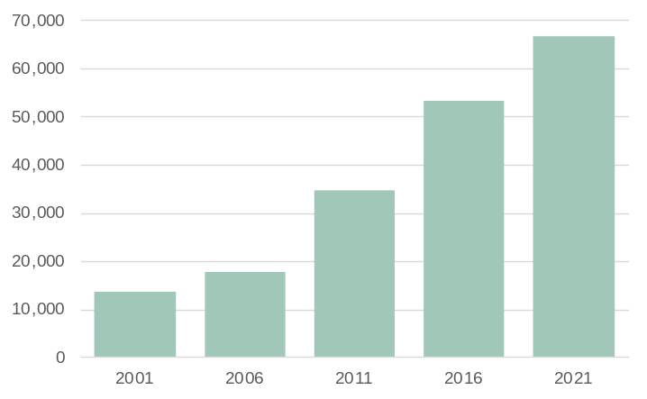
Note: Population counts as of June.
Source: Based on data from ABS Australia’s Population by Country of Birth.

- Western Australia had 66,550 residents in 2021 who were born in India, 25% more than in 2016.
- People born in India accounted for 7.1% of Western Australia’s overseas-born resident population in 2021, above the 6.0% share in 2016.
- People born in India were the 3rd largest overseas-born resident population in Western Australia in 2021.

United Kingdom-Western Australia trade relationship | Back to contents
Western Australia’s trade relationship with the United Kingdom began in the 1800s, shaped by colonial ties and the exchange of raw materials for British manufactured goods. Early exports such as wool and timber supported UK industries like textiles and construction, while Western Australia imported machinery, tools and consumer goods that helped build its infrastructure and industries. A major shift occurred in the 1960s when the United Kingdom joined the European Economic Community, reducing its reliance on Western Australia’s agri-food exports. At the same time, Western Australia was expanding trade with growing economies in Asia. Despite the fall in the relative importance of the trade relationship, Western Australia’s cultural and economic ties with the United Kingdom have remained strong.
In recent years, Western Australia’s exports to the United Kingdom have shifted toward minerals, especially gold. This has been driven by the United Kingdom’s role as a global financial hub and rising demand for gold during periods of economic uncertainty such as Brexit, the COVID-19 pandemic, and the Russia-Ukraine war. Western Australia’s refining capacity, particularly at the Perth Mint, has supported efficient processing and re-export of gold. Western Australia also exports mineral sands and nickel – used in UK manufacturing, electronics and renewable energy technologies – alongside meat, wine and niche agri-food products.
Imports from the United Kingdom include motor vehicles, advanced technology and specialty goods. This evolving trade relationship reflects a shift from traditional agri-food exports to high-value resources, with the United Kingdom gaining access to Western Australia’s resource wealth and premium produce, while Western Australia benefits from UK innovation, investment and global market access. The people-to-people relationship remains strong, with the United Kingdom being the largest source of both international visitors to Western Australia and the overseas-born resident population in Western Australia.

Western Australia’s trade in goods with the United Kingdom
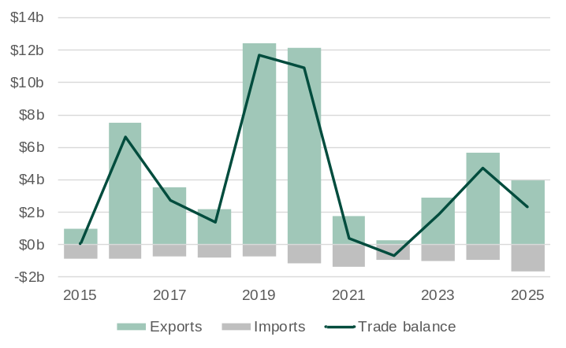
Note: Imports are shown as negative values because they are an outflow of expenditure from the economy.
Source: Based on data from ABS International Trade in Goods.

- Western Australia maintains a trade surplus with the United Kingdom, exporting a higher value of gold and agri-food products than the value of its imports of mainly gold and motor vehicles.
- The value of Western Australia’s goods exports to the United Kingdom was $4.0 billion in 2025, 30% lower than in 2024.
  - The fall in the value of Western Australia’s exports to the United Kingdom in 2025 reflected lower exports of non-monetary gold, with a greater share of Western Australia’s non-monetary gold exports in 2025 going to the United States.
- The value of Western Australia’s goods imports from the United Kingdom was $1.6 billion in 2025, 79% higher than in 2024. The increase was due to more imports of non-monetary gold.

Western Australia-United Kingdom main commodities traded: 2025
The tables below show the values for the main commodities traded between Western Australia and the United Kingdom in 2025.
Exports | Value ($m) | Share (%) | Imports² | Value ($m) | Share (%)
Non-monetary gold | 3,356 | 84.8 | Non-monetary gold³ | 745 | 45.7
Silver and platinum | 372 | 9.4 | Motor cars | 80 | 4.9
Nickel | 64 | 1.6 | Electricity distribution equipment | 70 | 4.3
Mineral sands¹ | 56 | 1.4 | Industrial machinery and equipment | 70 | 4.3
Meat (lamb) | 37 | 0.9 | Measuring and checking instruments | 49 | 3.0
Alcoholic beverages | 12 | 0.3 | Engines and motors (non-electric) | 47 | 2.9
Measuring and checking instruments | 8 | 0.2 | Nickel | 40 | 2.5
Gold coin | 6 | 0.2 | Taps, cocks and valves | 29 | 1.7
Medicine and pharmaceuticals | 5 | 0.1 | Mechanical handling equipment | 28 | 1.7
Industrial machinery and equipment | 4 | 0.1 | Manufactures of base metal | 27 | 1.7
All other exports | 38 | 1.0 | All other imports | 445 | 27.3
Total exports | 3,958 | 100.0 | Total imports | 1,631 | 100.0
Share of Western Australia’s exports | 1.7% |  | Share of Western Australia’s imports | 3.0%
Ranking as an export market | 9 |  | Ranking as an import market | 9
1. Titanium and zirconium ores. 2. Excludes confidential import items of mainly electrical machinery and equipment, although the value of these items is included in the total. 3. Western Australia imports non-monetary gold from other countries primarily for refining into high-purity products such as gold bars and coins at the Perth Mint, which are then re-exported globally.
Source: Based on. data from ABS International Trade in Goods and Services, Australia; and Department of Home Affairs, Integrated Cargo System data.

Visits from the United Kingdom to Western Australia
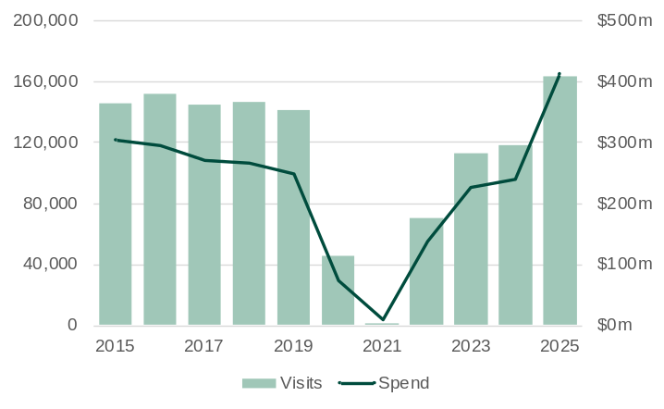
Source: Tourism Research Australia, International Visitor Survey.

- International visitors to Western Australia declined sharply from early 2020 due to COVID-19 travel restrictions, with the recovery beginning in 2022 at varying rates across markets.
  - In 2025, visitor numbers from the United Kingdom to Western Australia were 15.2% above pre-pandemic levels in 2019.
- The United Kingdom was Western Australia’s largest market for international visitors in 2025, with 163,098 visits (15.3% of the State’s total international visits).
  - Visitor numbers from the United Kingdom to Western Australia increased 38% in 2025.
- Visitors from the United Kingdom spent a total of $414 million in Western Australia in 2025, 73% higher than in 2024.
- On average, visitors from the United Kingdom spent $2,536 per visit in Western Australia in 2025, below the average of $3,188 per visit from all markets.

Student enrolments from the United Kingdom in Western Australia
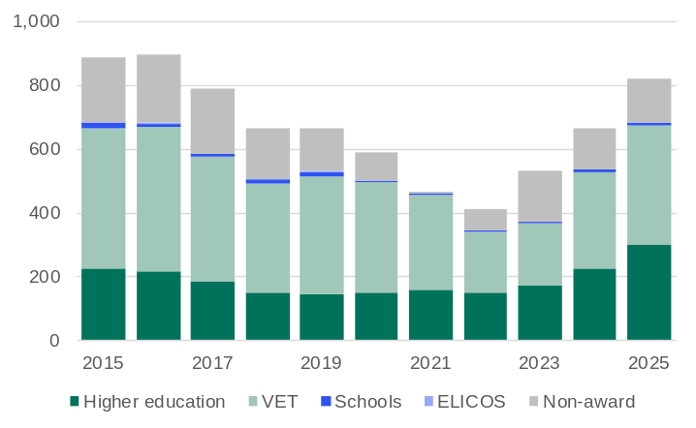
Note: Year to date in December. VET = Vocational education and training. ELICOS = English language intensive courses for overseas students. Non-award = Foundation courses or study abroad and exchange programs.
Source: Australian Department of Education and Training, International Education Data and Research.

- International student enrolments in Western Australia dropped sharply in 2020 and 2021 due to COVID-19 travel restrictions but began recovering in 2022 and climbed to record highs in 2024 and 2025, with growth varying across markets.
  - In 2025, student enrolments from the United Kingdom in Western Australia were 24% above pre-pandemic levels in 2019.
- The United Kingdom was Western Australia’s 21st largest market for international students in 2025, with 822 enrolments (0.9% of the State’s total international student enrolments).
  - Student enrolments from the United Kingdom in Western Australia increased 24% in 2025.
- Most students from the United Kingdom in Western Australia in 2025 were enrolled in either vocational education and training (45%) or higher education (36%).

Western Australian residents born in the United Kingdom
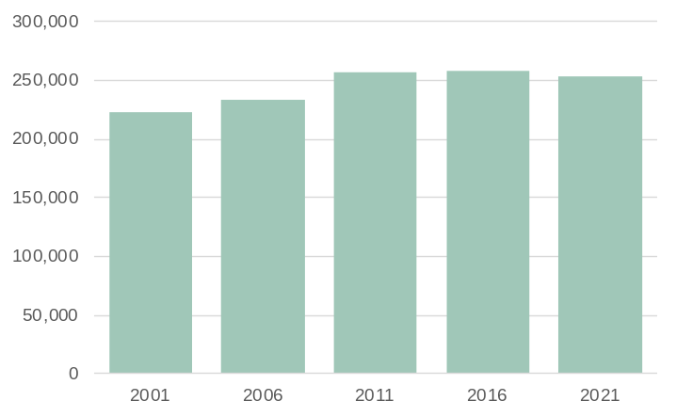
Note: Population counts as of June.
Source: Based on data from ABS Australia’s Population by Country of Birth.

- Western Australia had 253,440 residents in 2021 who were born in the United Kingdom, 1.5% less than in 2016.
- People born in the United Kingdom accounted for 27.0% of Western Australia’s overseas-born resident population in 2021, below the 28.7% share in 2016.
- People born in the United Kingdom were the largest overseas-born resident population in Western Australia in 2021.

Malaysia-Western Australia trade relationship | Back to contents
Western Australia’s trade relationship with Malaysia has evolved in a similar way to its relationships with other developed economies in Asia, with trade flows increasing as Malaysia’s economy developed and industrialised, and as Western Australia expanded production in its main export industries. This has been supported by trade liberalisation and agreements, including the Malaysia–Australia Free Trade Agreement in 2013, and the Comprehensive Strategic Partnership between Australia and Malaysia in 2021.
Trade in goods between Western Australia and Malaysia in recent years has been centred around petroleum. Western Australia exports crude oil and condensate to Malaysia, and at times LNG (noting Malaysia is itself a net exporter of LNG). Malaysia is one of Western Australia’s largest sources of refined petroleum imports, particularly diesel, which is used in large volumes in Western Australian industry, with this trade growing in importance since the closure of the BP Kwinana refinery.
Western Australia’s other exports to Malaysia include metals such as iron ore and alumina, and agri-food products such as wheat and meat. Battery and critical minerals are likely to become an increasingly significant part of the relationship, with Western Australia exporting rare earth concentrate to Malaysia from Lynas’s Mt Weld mine to its advanced materials plant in Malaysia for processing. Western Australia also imports a range of machinery, equipment and manufactured goods from Malaysia.
Malaysia has historically been a large market for Western Australia’s main services exports of tourism and international education, although numbers in both these sectors have fallen in recent years. Prior to the COVID-19 pandemic in 2019, Malaysia was Western Australia’s third largest source of international student enrolments, but a fall in enrolments from Malaysia combined with growth in enrolments from other countries led to its ranking falling to 14th in 2025.

Western Australia’s trade in goods with Malaysia
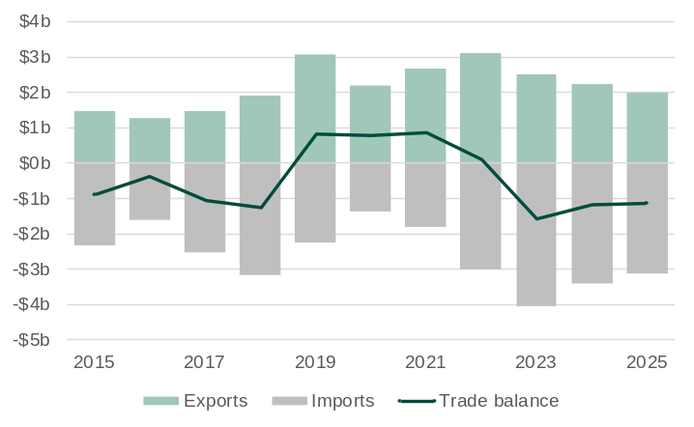
Note: Imports are shown as negative values because they are an outflow of expenditure from the economy.
Source: Based on data from ABS International Trade in Goods.

- Western Australia’s balance of goods trade with Malaysia has changed from deficit to surplus and then back to deficit in recent years, largely due to Western Australia importing more refined petroleum oil from Malaysia following the closure of the Kwinana oil refinery in 2021.
- The value of Western Australia’s goods exports to Malaysia was $2.0 billion in 2025, 11.1% less than in 2024.
- The value of Western Australia’s goods imports from Malaysia was $3.1 billion in 2025, 8.4% less than in 2024.
- The fall in the value of both exports and imports in 2025 can be largely explained by lower average oil prices in 2025 compared to 2024, which led to lower values of both petroleum exports and imports.

Western Australia-Malaysia main commodities traded: 2025
The tables below show the values for the main commodities traded between Western Australia and Malaysia in 2025.
Exports | Value ($m) | Share (%) | Imports⁵ | Value ($m) | Share (%)
Petroleum¹ | 393 | 19.8 | Refined petroleum oils | 2,090 | 67.1
Base metals | 278 | 13.9 | Tubes and pipes | 79 | 2.5
Gold ore² | 253 | 12.7 | Civil engineering plant and equipment | 53 | 1.7
Inorganic chemicals³ | 206 | 10.3 | Automatic data processing machines | 40 | 1.3
Wheat | 171 | 8.6 | Lime and cement clinkers | 32 | 1.0
Mineral sands⁴ | 169 | 8.5 | Fertilisers | 31 | 1.0
Iron ore | 151 | 7.6 | Materials of rubber | 30 | 1.0
Alumina | 88 | 4.4 | Industrial machinery and equipment | 30 | 1.0
Meat (lamb) | 66 | 3.3 | Insecticides and similar products. | 21 | 0.7
Nickel | 22 | 1.1 | Plastic materials for food | 20 | 0.6
All other exports | 194 | 9.8 | All other imports | 688 | 22.1
Total exports | 1,991 | 100.0 | Total imports | 3,113 | 100.0
Share of Western Australia’s exports | 0.8% |  | Share of Western Australia’s imports | 5.8%
Ranking as an export market | 12 |  | Ranking as an import market | 5
1. Liquefied natural gas, condensate, crude oil and liquefied petroleum gas. 2. May include other precious metal ore. 3.Mainly inorganic base chemicals (hydroxides). 4. Titanium and zirconium ores. 5. Excludes confidential import items of mainly articles of iron and steel, and electrical machinery and equipment, although the value of these items is included in the total.
Source: Based on. data from ABS International Trade in Goods and Services, Australia; and Department of Home Affairs, Integrated Cargo System data.

Visits from Malaysia to Western Australia
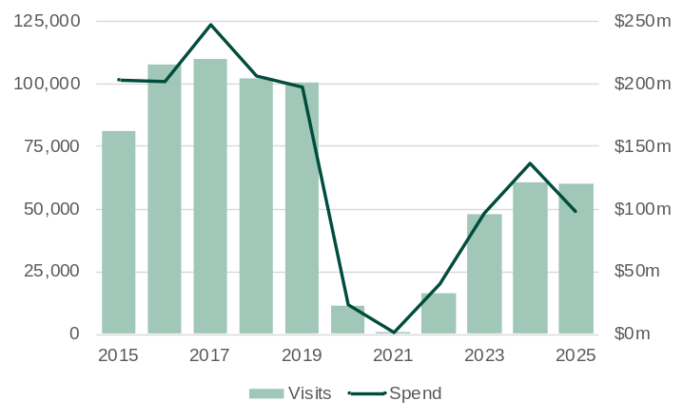
Source: Tourism Research Australia, International Visitor Survey.

- International visitors to Western Australia declined sharply from early 2020 due to COVID-19 travel restrictions, with the recovery beginning in 2022 at varying rates across markets.
  - In 2025, visitor numbers from Malaysia to Western Australia were 40% below pre-pandemic levels in 2019.
- Malaysia was Western Australia’s 5th largest market for international visitors in 2025, with 60,198 visits (5.6% of the State’s total international visits).
  - Visitor numbers from Malaysia to Western Australia fell 0.7% in 2025.
- Visitors from Malaysia spent a total of $98 million in Western Australia in 2025, 28% less than in 2024.
- On average, visitors from Malaysia spent $1,623 per visit in Western Australia in 2025, below the average of $3,188 per visit from all markets.

Student enrolments from Malaysia in Western Australia
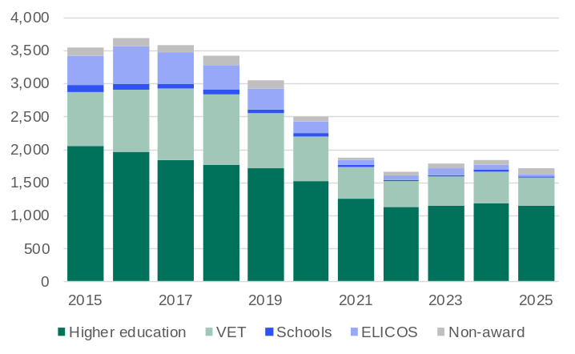
Note: Year to date in December. VET = Vocational education and training. ELICOS = English language intensive courses for overseas students. Non-award = Foundation courses or study abroad and exchange programs.
Source: Australian Department of Education and Training, International Education Data and Research.

- International student enrolments in Western Australia dropped sharply in 2020 and 2021 due to COVID-19 travel restrictions but began recovering in 2022 and climbed to record highs in 2024 and 2025, with growth varying across markets.
  - In 2025, student enrolments from Malaysia in Western Australia were 44% below pre-pandemic levels in 2019.
- Malaysia was Western Australia’s 14th largest market for international students in 2025, with 1,712 enrolments (1.9% of the State’s total international student enrolments).
  - Student enrolments from Malaysia in Western Australia fell 7.5% in 2025.
- Most students from Malaysia in Western Australia in 2025 were enrolled in higher education (67%), followed by vocational education and training (25%).

Western Australian residents born in Malaysia
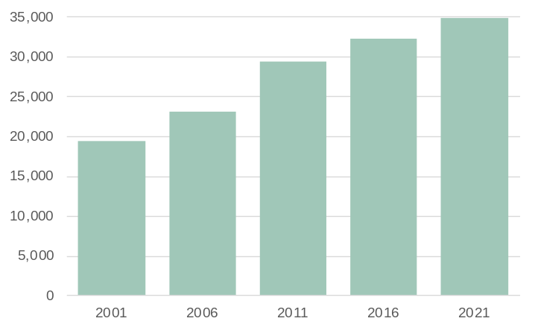
Note: Population counts as of June.
Source: Based on data from ABS Australia’s Population by Country of Birth.

- Western Australia had 34,800 residents in 2021 who were born in Malaysia, 7.9% more than in 2016.
- People born in Malaysia accounted for 3.7% of Western Australia’s overseas-born resident population in 2021, slightly above the 3.6% share in 2016.
- People born in Malaysia were the 6th largest overseas-born resident population in Western Australia in 2021.

Indonesia-Western Australia trade relationship | Back to contents
Western Australia’s trade relationship with Indonesia has deep historical roots dating back to the 1700s and has evolved into a strategic economic partnership shaped by geography and complementary industries. Trade became more formalised in the 1970s, with Indonesia emerging as a major buyer of Western Australian wheat.
Western Australia now exports a diverse range of commodities to Indonesia, including energy, minerals and agri-food products. Petroleum, including crude oil and at times LNG (noting Indonesia is itself a net exporter of LNG), is a key export, supporting Indonesia’s growing energy demand and enhancing its energy security by reducing reliance on Middle Eastern and Southeast Asian suppliers. Western Australia is also a major supplier of wheat, live cattle, and beef, critical to Indonesia’s food security and agribusiness sector. Mineral exports such as iron ore, alumina, lithium, copper, and mineral sands support Indonesia’s infrastructure development and emerging battery manufacturing industry.
Western Australia imports a variety of goods from Indonesia, including machinery and electrical equipment for industrial and consumer use, as well as fertilisers that support the State’s agricultural production. The trade relationship is increasingly strategic due to geographic proximity, complementary economic strengths and shared interests in critical minerals and clean energy technologies. People-to-people links – through education, tourism and cultural exchange – further strengthen ties.

Western Australia’s trade in goods with Indonesia
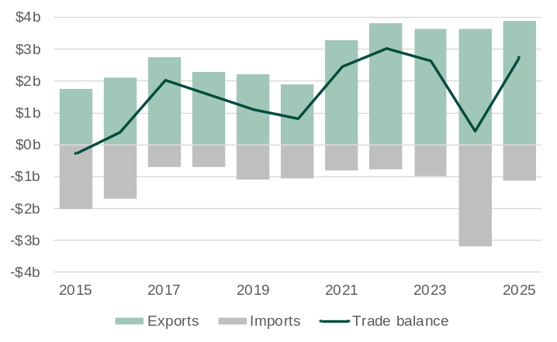
Note: Imports are shown as negative values because they are an outflow of expenditure from the economy.
Source: Based on data from ABS International Trade in Goods.

- Western Australia has a trade surplus with Indonesia as the value of its exports of commodities like petroleum, iron ore and wheat exceed the value of its imports from Indonesia such as machinery, equipment and refined petroleum products.
- The value of Western Australia’s goods exports to Indonesia was $3.9 billion in 2025, 7.1% higher than in 2024.
  - Western Australia’s exports of crude oil, LNG, and iron ore to Indonesia have risen over the past five years, driven by Indonesia’s rising fuel demand, a shift to natural gas for power generation and growth in steel production to support infrastructure development.
- The value of Western Australia’s goods imports from Indonesia was $1.1 billion in 2025, 65% lower than in 2024.
  - The large increase in Western Australia’s imports from Indonesia in 2024 was due mainly to the import of large industrial modules – including refrigeration compressor units and other LNG infrastructure – from Indonesia to Karratha for the Pluto LNG Train 2 project.

Western Australia-Indonesia main commodities traded: 2025
The tables below show the values for the main commodities traded between Western Australia and Indonesia in 2025.
Exports | Value ($m) | Share (%) | Imports² | Value ($m) | Share (%)
Petroleum¹ | 1,110 | 28.6 | Heating and cooling equipment | 183 | 16.2
Wheat | 977 | 25.1 | Manufactures of base metal | 58 | 5.2
Iron ore | 858 | 22.1 | Motor vehicle parts | 47 | 4.2
Live animals (cattle) | 189 | 4.9 | Industrial machinery and equipment | 45 | 4.0
Alumina | 173 | 4.5 | Lime and cement clinkers | 44 | 3.9
Lithium concentrate | 121 | 3.1 | Civil engineering plant and equipment | 30 | 2.7
Meat (beef) | 72 | 1.9 | Fertilisers | 29 | 2.6
Ferrous waste and scrap | 59 | 1.5 | Monitors and projectors | 28 | 2.5
Pulp and waste paper | 42 | 1.1 | Insecticides and similar products | 25 | 2.2
Pigments and paints | 41 | 1.1 | Paper and paperboard | 23 | 2.0
All other exports | 243 | 6.3 | All other imports | 615 | 54.6
Total exports | 3,886 | 100.0 | Total imports | 1,126 | 100.0
Share of Western Australia’s exports | 1.6% |  | Share of Western Australia’s imports | 2.1%
Ranking as an export market | 10 |  | Ranking as an import market | 13
1. Liquefied natural gas, condensate, crude oil and liquefied petroleum gas. 2. Excludes confidential import items of mainly articles of iron and steel, and machinery and mechanical parts, although the value of these items is included in the total.
Source: Based on. data from ABS International Trade in Goods and Services, Australia; and Department of Home Affairs, Integrated Cargo System data.

Visits from Indonesia to Western Australia
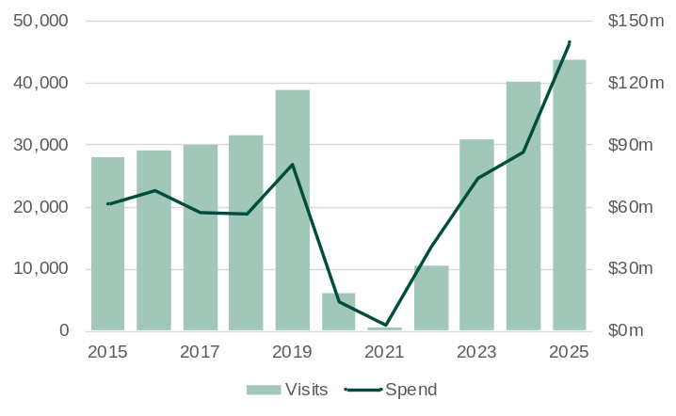
Source: Tourism Research Australia, International Visitor Survey.

- International visitors to Western Australia declined sharply from early 2020 due to COVID-19 travel restrictions, with the recovery beginning in 2022 at varying rates across markets.
  - In 2025, visitor numbers from Indonesia to Western Australia were 12.6% above pre-pandemic levels in 2019.
- Indonesia was Western Australia’s 8th largest market for international visitors in 2025, with 43,725 visits (4.1% of the State’s total international visits).
  - Visitor numbers from Indonesia to Western Australia increased 8.5% in 2025.
- Visitors from Indonesia spent a total of $140 million in Western Australia in 2025, 62% more than in 2024.
- On average, visitors from Indonesia spent $3,207 per visit in Western Australia in 2025, slightly above the average of $3,188 per visit from all markets.

Student enrolments from Indonesia in Western Australia
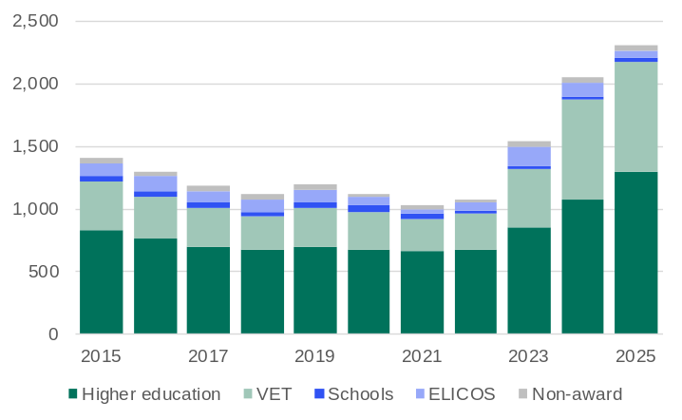
Note: Year to date in December. VET = Vocational education and training. ELICOS = English language intensive courses for overseas students. Non-award = Foundation courses or study abroad and exchange programs.
Source: Australian Department of Education and Training, International Education Data and Research.

- International student enrolments in Western Australia dropped sharply in 2020 and 2021 due to COVID-19 travel restrictions but began recovering in 2022 and climbed to record highs in 2024 and 2025, with growth varying across markets.
  - In 2025, student enrolments from Indonesia in Western Australia were 92% above pre-pandemic levels in 2019.
- Indonesia was Western Australia’s 12th largest market for international students in 2025, with 2,306 enrolments (2.6% of the State’s total international student enrolments).
  - Student enrolments from Indonesia in Western Australia increased 12.3% in 2025.
- Most students from Indonesia in Western Australia in 2025 were enrolled in higher education (56%), followed by vocational education and training (38%).

Western Australian residents born in Indonesia
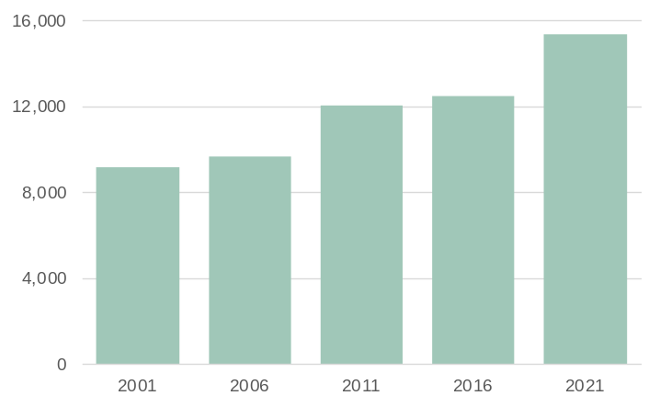
Note: Population counts as of June.
Source: Based on data from ABS Australia’s Population by Country of Birth.

- Western Australia had 15,350 residents in 2021 who were born in Indonesia, 23% more than in 2016.
- People born in Indonesia accounted for 1.6% of Western Australia’s overseas-born resident population in 2021, above the 1.4% share in 2016.
- People born in Indonesia were the 12th largest overseas-born resident population in Western Australia in 2021.

ASEAN-Western Australia trade relationship | Back to contents
The foundation for long-term economic cooperation between Australia and the Association of Southeast Asian Nations (ASEAN) was set in 1974 when Australia became ASEAN’s first dialogue partner. Initially focused on bilateral facilitation, the relationship evolved in the 1990s toward regional integration, culminating in the ASEAN-Australia-New Zealand Free Trade Agreement, which came into force in 2010 and significantly reduced tariffs and enhanced trade flows.
ASEAN has since become a major trading partner for Western Australia, offering a diversified export market for goods such as petroleum, iron ore, gold and wheat, reflecting ASEAN’s energy, industrial and food security needs. Services including tourism, education, training and technical expertise also contribute to mutual economic development. ASEAN is particularly important as a source of refined petroleum products, supplying diesel and aviation fuel critical to Western Australia’s transport, mining and agricultural sectors. The proximity of Southeast Asia to Western Australia and refining capacity in ASEAN countries make imports cost-effective and reliable, with ASEAN’s role expected to grow as its energy infrastructure expands.
Meanwhile, trade patterns within ASEAN have undergone significant transformation with Singapore, Malaysia and Indonesia emerging as major trading hubs. Singapore leads in intra-regional trade, particularly in electrical machinery and equipment, while Malaysia also plays a major role in exporting similar goods. Indonesia offers goods such as palm oil, coal, rubber and manufactured products, along with services in tourism, logistics and digital technology. Vietnam has become ASEAN’s largest exporter overall, while Singapore is the top importer.
Alongside traditional trade, ASEAN is increasingly focusing on regional value chains and digital integration. As value chains and digitalisation accelerates, ASEAN’s trade is expected to become more interconnected, resilient and innovation driven. Western Australia is adapting to these changes by focusing on opportunities in emerging sectors such as low-carbon energy and battery minerals.

Western Australia’s trade in goods with ASEAN countries
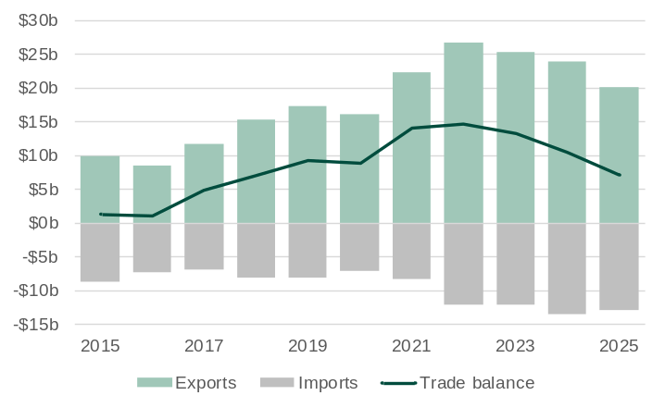
Note: Imports are shown as negative values because they are an outflow of expenditure from the economy.
Source: Based on data from ABS International Trade in Goods.

- Western Australia's trade surplus with ASEAN is maintained by the value of its exports of mainly LNG, iron ore, gold and wheat exceeding the value of its imports from ASEAN, including refined petroleum oils and motor vehicles.
- The value of Western Australia’s goods exports to ASEAN was $20.1 billion in 2025, 16.2% lower than in 2024.
  - The value of Western Australia’s exports to ASEAN has fluctuated over the past five years, primarily due to price volatility in commodities such as LNG and iron ore, which account for a large share of the State’s exports to the region.
- The value of Western Australia’s goods imports from ASEAN was $12.8 billion in 2025, 4.8% lower than in 2024.

Western Australia-ASEAN main commodities traded: 2025
The tables below show the values for the main commodities traded between Western Australia and ASEAN countries in 2025.
Exports | Value ($m) | Share (%) | Imports⁴ | Value ($m) | Share (%)
Petroleum¹ | 10,177 | 50.7 | Refined petroleum oils | 6,838 | 53.3
Wheat | 2,605 | 13.0 | Motor vehicles for transporting goods | 764 | 6.0
Iron ore | 2,413 | 12.0 | Non-monetary gold⁵ | 477 | 3.7
Non-monetary gold | 1,034 | 5.2 | Motor cars | 348 | 2.7
Gold ore² | 380 | 1.9 | Heating and cooling equipment | 344 | 2.7
Mineral sands³ | 312 | 1.6 | Edible products and preparations | 194 | 1.5
Base metals | 299 | 1.5 | Industrial machinery and equipment | 144 | 1.1
Live animals (cattle) | 266 | 1.3 | Manufactures of base metal | 130 | 1.0
Alumina | 261 | 1.3 | Lime and cement clinkers | 124 | 1.0
Ferrous waste and scrap | 243 | 1.2 | Civil engineering plant and equipment | 124 | 1.0
All other exports | 2,063 | 10.3 | All other imports | 3,337 | 26.0
Total exports | 20,053 | 100.0 | Total imports | 12,821 | 100.0
Share of Western Australia’s exports | 8.4% |  | Share of Western Australia’s imports | 23.8%
Ranking as an export market | n.a. |  | Ranking as an import market | n.a.
1. Liquefied natural gas, condensate, crude oil and liquefied petroleum gas. 2. May include other precious metal ore. 3. Titanium and zirconium ores. 4. Excludes confidential import items of mainly articles of iron and steel, and machinery and mechanical parts, although the value of these items is included in the total. 5. Western Australia imports non-monetary gold from other countries primarily for refining into high-purity products such as gold bars and coins at the Perth Mint, which are then re-exported globally. n.a. = not applicable.
Source: Based on. data from ABS International Trade in Goods and Services, Australia; and Department of Home Affairs, Integrated Cargo System data.

Western Australia’s export of goods to ASEAN countries
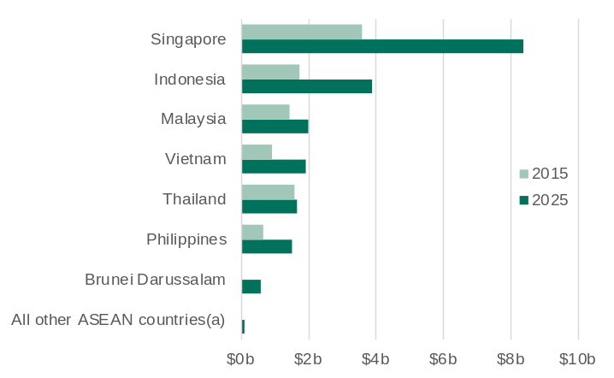
(a) Myanmar, Cambodia, Laos and Timor Leste.
Source: Based on. data from ABS International Trade in Goods and Services, Australia.

- The value of Western Australia’s exports of goods to ASEAN countries more than doubled over the past 10 years, from $9.9 billion in 2015 to $20.1 billion in 2025. The increase was driven by rising demand for petroleum (especially LNG), iron ore and gold, alongside strong growth in agri-food.
- Singapore accounted for 42% of the value of Western Australia’s exports to ASEAN countries in 2025, followed by Indonesia (19%), Malaysia (10%), Vietnam (10%), Thailand (8%) and the Philippines (8%).
- Western Australia’s exports to individual ASEAN countries reflect the different trade needs of each country: petroleum products have been concentrated in Singapore, Thailand, Indonesia and Malaysia due to energy and industrial demand; iron ore exports have been limited but growing to Vietnam and Indonesia for construction and manufacturing; gold exports have steadily risen with Singapore a key refining and trading hub; and exports of agri-food products like wheat and livestock have grown to Indonesia and the Philippines, supporting food security and population growth.

Western Australia’s petroleum¹ exports to ASEAN countries
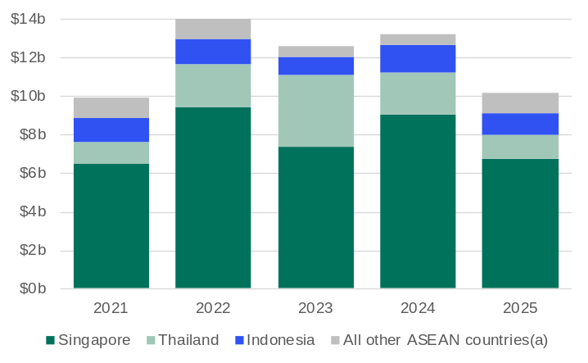
1. Liquefied natural gas, condensate, crude oil and liquefied petroleum gas. (a) Brunei Darussalam, Malaysia, Philippines, Vietnam, Timor-Leste, Myanmar, Cambodia and Laos.
Source: Based on. data from ABS International Trade in Goods and Services, Australia; and Department of Home Affairs, Integrated Cargo System data.

- Western Australia's petroleum exports to ASEAN are primarily LNG with condensate, crude oil and LPG also exported.
- The volume of Western Australia’s petroleum exports to ASEAN has been relatively steady over the past five years, with changes in prices leading to fluctuations in the value of these exports.
- ASEAN accounted for 25% of the value of Western Australia’s petroleum exports in 2025, a share that has been relatively stable over the past five years. Within ASEAN, the largest markets in 2025 were Singapore (66%), Thailand (12%), and Indonesia (11%).

Western Australia’s imports of goods from ASEAN countries
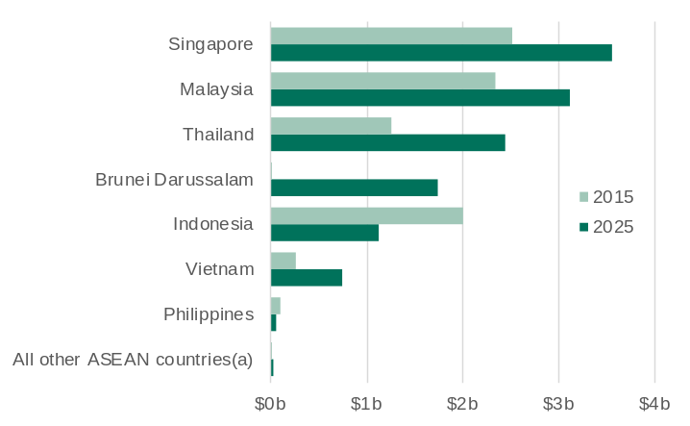
(a) Myanmar, Cambodia, Laos and Timor-Leste.
Source: Based on. data from ABS International Trade in Goods and Services, Australia.

- The value of Western Australia's imports from ASEAN countries increased by 50% over the past 10 years, from $8.6 billion in 2015 to $12.8 billion in 2025. The increase was driven by demand for refined petroleum products following the Kwinana oil refinery closure in 2021, as well as imports of electronics, machinery and consumer goods.
  - The biggest increase in imports over the past 10 years has been from Brunei Darussalam, from $24 million in 2015 to $1.7 billion in 2025. Over 98% of the value of Western Australia’s imports from Brunei Darussalam in 2025 was from refined petroleum products.
- Singapore accounted for 28% of the value of Western Australia’s imports from ASEAN countries in 2025, followed by Malaysia (24%), Thailand (19%), Brunei Darussalam (14%) and Indonesia (9%).

Visits from ASEAN countries to Western Australia
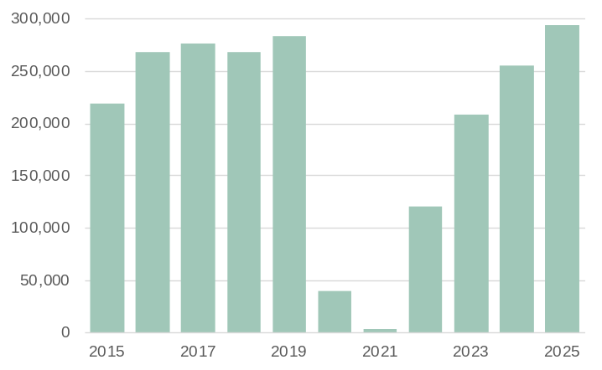
Note: Visitor spend is not shown as data is not available for all ASEAN countries.
Source: Tourism Research Australia, International Visitor Survey.

- International visitors to Western Australia declined sharply from early 2020 due to COVID-19 travel restrictions, with the recovery beginning in 2022 at varying rates across markets.
  - In 2025, visitor numbers from ASEAN countries to Western Australia were 3.6% above pre-pandemic levels in 2019.
- ASEAN is a large international visitor market for Western Australia, with 293,362 visits in 2025 (27.5% of the State’s total international visits).
  - Visitor numbers from ASEAN countries to Western Australia increased 15.1% in 2025.

Student enrolments from ASEAN countries in Western Australia
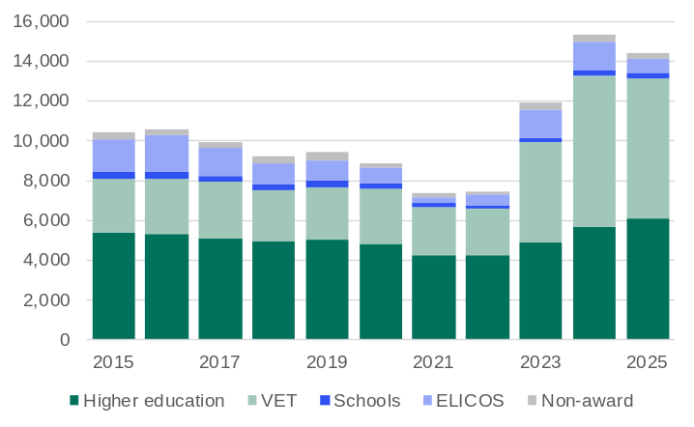
Note: Year to date in December. VET = Vocational education and training. ELICOS = English language intensive courses for overseas students. Non-award = Foundation courses or study abroad and exchange programs.
Source: Australian Department of Education and Training, International Education Data and Research.

- International student enrolments in Western Australia dropped sharply in 2020 and 2021 due to COVID-19 travel restrictions but began recovering in 2022 and climbed to record highs in 2024 and 2025, with growth varying across markets.
  - In 2025, student enrolments from ASEAN countries in Western Australia were 53% above pre-pandemic levels in 2019.
- ASEAN is a large international student market for Western Australia, with 14,432 enrolments in 2025 (16.1% of the State’s total international student enrolments).
  - Student enrolments from ASEAN countries in Western Australia fell 5.9% in 2025.
- Most students from ASEAN countries in Western Australia in 2025 were enrolled in either vocational education and training (49%) or higher education (42%).

Western Australian residents born in ASEAN countries
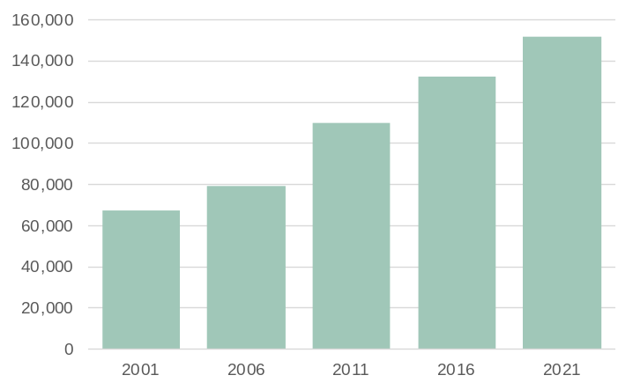
Note: Population counts as of June.
Source: Based on data from ABS Australia’s Population by Country of Birth.

- Western Australia had 151,960 residents in 2021 who were born in ASEAN countries, 15.0% more than in 2016.
- People born in ASEAN countries accounted for 16.2% of Western Australia’s overseas-born resident population in 2021, above the 14.8% share in 2016.
- The Philippines (40,470) accounted for the largest number of ASEAN-born residents in Western Australia in 2021, followed by Malaysia (34,800) and Vietnam (19,920).

EU-Western Australia trade relationship | Back to contents
Western Australia’s trade relationship with the European Union (EU) has evolved from a historically distant engagement into a growing and strategically important partnership. At a national level, the 1990s marked a turning point with closer diplomatic and economic ties. The EU has become a significant trading partner for Western Australia outside of Asia, with major goods exported including canola seeds, gold, mineral sands and other minerals, reflecting the EU’s demand for agricultural products and strategic minerals essential for its clean energy agenda. Imports from the EU consist mainly of machinery and transport equipment supporting Western Australia’s industrial and resource sectors.
Services trade is also growing, particularly in tourism and professional services, with the EU being a large tourism export market for Western Australia. The Australia-EU Framework Agreement, which entered into force in 2022, and the Strategic Partnership on critical raw materials signed in 2024, are expected to deepen cooperation and trade. As the EU accelerates its green and digital transitions, Western Australia is well positioned to supply the critical minerals and expertise needed, particularly in battery minerals, renewable energy and low-carbon technologies.
Formal negotiations for a Free Trade Agreement (FTA) between Australia and the EU began in 2018, with both parties announcing the conclusion of negotiations in March 2026 for the Australian-European Union Free Trade Agreement. The agreement will result in 98 per cent of the current value of Australia’s exports entering the European Union duty free and support investment in both directions.

Western Australia’s trade in goods with EU countries
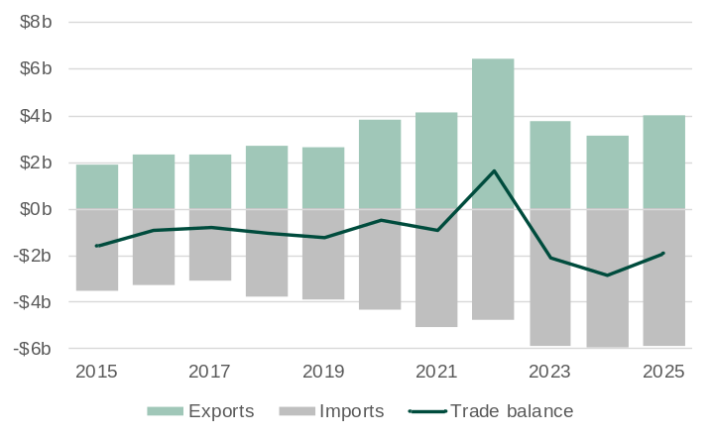
Note: Imports are shown as negative values because they are an outflow of expenditure from the economy.
Source: Based on data from ABS International Trade in Goods.

- Western Australia generally has a trade deficit with the EU because the value of its exports – mainly agricultural goods and raw materials – is less than the value of its imports such as machinery and transport equipment.
  - Western Australia had a small trade surplus with the EU in 2022 due to a large increase in the value of exports of canola seeds, which was driven by strong demand in many EU countries for canola for biodiesel production amid reduced supply from Canada and declining EU harvests.
- The value of Western Australia’s goods exports to the EU was $4.0 billion in 2025, 29% higher than in 2024.
- The value of Western Australia’s goods imports from the EU was $5.9 billion in 2025, 0.8% lower than in 2024.

Western Australia-EU main commodities traded: 2025
The tables below show the values for the main commodities traded between Western Australia and EU countries in 2025.
Exports | Value ($m) | Share (%) | Imports⁶ | Value ($m) | Share (%)
Canola seeds | 1,677 | 41.8 | Civil engineering plant and equipment | 774 | 13.1
Gold coin | 1,044 | 26.0 | Motor vehicles for transporting goods | 431 | 7.3
Mineral sands¹ | 326 | 8.1 | Motor cars | 313 | 5.3
Pigments and paints | 139 | 3.5 | Industrial machinery and equipment | 203 | 3.5
Non-monetary gold | 136 | 3.4 | Aircraft and associated equipment | 184 | 3.1
Gold ore² | 128 | 3.2 | Mechanical handling equipment | 167 | 2.8
Animal feed³ | 76 | 1.9 | Pumps for air or gas | 159 | 2.7
Natural abrasives⁴ | 48 | 1.2 | Silver and platinum | 157 | 2.7
Inorganic chemicals⁵ | 43 | 1.1 | Motor vehicle parts | 155 | 2.6
Ships, boats and floating structures | 39 | 1.0 | Measuring and checking instruments | 149 | 2.5
All other exports | 361 | 9.0 | All other imports | 3,197 | 54.3
Total exports | 4,017 | 100.0 | Total imports | 5,889 | 100.0
Share of Western Australia’s exports | 1.7% |  | Share of Western Australia’s imports | 10.9%
Ranking as an export market | n.a. |  | Ranking as an import market | n.a.
1. Titanium and zirconium ores. 2. May include other precious metal ore. 3. Mainly hay and lupins. 4. Mainly garnet. 5. Mainly silicon. 6. Excludes confidential import items of mainly machinery and mechanical parts, and articles of iron and steel, although the value of these items is included in the total. n.a. = not applicable.
Source: Based on. data from ABS International Trade in Goods and Services, Australia; and Department of Home Affairs, Integrated Cargo System data.

Western Australia’s exports of goods to EU countries
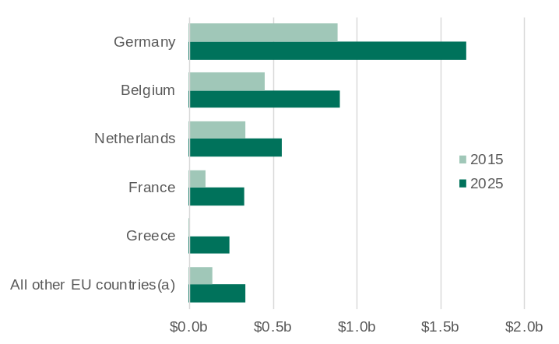
(a) Spain, Finland, Italy, Portugal, Sweden, Poland, Denmark, Austria, Bulgaria, Czechia, Ireland, Slovakia, Romania, Luxembourg, Estonia, Latvia, Hungary, Slovenia, Malta, Croatia, Lithuania and Cyprus.
Source: Based on. data from ABS International Trade in Goods and Services, Australia.

- The value of Western Australia’s exports of goods to EU countries more than doubled over the past 10 years, from $1.9 billion in 2015 to $4.0 billion in 2025.
- Germany accounted for 40% of the value of Western Australia’s exports to EU countries in 2025, followed by Belgium (22%), the Netherlands (13%), France (12%) and Greece (4%).
- Western Australia's exports to the EU over the past decade have been concentrated in key commodities including canola seeds, gold, minerals and agri-food products. Demand has been driven by the EU’s need for sustainable energy inputs, gold primarily for monetary reserves, investment and jewellery fabrication, raw materials for refining and re-export, and food products.

Western Australia’s canola seed exports to EU countries
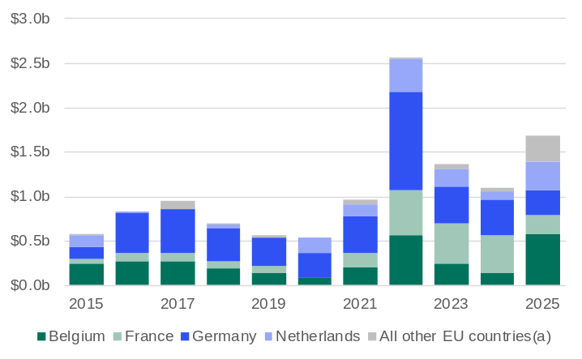
(a) Greece, Spain and Portugal in 2025.
Source: Based on. data from ABS International Trade in Goods and Services, Australia.

- Western Australia has grown the value of its exports of canola seeds to EU countries over the past decade. This has been driven by strong European demand for non-genetically modified biodiesel feedstocks and supported by Western Australia’s low emissions, International Sustainability and Carbon Certification assurance and rain-fed farming that meet EU sustainability standards.
- The value of Western Australia’s canola seeds exports to EU countries in 2025 was $1.7 billion.
  - The highest value of Western Australia’s canola seeds exports to EU countries in a calendar year was $2.6 billion in 2022, when many EU countries were seeking alternative fuels amid much higher prices for oil and gas.
- In 2025, EU countries accounted for 62% of the value of Western Australia’s canola seeds exports. Within the EU, the largest markets in 2025 were Belgium (34%), the Netherlands (19%) and Germany (16%).

Western Australia’s imports of goods from EU countries
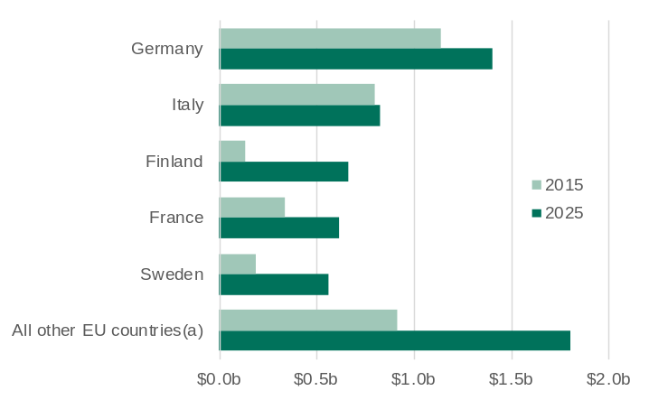
(a) Spain, Netherlands, Poland, Denmark, Belgium, Czechia, Austria, Slovakia, Hungary, Ireland, Portugal, Romania, Lithuania, Greece, Slovenia, Estonia, Bulgaria, Croatia, Latvia, Luxembourg, Cyprus and Malta.
Source: Based on. data from ABS International Trade in Goods and Services, Australia.

- The value of Western Australia’s imports from EU countries increased by 67% between 2015 and 2025.
- Germany accounted for 24% of the value of Western Australia’s imports from EU countries in 2025, followed by Italy (14%), Finland (11%), France (11%) and Sweden (10%).
- The value of Western Australia's imports from Finland, France and Sweden have increased substantially over the past decade, driven by demand for specialised machinery, motor vehicles and equipment to support the State’s mining industry and infrastructure projects. France also contributed luxury goods and advanced technologies, with growing collaboration in aerospace (Airbus products), renewables and critical minerals.

Visits from EU countries to Western Australia
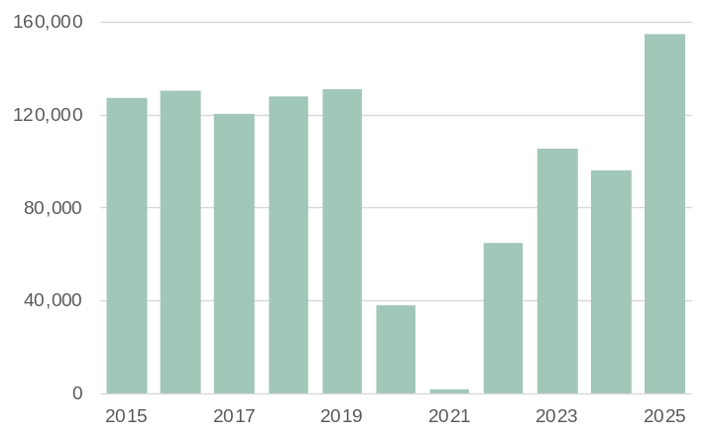
Note: Visitor spend is not shown as data is not available for all EU countries.
Source: Tourism Research Australia, International Visitor Survey.

- International visitors to Western Australia declined sharply from early 2020 due to COVID-19 travel restrictions, with the recovery beginning in 2022 at varying rates across markets.
  - In 2025, visitor numbers from EU countries were 18.0% above pre-pandemic levels in 2019.
- The EU is a large international visitor market for Western Australia’s, with 154,972 visits in 2025 (14.5% of the State’s total international visits).
  - Visitor numbers from EU countries to Western Australia increased 61% in 2025.

Student enrolments from EU countries in Western Australia
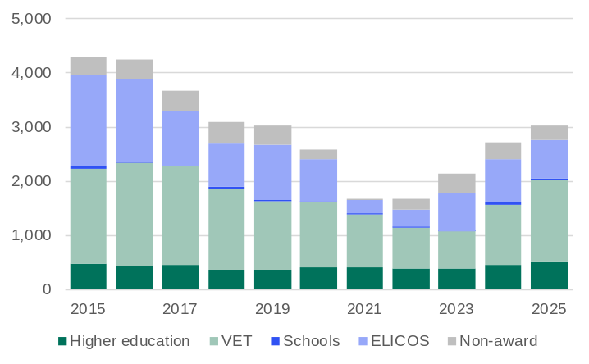
Note: Year to date in December. VET = Vocational education and training. ELICOS = English language intensive courses for overseas students. Non-award = Foundation courses or study abroad and exchange programs.
Source: Australian Department of Education and Training, International Education Data and Research.

- International student enrolments in Western Australia dropped sharply in 2020 and 2021 due to COVID-19 travel restrictions but began recovering in 2022 and climbed to record highs in 2024 and 2025, with growth varying across markets.
  - In 2025, student enrolments from EU countries were 0.1% below pre-pandemic levels in 2019.
- The EU is a relatively small international student market for Western Australia, with 3,027 enrolments in 2025 (3.4% of the State’s total international student enrolments).
  - Student enrolments from EU countries in Western Australia increased 11.7% in 2025.
- Most students from EU countries in Western Australia in 2025 were enrolled in either vocational education and training (50%) or intensive English language courses (23%).

Western Australian residents born in EU countries
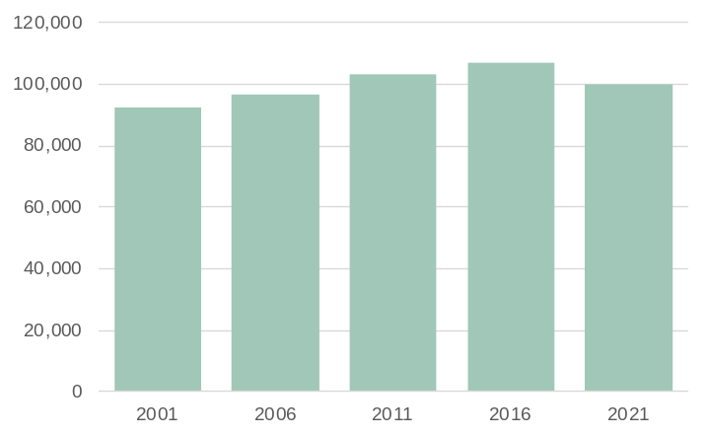
Note: Population counts as of June.
Source: Based on data from ABS Australia’s Population by Country of Birth.

- Western Australia had 99,680 residents in 2021 who were born in EU countries, 6.6% less than in 2016.
- People born in EU countries accounted for 10.6% of Western Australia’s overseas-born resident population in 2021, below the 11.9% share in 2016.
- Ireland (19,910) accounted for the largest number of EU-born residents in Western Australia in 2021, followed by Italy (19,280) and Germany (12,390).

GCC-Western Australia trade relationship | Back to contents
Western Australia began exporting live sheep to Gulf Cooperation Council (GCC) countries in the 1960s, with Kuwait receiving the first major shipment in 1960. The trade expanded significantly through the 1970s and 1980s to meet growing demand for fresh meat, becoming economically important for Western Australian sheep farmers and supported by GCC food subsidy programs. Despite periodic suspensions due to animal welfare concerns, the trade persisted for decades but is now in decline, with a legislated federal ban set to end live sheep exports by sea from Australia by 1 May 2028.
The establishment of the Invest and Trade WA office in Dubai in 2002 marked a strategic shift toward broader engagement across sectors and has facilitated broader trade between Western Australia and GCC countries. Exports such as alumina (used in aluminium production), canola seeds, wheat, meat, and barley have supported the region’s industrial manufacturing and food security. Alumina is especially critical for smelters in Bahrain, the UAE, Oman, and Qatar, while agri-food exports meet growing demand for high-quality produce. Saudi Arabia and the UAE emerged as key alternative markets for Western Australia’s barley exports, during the period in which China imposed an 80.5 per cent tariff on imports of Australian barley. This helped maintain export volumes and revenue for Western Australian exporters during a period of disruption.
The value of Western Australia’s imports from GCC countries fell from 2020, as the closure of the Kwinana refinery led to the State no longer importing crude oil. Western Australia does import refined petroleum from GCC countries, mostly the UAE, but the bulk of Western Australia’s petroleum imports are now from Asia. Fertiliser has emerged as Western Australia’s highest value import from the GCC, particularly from Saudi Arabia, which is increasingly important to Western Australian agriculture.

Western Australia’s trade in goods with GCC countries
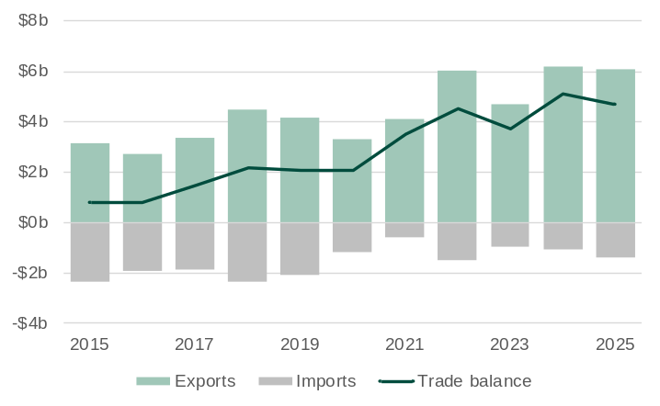
Note: Imports are shown as negative values because they are an outflow of expenditure from the economy.
Source: Based on data from ABS International Trade in Goods.

- Western Australia’s trade surplus with the GCC has been driven by rising alumina exports, alongside increased agricultural exports – particularly canola seeds, wheat, meat, and barley – that address food security needs. The 2021 closure of the Kwinana oil refinery also reduced crude oil imports from the UAE, further widening the trade surplus.
- The value of Western Australia’s goods exports to the GCC was $6.1 billion in 2025, 1.1% lower than in 2024.
- The value of Western Australia’s goods imports from the GCC was $1.4 billion in 2025, 32% higher than in 2024.

Western Australia-GCC main commodities traded: 2025
The tables below show the values for the main commodities traded between Western Australia and GCC countries in 2025.
Exports | Value ($m) | Share (%) | Imports⁴ | Value ($m) | Share (%)
Alumina | 3,924 | 64.4 | Fertilisers | 782 | 55.8
Canola seeds | 610 | 10.0 | Refined petroleum oils | 370 | 26.4
Petroleum¹ | 494 | 8.1 | Inorganic chemicals⁵ | 65 | 4.7
Mineral sands² | 181 | 3.0 | Aluminium | 21 | 1.5
Barley | 178 | 2.9 | Jewellery | 16 | 1.2
Non-monetary gold | 176 | 2.9 | Manufactures of base metal | 8 | 0.6
Meat | 173 | 2.8 | Pumps for air or gas | 8 | 0.5
Wheat | 124 | 2.0 | Tubes, pipes and hoses | 7 | 0.5
Natural abrasives³ | 61 | 1.0 | Mechanical handling equipment | 6 | 0.4
Vegetables | 45 | 0.7 | Civil engineering plant and equipment | 6 | 0.4
All other exports | 123 | 2.0 | All other imports | 112 | 8.0
Total exports | 6,088 | 100.0 | Total imports | 1,401 | 100.0
Share of Western Australia’s exports | 2.6% |  | Share of Western Australia’s imports | 2.6%
Ranking as an export market | n.a. |  | Ranking as an import market | n.a.
1. Liquefied natural gas, condensate, crude oil and liquefied petroleum gas. 2. Titanium and zirconium ores. 3. Mainly garnet. 4. Excludes confidential import items of mainly articles of iron and steel, although the value of these items is included in the total. 5. Mainly sodium hydroxide (caustic soda) used in alumina and gold refining. n.a. = not applicable.
Source: Based on. data from ABS International Trade in Goods and Services, Australia; and Department of Home Affairs, Integrated Cargo System data.

Western Australia’s exports of goods to GCC countries
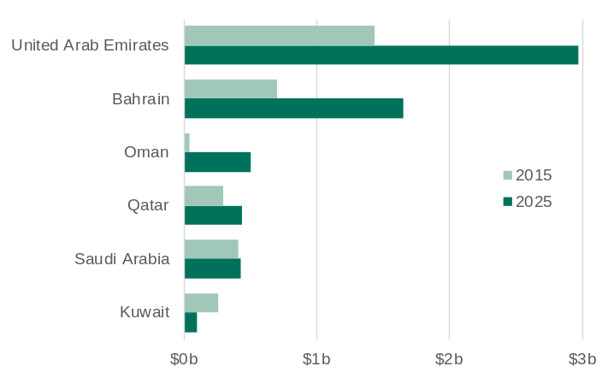
Source: Based on. data from ABS International Trade in Goods and Services, Australia.

- The value of Western Australia’s export of goods to GCC countries almost doubled from 2015 to 2025, driven by rising demand for alumina to support expanding aluminium smelting industries.
- The GCC is a significant and growing agri-food export market for Western Australia, due to their food security strategies and investment in processing and re-export infrastructure. The UAE imports large volumes of wheat, meat and barley. Kuwait, Oman and Bahrain are also key destinations for wheat, while Saudi Arabia and Qatar import substantial quantities of meat. Kuwait also imports live sheep and Saudi Arabia imports barley.
- The UAE accounted for 49% of the value of Western Australia’s exports to GCC countries in 2025, followed by Bahrain (27%), Oman (8%), Qatar (7%), Saudi Arabia (7%) and Kuwait (2%).

Western Australia’s alumina exports to GCC countries
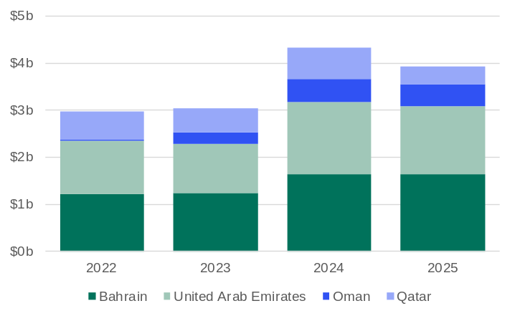
Source: Based on. data from ABS International Trade in Goods and Services, Australia.

- The GCC has become a major market for Western Australia's alumina exports, driven by its rapidly growing aluminium smelting industry, which leverages low-cost natural gas and produces from advanced facilities like Bahrain’s Alba Smelter and the UAE’s Emirates and Dubai Aluminium Smelters – among the largest globally – to supply markets around the world.
- The value of Western Australia’s alumina exports to GCC countries was $3.9 billion in 2025.
- GCC countries accounted for 55% of the value of Western Australia’s alumina exports in 2025. The largest markets within the GCC were Bahrain (47%), UAE (37%), Oman (12%) and Qatar (9%).

Western Australia’s imports of goods from GCC countries
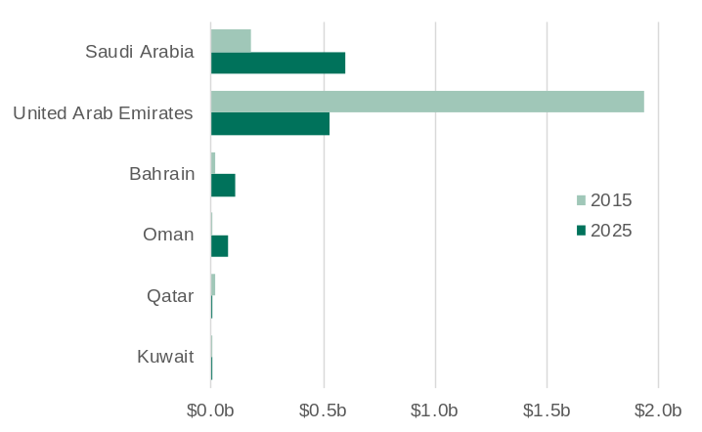
Source: Based on. data from ABS International Trade in Goods and Services, Australia.

- The value of Western Australia’s imports from GCC countries fell by 38% over the 10 years to 2025, largely driven by a sharp decline in imports from the UAE. This drop was primarily due to the closure of the Kwinana oil refinery in 2021, which had relied heavily on imported crude oil – especially Murban crude from Abu Dhabi – significantly reducing the State’s need for crude oil imports.
- Over the past decade, Western Australia’s fertiliser imports from Saudi Arabia and Oman have expanded significantly due to a structural shift in global supply chains, particularly following China's restrictions on ammonium phosphate exports. Saudi Arabia and Oman, employing their natural gas reserves and large-scale production of nitrogen-based fertilisers like urea and ammonia, have filled the gap, becoming key suppliers to Western Australia’s agricultural sector.

Visits from GCC countries to Western Australia
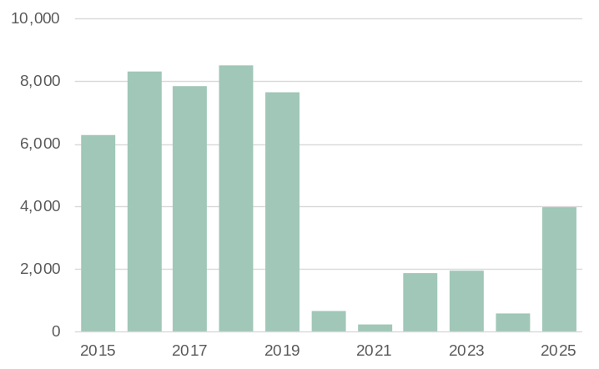
Note: Visitor spend is not shown as data is not available for all GCC countries.
Source: Tourism Research Australia, International Visitor Survey.

- International visitors to Western Australia declined sharply from early 2020 due to COVID-19 travel restrictions, with the recovery beginning in 2022 at varying rates across markets.
  - In 2025, visitor numbers from GCC countries to Western Australia were 48% below pre-pandemic levels in 2019.
- The GCC is not a large international visitor market for Western Australia, with 3,991 visits in 2025 (0.4% of the State’s total international visits).
  - Visitor numbers from GCC countries to Western Australia increased more than six-fold in 2025 (from a low base in 2024).

Student enrolments from GCC countries in Western Australia
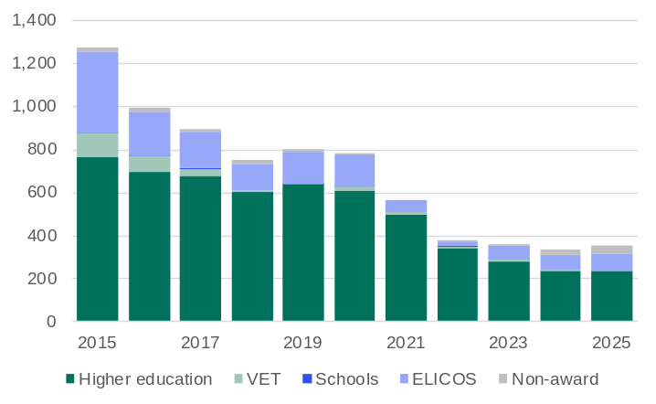
Note: Year to date in December. VET = Vocational education and training. ELICOS = English language intensive courses for overseas students. Non-award = Foundation courses or study abroad and exchange programs.
Source: Australian Department of Education and Training, International Education Data and Research.

- International student enrolments in Western Australia dropped sharply in 2020 and 2021 due to COVID-19 travel restrictions but began recovering in 2022 and climbed to record highs in 2024 and 2025, with growth varying across markets.
  - In 2025, student enrolments from GCC countries were 56% below pre-pandemic levels in 2019.
- The GCC is a small international student market for Western Australia, with 354 enrolments in 2025 (0.4% of the State’s total international student enrolments).
  - Student enrolments from GCC countries in Western Australia increased 6.0% in 2025.
- Most students from GCC countries in Western Australia in 2025 were enrolled in higher education (66%), followed by intensive English language courses (24%).

Western Australian residents born in GCC countries
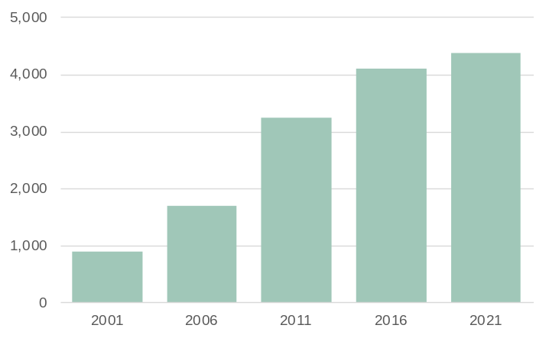
Note: Population counts as of June.
Source: Based on data from ABS Australia’s Population by Country of Birth.

- Western Australia had 4,370 residents in 2021 who were born in GCC countries, 6.6% more than in 2016.
- People born in GCC countries accounted for 0.5% of Western Australia’s overseas-born resident population in 2021, in line with the 0.5% share in 2016.
- The UAE (1,640) accounted for the largest number of GCC-born residents in Western Australia in 2021, followed by Saudi Arabia (1,230) and Kuwait (630).

Western Australia’s exports of goods by market ($billion)
Back to contents
The table below shows Western Australia’s top 20 goods export markets for 2025 and the value of exports to these markets for each year from 2015 to 2025. China has been Western Australia’s largest market for goods exports since 2006 when it overtook Japan, with its share of Western Australia’s total goods exports reaching a high of 60.7% in 2021. In 2025, over half of Western Australia’s top 20 export markets were in Asia, reflecting the State’s geographic proximity to Asia, its well-established regional trade ties and demand for mineral, energy and agrifood products from these markets.
The value of Western Australia’s exports, both in total and to individual markets, can fluctuate from year to year due to changes in prices for the State’s export commodities and changing market demand. An example of this was in 2025, when higher demand for Western Australian gold from the United States, combined with a higher gold price, led to a significant increase in the value of the State’s exports to the United States.
2025 rank | Market | 2015 | 2016 | 2017 | 2018 | 2019 | 2020 | 2021 | 2022 | 2023 | 2024 | 2025 | Share (%)
1 | China | 48.5 | 51.8 | 59.8 | 68.6 | 95.1 | 104.8 | 145.7 | 136.3 | 152.8 | 123.7 | 124.1 | 52.3
2 | Japan | 16.7 | 13.8 | 16.5 | 23.1 | 24.0 | 17.9 | 25.5 | 36.6 | 30.5 | 26.5 | 23.6 | 9.9
3 | South Korea | 7.1 | 6.1 | 7.1 | 8.6 | 10.4 | 10.3 | 15.8 | 20.0 | 16.0 | 15.8 | 17.4 | 7.3
4 | United States | 1.6 | 1.2 | 1.1 | 1.4 | 1.3 | 6.7 | 3.3 | 4.0 | 3.8 | 3.4 | 14.5 | 6.1
5 | Singapore | 3.6 | 2.3 | 3.6 | 6.2 | 7.5 | 7.6 | 9.5 | 12.6 | 9.9 | 12.0 | 8.4 | 3.5
6 | Hong Kong | 5.9 | 6.7 | 8.7 | 7.0 | 3.8 | 4.2 | 3.2 | 4.9 | 5.7 | 7.8 | 8.2 | 3.4
7 | Taiwan | 1.5 | 1.6 | 2.0 | 3.0 | 3.8 | 3.1 | 6.2 | 10.9 | 7.2 | 6.3 | 5.8 | 2.5
8 | India | 2.1 | 1.3 | 2.4 | 3.5 | 1.7 | 1.2 | 3.2 | 3.4 | 4.7 | 6.5 | 4.6 | 1.9
9 | United Kingdom | 1.0 | 7.5 | 3.5 | 2.2 | 12.4 | 12.1 | 1.8 | 0.3 | 2.9 | 5.7 | 4.0 | 1.7
10 | Indonesia | 1.7 | 2.1 | 2.8 | 2.3 | 2.2 | 1.9 | 3.3 | 3.8 | 3.6 | 3.6 | 3.9 | 1.6
11 | United Arab Emirates | 1.4 | 1.2 | 1.8 | 2.5 | 2.3 | 1.5 | 1.4 | 2.4 | 1.9 | 2.7 | 3.0 | 1.3
12 | Malaysia | 1.5 | 1.3 | 1.5 | 1.9 | 3.1 | 2.2 | 2.7 | 3.1 | 2.5 | 2.2 | 2.0 | 0.8
13 | Vietnam | 0.9 | 0.9 | 1.1 | 1.0 | 1.2 | 1.6 | 2.5 | 1.9 | 2.3 | 1.9 | 1.9 | 0.8
14 | Thailand | 1.6 | 1.1 | 1.6 | 2.9 | 1.6 | 1.3 | 2.5 | 3.0 | 4.2 | 2.2 | 1.7 | 0.7
15 | Bahrain | 0.7 | 0.6 | 0.8 | 1.3 | 1.0 | 0.8 | 1.1 | 1.2 | 1.3 | 1.7 | 1.7 | 0.7
16 | Germany | 0.9 | 1.4 | 1.2 | 1.3 | 1.3 | 2.1 | 2.0 | 3.1 | 1.5 | 1.4 | 1.7 | 0.7
17 | Philippines | 0.7 | 0.9 | 1.1 | 1.0 | 1.6 | 1.0 | 1.5 | 1.9 | 2.3 | 1.2 | 1.5 | 0.6
18 | South Africa | 0.7 | 0.4 | 0.7 | 1.0 | 0.8 | 0.6 | 0.7 | 0.8 | 0.8 | 1.1 | 1.1 | 0.4
19 | Belgium | 0.5 | 0.5 | 0.4 | 0.4 | 0.3 | 0.4 | 0.5 | 1.0 | 0.7 | 0.5 | 0.9 | 0.4
20 | Mozambique | 0.5 | 0.4 | 0.5 | 0.7 | 0.5 | 0.4 | 0.5 | 0.7 | 0.6 | 0.8 | 0.7 | 0.3
 | Other | 3.8 | 3.6 | 5.0 | 5.6 | 5.3 | 5.5 | 7.1 | 8.7 | 7.9 | 7.5 | 6.9 | 2.9
 | Total exports | 102.7 | 106.5 | 123.1 | 145.2 | 181.2 | 187.3 | 239.8 | 260.6 | 263.0 | 234.5 | 237.4 | 100.0
 | ASEAN | 10.0 | 8.5 | 11.7 | 15.2 | 17.3 | 16.1 | 22.4 | 26.6 | 25.3 | 23.9 | 20.1 | 8.4
 | EU | 1.9 | 2.4 | 2.3 | 2.7 | 2.6 | 3.8 | 4.2 | 6.4 | 3.8 | 3.1 | 4.0 | 1.7
 | GCC | 3.1 | 2.7 | 3.4 | 4.5 | 4.1 | 3.3 | 4.1 | 6.0 | 4.7 | 6.2 | 6.1 | 2.6
1. Mainland. 2. Special Administrative Region of China. Note: CAGR = Compound Average Growth Rate; ASEAN = Association of Southeast Asian Nations; EU = European Union (27 member states); GCC = Gulf Cooperation Council. Source: Based on data from ABS International Trade in Goods and Services, Australia.

Western Australia’s imports of goods by market ($billion)
Back to contents
The table below shows Western Australia’s top 20 goods import markets for 2025 and the value of imports from these markets for each year from 2015 to 2025. In 2025, over half of Western Australia’s top 20 import markets were in Asia, reflecting the geographic proximity of these markets to the State, competitive manufacturing costs in the region and strong trade relationships that support the supply of refined petroleum, machinery and transport equipment, intermediate inputs for local industries, electronics, and consumer goods.
Some of the major changes in the values and rankings of import markets over the past decade have been due to changes in petroleum prices, the shift in petroleum imports from crude oil to refined products from Southeast Asia – especially Malaysia and Brunei Darussalam – following the closure of the Kwinana Oil Refinery in 2021, changes in the volume of gold imports for processing at the Perth Mint, and the importation of specific, high-value capital equipment for the resources industry (for example, the import of the Prelude floating LNG vessel from South Korea in 2017).
2025 rank | Market | 2015 | 2016 | 2017 | 2018 | 2019 | 2020 | 2021 | 2022 | 2023 | 2024 | 2025 | Share (%)
1 | China¹ | 5.3 | 4.1 | 4.1 | 4.7 | 5.4 | 6.1 | 6.9 | 10.1 | 10.2 | 10.7 | 11.2 | 20.8
2 | United States | 3.0 | 2.9 | 2.4 | 2.6 | 4.4 | 4.6 | 3.7 | 4.6 | 6.9 | 7.1 | 6.5 | 12.0
3 | Singapore | 2.5 | 1.6 | 1.8 | 2.4 | 1.9 | 1.1 | 2.9 | 4.2 | 2.8 | 2.4 | 3.6 | 6.6
4 | Japan | 2.3 | 3.7 | 3.9 | 3.9 | 2.7 | 2.4 | 2.4 | 2.9 | 3.4 | 3.4 | 3.5 | 6.5
5 | Malaysia | 2.3 | 1.6 | 2.5 | 3.1 | 2.3 | 1.4 | 1.8 | 3.0 | 4.1 | 3.4 | 3.1 | 5.8
6 | Thailand | 1.3 | 1.9 | 1.4 | 1.4 | 2.3 | 2.7 | 1.6 | 1.7 | 2.0 | 2.2 | 2.5 | 4.5
7 | India | 0.5 | 0.3 | 0.5 | 0.4 | 0.4 | 0.7 | 1.4 | 1.7 | 1.4 | 2.6 | 2.2 | 4.1
8 | Brunei Darussalam | 0.0 | 0.0 | 0.0 | 0.0 | 0.1 | 0.4 | 0.8 | 1.7 | 1.7 | 1.7 | 1.7 | 3.2
9 | United Kingdom | 0.9 | 0.8 | 0.7 | 0.8 | 0.7 | 1.2 | 1.3 | 0.9 | 1.0 | 0.9 | 1.6 | 3.0
10 | Germany | 1.1 | 0.9 | 0.9 | 1.0 | 1.1 | 1.0 | 1.1 | 1.2 | 1.5 | 1.5 | 1.4 | 2.6
11 | Canada | 0.5 | 0.3 | 0.3 | 0.4 | 0.4 | 0.4 | 0.5 | 0.5 | 0.6 | 0.5 | 1.4 | 2.6
12 | South Korea | 3.9 | 1.3 | 8.7 | 0.6 | 0.6 | 0.6 | 1.1 | 2.7 | 2.2 | 1.7 | 1.3 | 2.5
13 | Indonesia | 2.0 | 1.7 | 0.7 | 0.7 | 1.1 | 1.1 | 0.8 | 0.8 | 1.0 | 3.2 | 1.1 | 2.1
14 | New Zealand | 0.9 | 0.8 | 0.7 | 0.7 | 0.7 | 0.6 | 0.5 | 0.6 | 0.7 | 0.7 | 1.1 | 2.0
15 | Taiwan | 0.3 | 0.3 | 0.3 | 0.2 | 0.2 | 0.3 | 0.4 | 1.1 | 0.8 | 1.1 | 1.0 | 1.9
16 | Italy | 0.8 | 0.6 | 0.5 | 0.6 | 0.6 | 0.6 | 0.6 | 0.7 | 0.9 | 0.9 | 0.8 | 1.5
17 | South Africa | 0.2 | 0.1 | 0.1 | 0.2 | 0.2 | 0.2 | 0.2 | 0.2 | 0.3 | 0.8 | 0.8 | 1.5
18 | Vietnam | 0.3 | 0.3 | 0.2 | 0.3 | 0.3 | 0.3 | 0.3 | 0.4 | 0.5 | 0.5 | 0.7 | 1.4
19 | Finland | 0.1 | 0.1 | 0.2 | 0.3 | 0.4 | 0.5 | 0.4 | 0.5 | 0.6 | 0.6 | 0.7 | 1.2
20 | France | 0.3 | 0.3 | 0.2 | 0.3 | 0.4 | 0.3 | 0.4 | 0.3 | 0.5 | 0.6 | 0.6 | 1.1
 | Other | 7.7 | 8.2 | 7.6 | 9.2 | 7.3 | 7.0 | 6.4 | 6.7 | 5.8 | 5.7 | 6.9 | 12.9
 | Total imports | 36.4 | 31.9 | 37.9 | 33.9 | 33.4 | 33.5 | 35.5 | 46.7 | 48.7 | 52.0 | 53.9 | 100.0
 | ASEAN | 7.3 | 7.3 | 6.8 | 8.1 | 8.0 | 7.1 | 8.3 | 11.9 | 12.0 | 13.5 | 12.8 | 23.8
 | EU | 3.5 | 3.3 | 3.1 | 3.7 | 3.9 | 4.3 | 5.0 | 4.8 | 5.8 | 5.9 | 5.9 | 10.9
 | GCC | 3.0 | 1.9 | 1.8 | 2.2 | 2.5 | 1.2 | 1.1 | 1.2 | 1.1 | 1.1 | 1.2 | 2.3
1. Mainland. Note: CAGR = Compound Average Growth Rate; ASEAN = Association of Southeast Asian Nations; EU = European Union (27 member states); GCC = Gulf Cooperation Council. Source: Based on data from ABS International Trade in Goods and Services, Australia.

Western Australia’s total trade in goods by market ($billion)
Back to contents
The table below shows Western Australia’s top 20 trading partners for 2025, as measured by the sum of merchandise exports and merchandise imports for each market, and the value of total trade with these markets for each year from 2015 to 2025. As the value of Western Australia’s merchandise exports is much higher than the value of its merchandise imports, the rankings of Western Australia’s trading partners are more similar to the rankings for its export markets than its import markets.
2025 rank | Market | 2015 | 2016 | 2017 | 2018 | 2019 | 2020 | 2021 | 2022 | 2023 | 2024 | 2025 | Share (%)
1 | China¹ | 53.8 | 55.9 | 63.9 | 73.3 | 100.5 | 110.9 | 152.6 | 146.4 | 163.0 | 134.4 | 135.3 | 46.4
2 | Japan | 19.0 | 17.5 | 20.4 | 27.0 | 26.7 | 20.3 | 27.8 | 39.6 | 33.9 | 29.8 | 27.1 | 9.3
3 | United States | 4.7 | 4.1 | 3.5 | 4.0 | 5.7 | 11.3 | 7.0 | 8.7 | 10.7 | 10.4 | 21.0 | 7.2
4 | South Korea | 11.1 | 7.4 | 15.8 | 9.3 | 11.0 | 10.9 | 16.9 | 22.6 | 18.1 | 17.5 | 18.7 | 6.4
5 | Singapore | 6.1 | 3.9 | 5.4 | 8.6 | 9.4 | 8.7 | 12.4 | 16.8 | 12.6 | 14.4 | 11.9 | 4.1
6 | Hong Kong² | 6.0 | 6.9 | 8.7 | 7.3 | 3.9 | 4.7 | 3.3 | 5.3 | 5.9 | 7.9 | 8.5 | 2.9
7 | Taiwan | 1.8 | 1.9 | 2.2 | 3.2 | 4.0 | 3.4 | 6.7 | 12.1 | 8.0 | 7.4 | 6.9 | 2.4
8 | India | 2.6 | 1.6 | 2.9 | 3.9 | 2.2 | 1.9 | 4.6 | 5.1 | 6.1 | 9.1 | 6.8 | 2.3
9 | United Kingdom | 1.9 | 8.3 | 4.3 | 3.0 | 13.2 | 13.3 | 3.1 | 1.2 | 4.0 | 6.6 | 5.6 | 1.9
10 | Malaysia | 3.8 | 2.9 | 4.0 | 5.0 | 5.3 | 3.6 | 4.5 | 6.1 | 6.6 | 5.6 | 5.1 | 1.8
11 | Indonesia | 3.8 | 3.8 | 3.5 | 3.0 | 3.3 | 2.9 | 4.1 | 4.6 | 4.6 | 6.8 | 5.0 | 1.7
12 | Thailand | 2.8 | 3.0 | 3.0 | 4.3 | 3.9 | 4.0 | 4.0 | 4.7 | 6.2 | 4.4 | 4.1 | 1.4
13 | United Arab Emirates | 3.4 | 2.8 | 3.3 | 4.5 | 4.1 | 2.5 | 1.6 | 2.7 | 2.1 | 3.0 | 3.5 | 1.2
14 | Germany | 2.0 | 2.3 | 2.1 | 2.3 | 2.4 | 3.0 | 3.1 | 4.3 | 3.0 | 2.9 | 3.1 | 1.0
15 | Vietnam | 1.2 | 1.2 | 1.2 | 1.3 | 1.5 | 2.0 | 2.8 | 2.3 | 2.8 | 2.4 | 2.7 | 0.9
16 | Brunei Darussalam | 0.0 | 0.0 | 0.0 | 0.0 | 0.1 | 0.8 | 1.2 | 2.1 | 2.2 | 2.3 | 2.3 | 0.8
17 | South Africa | 0.9 | 0.6 | 0.8 | 1.2 | 1.0 | 0.8 | 0.9 | 1.0 | 1.1 | 1.9 | 1.9 | 0.6
18 | Bahrain | 0.7 | 0.6 | 0.8 | 1.3 | 1.0 | 0.8 | 1.1 | 1.3 | 1.3 | 1.7 | 1.8 | 0.6
19 | Canada | 0.6 | 0.6 | 0.5 | 0.6 | 0.5 | 0.5 | 0.7 | 0.7 | 1.1 | 0.7 | 1.6 | 0.6
20 | Philippines | 0.8 | 1.0 | 1.2 | 1.1 | 1.7 | 1.0 | 1.6 | 1.9 | 2.3 | 1.3 | 1.6 | 0.5
 | All other markets | 12.3 | 12.4 | 13.4 | 15.1 | 13.4 | 13.4 | 15.4 | 17.9 | 16.1 | 16.0 | 16.8 | 5.8
 | Total trade | 139.1 | 138.4 | 161.0 | 179.1 | 214.7 | 220.8 | 275.3 | 307.3 | 311.7 | 286.5 | 291.3 | 100.0
 | ASEAN | 18.5 | 15.8 | 18.5 | 23.3 | 25.3 | 23.2 | 30.7 | 38.6 | 37.3 | 37.4 | 32.9 | 11.3
 | EU | 5.4 | 5.6 | 5.4 | 6.5 | 6.5 | 8.1 | 9.2 | 11.2 | 9.6 | 9.1 | 9.9 | 3.4
 | GCC | 5.5 | 4.7 | 5.2 | 6.8 | 6.2 | 4.5 | 4.7 | 7.5 | 5.7 | 7.2 | 7.5 | 2.6
1. Mainland. 2. Special Administrative Region of China. Note: ASEAN = Association of Southeast Asian Nations; EU = European Union (27 member states); GCC = Gulf Cooperation Council. Source: Based on data from ABS International Trade in Goods and Services, Australia.

Western Australia’s international student enrolments by market
Back to contents
The table below shows Western Australia’s top 20 source markets for international student enrolments in 2025, and the number of enrolments from these markets for each year from 2015 to 2025. The number of international student enrolments in Western Australia more than doubled between 2022 and 2024 to be well above pre-pandemic levels, before falling slightly in 2025. South Asian countries now account for a very large share of Western Australia’s international student enrolments, with India, Bhutan, Pakistan, Nepal, Bangladesh all in the top seven source markets in 2025. The recovery has been slower for other markets, with Malaysia, Taiwan and South Korea still some way below their pre-pandemic enrolment numbers.
2025 rank | Market | 2015 | 2016 | 2017 | 2018 | 2019 | 2020 | 2021 | 2022 | 2023 | 2024 | 2025 | 2025 share (%)
1 | India | 6,092 | 7,814 | 7,840 | 7,965 | 8,919 | 9,153 | 8,210 | 8,670 | 11,665 | 15,314 | 15,044 | 16.8
2 | Bhutan | 907 | 1,141 | 1,361 | 1,775 | 2,220 | 2,289 | 1,865 | 3,097 | 10,165 | 11,920 | 11,264 | 12.6
3 | China | 6,983 | 7,251 | 8,037 | 8,444 | 8,379 | 7,093 | 5,795 | 5,159 | 6,344 | 8,535 | 9,015 | 10.1
4 | Pakistan | 1,450 | 1,481 | 1,445 | 1,423 | 1,745 | 1,975 | 1,911 | 2,548 | 5,119 | 5,524 | 5,450 | 6.1
5 | Philippines | 704 | 655 | 556 | 591 | 1,197 | 1,525 | 1,243 | 1,377 | 4,038 | 5,874 | 5,199 | 5.8
6 | Nepal | 884 | 947 | 1,139 | 1,357 | 1,874 | 2,100 | 1,897 | 2,714 | 3,544 | 4,370 | 4,777 | 5.3
7 | Bangladesh | 304 | 274 | 264 | 252 | 288 | 332 | 329 | 506 | 1,309 | 2,251 | 3,731 | 4.2
8 | Colombia | 1,120 | 1,277 | 1,265 | 1,368 | 1,701 | 1,746 | 1,303 | 1,656 | 3,153 | 3,698 | 2,872 | 3.2
9 | Vietnam | 2,111 | 2,242 | 2,026 | 1,704 | 1,589 | 1,493 | 1,293 | 1,284 | 2,095 | 2,963 | 2,835 | 3.2
10 | Kenya | 857 | 1,165 | 1,480 | 1,448 | 1,288 | 1,084 | 860 | 1,033 | 1,964 | 2,690 | 2,535 | 2.8
11 | Sri Lanka | 455 | 486 | 491 | 530 | 905 | 1,012 | 954 | 1,021 | 1,639 | 2,154 | 2,310 | 2.6
12 | Indonesia | 1,406 | 1,295 | 1,184 | 1,117 | 1,198 | 1,120 | 1,026 | 1,073 | 1,544 | 2,054 | 2,306 | 2.6
13 | Brazil | 2,643 | 2,989 | 2,568 | 2,461 | 2,308 | 1,910 | 1,259 | 1,423 | 2,007 | 2,549 | 2,295 | 2.6
14 | Malaysia | 3,552 | 3,682 | 3,590 | 3,417 | 3,056 | 2,506 | 1,882 | 1,661 | 1,790 | 1,851 | 1,712 | 1.9
15 | Japan | 744 | 1,011 | 1,081 | 1,127 | 1,173 | 860 | 509 | 840 | 1,242 | 1,530 | 1,409 | 1.6
16 | Singapore | 1,490 | 1,448 | 1,454 | 1,422 | 1,470 | 1,395 | 1,282 | 1,247 | 1,260 | 1,285 | 1,264 | 1.4
17 | Hong Kong | 1,839 | 2,126 | 1,943 | 1,654 | 1,391 | 1,279 | 1,260 | 1,323 | 1,544 | 1,463 | 1,239 | 1.4
18 | Mauritius | 767 | 937 | 885 | 819 | 832 | 793 | 644 | 589 | 782 | 1,084 | 1,042 | 1.2
19 | Taiwan | 2,047 | 2,519 | 2,220 | 1,777 | 1,417 | 1,019 | 774 | 684 | 754 | 970 | 1,009 | 1.1
20 | South Korea | 1,950 | 2,171 | 1,969 | 1,557 | 1,142 | 976 | 786 | 656 | 683 | 750 | 833 | 0.9
 | All other countries | 11,968 | 11,877 | 10,740 | 9,397 | 9,271 | 8,199 | 5,762 | 6,274 | 9,176 | 11,369 | 11,381 | 12.7
 | Total enrolments | 50,299 | 54,808 | 53,550 | 51,616 | 53,368 | 49,864 | 40,848 | 44,839 | 71,819 | 90,203 | 89,530 | 100.0
 | ASEAN | 10,391 | 10,537 | 9,926 | 9,237 | 9,413 | 8,892 | 7,343 | 7,477 | 11,912 | 15,342 | 14,432 | 16.1
 | EU | 4,290 | 4,247 | 3,677 | 3,090 | 3,031 | 2,587 | 1,665 | 1,668 | 2,131 | 2,709 | 3,027 | 3.4
 | GCC | 1,274 | 993 | 892 | 751 | 802 | 781 | 563 | 375 | 360 | 334 | 354 | 0.4
1. Mainland. 2. Special Administrative Region of China. Note: ASEAN = Association of Southeast Asian Nations; EU = European Union (27 member states); GCC = Gulf Cooperation Council; n.a. = Not available. Source: Australian Department of Education, International Student Data.

Western Australia’s overseas-born population (as of 30 June)
Back to contents
The table below shows the top 20 countries contributing to Western Australia’s overseas-born population in 2021 and how this has changed each Census year since 2001. In 2021, over 200 countries were represented in the States’s overseas-born population and Western Australia had the highest share of overseas-born people in its population of any Australian state or territory, with 34% compared to the national average of 29%.
2021 rank | Country | 2001 | 2006 | 2011 | 2016 | 2021 | 2021 share of overseas-born population (%)
1 | United Kingdom¹ | 222,650 | 232,900 | 256,120 | 257,380 | 253,440 | 27.0
2 | New Zealand | 49,680 | 54,240 | 80,970 | 87,350 | 85,590 | 9.1
3 | India | 13,550 | 17,740 | 34,640 | 53,370 | 66,550 | 7.1
4 | South Africa | 16,990 | 25,870 | 39,800 | 45,550 | 49,300 | 5.3
5 | Philippines | 5,970 | 8,140 | 19,880 | 33,430 | 40,470 | 4.3
6 | Malaysia | 19,390 | 23,080 | 29,430 | 32,250 | 34,800 | 3.7
7 | China² | 5,710 | 9,990 | 20,520 | 29,960 | 31,220 | 3.3
8 | Vietnam | 10,780 | 12,010 | 14,590 | 17,620 | 19,920 | 2.1
9 | Ireland | 9,720 | 10,540 | 17,050 | 21,580 | 19,910 | 2.1
10 | Italy | 24,630 | 23,630 | 21,750 | 21,960 | 19,280 | 2.1
11 | Singapore | 11,070 | 13,800 | 16,300 | 16,270 | 17,420 | 1.9
12 | Indonesia | 9,180 | 9,700 | 12,070 | 12,490 | 15,350 | 1.6
13 | Zimbabwe | 4,460 | 7,310 | 11,420 | 13,890 | 14,430 | 1.5
14 | Germany | 11,050 | 12,110 | 13,190 | 12,770 | 12,390 | 1.3
15 | United States | 6,890 | 8,310 | 10,400 | 11,450 | 11,890 | 1.3
16 | Thailand | 2,710 | 3,850 | 6,710 | 8,360 | 10,840 | 1.2
17 | Myanmar | 6,150 | 6,530 | 8,470 | 9,110 | 10,120 | 1.1
18 | Sri Lanka | 3,410 | 4,030 | 6,310 | 8,870 | 10,050 | 1.1
19 | Netherlands | 11,820 | 12,160 | 11,780 | 10,390 | 9,580 | 1.0
20 | Pakistan | 1,000 | 1,300 | 2,930 | 6,170 | 8,460 | 0.9
 | All other countries | 98,190 | 116,640 | 152,180 | 185,140 | 197,890 | 21.1
 | Total overseas-born population | 545,000 | 613,880 | 786,510 | 895,360 | 938,900 | 100.0
 | Australian-born population | 1,361,280 | 1,436,700 | 1,566,900 | 1,660,620 | 1,810,470
 | Total population | 1,906,270 | 2,050,580 | 2,353,410 | 2,555,980 | 2,749,370
 | Overseas-born share of total population (%) | 28.6 | 29.9 | 33.4 | 35.0 | 34.1
 | ASEAN | 67,120 | 79,190 | 110,040 | 132,130 | 151,960 | 16.2
 | EU | 92,440 | 96,280 | 103,250 | 106,680 | 99,680 | 10.6
 | GCC | 900 | 1,690 | 3,230 | 4,100 | 4,370 | 0.5
1. To be consistent with trade data used in this document, the United Kingdom includes Channel Islands and Isle of Man. 2. Mainland. ASEAN = Association of Southeast Asian Nations; EU = European Union (27 member states); GCC = Gulf Cooperation Council. Source: Based on data from ABS Australia’s Population by Country of Birth.

